ADVANCE Impact Statement

Clients 6.04

February 2002

1 Introduction 3
2 Pre-Upgrade Instructions 3
3 Post-Upgrade Instructions 3
4 Changes for 6.04 3
4.1 General 3
4.2 Acquisitions AdvAcq 4
4.3 Holdings AdvHoldings 5
4.4 Circulation AdvCirc 6
4.5 Maintenance AdvMaint 8
4.6 GeoWeb 8
4.7 AdvCat 8
4.8 AdvPac 9
5 Appendix A – Charges in Days 9
6 Appendix B – Deleted Item History 14
7 Appendix C – De/Sensitization of materials at Checkout and Checkin 16
8 Appendix D – Using AdvCat to add different scripts to MARC records 18
9 Appendix E – AdvPac - XML syntax 20
10 Appendix F – Using the CHECKOUT.HIST file 25
11 Revision History 27

Geac Canada Limited makes no warranty of any kind with respect to the completeness or accuracy of this document. Geac Canada Limited may make improvements and/or changes in the products and/or options described in this document at any time and without notice.
Copyright © 2002 Geac Canada Limited, 11 Allstate Parkway, Suite 300, Markham, Ontario, Canada L3R 9T8. All rights reserved. No part of this document may be copied, reproduced, stored in a retrieval system, or transmitted in any form or by any means—electronic, mechanical, recording, or otherwise—without the prior written consent of Geac Computers, Inc. For general information about Geac, please visit our World Wide Web site at http://www.geac.com.
Trademarks – ADVANCE, AdvAcq, AdvCat, AdvCirc, AdvHoldings, AdvMaint, AdvPac, GeoCat, and GeoPac are trademarks or registered trademarks of Geac Canada Limited or its affiliates. Microsoft, MS, Windows, Windows 95, and, Windows NT are trademarks or registered trademarks of Microsoft Corporation. Products mentioned in this document may have patents, patent applications, trademarks, copyrights, or other intellectual property rights. The furnishing of this document does not give you license to these patents, trademarks, copyrights, or other intellectual property.

Introduction

Impact statement for ADVANCE Clients Release 6.04. You must have ADVANCE 6.82 patch 22 installed on your ADVANCE server.

Pre-Upgrade Instructions
None

Post-Upgrade Instructions
None

Changes for 6.04

General
Fixes
- Fixed Problem with Z39.50 word browse searches that did not have the correct qualified attributes extracted. GeoWeb and other clients using the Z39.50 search engine were hanging on some qualified word browse searches. Also fixed a problem in the testing of qualifiers to check for the end of the list. This eliminates a potential place where a search also could have hung doing qualifiers. Also improved the logging to the &PH& file from the SERVER.FRONT program. (ADV9996)
- The Z39.50 RTF displays in AdvAcq, AdvCirc, and AdvHoldings did not correctly present some diacritics (SDR#11434)
- In the Adv clients, allow the user to change the font to BOLD and ITALIC for all printing except printing from a grid. (SDR #11356)
- During some Z39.50 searches, the system responds with the message, ‘record exceeds maximum size’ because the size of the returned record exceeds the maximum record size defined. There are three places where the maximum and preferred record sizes for Z39.50 are defined. The two places where they are defined on the Server have been updated in patch 22 to allow maximum and preferred buffer sizes of 300,000 (up from 50,000). You can use the Tuning option in GeoParms to increase the TCP receive buffer, maximum and preferred buffer sizes up to 102,400. If, after doing this, you still have records that cannot be displayed because they exceed maximum record size, you will have to edit the geos2.ini file directly. The values that need to change (in bold) are as follows:
[Buffers]
TCP_receive=240100 <-- this value should be larger than
Z3950_max=240000 Z3950_max and Z3950_preferred.
Z3950_preferred=240000 Maximum value is 300000
Z3950_srchrecs=12
Z3950_scanrecs=1

New Features

- In AdvAcq, AdvHoldings and AdvMaint – added Inventory number management. This feature is being included into the ADVANCE clients (not the Server) as a standard feature. In France and Southern Europe, barcodes are never considered legal identification numbers. The purpose of this feature is to allow the library to enter an inventory number whenever a barcode is assigned. Assignment of the inventory number is available in every client function dealing with copies:
  - ACQ : creation while receiving
  - HOLDINGS: item creation and update
  - Item creation from MARC record if item is created through 852 tags – this feature has been implemented through the use of subfield l in tag 953. Please make sure that you update your MARC tables to include subfield l in tag 953. No validation or edit-checking is done on the inventory number assigned to a PIECES record through the tag 953 subfield l.
  - HOLDINGS : an inventory number can be assigned to a serial copy set
  - Searching/browsing in INV.NUM.XREF using the Z39.50 search engine. An OS, an OCNL and an OSC code must be setup on the Server (in OSUP in OPAC) for the INV.NUM.XREF index file before the file can be searched. The search type for this file should be set to K (direct Key).
  - HOLDINGS: an inventory number can be assigned along with a barcode during Serial checkin or when Binding serial issues
When assigning inventory numbers, the user can type a prefix code, browse the list of valid Inventory number ranges or type an inventory number in free text. If the user types in a prefix code, the system assigns the next available number from that range. The user’s input is checked against the inventory number index to detect duplicate entries.
The management of inventory number ranges is done through AdvMaint
There is a new file created during installation – INV.NUM.XREF( type 18 Mod 4517 Sep 4 for 285000 PIECES and SCPY keys)
- AdvCat and AdvPac XML displays can now display Cyrillic, Arabic, Hebrew, Greek and CJK out of 880 tags in the MARC record
- Increased the font size for the message box that displays standard warning and error messages from AdvHoldings, AdvCirc and AdvAcq.

Acquisitions AdvAcq
Fixes
- Problem found when invoicing at time of receipt. If the order type of the order did not have an associated Invoice line type defined, the Invoice full detail form had problems displaying.
- During a Preorder search, if a search term with a diacritic as the first letter was used via any of the Z39.50 searches, the first letter was stripped from the search term and the search returned results based on the second character of the search term. For example, if you typed in ‘étude’ as a title search, the browse returned in the 'tude' section of the index. (SDR#11414)
- When AdvAcq timed out, the user was given a misleading error message instead of the standard, “connection to host has timed out” message. (SDR #11432)

New Features

- New feature added to Receiving function. When the user is entering barcodes during the receiving process, he/she will also be prompted to enter an inventory number. An inventory number can be assigned only if the user has entered a barcode. When returning items, the Assigning Barcodes and Inventory Numbers form displays but the user is not prompted to enter inventory numbers. The inventory numbers entered during the Receiving process are stored in the POTX file and then added to the PIECES record that is created by the Acq to Cat transfer. When the PIECES record is created, the inventory number is indexed in the INV.NUM.XREF (new) file.
- Order Transaction Detail form has been changed to include the Inventory Number(s) assigned during Receiving

Holdings AdvHoldings
Fixes
- When you bound issues from the Item Detail Multipart form, the system did not update the checkin date in the PARTS record. With this change, the system will update the checkin date as well as the checkin history whenever the checkin type changes in the PARTS record. (ADV9968)
- Increased the Claim Delay field on the Publication Pattern Predictions form to 5 characters.
- When you received items in a Retrieved or Inserted checkin box, the routing slip information was not correct (sometimes completely blank, sometimes contained information from the previous checked in issue). (ADV10009)
- When inserting a checkin box, permissions were not correctly assigned. If the user attempted to change the status of an item, the system responded with an error that the user had no permission to change that location.
- In Item Detail Multipart, changed tool tip to mention <F8> for Current Locn field.
- In serials checkin, if a title had copy sets for more than one shipto location, the information on screens containing future issues would sometimes contain the first expected date in all of the boxes (even though the rest of the predicted information was correct). This problem was cosmetic only. No data corruption resulted from this problem. (ADV10034) (SDR#11339)
- When a search term with a diacritic as the first letter was used via any of the Z39.50 searches, the first letter was stripped from the search term and the search returned results based on the second character of the search term. For example, if you typed in ‘étude’ as a title search, the browse returned in the 'tude' section of the index. (SDR#11414)
- Citations not numbered consecutively in citation list for Z39.50 searches
- Print Queue - "queued by" column did not contain the ADVANCE login user name.
- Fixed a Run Time error 13, Type mismatch problem from AdvHoldings. This problem occurred when editing certain PIECES and was caused by the contents of the PIECES circulation statistics field for 1993 (SDR #11326).

New Features

- New feature added to Pieces detail forms to allow entry of inventory number on the PIECES record. This new field appears instead of the Serial Identifier field on these forms Inventory numbers are not assigned to placeholder barcodes.
- The Parts Detail, Serial Checkin, Copy Set Detail and Binding List forms were changed to allow entry of the inventory number. On the Parts Detail, Serial Checkin and Binding List forms, the user is prompted for an inventory number only if a barcode is entered.
- Implementation of Deleted Items History in AdvHoldings. Users are able to store deleted item (PIECES) information into the PIECES.PILON file. This file will be used to generate reports and statistics. See appendix B for more information. There is a new set-up that allows users to define whether they want to retain deleted items (in the PIECES.PILON file) or not. It is under the CSAL keyword, line 14: (14. Log deleted pieces (1 = Yes): 1) Setting this parameter to "1" makes the system save deleted items in the PIECES.PILON file when the items are deleted from the client. The PIECES DELETION form in the client will not appear if it is set to "0". For more information about this feature, see Appendix B.

Circulation AdvCirc
Fixes
- The client will now accept PATRON barcodes that begin with a "0". The server code was changed for Release 6.82 to make patron barcodes beginning with a '0' valid but the equivalent change was not made to the client logic. (ADV9969) (SDR#11124)
- Minor problem with the Fines calculation. If the fine rate was an HOURLY (or Seconds!) based fine rule and the item was returned on a CLOSED day, ADVANCE failed to check whether the library was marked as closed on the actual day the item was returned. This problem may be seen in a real situation using our new CFRULE parameter. The parameter allows you to specify a special calendar for use in fines calculations - the idea being that on a Sunday, say, the library may be open for 2 hours in the afternoon, but since it is only open for this brief period, no fines are calculated - so they define a true calendar to say open on Sunday but a special one that tells the fine calculation that the library is closed (so that no fines are charged). This works fine if the book was due on a Saturday and returned on Monday but not if the book is returned on the Sunday. (ADV9974)
- When you created an item level hold, the hold scope was set to null by mistake (ADV9995)
- When you registered a new patron, the patron expiry date was not defaulting from CPC field 4 as on the Server.
- When creating records using Conversion on the fly, updates to Circ code were not saved to the new PIECES record. (ADV10015)
- When you checked in an item that was checked out and went ‘ON ROUTE’, two inserts were produced if the ‘ON ROUTE’ status was set to produce inserts.(ADV10030) (Heat #11855)
- <F1> in items maintenance all pointed to Help for Item Action (instead of last patron, recall, item status, Checkin/out notes)
- Fixed run-time error '91' after canceling the renewal of an item due in RBR
- When displaying Items Out on the client, make sure that the list is in Due Date order. (ADV10071)
- Fixed confusing messages when renewing an Overdue item that was due in RBR.(ADV10077) (Heat# 12005)
- ‘ON ROUTE’ inserts did not print a newline after the 'ON ROUTE...' message. (ADV10041)
- If overdue items were checked in with the checkin date changed, the Returned date field on the Account History and Account History Summary forms was displaying the actual checkin date instead of the Check-in Date specified by the CD command.
- When placing a new hold (by title), if the patron barcode was entered with spaces, the patron could not be retrieved. (ADV10057) (SDR#11293)
- When a search term with a diacritic as the first letter was used via any of the Z39.50 searches, the first letter was stripped from the search term and the search returned results based on the second character of the search term. For example, if you typed in ‘étude’ as a title search, the browse returned in the 'tude' section of the index. (SDR#11414)
- If you placed a new hold by title using a replaced patron barcode, the system would display a blank Hold Detail form
- When you created an item-level hold in AdvCirc, the hold scope was displaying as System wide instead of showing as a Copy Hold. (SDR #11248)
- In Patron Registration (AdvCirc), it was not possible to delete a patron record that had wrong/missing data in either the Patron Code or Patron Group fields. (SDR#11155)

New Features

- Display warning message in Checkout when a Patron has Holds available on the hold shelf. The message includes the title and pickup location of the hold. (ADV9979)
- Added an option to maintain and display birth date and age on the Patron Registration form. This option is controlled through setup in the Circulation Control table – (CCT keyword). Added the Switch Membership button to the Checkout screen. (ADV9988)
- Added the ability to use the PC’s sound card for error and warning message sound alerts. The sound wav files are installed in the Client install folder (ie Geac, Geos2). The error sound file is called AdvError.wav and the warning sound file is called AdvWarn.wav. Both files are initially installed as a simple beep sound. The user can change the sound to whatever sound .wav file he/she wants by overwriting the files. If you remove the files or do not have a sound card, the standard PC Beep is used.
- Changes for showing the Checkout history from either the HOUSEBOUND.HISTORY file or the CHECKOUT.HIST file. If showing history from the CHECKOUT.HIST file, the Checkout History Summary items are clickable to show checkout and checkin information for the item. This is an add-on feature and is not part of the standard upgrade. For the Checkout History special option, the CCT CIRC.CONTROL record has to have the option "Keep checkout history for non housebound patrons" turned on. Also, each patron has to have the "History" flag turned on for the system to record the CHECKOUT.HIST record for history. These system-wide and individual patron controls are to ensure that privacy concerns are dealt with appropriately. If you wish to use this feature or find out more about it, please contact your Geac Account Manager.
- Added logic for using a De/sensitization device for checkins and checkouts from the circulation client. This is an add-on feature and is not part of the standard upgrade. If you wish to use this feature or find out more about it, please contact your Geac Account Manager. Also see Appendix C.
- Implementation of new Charges in Days functionality to allow the library to suspend patrons (for a number of days) for overdue items instead of charging fines for those overdue items. A new permission, Change suspension period for the Charges In Days function (#267) allows users to change the suspension period in checkout and checkin. This is an add-on feature and is not part of the standard upgrade. If you wish to use this feature or find out more about it, please contact your Geac Account Manager. See Appendix A for more details on this functionality.
- Do not save the previous search string if the search type is the patron’s barcode or patron’s ID. This change applies to the Patron Services and Patron Registration groups.
- Added a new Setup option “Grid Date/Time Format” to allow users to change the format of some of the grid date format types. This will allow the grids to be sorted by the user. If the Grid Date Format setup is blank, the system uses the Windows Regional date settings. This change affects the grids on the Items out, Items Lost, Blocks, and Checkout History forms only. To sort a column, click on the column heading. The sort is a simple ascii sort therefore only the format 'yyyy mm dd' will result in a strictly chronological sort. Any format can be specified. For example: the format 'dd mm yyyy' will sort by day then numeric month then year; the format 'mmm dd, yyyy' will sort alphabetically by month, then numerically by day, then year. If you want the time to sort correctly with the date, select the 24-hour time format display. This setting is retained for future sessions and can be changed at any time within a session by first clicking [Home] or entering <F3>

Maintenance AdvMaint
New Features

- Added Inventory Number Setup to AdvMaint. There is a new permission (#266) that is required by the user before Inventory number ranges can be maintained. This permission can be set from the AdvMaint tab on the user’s permission record. The site defines its own ranges. A range consists of a prefix (which can contain alphanumeric characters), first and last number of the range and input mask. When assigning inventory numbers (in AdvAcq or AdvHoldings), the user types in one of the Prefixes and the system returns the next available number in that range. The user is informed when the range is complete. New ranges can be added at any time but once used, a range cannot be deleted
- Added the ability to maintain Deletion codes. This new function is controlled through Permission 268 and is part of the Deleted Item History feature. (ADV10031)

GeoWeb
New Features and Fixes

- Allow GeoWeb to use the new feature that allows status override messages to be defined at the Sublocation level. (ADV10061)

AdvCat
Fixes
- Removed the sorting of MARC tags (in ascending order) when a record is filed to the Server from AdvCat. The order of the tags is left the same as they were entered. If the site wants to sort the order of the tags, it should be done in AdvCat before filing the record. (ADV9984) (SDR #11235)

New Features
- New feature added to allow the user to easily enter different scripts into the MARC record’s 880 tags. See example in Post-Upgrade instructions.

AdvPac
Fixes
- Changes to Z39.50 code to not return holdings information for Authority or Workfile searches. If the user was searching the Authority or Cat work file and the record syntax was set to USMARC and the LCN of the retrieved record matched the LCN of a record in the Main database, the retrieved record would display with holdings from the Main database. (ADV10021)(SDR #12289)
- When outputting multiple URIs in XML format, do not put a space before all URIs after the first URI. (ADV10051)
- The new feature on the 2nd screen of a Circulation Sublocation/Buildings Codes record (ADVANCE menu CHSC) allows users to have a status override message in both English and in French. The system was only displaying the English message. (ADV10081) (SDR# 11359)
- There is no longer duplicate checking when pushing a record to the Acquisitions workfile. This will allow records with nearly identical titles to be added to the Acquisitions workfile.

New Features

- When you choose XML record syntax for your searches, the Citation list is now displayed using stylesheets. See Appendix E for more details.
- Checked in changes for new XML holdings display in AdvPac. CIS codes now have a new field 'Patron should 'check the shelf' for Item = 1". This field should be set to '1' if an item with this status is likely to be found ‘on the shelf’. Also, in OHD - Pieces Descriptions, a new field, "3. Should patron 'check the shelf' for non-barcoded items with no status?: 1" has been added. These two fields are used so that the new XML holdings display (which shows Available/Owned counts of items) will display the most accurate 'Available' counts possible. 'Available' in this case means an item that the patron can check the shelf for. Another new feature includes the addition of the $9 subfield in the 856 tag. This subfield has been defined by Geac and, when set to 1, means that the URL should be shown at the BIB level only (not the Citation level). (ADV10079, ADV10080). To implement this new feature, add the $9 subfield to the 856 tag in BTSD and BTSE. In OBD in OPAC, add the $9 subfield to the URI definition in the XML-DETAILED-MAIN definition. See Appendix E for more details
- Added URIS (URI Secure) support into Server. Add new tag 956 (subfields u, y, 9 – same definition as 856) to BTSD and BTSE. Add the URIS definition to the OBD definition - XML-DETAILED-MAIN.
- Add Year definition to the OBD definition - XML-DETAILED-MAIN. The definition for Year takes its value from Tag 008 position 7,10.

Appendix A – Charges in Days
The ‘Charges in days’ feature allows the library to suspend patrons (for a number of days) for overdue items instead of charging fines for those overdue items. This is not a standard feature and needs to be ‘enabled’ by Geac staff.
After this feature has been ‘enabled’, there is some set up that the library must do before using it.

Server set-up includes CTC, CPFB, CCT, CPGC and OCP - CIND (new).

CTC – create a new block code 15 for charging fines in days vs. money

CIRCULATION TRANSACTION

BLOCK CODE : 15
----------------------------------------------------------------------
1. Description : Late return penalty point+
2. Charge controlled (1 = Yes) : 1
3. Create transaction manually (1 = Yes) : 1
4. Delete transaction manually (1 = Yes) : 1
5. Type of transaction (1 = Partial) : 2
(2 = Full )
6. Display transactions (1 = Yes) : 1
7. Charges in days per each overdue day : 2
8. Display in Checkout (1 = Yes) :
9. Display in Checkin (1 = Yes) :
10. Display in HRT/MB (1 = Yes) :
11. Link to Membership Code (1 = Yes) :

CPFB – create a new transaction code 15

TRANSACTION CODES & ACCOUNT

TRANSACTION CODE : 15
----------------------------------------------------------------------
1. Description : Late return penalty points
2. Receipt Display code : RL
3. Receipt Code Description #1 : Materials returned late. Fine charge+
4. Receipt Code Description #2 : patron record. Remember ! 200 is the +
5. Institutions (No sublocations) : AU = ACADEMIC LIBRARY STANDARDS
6. Sublocations : CAM1 = Academic Library MAIN #1
7. Fund Code :
8. Default Cost of Transaction :

CCT – turn on charging fines at checkin
Default for charging fines at checkin (1=Yes) this must be set to 1

CPGC – assign transaction code 15 in CPGC codes
12) Period/Rule Length Amounts Trans.Code Min.Charge Max.Charge
D 1 0.00 15 0.00 0.00

OCP – CIND – this job should run daily
PRODUCTION
Number of records : 10
Code Description of code
------- --------------------------------------------------------
1. C Notice Production 18 OCT 2001 12:00am
2. CA Collection Agency Status Update 16 OCT 2001 12:10pm
3. CIND Update charges in days (clean th 17 OCT 2002 11:59pm
4. CLEANUP Calendar Cleanup Routine 19 OCT 2001 04:00am
5. DUEDATE Build Due Dates Table 21 OCT 2001 08:00am
6. EMAIL Email Notices 01 JUL 2003 05:00am
7. HOLDS Holds: Upgrades/Purchase Alerts 16 OCT 2001 12:11pm
8. I Invoice Production 26 OCT 2001 12:00am
9. RBR RBR Processing - OPAC Index Upda 01 NOV 2001 12:11pm
10. S Statement Production 16 OCT 2001 12:30pm

PRODUCTION CODE : CIND
-------------------------------------------------------( Page 1 of 2 )
1. Description : Update charges in days (clean+
2. Production Charge :
3. Production Period : D
(U=Minutes, D=Daily
W=Weekly, M=Monthly)
4. Length of period : 365
5. Period detail (Time,Day,Week) : 23:59
6. Next Production Date : 17 OCT 2001
7. Next Production Time : 11:59pm
8. Automatically Output (1 = Yes) : 0
9. Automatically Email if used :
(1 = Spool to dispatch queue)
(2 = Mail immediately)
10. System Printer # :
11. Default Contact Method :
12. Default Holiday Contact Method :

SERVER CHANGES
Checkin

No messages are displayed on the screen for overdue items that are charged in suspension days

Checkout

If the PATRON record’s PAT.CHARGES.IN.DAYS<1,1> attribute has a suspension date, Checkout will not allow any checkouts or renewals. It displays:
2:01pm CIRCULATION CHECKOUT

Enter Patron Name or Barcode : 29999000001122 Champ,Tony
Blocks : 2 Fines : 77.00 Items out : 1 Holds : 1

This patron is being suspended. No checkout allowed!
Suspended until: 10/23/01
Press any key to continue

Patron registration

No changes in Patron registration screen on the Server.

Phantom - CIND

There is a new phantom process for the Charges-in-days functionality. This phantom selects all patrons whose suspension date ends at today’s date and clears out the suspension periods for these patrons.
In the PATRON record, PAT.CHARGES.IN.DAYS attribute will be updated and
1st mv is the date when the suspension ends
2nd mv contains item barcode and its due date (free text)
3rd mv is the number of days overdue
4th mv is the charges in number of days for overdue

CLIENT CHANGES:

Checkin

If the item is charged in days, then it displays a window:
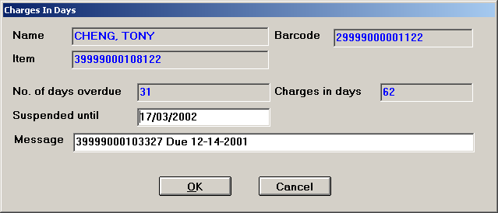

The ‘Suspended until’ field is updateable (if you have permission 267) and contains the date that the user is suspended until. Updating this field changes the ‘Charges in days’ field which is calculated by subtracting Due Date from Suspended date. The ‘Message’ field defaults to the barcode plus Due date (the message field accumulates information -barcode and due date- for each checked-in item separated by ‘/’). This field is also updateable and can contain free text.

After selecting the OK button, if you have made any changes, the system prompts whether you want to save the changes.

Checkout

If the patron is suspended, Checkout displays the form below:

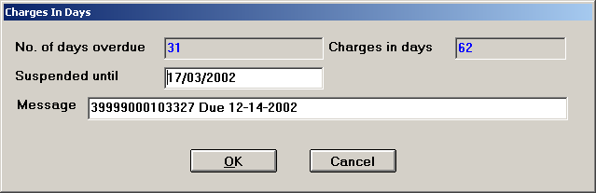

The ‘Suspended until’, ‘Message’ and the OK button function the same as in Checkin.

Patron registration

On the Patron Registration form, when the patron is under suspension, a new field displays beside the Patron’s name. This field is not updateable and is not visible if the patron is not under suspension.

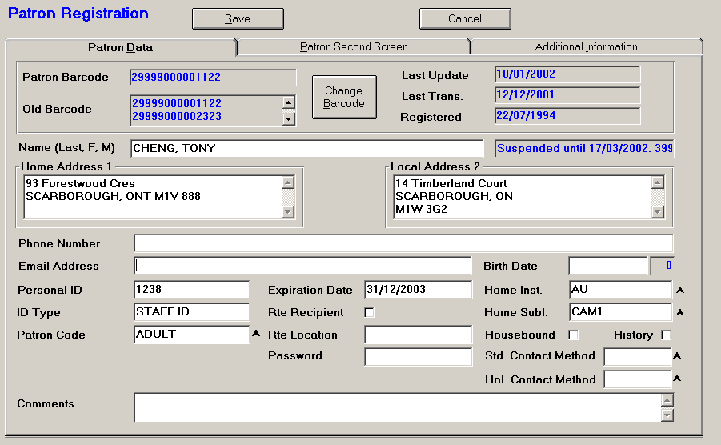

Appendix B – Deleted Item History

Deleted item history may be stored in a file called PIECES.PILON. This is a new file and will be used for future reporting and statistical purposes. This file is automatically created at the time of the upgrade. If the library wishes to retain a history of deleted items (in the PIECES.PILON file), there is a new setup option in the CSAL keyword in CAT, 14. Log deleted pieces (1 = Yes): 1. Setting this parameter to "1" prompts the user to save deleted items in the PIECES.PILON file when items are deleted from the client. If this parameter is set to “0”, no prompting is done when pieces are deleted from the client and the PIECES information is not saved to the PIECES.PILON file.

Prompting the user when items are deleted:
When selected items are successfully deleted, a form appears to prompt whether you want to save the information from the selected items in the PIECES.PILON file. The default is set to Yes.

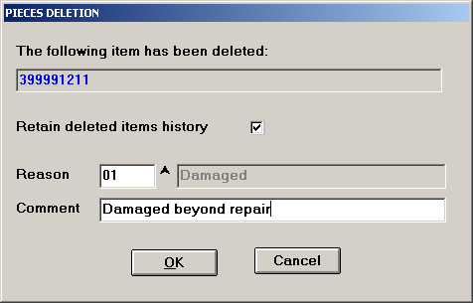

If Retain deleted items history is not selected, all fields will be disabled.
A valid Deletion code is required in the Reason field. F8 can browse the codes.
The Comment field is free text and can be used to describe why the item was deleted.
Choose OK to retain history and exit. The selected Deletion code and comment are applied to all of the selected items.
Choose Cancel to exit without retaining history.

DELC is a new keyword on the Server that is used to set up Deletion codes. It is called from the MASTER menu in ADVANCE. It is a hidden keyword that does not appear on any menu. Deletion codes are used to specify why an item (PIECES) was deleted when the user chooses to save the deleted item history. Deletion codes can also be set up from the AdvMaint client. The maintenance of Deletion codes is controlled by permission 268.

SERVER CHANGES
The ability to save deleted item history has not been implemented on the Server. When PIECES are deleted on the Server, no history is retained.

PIECES.PILON file structure
The structure of the PIECES.PILON file is equivalent to the PIECES file structure with the following exceptions:

Attributes:
<2> Deletion port/User/TTY (S$PORT:VM:S$USER:VM:LOGTTY)
<60> Deletion date
<61> Deletion code
<62> Comment
<63> Bib format
<64> Title
<65> Author
<66> Imprint

Appendix C – De/Sensitization of materials at Checkout and Checkin
This feature allows for the de/sensitization of materials at checkout and checkin on the Circulation client. This is not a standard feature and needs to be ‘enabled’ by Geac staff.
After this feature has been ‘enabled’, there is some set up that the library must do before using it.

Keyword CCT – define circulation codes for Magnetic Media and In Library use only material. Material defined for Use In Library Only will not be de/sensitized.

Control record : CIRC.CONTROL
-------------------------------------------------------( Page 3 of 3 )
1. De/sensitization Magnetic media - Circ Code : AV1 = AUDIO+
2. De/sensitization Use In Library Only - Circ Code : RARE = RARE+

Keyword CIPC – Checkin Port Control – in your Checkin port records, define the code sequences that sensitize your magnetic media and non-magnetic media

Keyword CPPC – Checkout Port Control – in your Checkout port records, define the code sequences that desensitize your magnetic media and non-magnetic media

Whatever device you are using for de/sensitization must be defined in Windows as a printer device (it can be defined as local or network).

In the AdvCirc client, define a De/sensitization device in the same way as you define a receipt printer

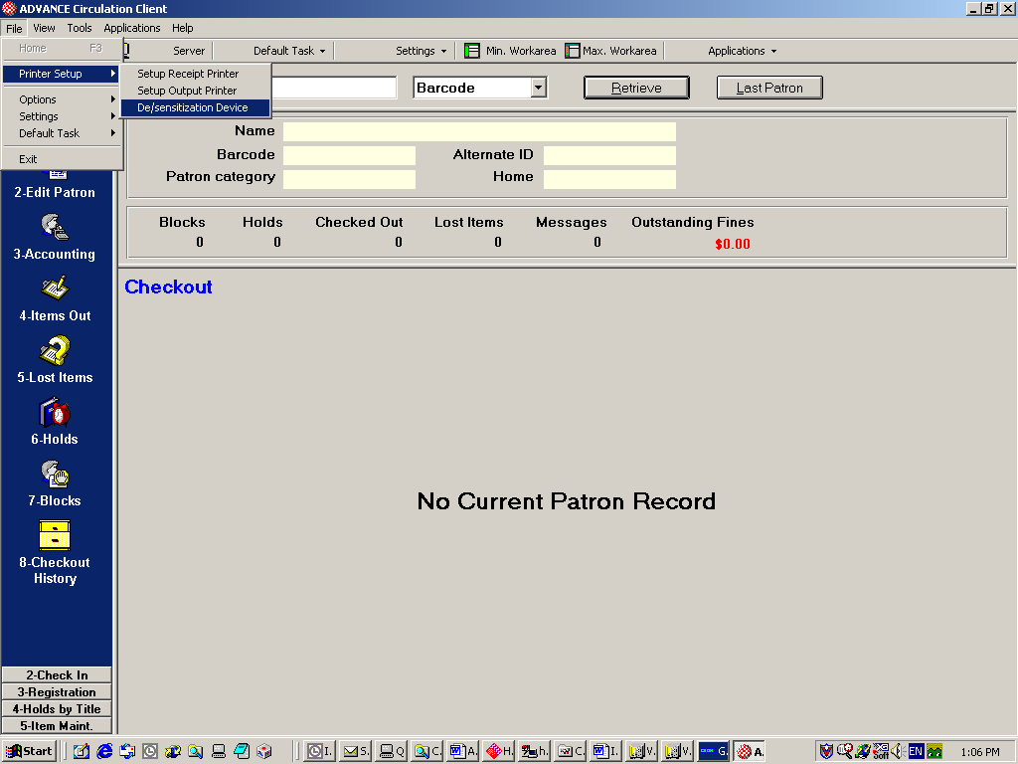

Appendix D – Using AdvCat to add different scripts to MARC records
880 tags in a MARC21 record are used to specify alternate graphic representation of tags that already exist in the record. For example, 880 tags have been created in the MARC record below to specify the CJK representation of various tags that already exist in the record in English.
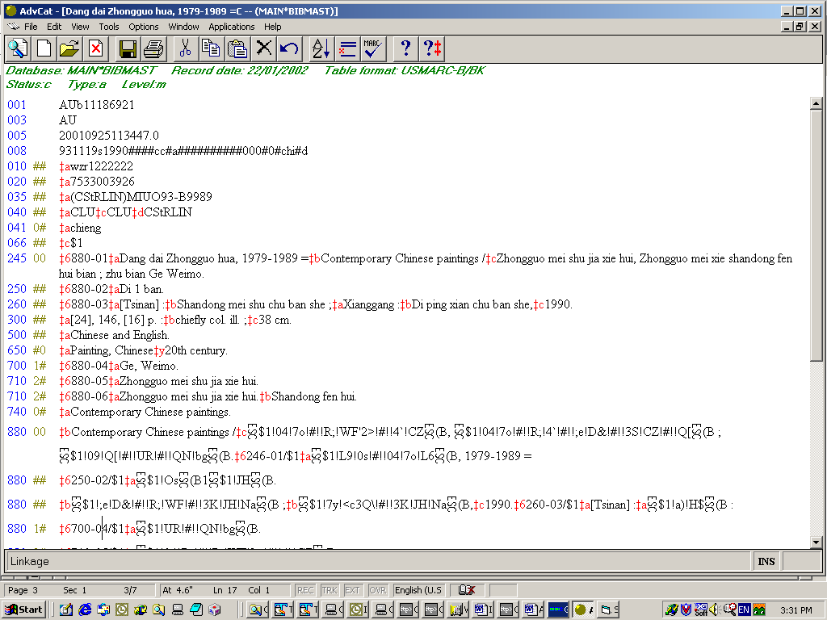

Recent changes to AdvCat make it easy to add alternate graphic representation to 880 tags.
First of all, position the cursor in the correct subfield of the 880 tag. Using the mouse, right click and a drop-down list of available scripts appears. Choose the script that you wish to use.
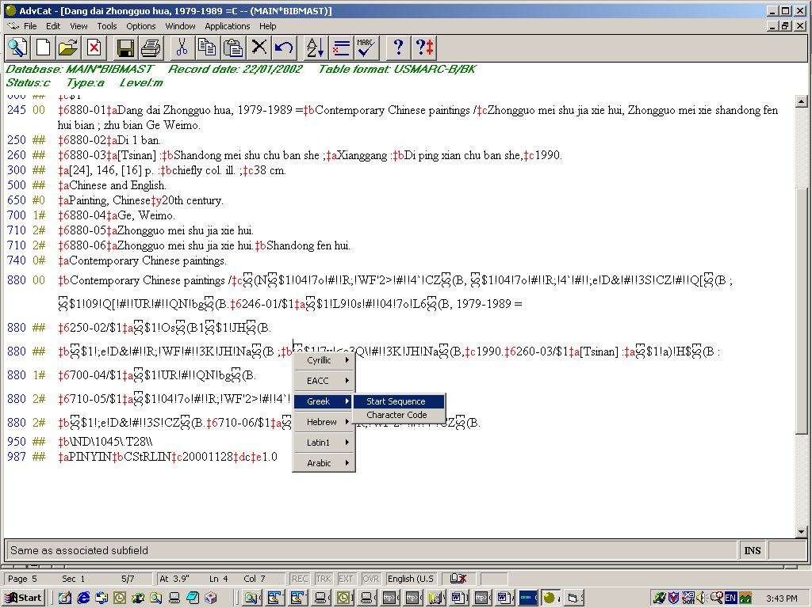

The system will then allow you to add the start sequence character (this is used to tell the system which script you are going to use for the characters that follow). After entering the start sequence character, you can use the Character Code option to create characters in the specified script – see the following form.

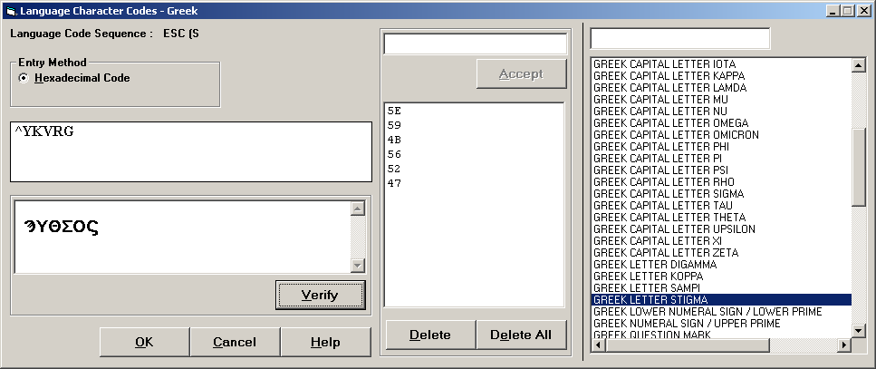

Select the characters you want by double-clicking in the box on the right-hand side of the form. Once the characters are in the middle box, you can manipulate their positions by right-clicking a character and dragging it (this is useful when manipulating combining diacritics and the characters that they should appear with). Use the Verify button to see the results of your character selection.
Use the OK button to add your character selection to the MARC record and return to the MARC editing form.
Make sure that you switch back to Latin by inserting a Latin start sequence.
For more information on tag 880 – alternate graphic representation see
http://lcweb.loc.gov/marc/specifications/ - MARC8 environment

Appendix E – AdvPac - XML syntax
The following displays are controlled through the use of stylesheets.

Single-parts:

A sample citation list after searching for CAT in TITLE:

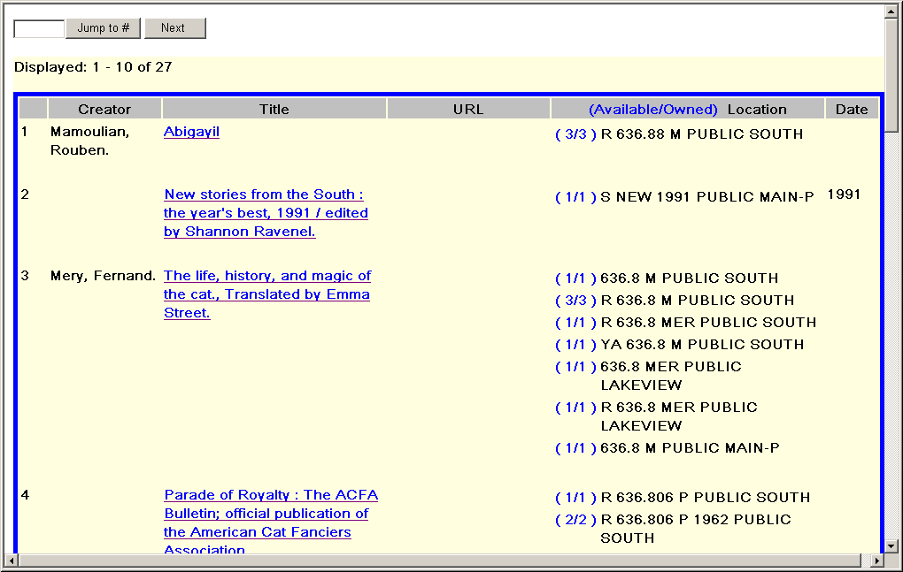

Clicking on the title, takes the user to the detail display:
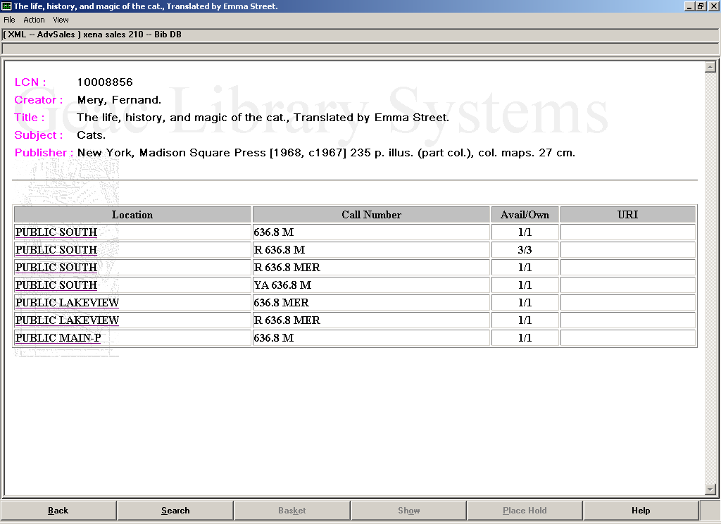
Clicking on any of the rows takes you to a detailed holdings display:
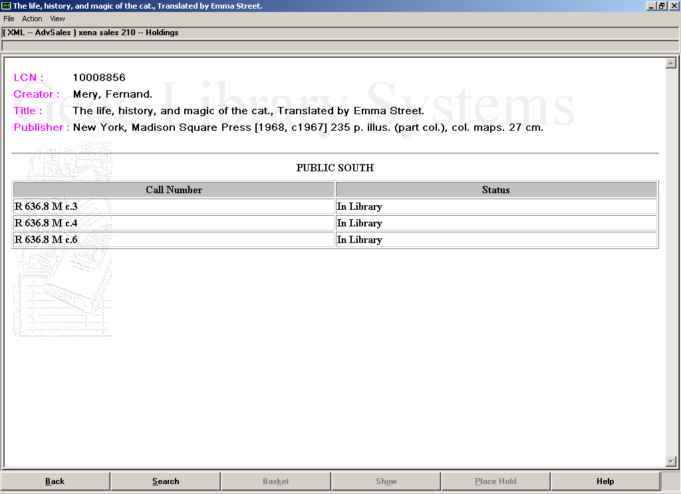

Serials and Multiparts:
A sample citation list after searching for JOURNAL in TITLE:
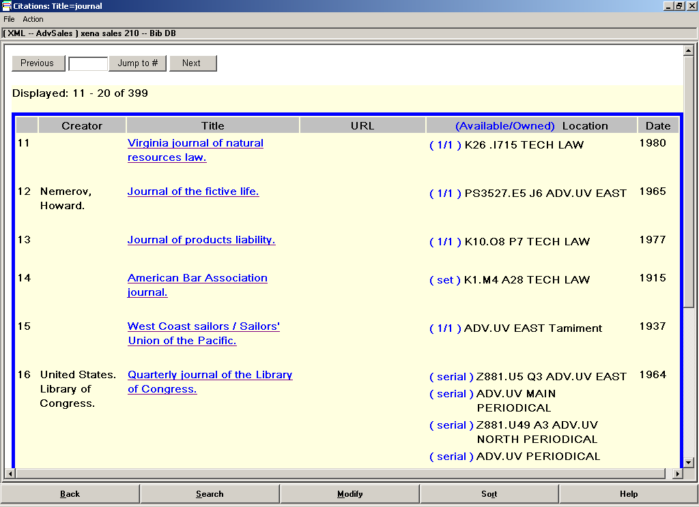
Clicking on the title, takes the user to the detail display:
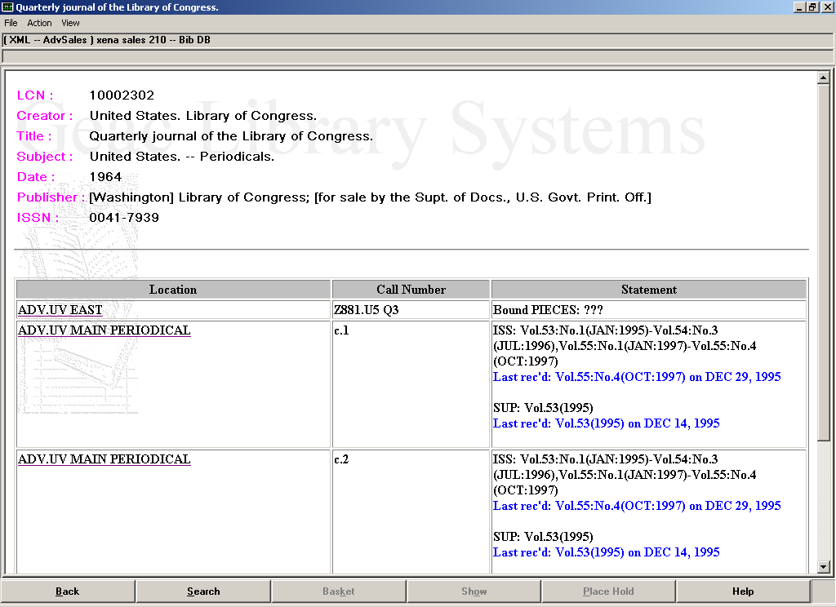
Clicking on any of the rows takes you to a detailed holdings display:
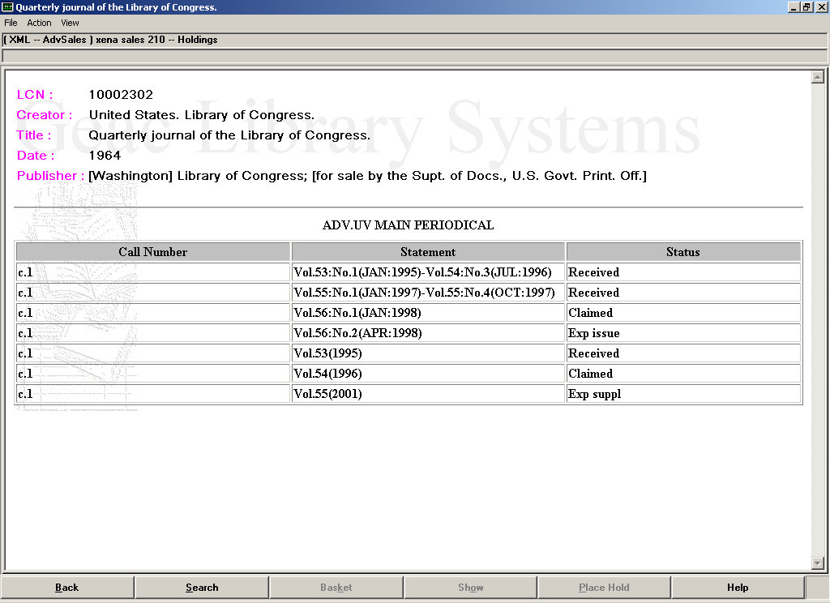

Appendix F – Using the CHECKOUT.HIST file

If showing history from the CHECKOUT.HIST file, the Checkout History Summary items are clickable to show detailed checkout and checkin information for the item. This is an add-on feature and is not part of the standard upgrade.
For the Checkout History special option, the CCT CIRC.CONTROL record has to have the option "Keep checkout history for non housebound patrons" turned on. Also, each patron has to have the "History" flag turned on for the system to record the CHECKOUT.HIST record for history. These system-wide and individual patron controls are to ensure that privacy concerns are dealt with appropriately.

Note: This new feature uses secondary indexes. UniVerse creates these indexes using a full path. You CANNOT just copy this file from one account to another (ie Live to Test account) without first deleting the secondary index in the original account. Once the copy is complete, you can then build the secondary index in both the original and new account (talk to your Installer about maintaining these indexes)
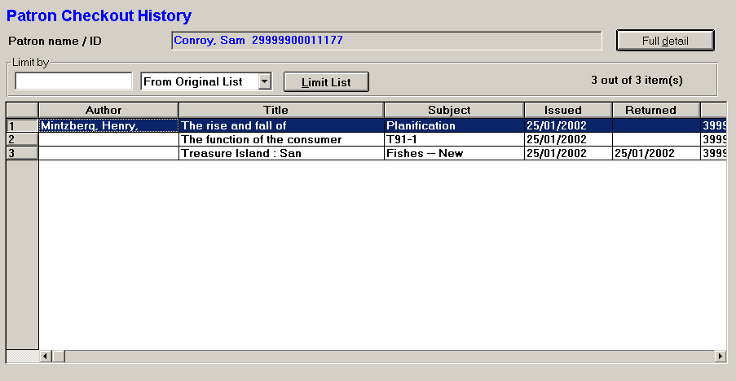

The Patron Checkout History form includes the items currently checked out to the patron followed by the historical items checked out by the patron (stored in the CHECKOUT.HIST file). The currently checked out items are easily identified because they have no Returned date. The CHECKOUT.HIST file is written to at checkin time.
If a site is using the Housebound option and turns on the CHIST option, the checkout history from the client will only show the records from the CHECKOUT.HIST file even though the HOUSEBOUND.HISTORY file is still written to.

Double-clicking on one of the items produces the following Patron Checkout History Full Details form:

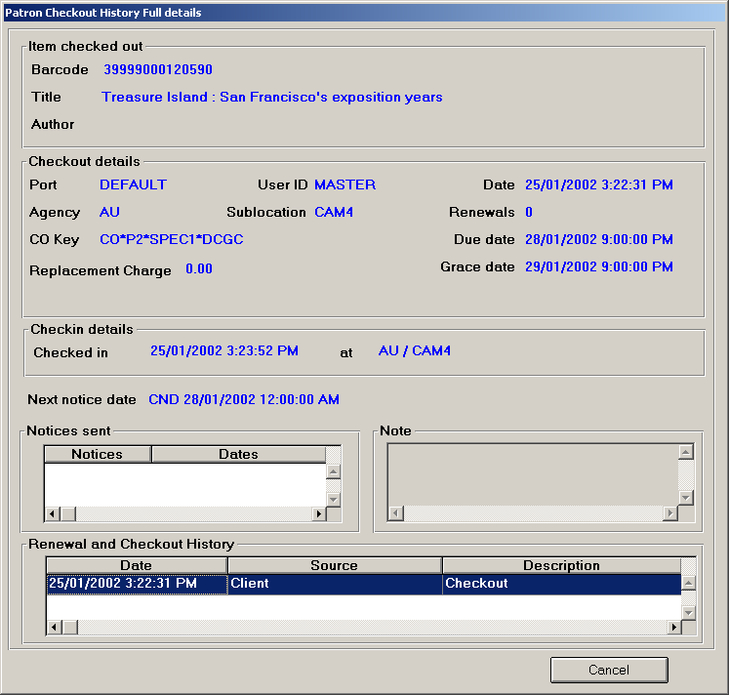

Revision History

Date | Version | Comments
January 22, 2002 | 1 | Initial draft

