

Merging records in Aleph Cataloguing
The records to be merged must both reside on the Server prior to merging.

A.
Search for a better record, either from:
1. From the Aleph Catalogue (NOV01) or
2. Retrieve better record, from external site.
3. Copy the record and file the better record.

B. [Eight steps]
1. Search and retrieve the brief or older/other record, from the Aleph Catalogue (NOV01).

2. Choose “Locate similar record” from the Edit Menu

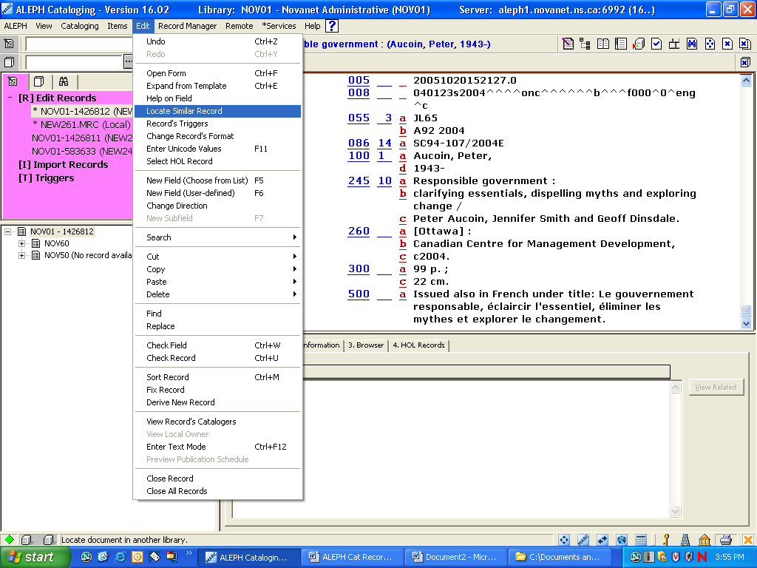
3. In the pop-up box “Locate similar record” choose library [Must be Novanet ONLY]

4. Click on “Locate” and the number of records for the library will appear.

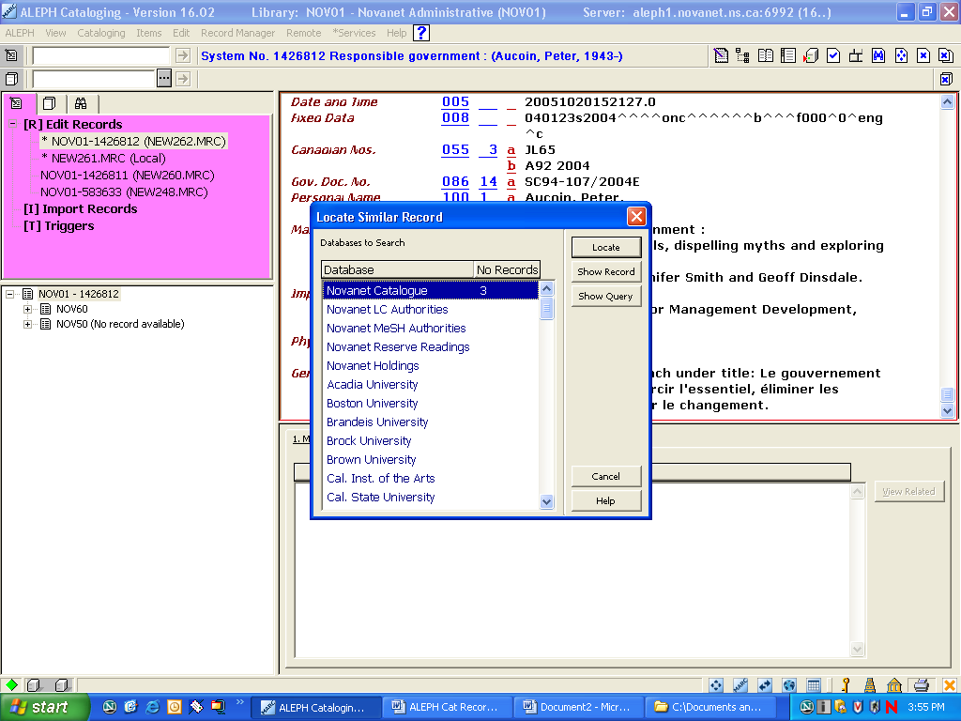

5. Click on “Show record” button

6. From the “Brief list” pop-up box, choose the record that will merge with the older record you already have open.

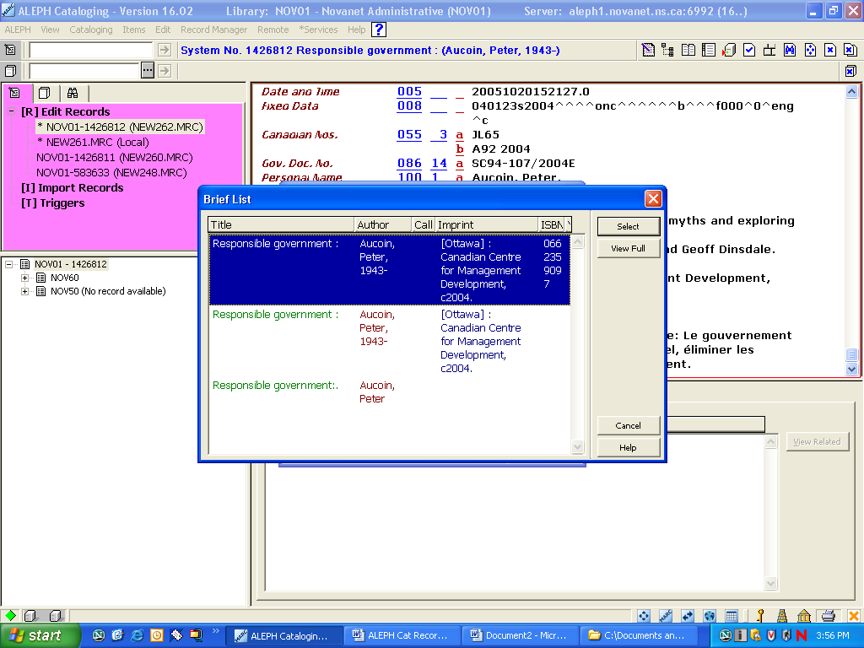

7. The “Aleph Catalog – pop-up box will appear with the following message: “Do you want to merge the record into the current record?
Answer “yes”

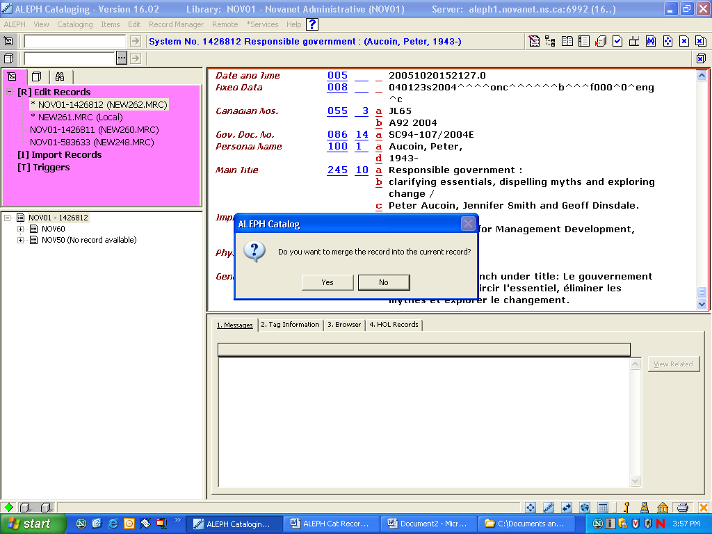

8. Click on ”Save on Server and Local Drive ” from the Cataloguing Menu.

