

Adding unexpected serial issues

- Go to the Check-in screen
[O] Control [PatternHOL]/K[Check-in]

In the Upper Right Pane:
- In 1. All tab, highlight the issue just before the one you want to insert.
- Mouse click on “Duplicate” button.

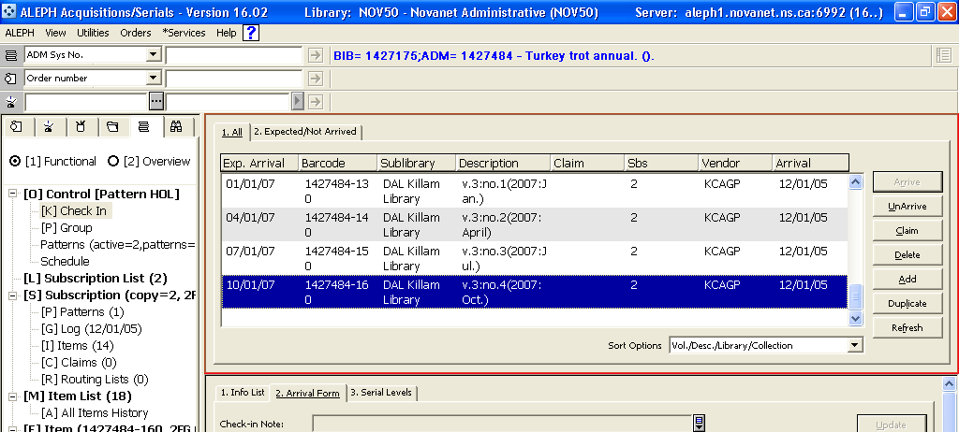

In the Lower Right Pane, now active:
- Go to “3. Serial Levels” tab
- Change the Enumeration/chronological information
- Clear information in the “Description” box
- Mouse click on “Add”. The “Description” box will populate automatically.

