Aleph Version 18: Some New Functionality
[Does not cover Authorities, OWN Field or ADAM]

General

The cataloguer’s username now appears in the upper right corner of the top blue task bar.

Searching

1. Clear Refine Button

A new button, Clear Refine, has been added to the Find tab. Clicking this button clears
text from the Refine Query field.

2. Find Tab

The positions of the OK and Clear buttons have been changed. The OK button now
appears to the left of the Clear button.

3. Multi-base CCL Search in GUI

When a Multi-base CCL Search is performed and fails in several bases, error
messages display one after another, indicating in which databases the search has failed.

4. Multi-Field Search

A check box for "Words Adjacent" has been added to the Multi-field Search tab of the Find node. Selecting the Words Adjacent option instructs the system that the words in the search string must be in the same field and must appear next to each other in the record.
5. Alternative Browse List Display

A new option has been added to the Search Browse window, Include BIB/HOL
Data. When this option is selected, the browse list changes, as follows:

• the columns change to include (1) Headings (2) Bibliographic Info: title and main entry from the bibliographic record, and (3) Holding (location) Info from the
HOL record
• the headings are no longer displayed once only; rather, the same heading is
repeated for each separate bibliographic record, and for each holdings record.

This feature was added in response to a need for holdings display in a call number
browse list, but is not limited to one particular type of heading. It is, however, limited
to headings lists in which each heading is linked to a small number of bibliographic records. When activated on a list that has many records linked to a single heading, a “Failed to read reply” (time-out) message will display.

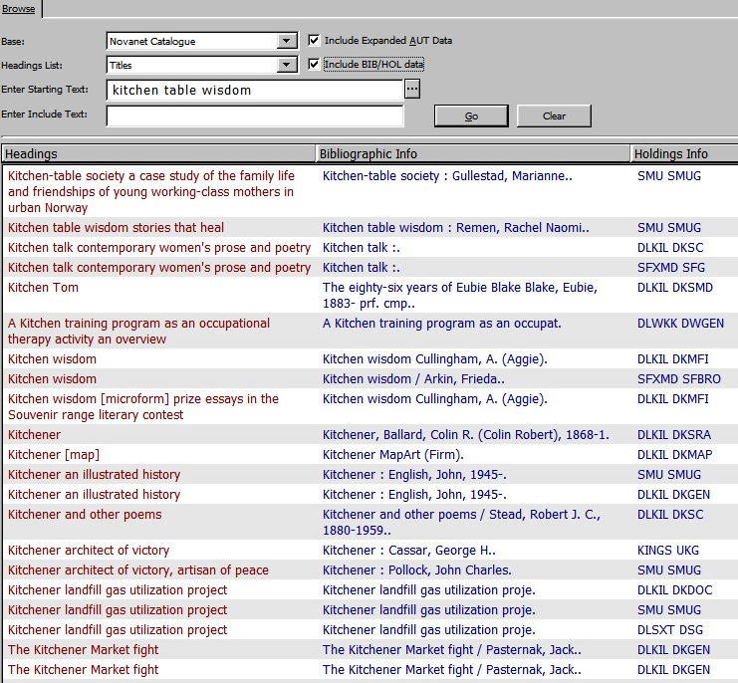

- Browsing Long Headings Enhancements

You can now enter up to 2000 characters in the Enter Starting Text field, so you can
type the exact string to be retrieved. In addition, a new field, Enter Include Text, has been added below the Enter Starting Text field. This new field allows you to retrieve the exact heading efficiently by entering a specific string without having to type all the text, ie. text in the Enter Starting Text field.

- Authority Recheck for Selected Heading

Highlighting an entry in the Browse List, and clicking the new AUT Recheck button
initiates re-checking the heading for a matching Authority record. Re-check can be
activated only if the heading is not related to an authority record, only if the heading
is not a cross-referenced to another heading, and only if a single heading has been
chosen.

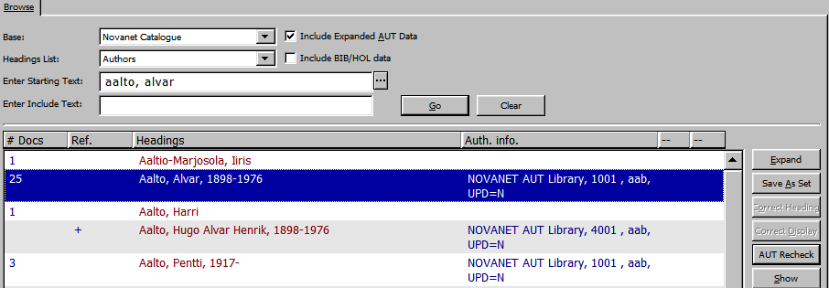

8. Catalog from Browse

From the browse list, it is possible to directly transfer records related to one or more
headings to the cataloging tab of the Cataloging module. A Catalog button has been
added to facilitate this action. You can use the Shift and Ctrl keys to select multiple headings, but the action is limited to 100 records.

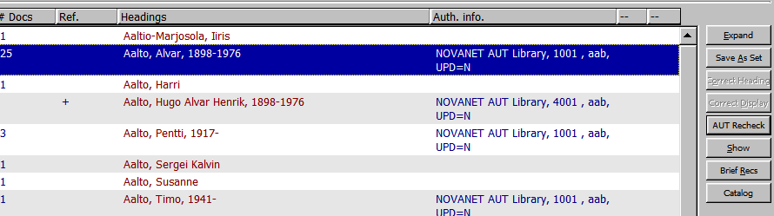

- Item Bar

The retrieval of item records through the Item Bar has been enhanced. Previously, the retrieval of items was performed only by item barcode or by call number. Now, the Item Bar of the Cataloguing module enables retrieval of items by the following options:

- BIB System No.
- ADM System No.
- Barcode
- Call Number

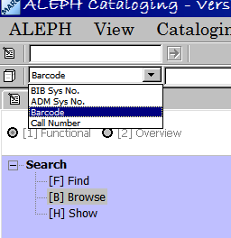

Using the Cataloguing Editor

- It is now possible to use the mouse to scroll through a record open in the cataloguing editor. You don’t need to use the scroll bar. You can also use the mouse to scroll through the search browse list display.

2. You can expand ALL nodes of a record in the Overview Tree by clicking Expand All Nodes, when you right click the mouse.

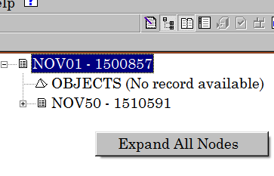
Right-click mouse to see this command

- Using the Split Editor:

Before, if the split editor was used, an empty pane was populated only if it was ‘selected’. Now, if the split record editor is used and one of the panes is occupied by a record, the empty pane will be populated by the next open record.

- Search Headings Functionality:

Search Headings functionality now works per base and not only per library. For this reason, some commands have been changed:

- ‘Search Field Headings of Current Library’ has been renamed Search Field Headings of Current Base
- ‘Search Subfield Headings of Other Library’ has been renamed Search Subfield Headings of Other Base

- Closing Records

The Close All Records and Close Record commands are now located under the Cataloging menu instead of the Edit menu.

6. When you change a record’s format (Edit/Change Record’s Format), a ‘*’ appears by the bib number in the Record Tree, which may help to remind you to file the record again.

7. Records Navigation

There is a new command under the Cataloguing menu: Cataloging/Records Navigation, or, Ctrl-G, which allows you to cycle through all open records. Whenever this command is used, the next open record is put into focus, that is, it can be edited, and its node is highlighted on the Record Tree as the currently edited record.

8. Subfields

When using the Edit/New Field, or F6, command, subfield ‘a’ will automatically be added, instead of a blank. It is no longer possible to enter a blank subfield for fields that should contain subfields.

Holdings

1. It is now possible to move a HOL record, including all attached items, from one BIB record to another.

In the Overview Tree, open two BIB records and do one of the following:

- Select the source HOL record and press Ctrl+X , then select the target BIB record and press Ctrl+V
- Drag the source HOL record to the target BIB record
- ** It seems that you have to be really precise where you drag and drop**

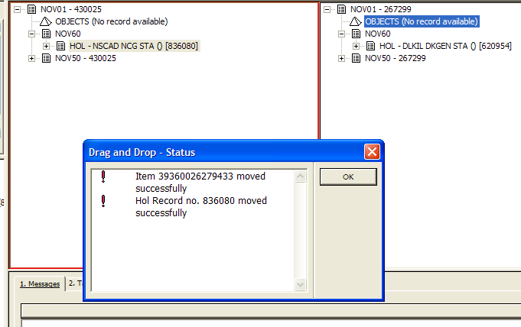
Drop right on top of this little box

- If any of the attached items is connected to an order or to a subscription, neither the items nor the HOL record will be moved
- In a multi-ADM environment, items will stay in the same ADM library. If no ADM record exists for the target, a new ADM record will be created

Items

- Multiple Item Delete

It is now possible to delete multiple item records at one time. Hold down the Shift or Ctrl keys while clicking the required items in the Items List. Clicking Delete will delete all selected items.

If a block, such as an existing hold request or a booking request, is encountered while deleting the item, a dialog box opens up, allowing the following options:
- • Override only this record's requests. If any other item also has Hold/Photocopy Requests another override pop-up message will be displayed.
- • Override all Hold/Photocopy Requests. If any other item also has Hold/Photocopy Requests no message will pop up.
- • Continue the deletion process while skipping this item.
- • Stop the deletion process.

2. New Edit BIB Record Icon
In the upper right-hand corner of the Item Bar, an Edit BIB Record icon has been
added. This icon facilitates moving from the Items tab to the Cataloging tab within the
same bibliographic record. Therefore, it is no longer necessary to change the
view from Functional to Overview in order to move from the Items tab to the
Cataloging tab, within the same record.

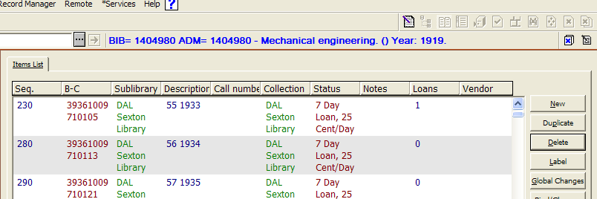
Edit BIB record

