

Deleting records from the Aleph Server

To delete a record from the Aleph server is a four step process:
A. Delete the item(s)
B. Delete the Administration record
C. Delete the Holdings record
D. Delete the Bibliographic record
If only the holdings of one institution are to be removed – just steps A and C are completed

A. Delete item(s)

1. Search for title Navigation Pane / Main tab / Binoculars Icon
2. Retrieve into Cataloguing editor
3. Mouse click on Items Tab Navigation Pane / Main tab / Item Icon
4. Choose correct item and highlight, in Upper Right Pane
5. Press the “Delete” button in Upper Right Pane

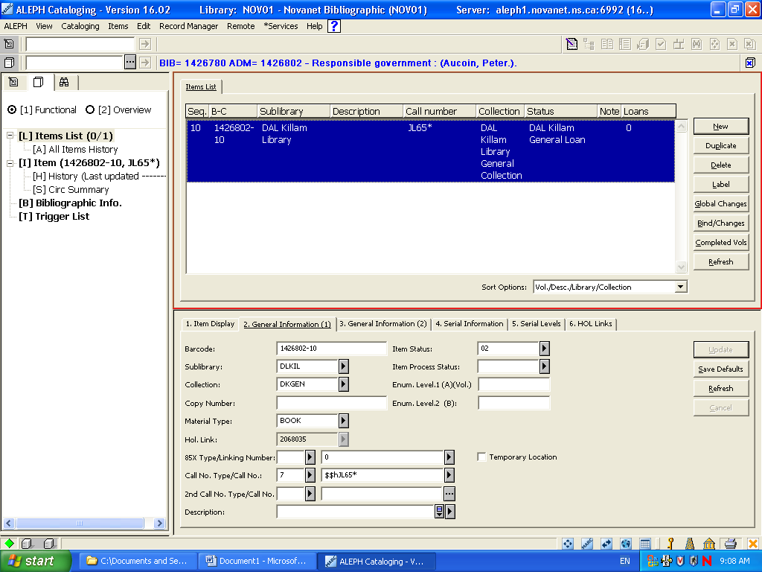

B. Delete Administration Record

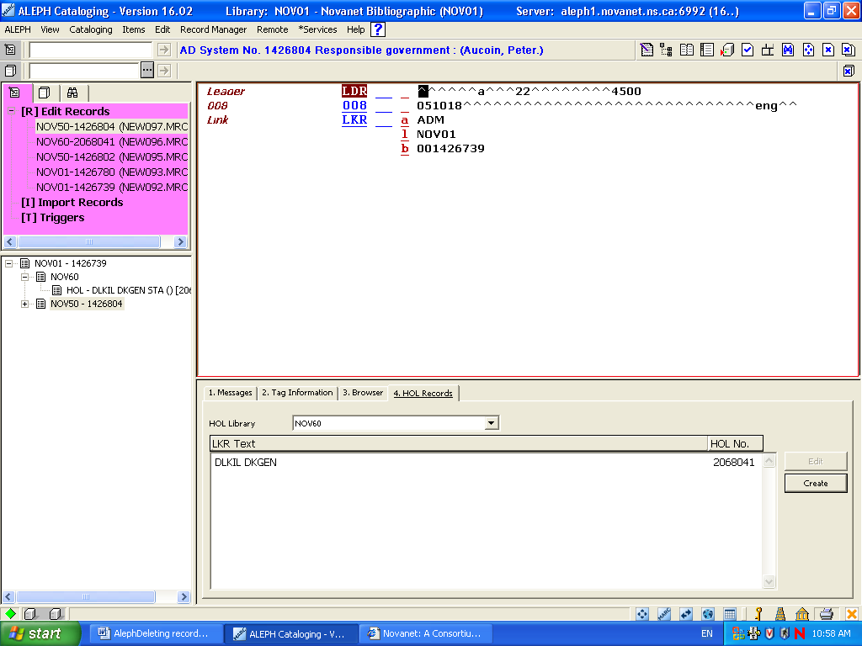

1. Return to Cataloguing Editor Navigation Pane / Main tab / Record Tab
2. Select NOV50 node from the Lower Left Pane
3. Select the Delete from server from the Edit Menu
Main Menu Bar / Edit / Delete / Delete from Server

C. Deleting Holdings Record

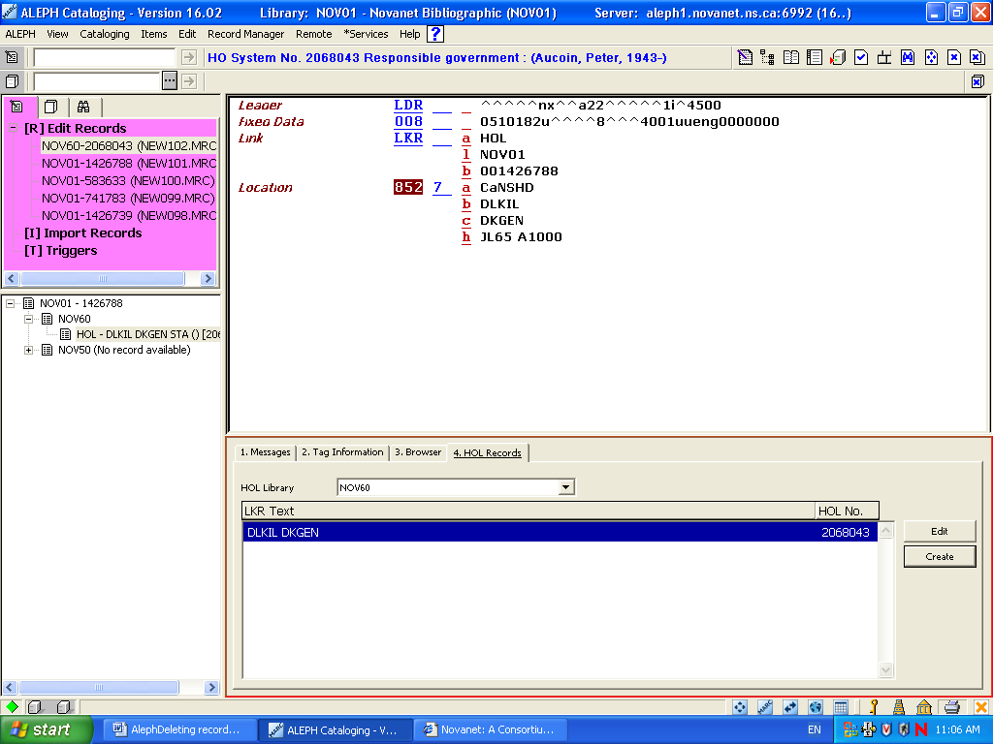

1. Activate Holdings Record by pressing “4. HOL Tab” in Lower Right Pane Navigation Pane / Main tab / Record Tab
2. Press “Edit” Button in Lower Right Pane
3. Select the Delete from server from the Edit Menu
Main Menu Bar / Edit / Delete / Delete from Server

Delete Bibliographic Record

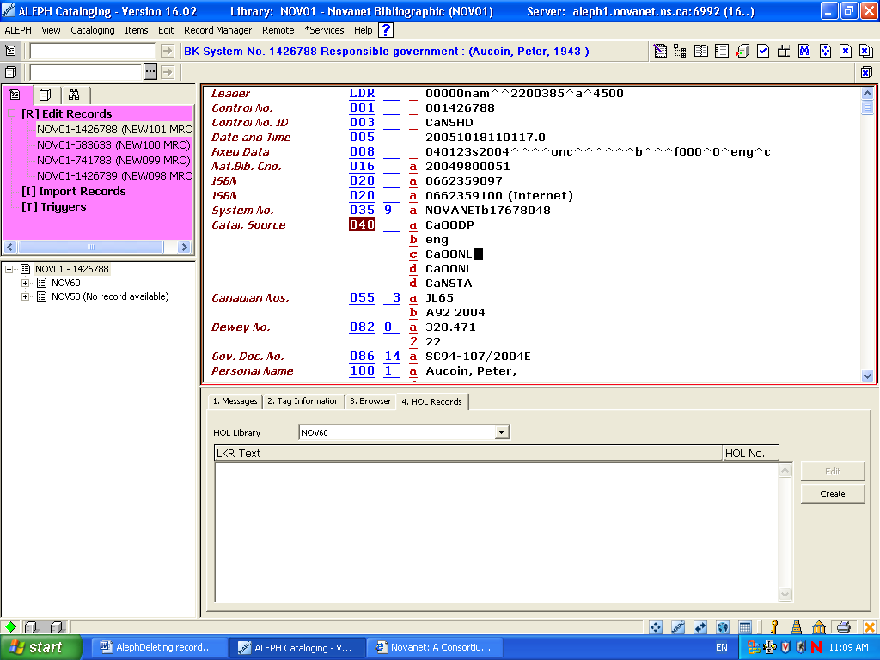

1. Retrieve into the Cataloguing Editor Navigation Pane / Main tab / Record Tab
2. Select the Delete from server from the Edit Menu
Main Menu Bar / Edit / Delete / Delete from Server
Deleting record from Local server (hard-drive)

1. Go to “Delete New* Records” off the Cataloguing Menu
Main Menu Tab / Cataloging / Delete New* Records
2. A pop-up box will appear
3. Mouse click on “Yes”

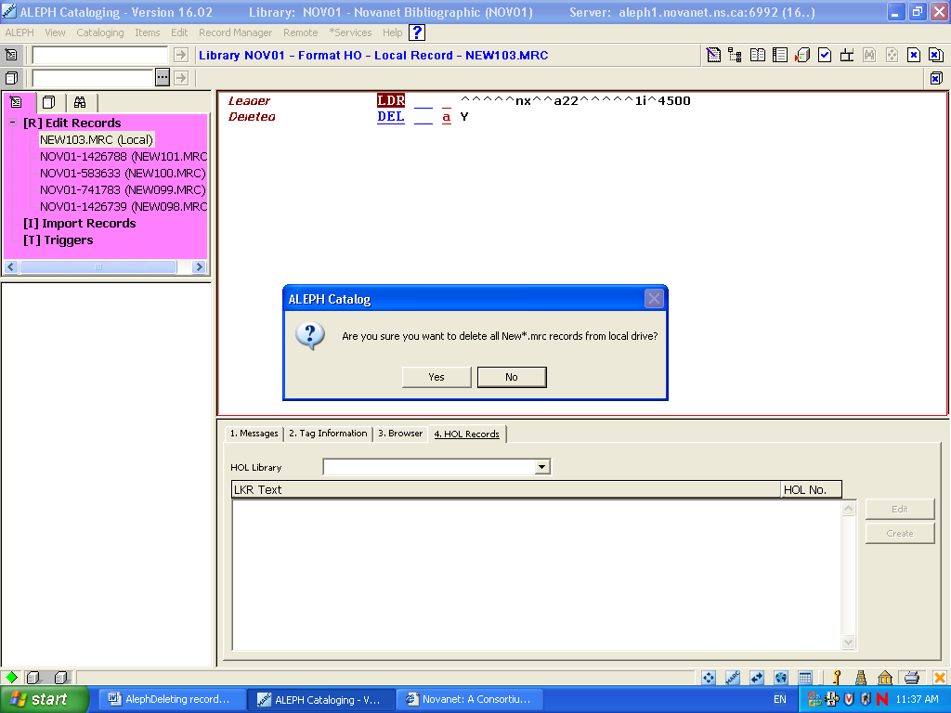

Note: All record on your hard drive that have NEW in their title will be deleted.

(If there are particular titles that continue to be needed on your hard-drive only, those records need to be re-named prior to doing this clean up routine.
Re-name by going to
Main Menu Bar / Cataloging / Open Record on Local Drive /
1. Highlight title
2. Press “Open’ Button
3. Go to “Rename on Local Drive” Main Menu Bar / Cataloging /Rename on Local Drive
4. In pop-up box rename the title [example NEW225.MRC becomes Killam0503.MRC]

Suppressing record from the OPAC only
Example: Membership records

In the Cataloguing Editor
Add a line
STA -- $a SUPPRSSED (in capital letters)

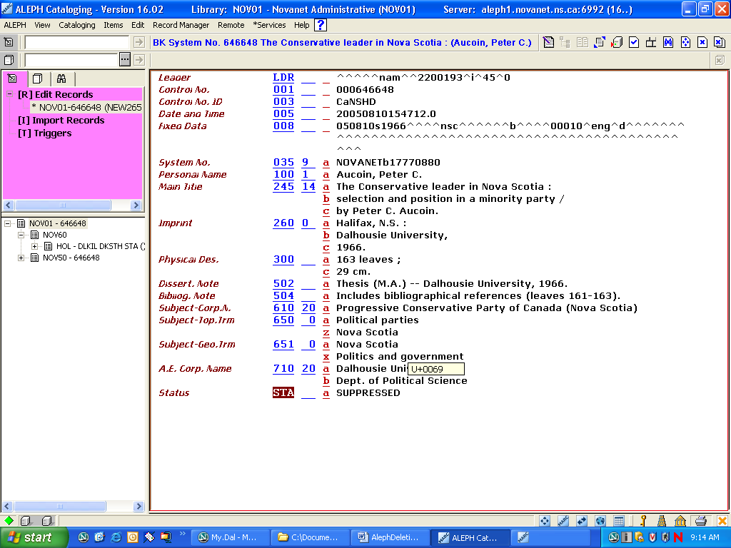

Deleting when the lost/fines are being charged

In the Cataloguing Editor
Add a line
STA -- $a DELETED (in capital letters)

