

Aleph Serials Routing Lists

Routing List Functionality
It is possible to create routing lists in Aleph. The list may only have one person on it or many, depending on the title.

A. Routing List Node:
You can access the Routing List node by clicking on it from the Navigation Pane. This list all routing lists associated with the subscription.
Navigation Pane / [S] Subscription /[R] Routing list

B. Routing List Root Display:
Routing List Root found near the bottom of the Navigation Pane. This list all routing lists associated with the title. Navigation Pane / Routing list (Root)

Circulation Policy Required if You Wish to Loan Issues:
In order to effectively use Routing Lists in Novanet, a circulation policy for any items you wish to loan to staff or faculty for routing will need to be made.
Any non-circulating items will not be allowed to be loaded in Novanet (B. Slauenwhite Oct.2005)

Creating a Routing List without Circulation status

You can use the Routing Lists function to simply create a routing list without loaning the periodical to the members of a routing list. There simply would be no check-out through the Circulation Client.

Routing Lists Node
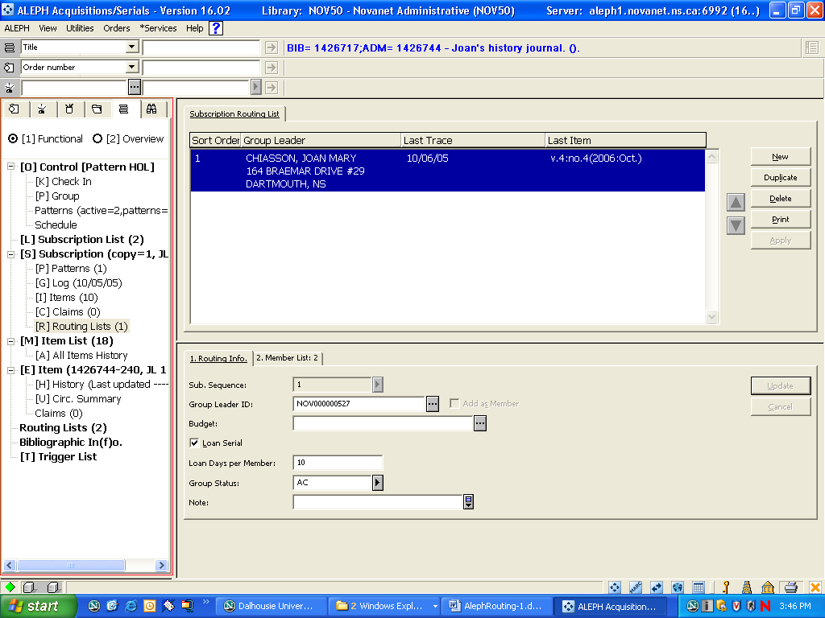
Figure 1: Routing Lists Node

The Upper Pane of the Routing List Node
Upper Pane Display:
The Upper Pane will display a list of Routing Lists that appear for this subscription.
Buttons on the Upper Pane:
- New: Use this button to create a new routing list. When you click on New, the Lower Right Pane will open on Tab 1, entitled “1. Routing Info”.
- Duplicate: Use this button to duplicate an existing routing list.
- Delete: Use this button to delete a routing list. Note that issues cannot be out on loan if you wish to delete a routing list.
- Print: Use this button to print out a routing list. Note; When you create a routing list, the system will automatically print out a routing list for the issue when you check the issue in (arrive it), on the Check-In Node.
- Apply: If you have more than one routing list for a subscription, you can select which routing list group will receive the routed issue first. Use the up and down arrow keys to the right of the Routing List window in the Upper Pane and click the Apply button.

The Lower Pane of the Routing List Node
Lower Pane Display: The Lower Right
Pane will allow you to add or edit an existing Routing List.
If you click New on the Upper Pane, the Lower Pane will open and tab 1 “1. Routing Info”
- Tab 1 “1. Routing Info. This tab will provide information about what subscription the routing list is linked to and information about the set up of the routing list.
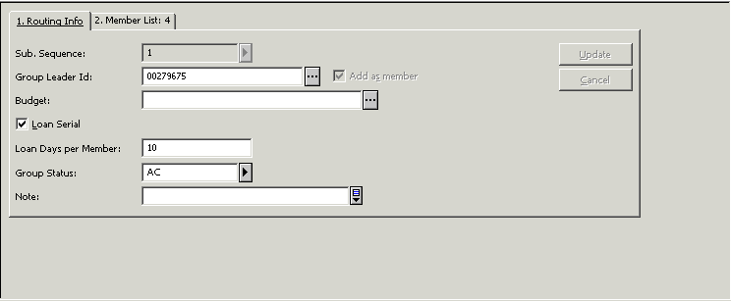
Figure 2: Routing List Node, Lower Pane, Tab 1: Routing Info

Tab 2: This contains the list of members on the Routing List
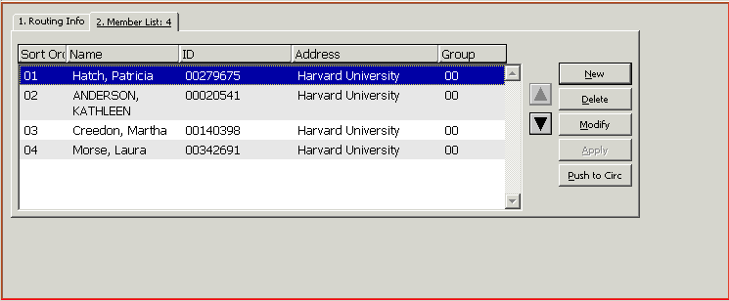
Figure 3: Routing List Node, Lower Pane, Tab 2: Member List

Creating a Routing List
1. Start by choosing your library's subscription
In the Navigation Pane / [L] Subscription List - click on the appropriate subscription
2. Go to the Routings List node
In the Navigation Pane /[S] Subscription / [R] Routings List node – Click on the node
3. In Upper Right Pane click on the “New” button.
4. In the Lower Right Pane: the 1. Routing Info. tab opens.,
a. Sub. Sequence (Subscription sequence) will be automatically populated from the Navigation Pane / [L] Subscription List, that has been already been chosen.
b. Group ID –
i) Open box, obtain patron information (coming from Patron ID)
ii) Click on Patron name, fill in “Enter starting point” box (example: Chiasson, Joan),
iii) Press enter,
iv) Highlight the correct patron
v) Click the “Select” button.
c. Loan serial – check box - if the issue is to be tracked by the Circ. System (optional)
d. Loan days per member - the number of days a person may borrow the issue. This maybe tracked by the system. (used with 3 c above; optional)
e. Group Status – must be active to receive a message each time an issue is received. It is a drop down box.
f. Note field – free text field (maximum of 2000 characters)
g. Routing list creation – click on the “Add” button (Lower Right Pane)
***Do NOT use the Budget line (for Corporate Libraries only)
4. Members List tag: Lower Right Pane: the 2. Member List tag (adds members to the routing list)
a. Click on the “New” button
b. Add routing list members by their patron ID. Complete as number 3b above.
c. Click on “Update” button

1.Dialog Box Indicating Item has Routing List:
Navigation Pane / [O] Control / [K] Check-in
Once you have set up a routing list, the system will bring up a dialog box each time you check in an issue indicating that there is a routing list associated with the item. The list then can be printed at your printer & sent to the client with the physical item.
2. Discharging routed items
Main menu / Utilities / Return from Routing Group /Item barcode
The item barcode is on the routing slip, the check-in box or on the issue.

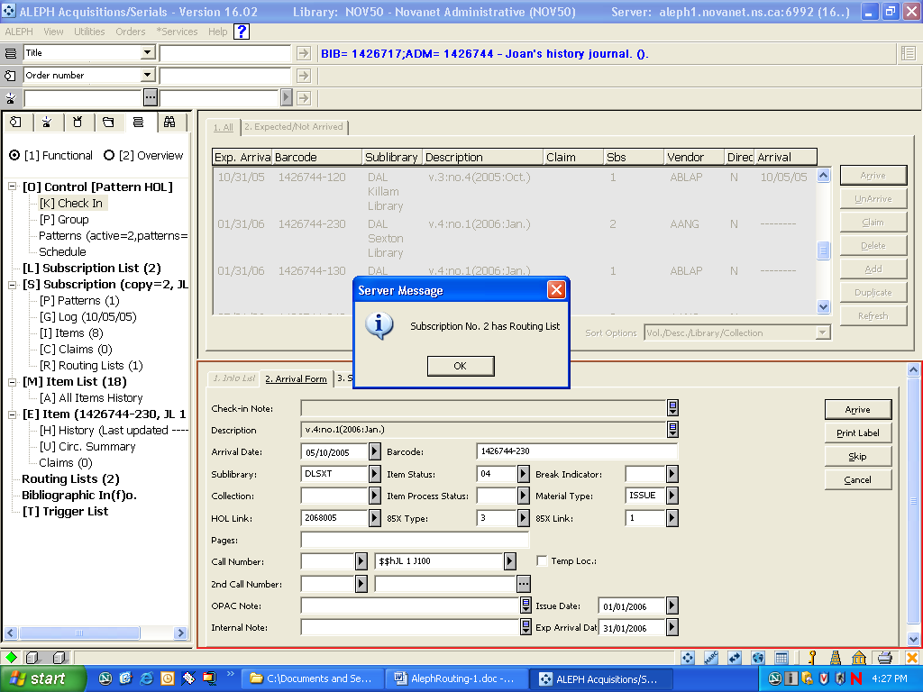
Figure 4. Routing notice in [K] Check-in Box
An example of a Serial Route List
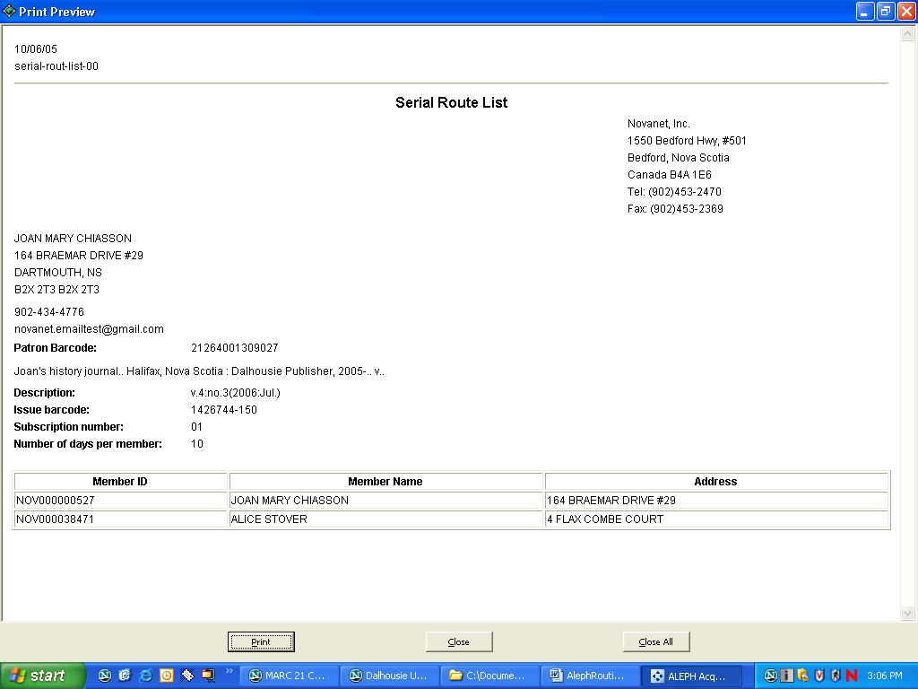
Figure 5. Serial Route List

Routing Lists Root Navigation Pane / Routing Lists
Navigation Pane Display: The Routing Lists Root will display the number of all routing lists associated with this title, not just the routing lists associated with a particular subscription.

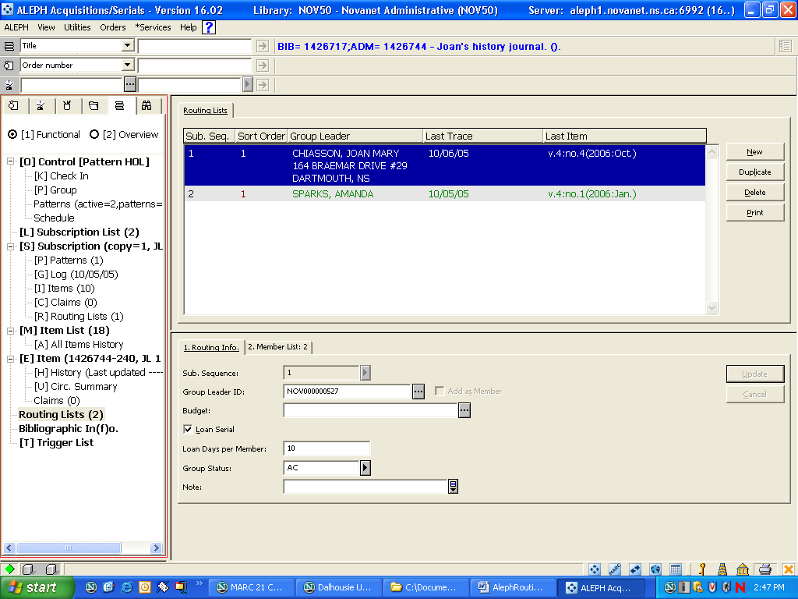
Figure 6: Routing Lists Root

Upper Pane Display: In the Upper Pane, you will see the list of routing lists associated with the title.
The Lower Pane will display Routing List information about the list that is highlighted in the Upper Pane.

