Basic Search Strategies in ALEPH using the Search Tab

Oct / Nov 2005

There are 4 types of searches performed using the Search Tab:

1. Advanced

2. Multi-Base CCL

3. Multi-Field

4. Browse

1. Advanced Search

Advanced search allows you to perform a search in a group of basic fields, or in a specific field such as title or subject.

To perform an Advanced search click on ‘(F)‘Find’ in the Navigation pane (left pane)

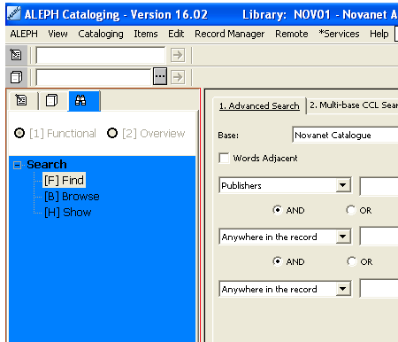

After you click on Find, the Find search box opens to the right.
Advanced Search is the default tab for this window. You can search up to three separate keyword indexes using Advanced Search. The pull down list has all available search fields, and three styles of search. Once you select an index it will remain persistent on the Advanced Search tab until you change it.

To perform an Advanced Search:

1. Select a base: Novanet Catalogue ( NOV01) is the default.

2. To search a phrase check off the ‘Words Adjacent’ box (otherwise leave it blank).

3. Select the keyword you wish to search from the drop down menu.

4. Enter your search term in the field to the right of the first index box.

5. To search more than one keyword index, choose one of the Boolean operators found below the first search field (AND, OR or NOT).

6. Select the next index you wish to search in the Second search field and enter a term.

7. Click OK.

Beneath your search a list of sets will indicate the total number of records found in your search:
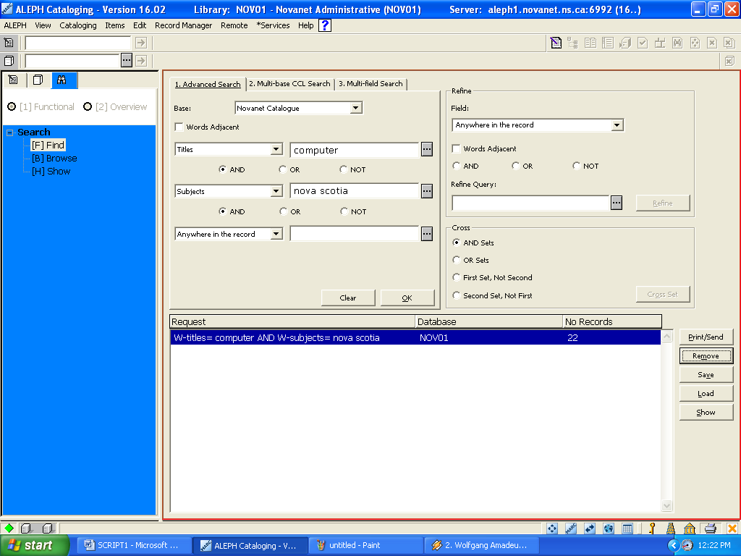

Click on ‘Show’ to view the results. Note that the ‘Show’[H] option is now highlighted under Search (left pane)

Search results:

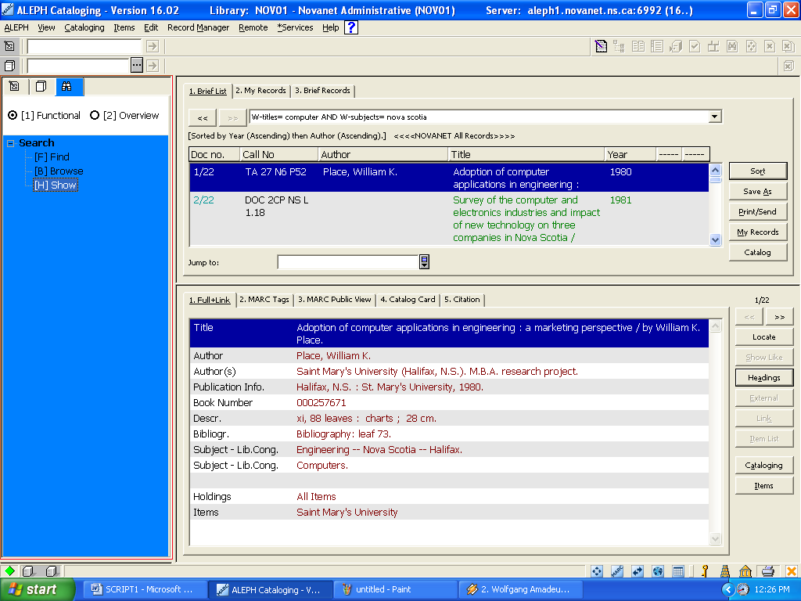

Search history can be found to the right of each search field. Click on the box to see the previous term that was searched. Click ‘Find’(left) to go back to the search box.

Search history:
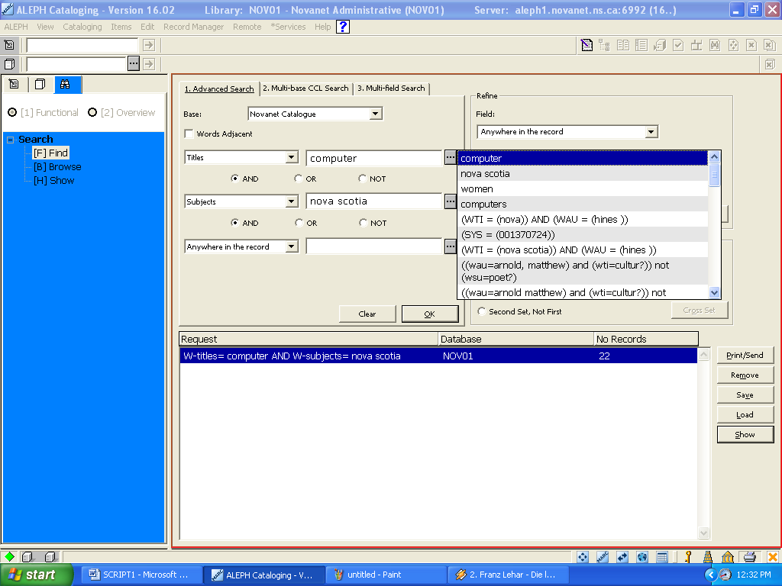

ALEPH supports and , or, and not Boolean operators. and is assumed if no operator is present. Operators can be typed in English or expressed by using any of the following conventions:
- AND = + (plus sign)
- AND = & (ampersand)
- OR = | (pipe sign)
- NOT = ~ (tilde)

More details on Searching:
All searches can be further limited by language, format, years and location. You can define these limits at the bottom of each Search screen.
In addition to the Search Hints at the bottom of each Search screen, the following are additional rules for all types of searches:
The ? character or * character (asterisk) can be placed at the left, right or middle of a portion of a word, but it can never be used more than once in a text string.
The # symbol can be used to find variant spellings in cases where one version of the word has one more character than another version. For example, colo#:r will find both color and colour; and arch#eology will find both archaeology and archeology.
The ! character can be used to find variant spellings in cases where a single character may vary. For example, wom!n will retrieve both woman and women.
The % symbol, followed by a number, can be placed between two words to indicate that you want the words to appear within a particular distance from each other, irrespective of what order the words appear in. For example, england %3 ballads will retrieve Ballads of England , Ballads of Merry Olde England and England and Her Ballads.
The ! character, followed by a number, can be placed between two words to indicate that you want the words to appear within a particular distance from each other, and in the same order in which you type the words. In this case, ballads !3 england will retrieve Ballads of England and Ballads of Merry Olde England but not England and Her Ballads.
The -> (hyphen and greater than symbols) can be placed between two words. This indicates that you want to retrieve records that have words from (and including) the first word, through the second word. This search is particularly helpful for limiting a set of records by year of publication. You cannot use to instead of the symbols.
Here is an example: 1993 -> 1996

2. . Multi-Base CCL Searching

The second tab in Find Search is Multi-base CCL search. You can use Common Command Language (CCL) to search for words and headings in several different indexes at once. CCL supports complex Boolean searching. You must specify the code of the word and the heading indexes to be searched. Abbreviations used in CCL can be found in the help menu under ‘Command language”.
You can use the Multi-base on more than one database at a time. This lets you retrieve a set of records in your selected databases which match your specified criteria. When you click Go, the Previous Searches list of Search Requests appears.

Select another location (McGill & Memorial) as well as Novanet :

For example an initial search:
wau=Hines sherman not wti=nova
Finds anything written by Sherman Hines, which has NOT been assigned a subject beginning with the word Nova

ALEPH displays results for McGill (4), Memorial (15) and Novanet (15),
at this point we can click the ‘Show’ button to display the highlighted results.

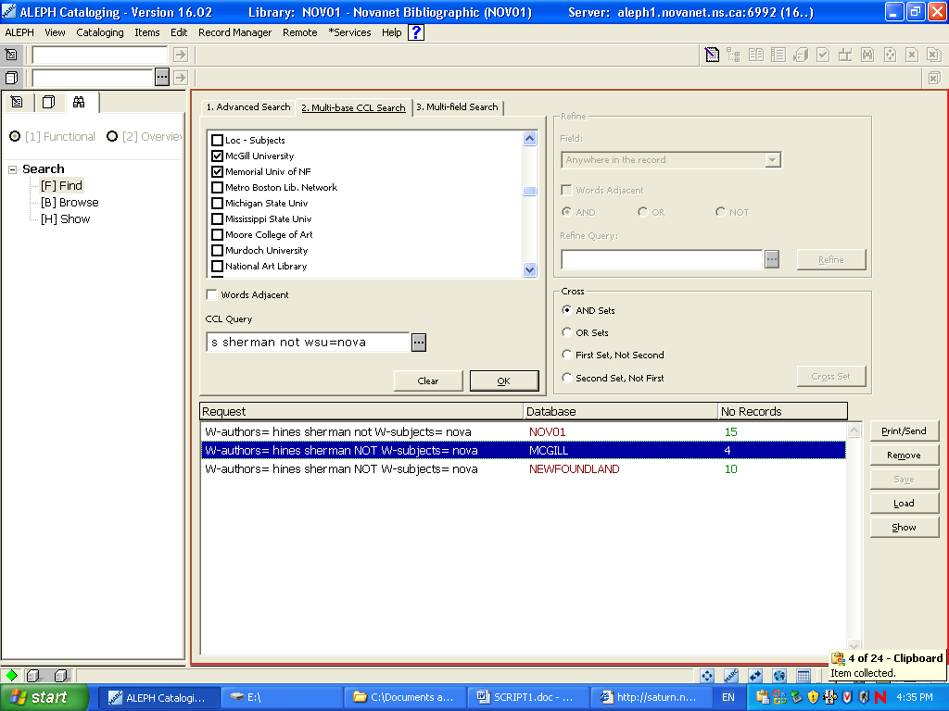

McGill results (4):
Note that the search tab on the left indicates that we are in ‘Show’, and the active window is highlighted in red. To perform a similar search go back (up) to ‘Find’.

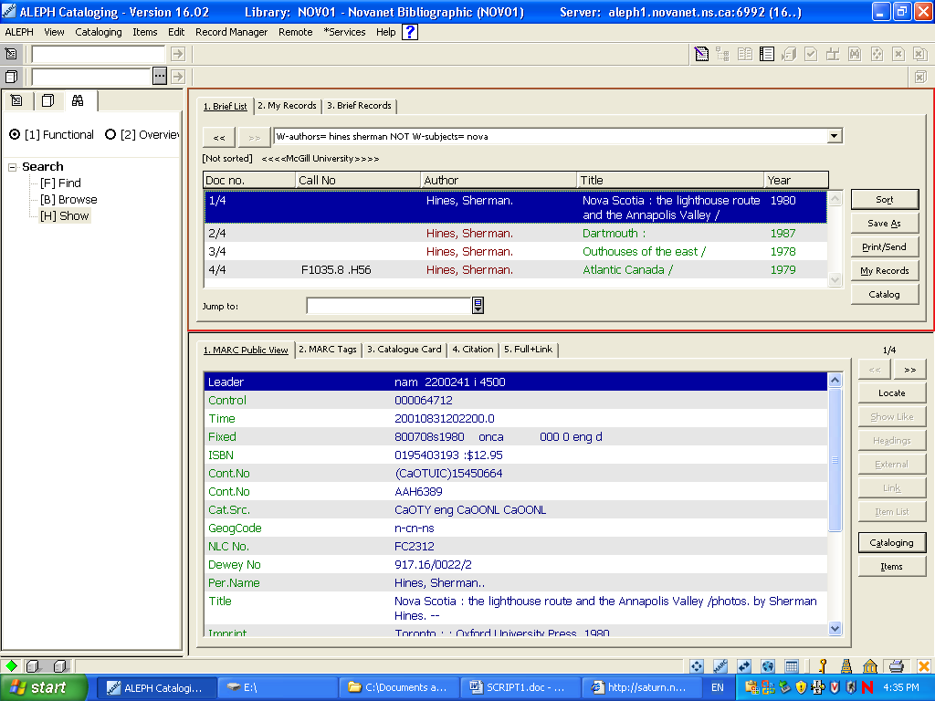

Abbreviations used by the Common Command Language
(Found in the Help menu under ‘Command language’)
LCC - LC Class
LCN - LC Shelf
DDC - Dewey
TIT - Titles
AUT - Authors
IMP - Imprint
SUB - Subjects
SRS - Series
LOC - Location
WRD - Words
WTI - Words in title field
WAU - Words in author field
WPE - Words in personal author field
WCO - Words in corporate author field
WME - Words in meeting field
WUT - Words in uniform title field
WPL - Words in place field
WPU - Words in publisher field
WSU - Words in subject field
WSM - Words in MeSH subjects
WST - Words in status
WGA - Words in geographical area
WYR - Year of publication

3. Multi-Field Search:

The third tab in Find search box is Multi-field Search.
The Multi-Field Search lets you search more than one word group at the same time in 7 key specific indexes. It’s a quick way to search the most common keyword indexes. The more fields you can fill in, the narrower the search. Note we have selected the

‘Multi-field search’ tab using ‘Search | Find' in the left pane:

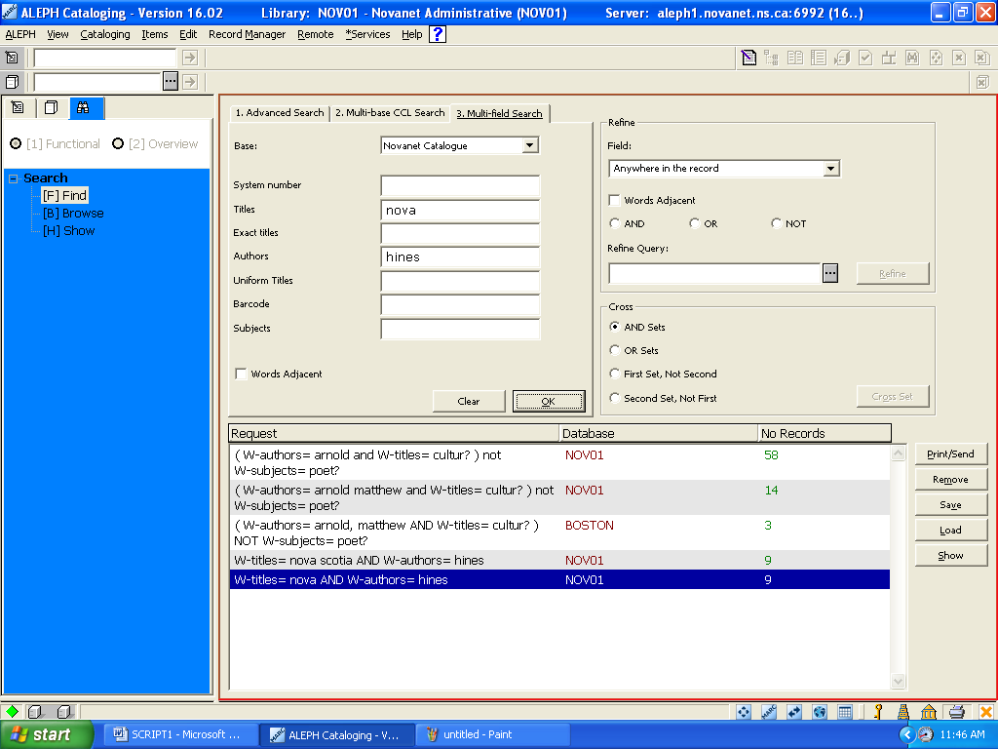

At this point we could go back to the ‘Advanced’ or CCL’ search tab and our last search string and results are retained.

4. Browse search:

The second option under the Search tab is Browse.

Clicking on the Search | [B] Browse option opens the Browse search function,

Select a base to search (Novanet) and choose a heading from the drop down menu
(subject) and enter a search term (Bush family)

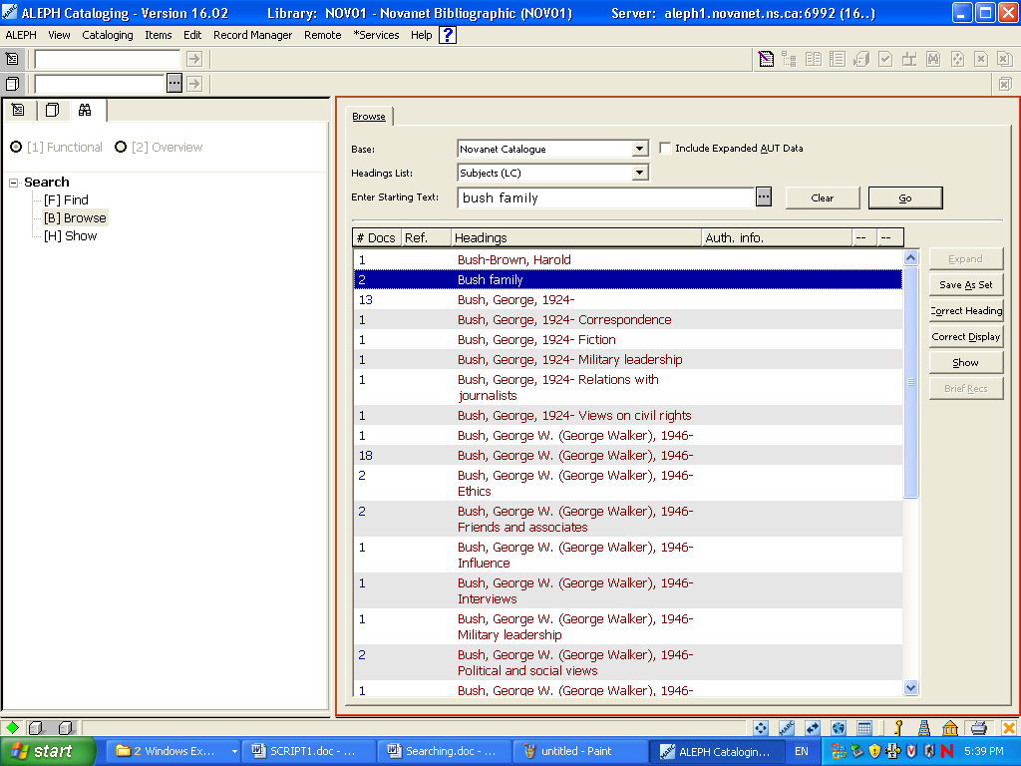

Note that at present the Browse function is not available for searching External bases
(such as LC or Amicus).

Novanet displays 2 hits for ‘Bush family’, highlight a selection (Bush family) and click on ‘Show’ then view the results:

