

Binding in Aleph

Open the Acquisitions/Serials Module
Enter username and password

Locating a title
Search for title using the Serials Bar
The Serials Bar is the first bar you see in the Acquisitions/Serials Module. The icon to the left of the bar matches with the icon on the Serial Tab.
You can use the Serials Bar to locate serials by selecting one of the options from the drop down menu: BIB Sys No., BIB Title, BIB Author, BIB ISSN, Barcode and ADM Sys no.
The Serials Bar is the most efficient way to find a serial by ISSN.
1. Select BIB ISSN from the menu
2. Type in the ISSN in the second field.
3. Click on the Blue Right Arrow or hit the <Enter> key.
Note that you must input a complete number, or author word or title. You can NOT truncate searches in the middle of words using the Serials Bar. If you find one record, the Serial Tab will open and the Check-In List will display in the Upper Pane. The first issue on the Check-In List will display in the Lower Pane.
Next to the Serial Bar, you will see SYS No, ADM No., title and author information about the record.

If you retrieve more than one search result using the Serials Bar, the system will display a dialog box that will indicate that multiple entries have been found and asking you if you wish to see the results.
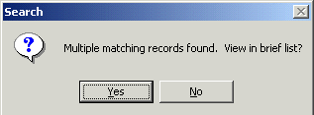
Click yes to the dialog box, the system will open the Search Tab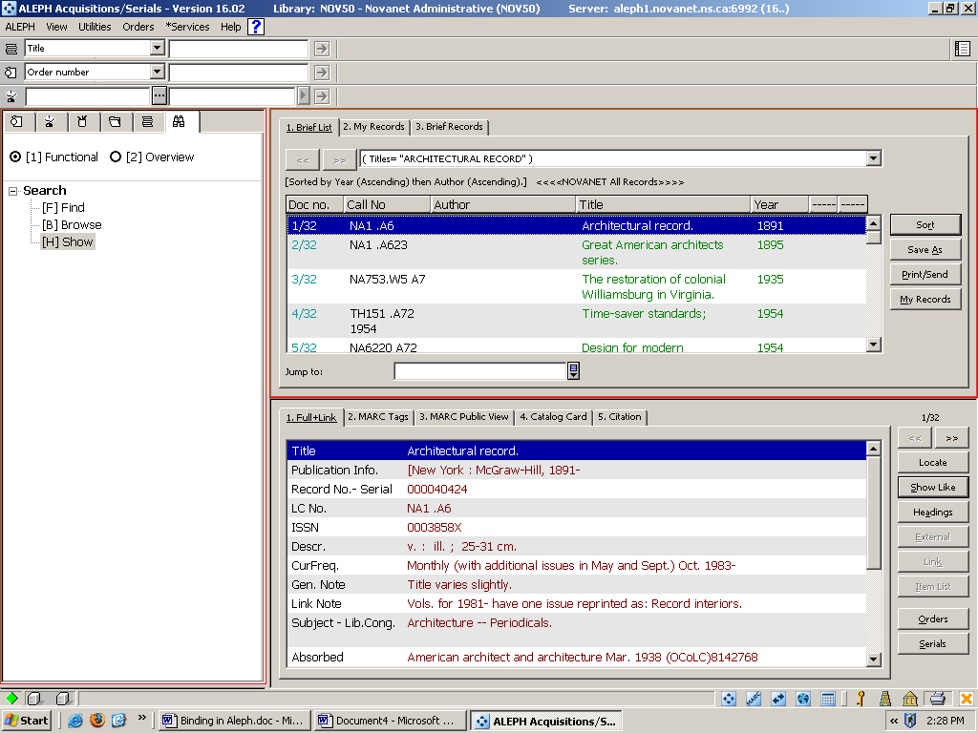 to the Show Node. The Upper Pane will display a Brief List. Highlight the record you would like to retrieve and select the Serial Button from the Lower Pane right side. This will activate the Serials Tab within the Acquisitions/Serials client.

Update Item Status
Select the [L] Subscription List root, click on the [I] Items Node.
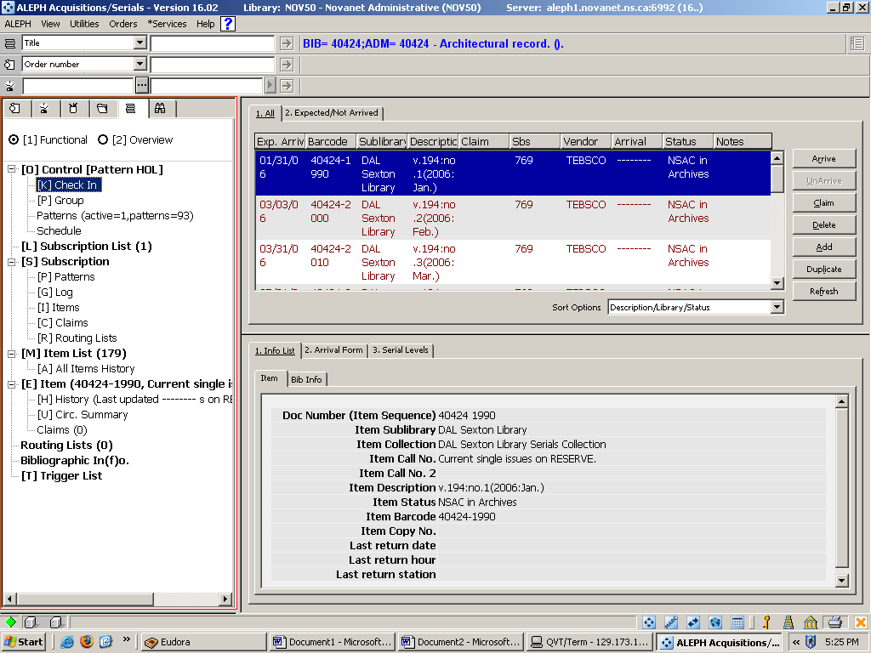
Notice that values do not display beside any of the Roots or Nodes. (ex. Number of items).

Select [L] Subscription List and values will display

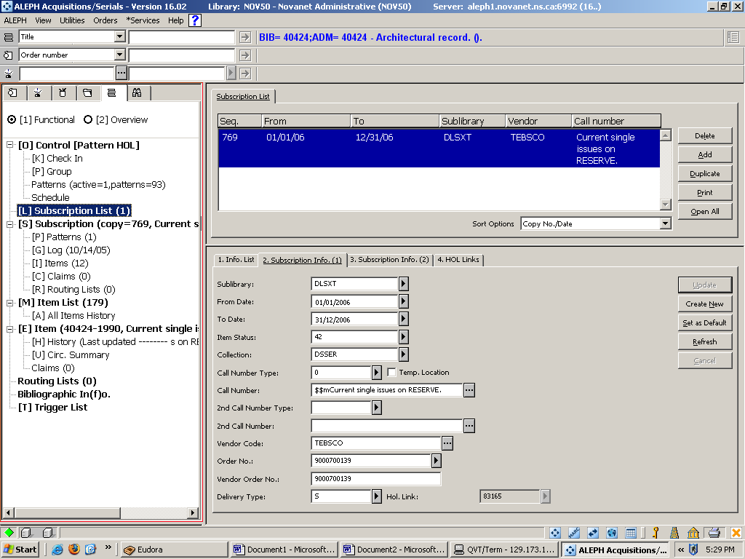

This will open up the Items List in the upper pane. Scroll to find the first item from the list you will send to the bindery. Select the item; click the Bind/Changes button.
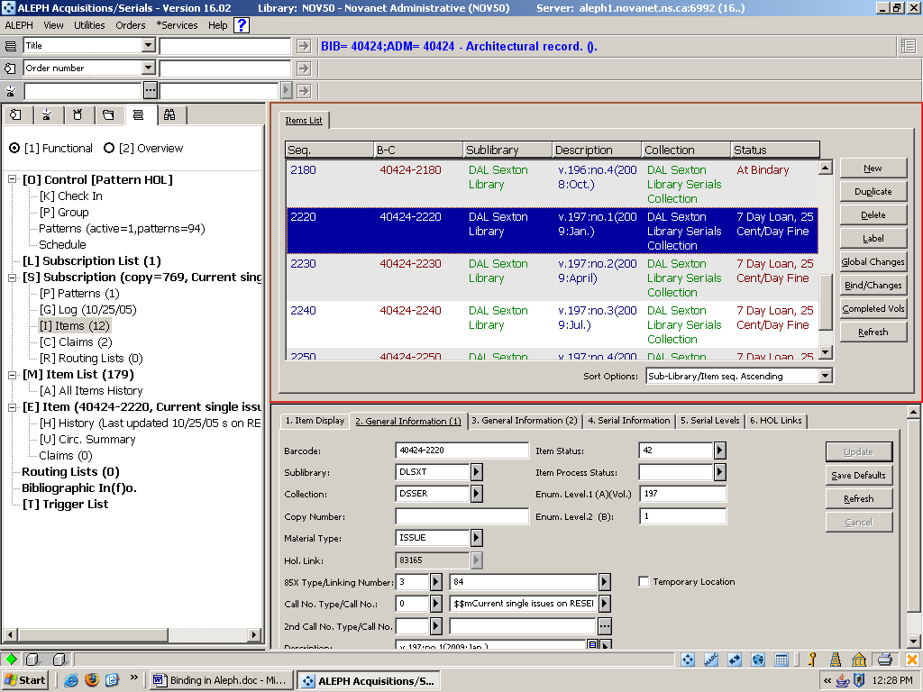
This will open the Items List for Binding window. Select the range of items in your binding unit. To do this select the first item in your range; hold the shift key; and select the last item. Click the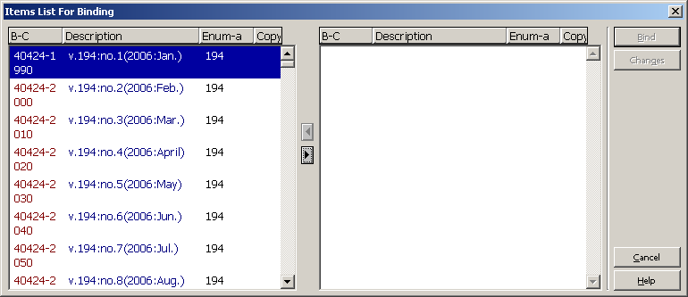right arrow to move selected items to the right pane. You can also move one issue at a time.
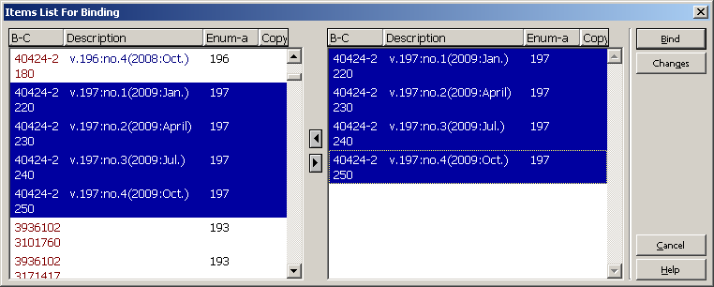
If you inadvertently select the wrong issue, you can simply click on it in the right hand pane and click on the left arrow button to return item to the pane of the Items List for Binding window. Once all items have been moved to the right pane, select/highlight all item records in the right pane; Click the Changes button.

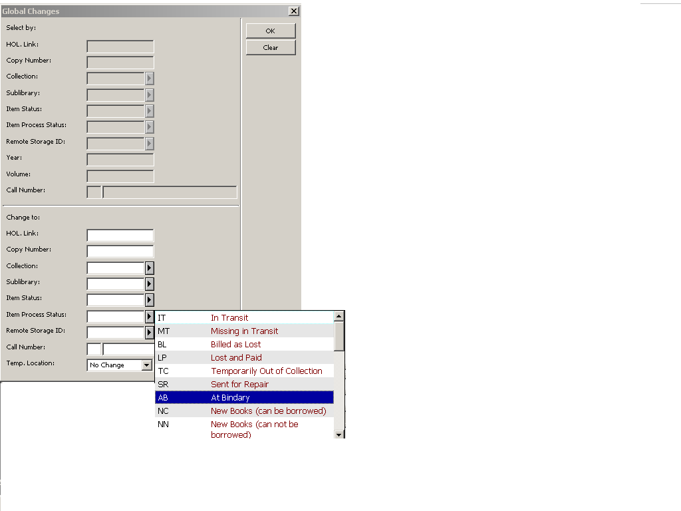
This will open the Global Changes window. From the Item Process Status field; click the right arrow;

Select or double click from the drop down list AB At Bindery code; click the OK button. This action will simultaneously change the item process status of each item record you selected.
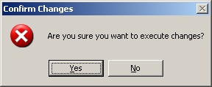

Confirm changes window will open; click Yes. This will close the Global Changes window.

To close the Items List for Binding window click cancel or the X in the top right hand corner of window. This will return you to the Items List in the upper pane. Notice the status change of your item records.
View from OPAC before 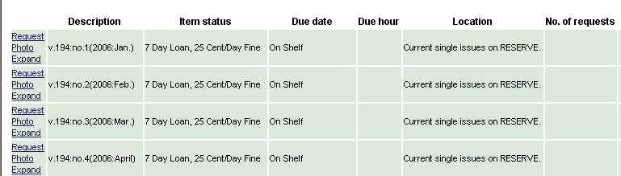
View from OPAC after
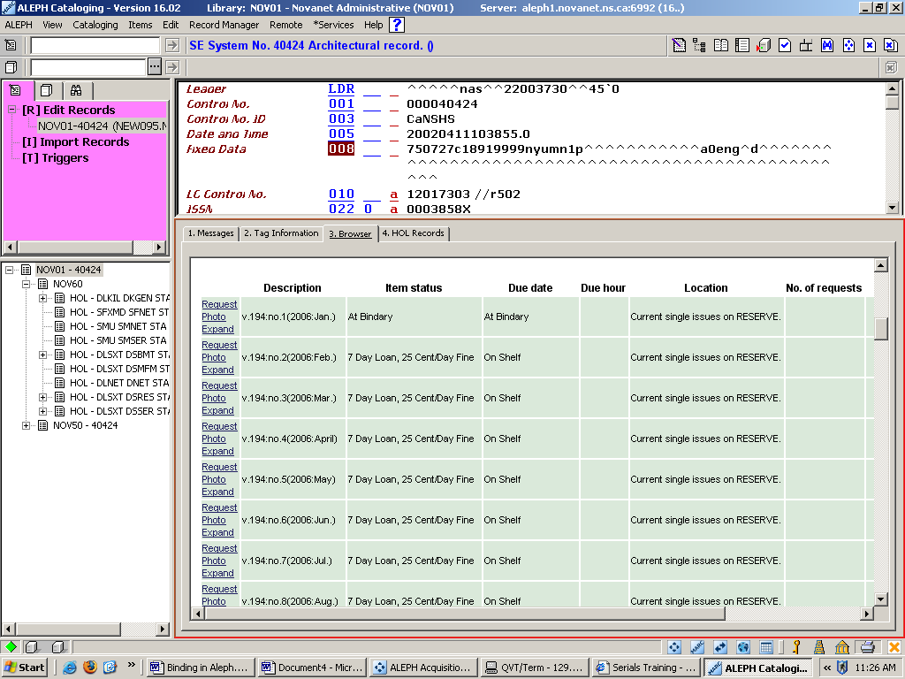

Items returning from the bindery
The process of merging item records, is used when a set of pulled issues have returned from the bindery. You can merge the issues for a title into a single item to represent a bound volume in Aleph.
Repeat steps for locating a title
Select the [S] Subscription List root, click on the [I] Items Node.
In the Upper Pane highlight the first item for your bound volume (status should read At Bindery) and click the Bind/Changes button on the right hand side of the Items List.
The Items List for Binding window will open.
Select the range of items in your binding unit. To do this select the first item in your range; hold the shift key; and select the last item. Click theright arrow to move selected items to the right pane. You can also move one issue at a time.
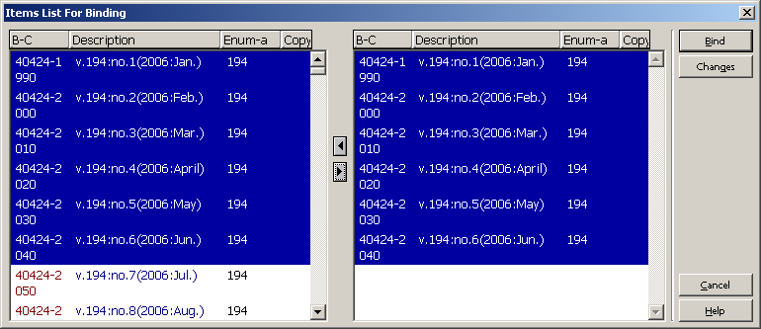
If you inadvertently select the wrong issue, you can simply click on it in the right hand window and click on the left button to return item to the left hand side of the Bind/Changes List.
Click on the Bind button. This will open up the item record for the first issue selected. The Item Expand window will open.
Note: If all issues had not yet arrived and /or had been claimed and/or on a routing list, the system would have given you an error message.

Click 2. General Information (1) tab. In this tab you will update the following fields:

Barcode – wand or type in library barcode. Note: If you leave this field blank the system will populate with a system generated barcode.
Item Process Status – delete any previous codes from this field, the system will update accordingly.
Enum. Level.2 (B) – delete info.
Description – used to describe a specific item. This field is similar to the Bound Label field in Geac.
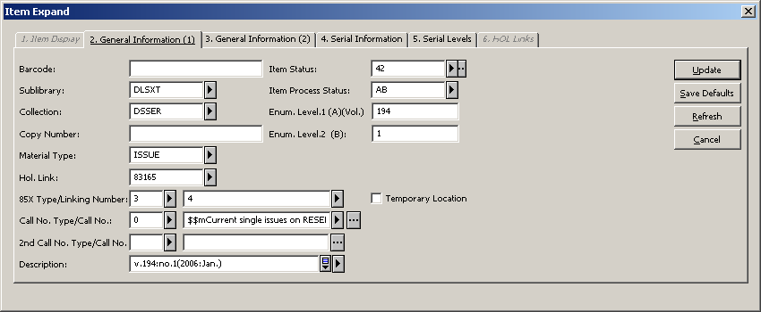
Click 5. Serials Levels tab and delete Enum Level.2 (J), for second level chronology.
Click Update to save changes.
Also, for your information Aleph can populate the Description field automatically for the bound volume. Complete your steps down to deleting Enum Level. 2 (J), go to tab 4. Serials Information and blank out the description field and then click Update to save changes.

