

Changing Frequency/ Publication Patterns in Aleph

If your title experiences a publication pattern change, you must create a new 853 field in your holdings record. You can add, edit, or update (change) publication patterns via the Cataloguing Client or Acquisitions/Serials Client. For the purpose of this training session we will explore the Acquisitions/Serials Client method.

Open the Acquisitions/Serials client - Enter username and password

Search title to be updated and bring title into Serials. This will activate the Serials Tab within the Acquisitions/Serials client.
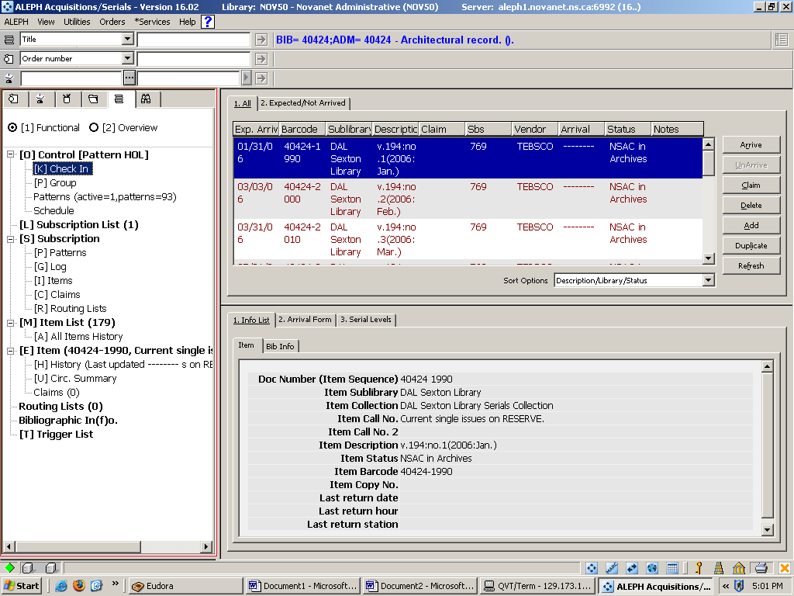
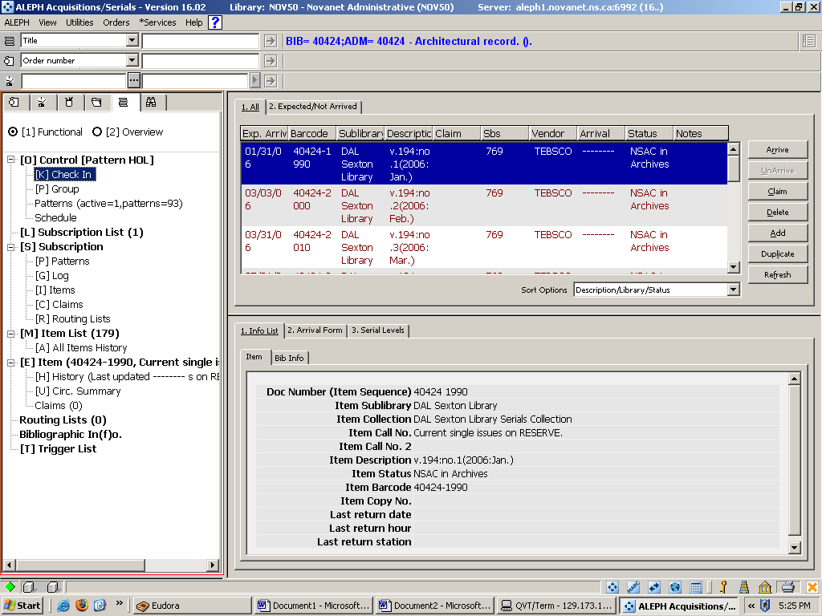
Notice that values do not display beside any of the Roots or Nodes. (ex. Number of items).

Select [L] Subscription list and values will display

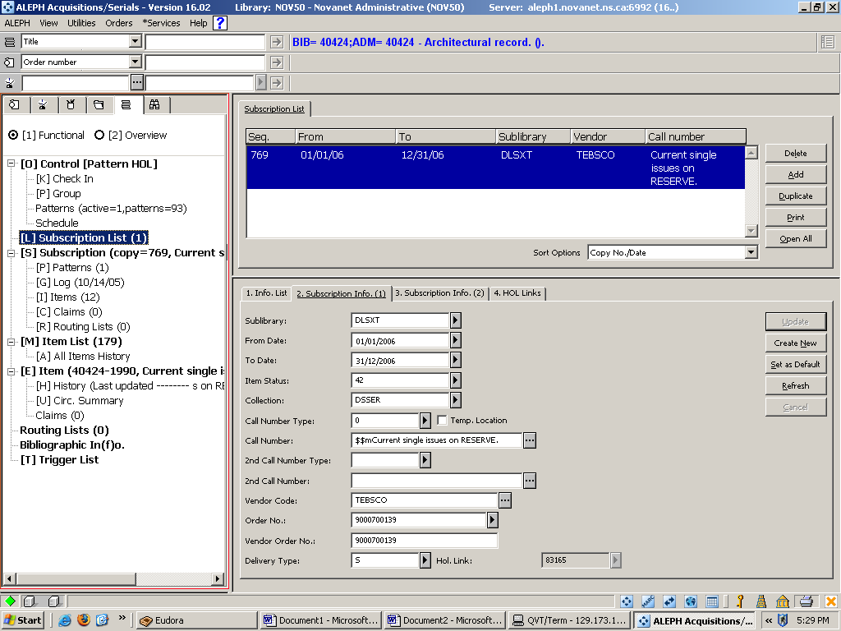
Before you update your publication pattern you should check and/or update subscription information.

Select [L] Subscription list; this will activate the tabs in the lower pane. Tab 2. Subscription Info. (1); make sure the To Date field is set to a date far off in the future.
Tab 3. Subscription Info. (2); update the claim intervals to reflect the frequency change.
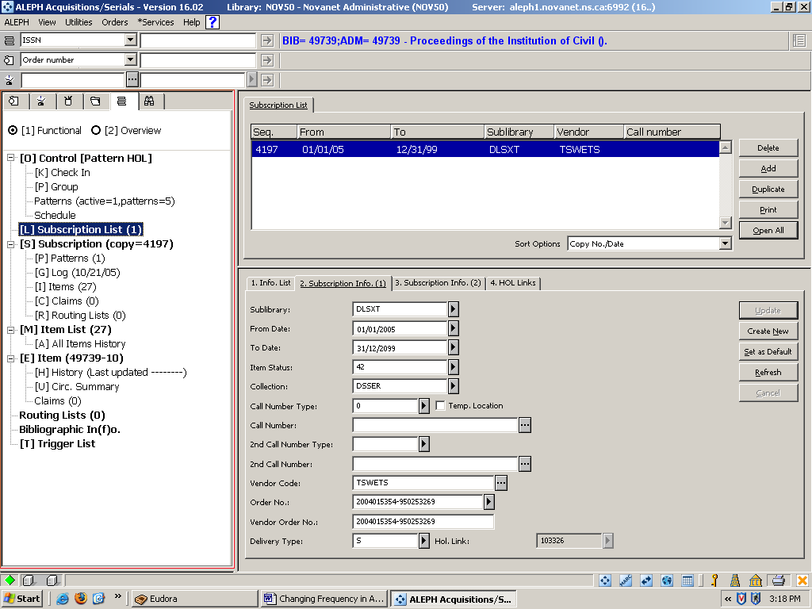
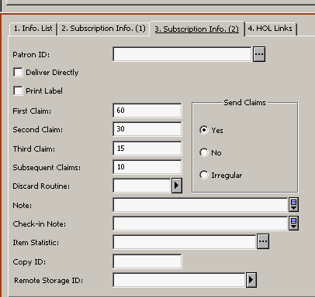

In the left pane under [S] Subscription root, select [P] Patterns. Note: The patterns node should show a value of 1. ex. [P] Patterns (1). This means that there is 1 active pattern for this subscription.

This will active tab 1. Patterns in the upper pane; click the Add button. Choose Pattern Document window opens. Select holdings (NOV60) record for your library. Click OK
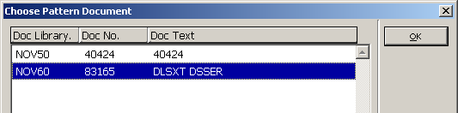
The window will disappear. This will activate tab 3. Patterns in the lower pane.

Click the Template button. This will open a window called Choose Pattern Template file. Select pattern from upper pane of window. Click OK to close window.
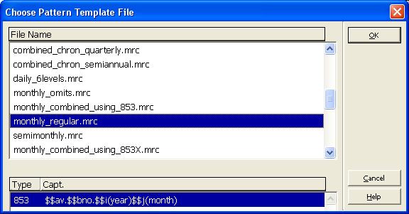
Fields in the lower pane tab 3. Patterns will populate according to the template you selected. Click the Add button. This will activate tab 1. Patterns in the upper pane and your new pattern will be highlighted.
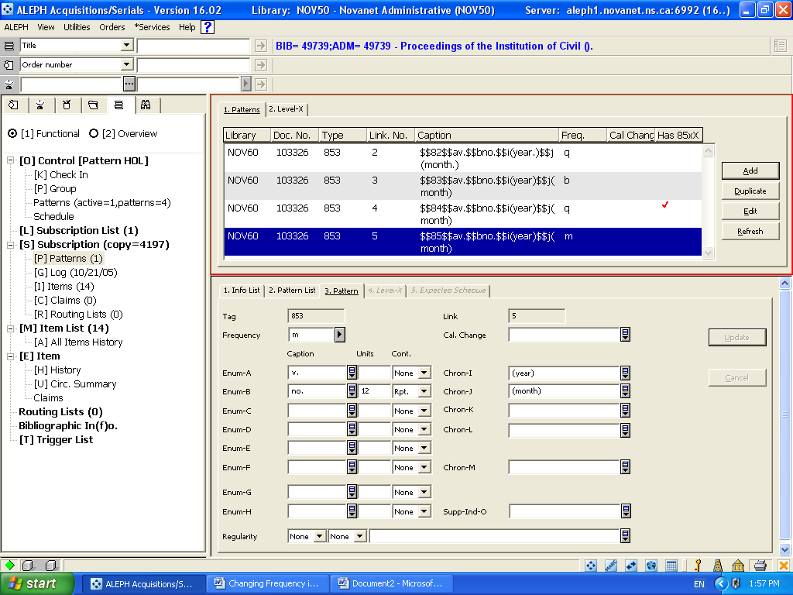

**NOTE: At this step note the Link No. of the pattern you just created. This information will be needed in the next step to link the 853 and 853x. Also, note the red checkin the 85xX column. This indicates that this 853 has an active 853x attached. To make your new 853 pattern active, we have to add a new 853x to the new 853 pattern delete the old 853x.
In the upper pane select tab 2. Level-X and click the Add button. This will activate the lower pane, click the Template button. Select pattern from upper pane of window. Click OK button to close window. Fields in the lower pane tab 4. Level-X will populate according to the pattern you selected. At this point you will have to update the fields according to the item you have in hand or where you would like the prediction to begin.
** Link your new 853x to your 853 by clicking the down arrow in the Link field and selecting the number that represents the 853 tag. ** Click the Add button.
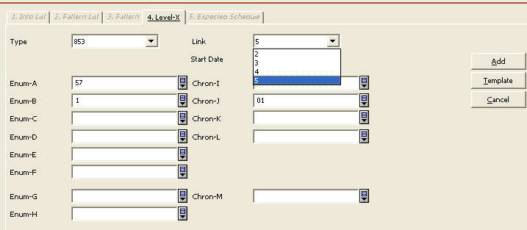

Select Tab 5. Expected Schedule in the lower pane and check that the pattern is predicting correctly. If it does you can go ahead and click the Open Items button on tab 5. Expected Schedule . To view newly created items go to navigation pane click [K] Check in; [I] Items or [M] Items List.
If it is not predicting what you want go back to tab 4.Level-X and edit.

The new publication pattern should be the only one active, to make this happen we have to delete the 853x tag from the previously active 853 publication pattern; Currently showing two active publication patterns.
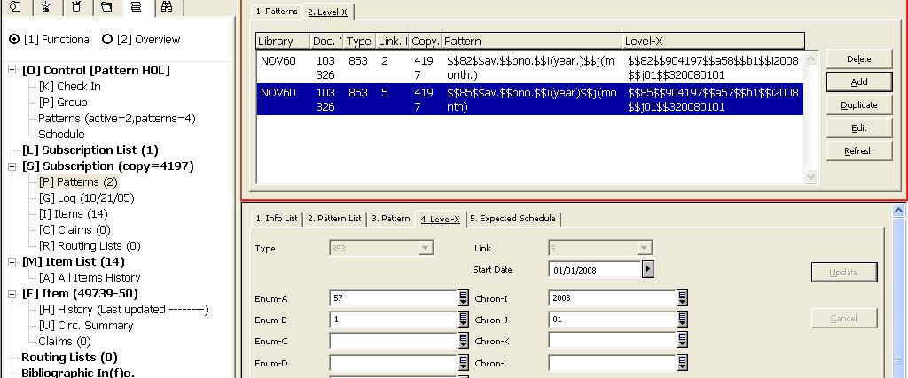
Select tab 2.Level X ; select 853x you want to delete and click the Delete button; then the Refresh button.
Notice that there is now only one active publication pattern.
