

Claiming in Aleph

Open the Acquisitions/Serials Client

Enter username and password

Search title to be claimed and bring into Serials. Note: If you search using the Serials Bar and you get a direct hit your record will open automatically in the Serials Tab. If you get a list you will have to bring your record into the Serials Tab.

Select [L] Subscription List on the Serials Tab in the navigation pane.

Select [K]Check in root this will activate the 1.All tab in the upper pane.

Click tab 2.Expected/Not Arrived in top pane, this will display both expected issues and those with outstanding claims. Select item/issue to be claimed.

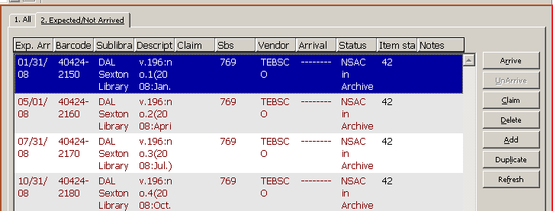

Click “Claim” button to the right of the upper pane. This will open the claim list window.

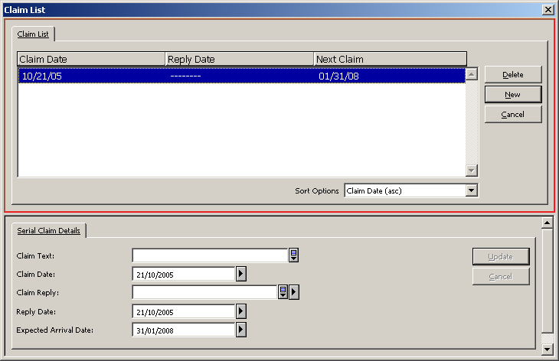
If you have claimed this issue before the top pane will list past claims for this issue.

Adding a new claim

Click the New button on the right side of the upper pane. This will activate the Serial Claim Details tab in the lower pane, where you will add your new claim.

Claim Text field – will allow you to add additional information concerning claim you would like to relay to vendor. This field will appear on the claim letter and in the claim list window.

Claim Date field – is the date you are activating the claim (system will populate)

Format field – Click the right arrow and select from the drop down list the claim code.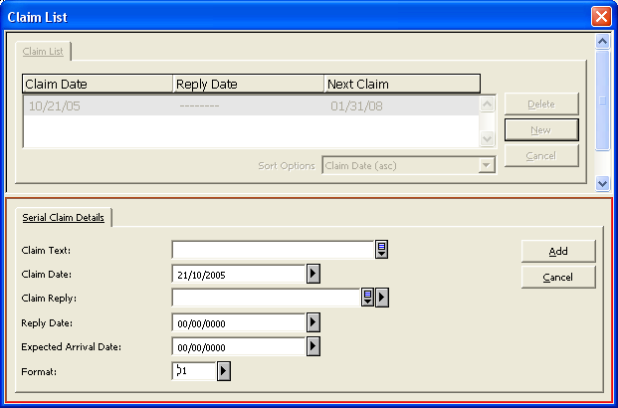

Click the Add button to create the claim. The claim letter window will appear. Click the Print button, to print claim it if you want and close window. To close the claim list window, click the X in the top right corner or “cancel.”
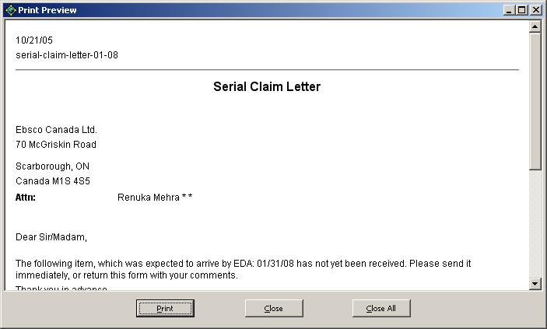

Adding claim reply note from vendor

Select [L] Subscription List on the Serials Tab in the navigation pane.

Select [C] Claims this will activate the Claim List tab in the upper pane.
Highlight the claim in the upper pane; in the lower pane add your note in the Claim Reply field and click Update. The note will appear in the claim list window under the claim reply column.

Claim reply – if you receive a reply from the vendor you can summarize reply. This field holds up to 200 characters.

Reply date – If this is the 1st vendor reply, the system will automatically populate it with today’s date.

Expected Arrival Date – complete if the expected arrival date has changed.

If you want to delete a claim, under [S] Subscription in the left pane select [C] Claims highlight the claim. In the upper pane select/highlight item you wish to delete and click the delete button.

In Check-in, the right pane will display the claim date under the Claim column. If you do not see column “Claim” place your cursor on the gray bar with the column descriptions and right click. Check the box Claim click OK. The column should display in the Items Window.

The Expected date of the issue will not change. The date of the Next Claim can be viewed by clicking the Claim button to view the Claim List window.

The Claim Date will display even after the issues is Arrived. After an issue is created, claimed and arrived the window will display the original Expected Date, The Arrival Date and the Claim Date.

