

Combining Serial issues

Before “arriving” the combined issues
1. Go to the Group check-in screen [O] Control [Pattern ADM] / [P] Group
2. Highlight first issue to be combined
3. Press the “Shift” key and mouse click on the other issue to be combined. Two (or more) issue will now be highlighted.

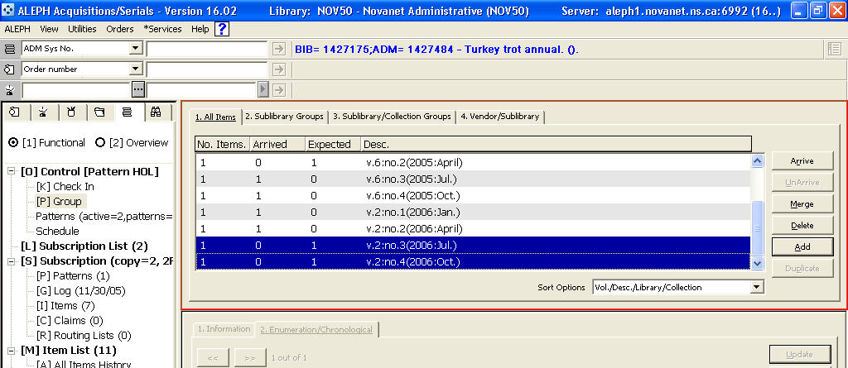
Figure 1 Merging issues

4. In the Upper Right Pane, mouse click on the “Merge” button.

The lower Right Pane will now be activated.
5. Open “2. Enumeration/Chronological” tag.
6. Alter the enumeration and chronology boxes, to reflect the combined issue.
7. Clear the “Description” box
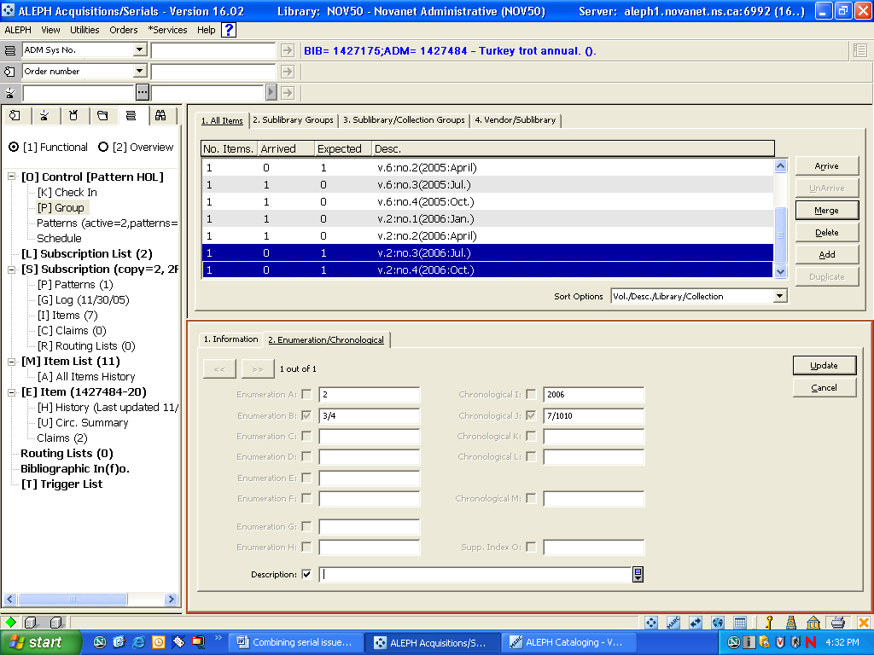
Figure 2 - Updating the combined issue description

8. Mouse click on the ”Update” button. The description box will fill automatically.

Arriving the combined issue
9. Go to the Check-in screen [O] Control [Pattern ADM] / [K] Check-in
10. Highlight the issue (that is now combined), in the Upper Right Pane.
11. Mouse-click the “arrive” button

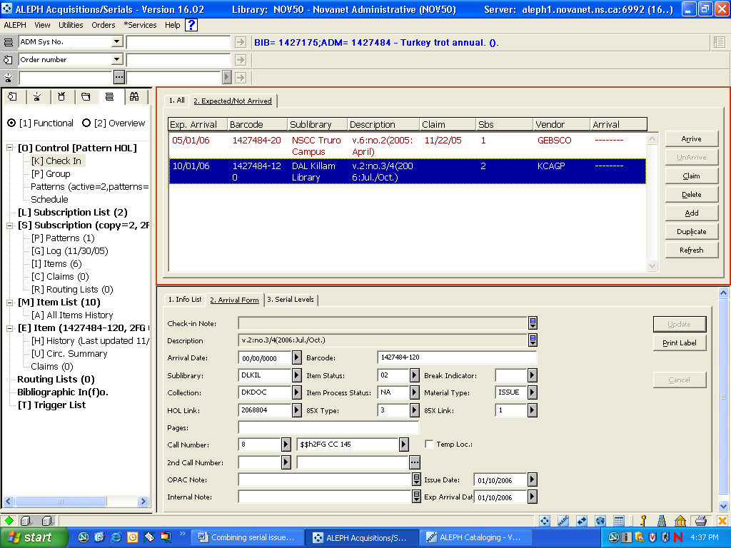
Figure 3 - Arriving the combined issue

The lower right pane will now be active
12. Review and update the information, as needed.
13. Mouse-click the “arrive” button.
14. A pop-up box called a “Serial activity log” will appear, stating that the operation was successful. Close the box.

