Creating an 866 (Textual Holdings Statement)

An 866 (Textual Holdings Statement) is added to the holdings record in the Cataloguing module. To add and 866 tag, we need to push the title from the Serial Tab into the Cataloging Module.

Pushing a title from Serials to Cataloging

- From the Subscription List, click on Tab 4 in the Lower Pane, HOL Links. Your library's holdings record will be highlighted, and the red check mark indicates that your subscription is linked to this
holdings record.

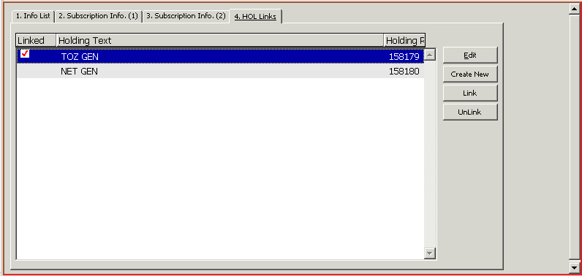
Figure 20: Subscription Info Root, Tab 4, HOL Links

- Click the Edit button. This will open the Cataloging Module to the Records Tab, and the Holdings Record will display in the Upper Pane.
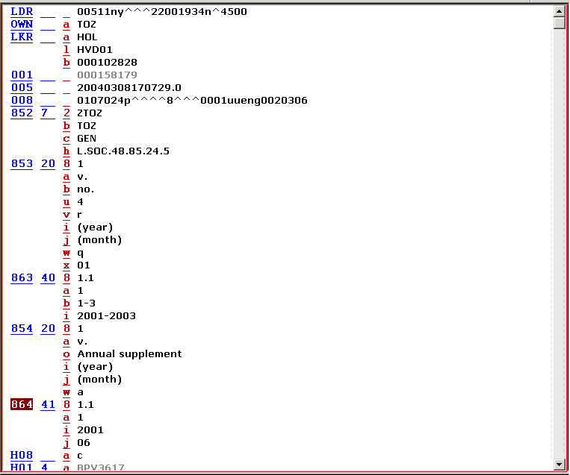

Highlight the MARC tag where you wish to insert a new field.

To retrieve the Edit menu, click your right mouse button inside the white space in the open record:
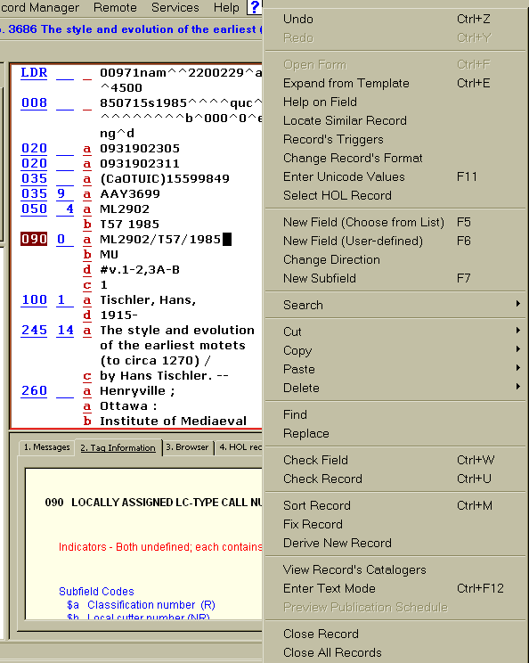

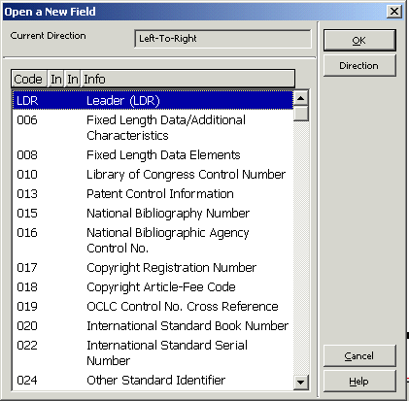
- From the Edit drop down menu choose New field (choose from list) or hit the F5 function key. The Open a New Field Dialog Box will open.
Figure 58: Open a New Field Dialog Box
- You can get to the range you are interested in by typing the number. E.g., type 4 to get to the 4xx part of the list. Then select the field you wish to add and click OK or the Enter key. Or, you can simply highlight the desired field from the list and click on OK or hit the Enter Key.

- Fill in the necessary subfields.

OR

If you know what field you would like to add to the record:

- From the Edit drop down menu choose New field (user defined) or hit the F6 function key. Aleph will create a blank field for you to fill in on the the holdings record:
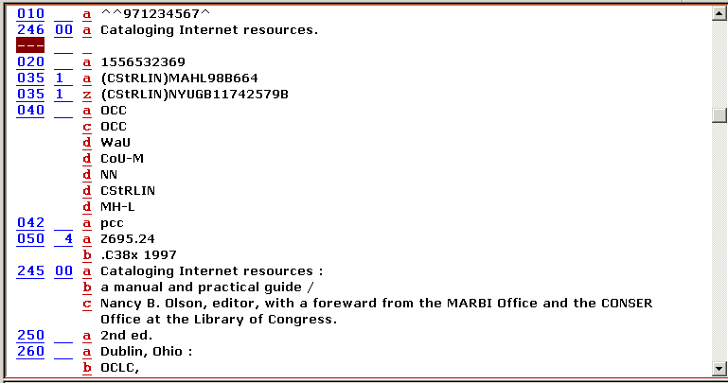

Create the 866 field
866 50 av.1(1960)- NOTE: [Current issues in DALSCI READING ROOM - PHYSICS]
and hit Enter.

Note: fields can be added anywhere in the record; once you hit Enter, the system sorts the field.

Tag Information

The Tag Information Tab is available as a guide to the use of valid indicator and subfield codes.

To get help on a field:
- Highlight the MARC field you want help with
- Choose Help on field from the Edit drop down menu or hit the <Ctrl>+G function keys. Tab 2 on the Lower Pane will open providing information about the MARC tag, indicators and subfield values.

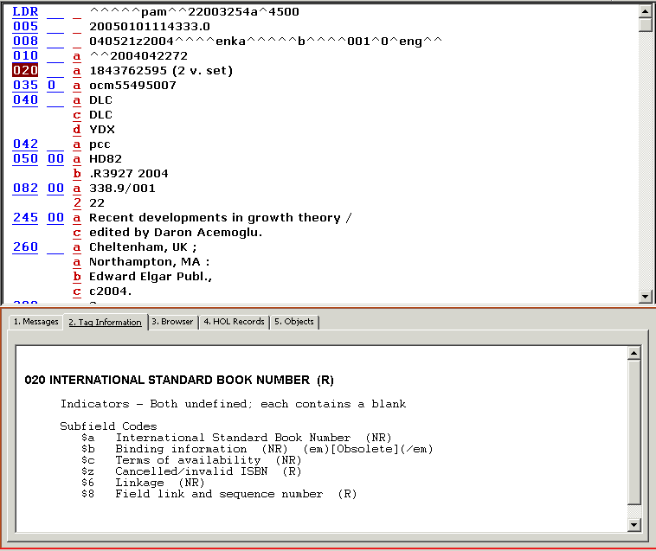

Additional Editing Tips

If you have the cursor anywhere on the record, right-clicking will bring up the Edit menu.
Hitting Enter at any time rearranges or sorts the fields and subfields, and deletes any empty fields. Also note: if you are using a template, which has empty fields that you intend to fill in, you will lose them by hitting the Enter key.

- Choose Help on field from the Edit drop down menu or hit the <Ctrl>+G function keys. Tab 2 on the Lower Pane will open providing information about the MARC tag, indicators and subfield values.
Whenever you make changes to a holdings record in Aleph, you must save your changes to the server. Click on the Save to Server Icon found on the top right of the Cataloging Module to save your changes. Override any green error messages.

