Getting started in Aleph
Cataloging Oct/Nov 2005

Introduction:
Welcome to the Cataloging Module for the ALEPH ILS.

Our sessions will be divided into 2 parts:
Session One:
Todays session (BASIC) will provide an introduction to some the essential elements
of ALEPH, with emphasis on the Cataloging module. Our goal will be to provide an understanding of the various features in ALEPH so that we become familiar with navigating, searching and basic editing of Bibliographic and Holdings and Items. This will allow each of us to really dig more deeply into the system at our own pace in the following weeks. Clearly the purpose of today’s session won’t be to teach Cataloging, but to provide a Basis for working comfortably in ALEPH.

Remember:
FUNCTIONALITY TESTING BEGINS AFTER TRAINING HAS TAKEN PLACE
THE PHASE BETWEEN:
TRAINING → START OF PRODUCTION IN ALEPH IS A VERY IMPORTANT ONE.

Session Two:
ADVANCED (Tomorrow) will focus in-depth on aspects of original
cataloging, highlighting essential features such as creating and using templates,
using and adding new authorities, and remote access.
Again particular emphasis will be on allowing ample time for hands-on experience,
especially in the afternoon.

ALEPH CATALOGING (BASIC)
OCT/NOV 2005

Contents

- What is the Aleph ILS ?

- Layout of the ALEPH Cataloguing module

- ALEPH Library structure

- Terminology

- Logging in

- Connecting to a Database

- Printing

- Logging out

1. What is the ALEPH ILS?

ALEPH is an acronym for Automated Library Expandable Program, an integrated library system that manages staff and patron access to our Novanet library catalog information.

Why a new system?
Novanet Library Management determined that ongoing support costs, and new opportunities for wider regional collaboration warranted replacing the current Geac Advance system.
The new ALEPH system offers NOVANET users many new features which will become apparent as we delve into the system.

Other libraries using ALEPH:
This library management system is currently being used by over 1000 libraries in 50 countries around the world.
Some North American library sites which are using it:
- Harvard University Libraries
- MIT Libraries
- McGill Libraries
- University of Michigan Libraries
What are some Cataloging features?

The Module offers the choice of using standard or locally-defined templates. Shortcut keys minimize mouse clicks & keyboarding. Word-processing features enhance workflow. Library-defined routines streamline workflow by automatically generating cataloging data. ALEPH uses checks to validate records as they are saved and retains messages in a log for follow-up.
Records and data from bibliographic utilities (OCLC) and other External libraries can be imported via the Z39.50 protocol.
Database maintenance is enhanced as staff can consult authority files, search the catalog, import records from external databases, edit multiple records, use copy-and-paste, and index any tag in the Bibliographic record. Global change & Authority control ensures the maintenance of a high-quality database.

Logging in to ALEPH:

Select START|ALL PROGRAMS|ALEPH -- Novanet Test|Cataloging
(or Choose the Desktop folder ALEPH – NOVANET Test)

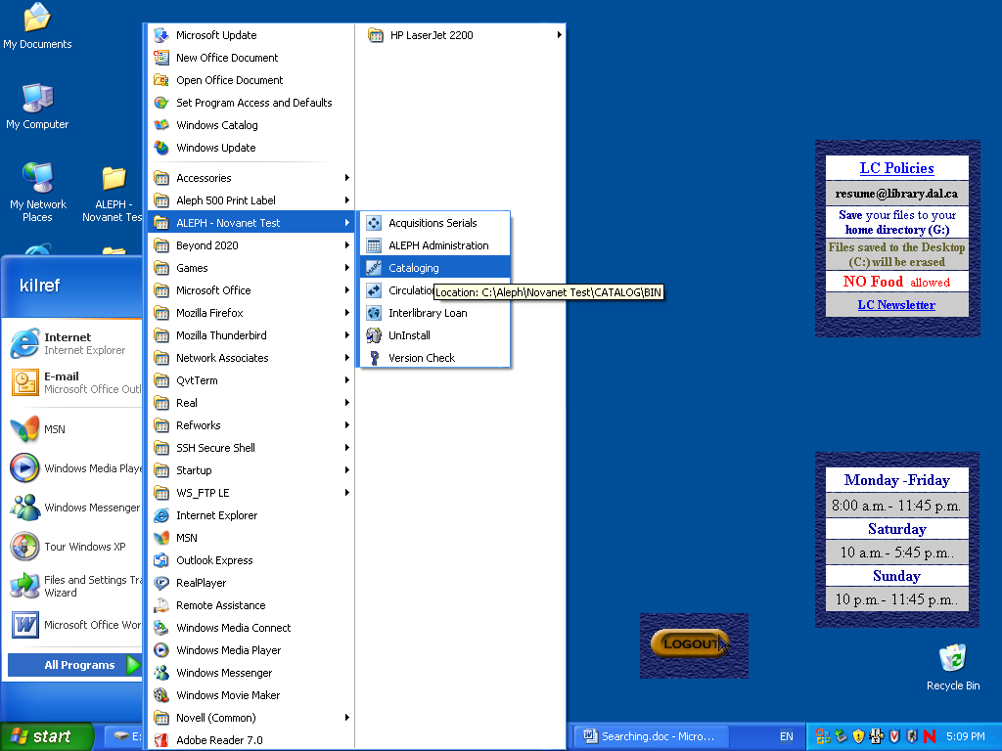

If you choose to you can create a shortcut on your desktop for the module 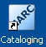 and double-click on it to open Aleph.
The ALEPH password dialog box will display:

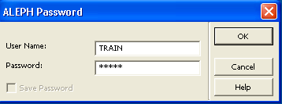

For today’s training we will be using: Train | Train.
(You will use your own individual username and password to connect at your own desktop.)

Connecting to a database:
When the client/module opens you should be connected to a Database (Library)
To connect to a different Database, under the main menu select
ALEPH | Connect to …
Permitted databases display: Choose NOV01 Novanet Bibliographic

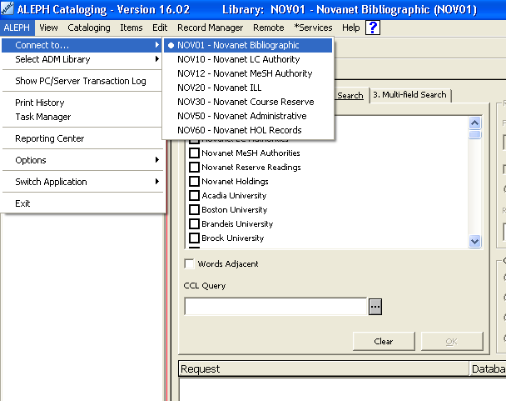

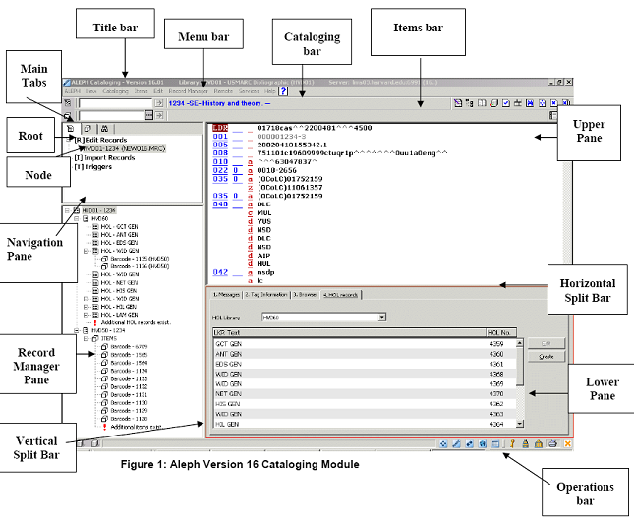

Layout of the ALEPH Cataloging Module

Layout

Title Bar:
The Blue bar at the top of the screen indicates that we are in ALEPH Cataloging, and gives Library (NOV01) and Server information.
Menu Bar:
Main menu options. The two most essential menus in our module are the Cataloging and Edit menus. If you right click on them now, some of the functions are not activated (greyed out) until we are in an applicable part of the module or have records active. The contextual help button at the right on the Menu bar. (Note: These menus can also be opened using <alt>+ the first letter of each menu choice, but for Training we will be using the drop–down menus since they help to show the functions in context.)
(fig.)Title Bar and Main Menu Bar

Cataloging Bar:
Enter a system number to bring up a bibliographic record. Once you bring up
a record using the Cataloging Bar, the system number, record format, title and author information displays next to the Cataloging Bar. A series of icons to the right of the
bar also become active.

(fig.) Cataloging Bar

Mousing over these icons brings up their labels. For example, the 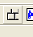
icon activates a Floating keyboard to insert special language characters and symbols in MARC bibliographic records.

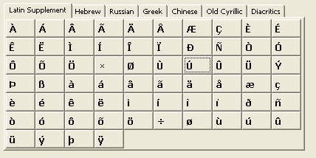
(fig.) Floating keyboard

Items Bar:
Scan or type in a barcode number to bring up a record on the Item Tab. The Items Bar works only with the Items Tab in Cataloging.
Once you bring up a record using the Items Bar, the systems number , record format, title and author information displays next to the Items Bar.

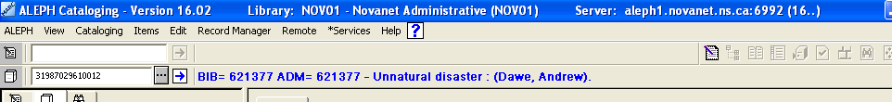
(fig.) Items Bar

Upper Pane:
Displays search options or records (Bibliographic and/or Holdings)
The active pane is always highlighted in red.

Horizontal Split Bar:
Resizes the Upper and Lower panes. These new sizes remain persistent after you use it.

Lower Pane:
Displays search results, or displays specific message, tag, holdings, and is the pane that displays the Web Opac (EDIT | View in Web Opac ) when a bibliographic record is active:

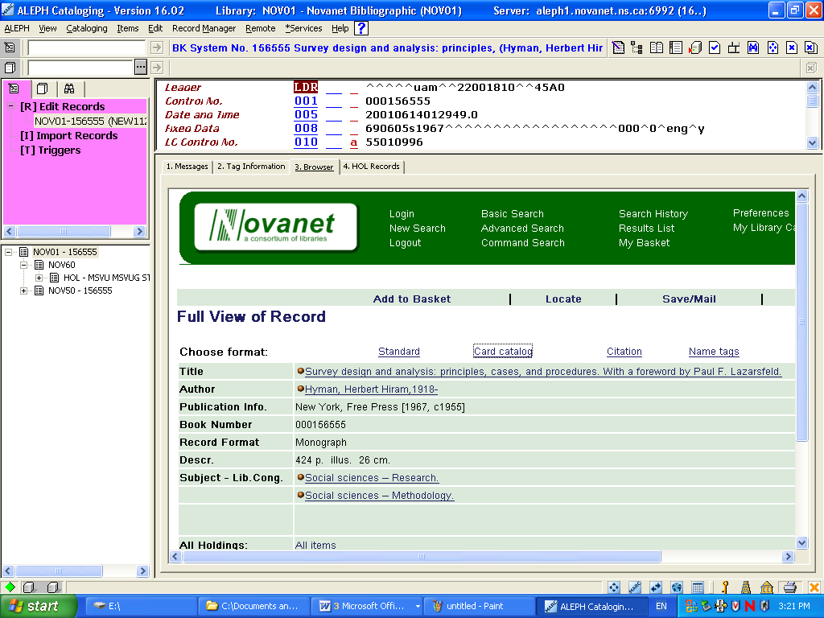
(fig.) Resized Lower pane displaying WebOpac within the Cataloging module.

Operations Bar:

(At the Lower right of screen) Displays icons the Applications toolbar, Change password/login, Library icon, Server prompts, Language selection, and Printer configuration. The orange ‘X’ closes all modules at once (without promts).

(fig.) Operations Bar
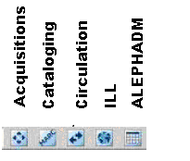
(fig.) Module (Library) icons within the Operations bar.

Vertical split bar: Resizes the Navigation pane (on left).
Navigation pane:
Lists functions available on a particular Tab. Consists of Roots
(Higher levelfinctions and Nodes (Lower level commands )

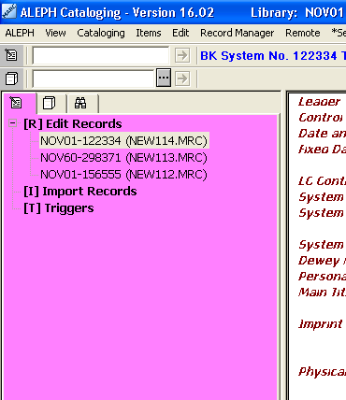
(fig.)Navigation Pane (Note that clicking inside the pane makes it active, highlighted in red).

Root: Specific function on a tab such as Edit record in the edit tab, Items list in the Items tab, and search options in the Search tab. Click on the root to open it in the Navigation pane.
Node: Individual command within a Root. For example in the search tab, there is a Root for Search, and below that are the nodes for Find, Search and Show.

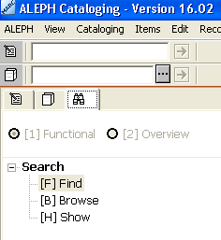

Main Tabs: The Cataloging module has 3 tabs
Tabs indicate a specific functional area within the module.

Records Tab:
Used for creating and editing bibliographic, holding and Authority records. Access the Records Tab by clicking on it. This activates the Cataloging Bar (one Bar above it) allowing a system number search.

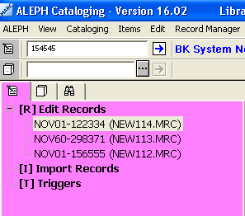
(fig.) Records Tab with System number search activated (Blue arrow)

Items Tab:
Used for creating and editing item records, binding and labelling. Clicking the Items tab also activates the Items Search box (directly above it) enabling barcode searching.

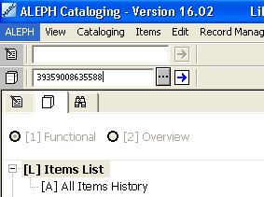
(fig.) Items tab activated (center tab).Blue arrow indicates Barcode search function is now enabled.

Search Tab:
Used for Searching bibliographic records and authorities.
When the Search tab is active the Find Search box to the right of it becomes active:

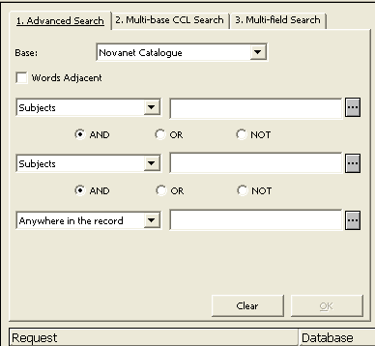

Functional and Overview Nodes: The Functional and Overview Nodes are found at the top of the Navigation Pane.
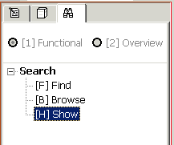

The Functional Node shows the functions available on that tab. For example, in Search, the Functional Node displays the search nodes (Find and Browse) and the Show node (display of search results).

The Overview Node displays an Overview of a title that allows you to see and move within a record group (a bibliographic record and all its linked holdings, items, orders, etc.) You can then move or "push" a title from the overview node into another part of the module (Items Tab to Records Tab, for example) or to another module (Items Tab to Acquisitions Module, for example). Choose the Overview Node to move a title from one module to another

Record Manager
There are some additional panes that are found only on the Records Tab in the Cataloguing Module:

Record Manager Pane: On this pane you will see bibliographic, holdings and
item information. You can see the items associated with each holdings record in the display. Double clicking on the NOV-01 system number will open the bibliographic record in the Upper Pane. Double clicking on a holdings record will open up the holdings record in the Upper Pane.
Double clicking on a barcode will open up the Items Record in the Items Tab. If there
are no items , double clicking on the word ITEMS will open up the Items Tab.
You can choose the OVERVIEW TREE by clicking on the icon in the Cataloging Bar.

Split Editor Mode: The Upper Pane can be separated in to two panes so you can see two bibliographic records at once. Click on the ‘Split- screen’ icon in the Cataloging bar on the upper right. It is also possible to view a bibliographic record in one pane and a holdings record the other pane:

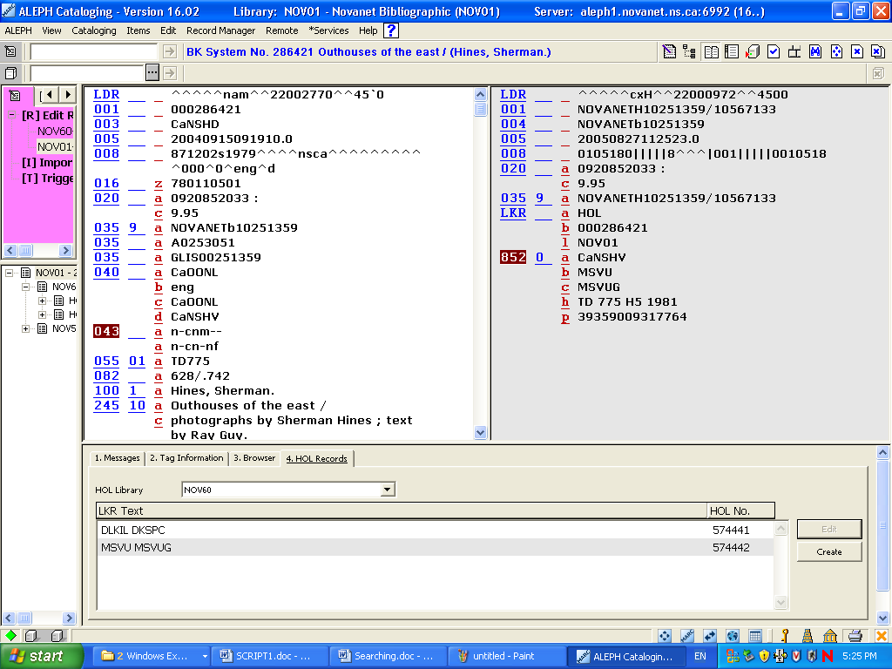

(fig.) Example of a split screen showing both the bibliographic (left pane) and MARC21 holdings data (right pane) together on the ALEPH desktop Upper pane.
The screen can be restored by clicking on the Split- screen icon again.

Other Features:

Resizing:
Often the desktop may not display everything that you have to see, so all of the desktop screens can be resized by mousing over the dividing bar till you see
the ‘double-arrow’ <-||-> and dragging to the desired size.

Persistence: The system will remember the last place you were when you close the module. For example, if you were on the Search Tab in the Cataloging client when you closed the module, the module will open up to that tab when you next open your Aleph client.

Persistent Column Headings: When you come upon a list that has column headings, such as the Items List in the Items Tab, you can add or subtract to the list of columns by right-clicking on any of the column headings. A Header Configuration Box will appear:

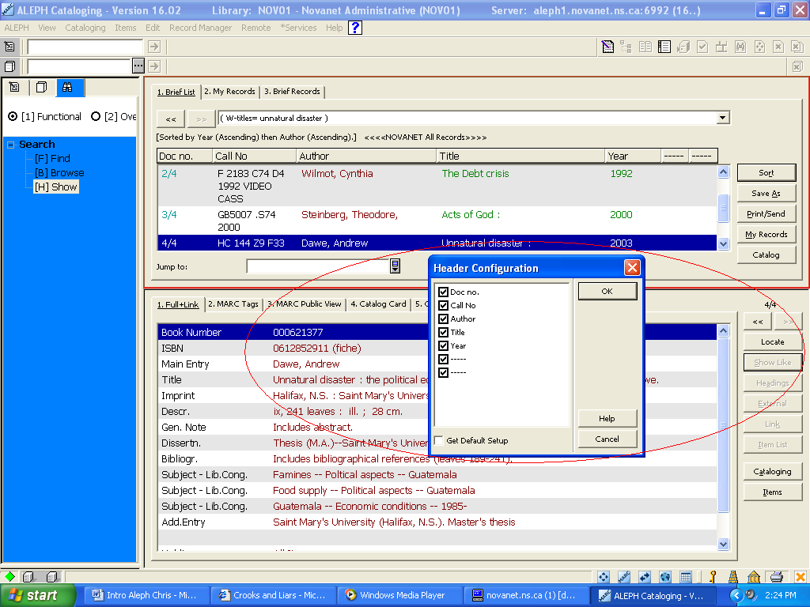
Fig. Header Configuration Box. (You can now add or subtract to the column headings. Once you click the OK button, these columns will remain persistent on your workstation.)

Switching to Other Modules : You can open up another module by clicking on one of the icons located on the Operations Bar. Note that this will not "push" the record you're working on to another module--use Overview to do that.

Context-Sensitive Help: In each Aleph Module, you will see a large blue question mark on the main menu. If you click on a certain area on your screen and then click on this icon, or press the F1 function key, you will get context-sensitive help for the area you are interested in.

Triggers [T]: A trigger is a reminder to perform a task related to the record. The Triggers function accessed through the Triggers option of the Navigation Tree of the Cataloging tab enables you to view triggers that are in effect within a certain period of time.
The Record's Triggers function on the Edit menu enables you to view, add and delete triggers from the Cataloging module that relate to the record currently being edited. These triggers may include messages produced by the system, informing you of errors found when the Check Record function was used.

Lock Records
The system will not allow a cataloger to save a record to the server if another cataloger has retrieved and saved it before the first cataloger.

In addition to this automatic security, you may lock a record so that only your changes can be saved on the server until you unlock the record. No one else can save his edited version on the server. Note that you may only lock a record that has a system number assigned to it.

To lock the current record, choose the Lock Record option from the Cataloging menu. The record will be locked and the phrase "Locked by current user" is displayed in the Cataloging bar. You may immediately continue editing the record.

Note that when you lock a record, someone else may call up the record from the server. When a cataloger loads a locked record, a warning is displayed. In addition, the phrase "Locked by another user" is displayed in the Cataloging bar.

To unlock the currently locked record, choose the Unlock record option from the Cataloging menu. The record will be unlocked and the message in the Cataloging bar informing you that it was locked is removed.

If you save changes on the server and then unlock the record, the other cataloger will not be able to save his changes on the server. If, however, you unlock the record without saving any changes on the server, the other user may then save his changes on the server.
Locked records are automatically unlocked after a period defined by your system librarian.

Unlock Records

After you unlock a record, another user will be able to save on the server changes he makes to the record. In order for his changes to be saved, the user must open the record only after it has been unlocked. You may only lock and unlock a record that has system number assigned to it.

To unlock the current record, choose Unlock Record from the Cataloging menu. The record will be unlocked but you will not receive a message informing you that it has been unlocked. You may immediately continue working.
Locked records are automatically unlocked after a period defined by your system librarian.

Help Resources

Online Help is available from the Help menu or from the “Help” buttons available
in most pop-up forms. You can use the Help index to search on a topic, as well as copy or print help screens.

5. About ALEPH ‘Library’ Structure:

An important concept in ALEPH is the use of the terminology to describe its structure.
Most importantly ALEPH’s use of the term ‘Library’.
When you click on the ALEPH menu and choose Connect to you will see a list of files:
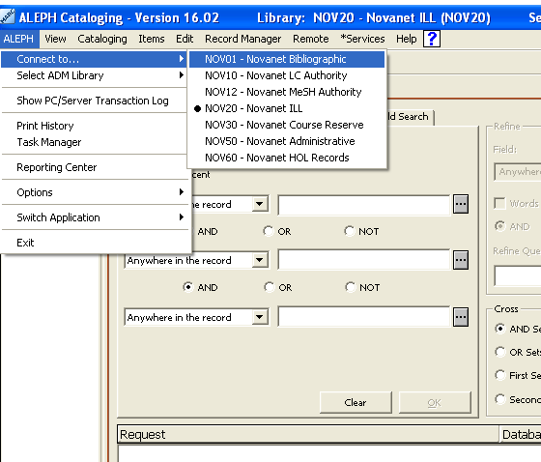

These are ‘Libraries’. They can also be thought of as ‘Databases’ in the ALEPH system. These Libraries enable ALEPH modules work together as an integrated system.
ALEPH identifies a Library with a 3 letter prefix (NOV) and a number. Note that the Library name appears to the right of the alphanumeric Library code.
When using any of the ALEPH modules you can see what ‘Library’ you are in by looking at the top of the screen on the title bar:

When you open a module in ALEPH you will be connected to the appropriate library.
To connect to another library, for example to search for an authority record, change
from the NOV01 library to the NOV10 library.

What we think of as physical Library Locations in Novanet (DALKELLOG, MSVU etc…) are called Sublibraries in ALEPH.

ALEPH Library = NOVANET ‘Database’
ALEPH Sublibrary = NOVANET ‘Library’

NOV60
Holdings
MSVU#328337
NOV01
Bib# 168122
Unlucky for Pringle
NOV60
Holdings
DLKIL# 328336
NOV50
ADM#168122
Orders, loans, holds/
recalls, billing

NOV50
Item barcode
39359008765187
NOV50
Item barcode
31264001146930

What is the ALEPH Desktop Client?
The software installed on your workstation that allows your PC to interact with the server where the NOVANET data resides. Staff will use the client to access various functional areas – circulation, acquisitions, cataloging MODULES.

7. Printing
The Print command prints the table that is displayed in an open window. If more than one window is open, the table in the active window will be displayed.

Click Print/Send to open the Record Formats window. Choose a format and determine whether you want to print the set, send it by e-mail or save it to disk. If you choose the latter, be sure to set the Print Mode to Normal.

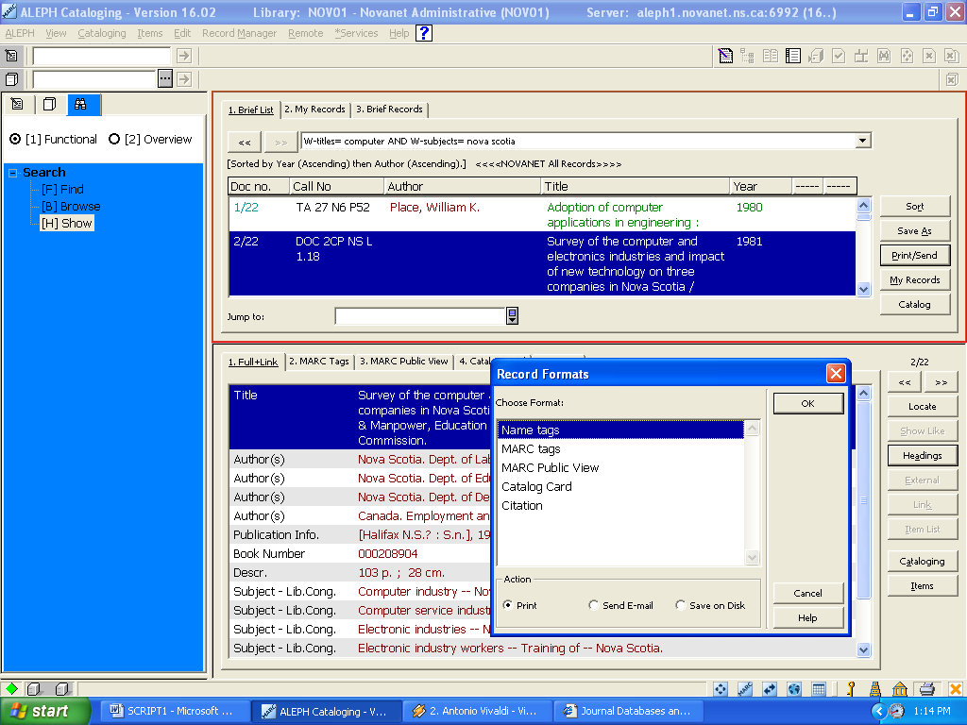

Select the desired format and choose ‘Print’:

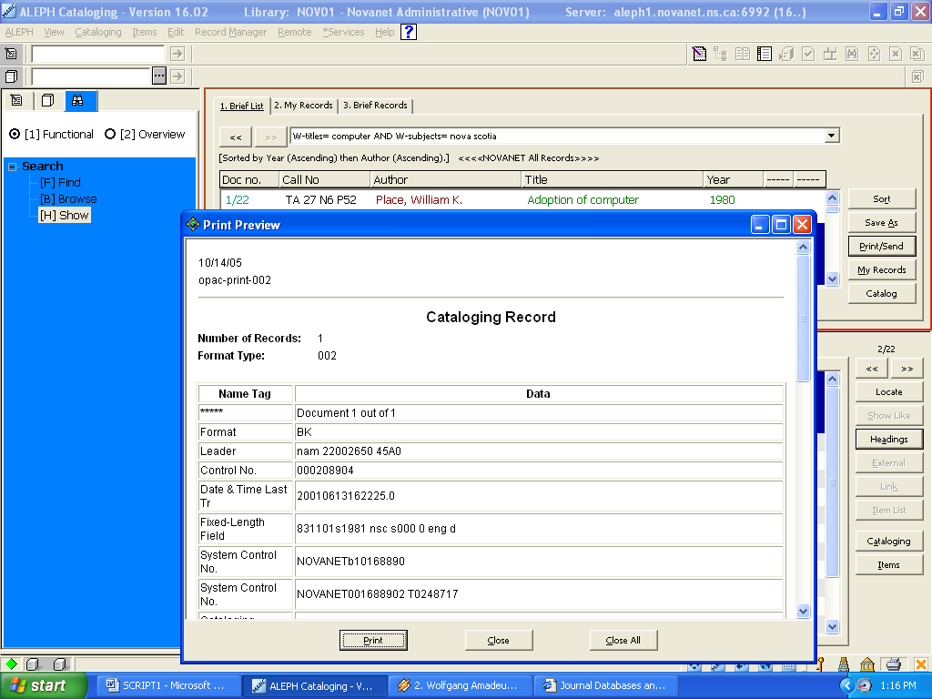

8. Logging out:
Aleph allows you to logout of one module at a time, or ALL modules simultaneously.
To exit a single module (application):
  - Select ALEPH/Exit from the main menu bar (or use [alt + F4]
  - Click the ‘Ok’ button on the Exit application dialog box.

To exit all open modules:
- Click the icon on the Operations bar (bottom right of the window) or choose ALEPH / Exit all ALEPH applications
You will exit ALL applications without any warning or dialog box

Record Manager Mode (Detail)

The Record Manager displays information regarding the record currently being edited in the Catalog Editor (upper pane of the Cataloging tab). The information is displayed in tree structure after opening a record from the server or after saving a new record. Note that the pane is left empty when editing records that have not been sent to server.

The purposes of the Record Manager are the following:

The Record Manager shows the records in the system that are related to the record currently being edited. For example, it displays the administrative record, the items and the holdings records attached to the selected bibliographic record. Note that the display in the Record Manager is limited to 800 lines.

The Record Manager provides access to the records associated to the record currently being edited. This is done by selecting the desired node and choosing the Load/Create Record option from the Record Manager menu or by selecting the same option when right-clicking on the desired node.

To edit the administrative cataloging record, highlight the administrative node and click Load/Create Record.

To edit a holdings cataloging record, highlight the desired record (leaf) under the holdings node and click Load/Create Record.

The Record Manager enables the creation of administrative and holdings records.

If no administrative record is linked to the bibliographic record, the message "No record available" is displayed. As explained above, when the Load/Create Record option is selected while highlighting the node of the administrative library, the administrative record linked to the current bibliographic record is retrieved and displayed for editing. If no administrative record is available, this option automatically creates the record and displays it for editing.

For holdings records, when the Load/Create Record option is selected while highlighting the node of the holdings library, a new holdings leaf is displayed under the node. In other words, a new record is created and displayed in the Catalog Editor for editing.

The Record Manager provides access to the Items function (Items tab) of the Cataloging module. The Items node is displayed under the administrative library node (for example, USM50). Double clicking the Items node enables you to view and/or add information about copies to the current record. You will be transferred automatically to the Items function (Items tab) of the Cataloging module. The Item node also lists the items available for the current record, double clicking an item transfers you to the Items tab and it enables you to view the specific copy information of the selected item.

Note that if no administrative record is linked to the current record, when double-clicking the Items node an administrative record is automatically created.

The display of items linked to holdings record can be determined by the system librarian. The following options are available:

The link is not displayed (items are displayed under the administrative record only).

The items are displayed both under the administrative record and under the linked holdings record.

The items are displayed only under the linked holdings record.

ADM and HOL libraries displayed in the tree are filtered according to the ADM library assigned to the connected staff user. For example, if the connected staff user is assigned to XXX50 ADM library, the ADM library displayed in the tree will be XXX50. If the connected staff user is a super staff user and is assigned ADMIN in the User Library field, (e.g., ALEPH/ALEPH), then all the ADM libraries which are related to the BIB library will be displayed.

