

Importing cataloguing records into Aleph version 16

Records coming from libraries with Z39.50 protocols, including OCLC are imported in a four step process.

The steps are:
1. Find a record.
2. Retrieve the record into the cataloguing module.
3. Copying the record.
4. Saving the record to the server.

1. Searching
Mouse-click on the “Binoculars” tab, in the Navigation Pane.
Mouse-click on the “1. Advanced Search” in the Upper Right Pane

Choose an external Library (Library of Congress), from the first drop-down menu.
Choose a search option (title, author, ISBN, etc.) from a drop-down menu [title phrases work in this search mode, authors must be entered last name first].

Type in your title
Press on “OK”

A title list will appear in the Lower Right Pane
Press the “Show” button.

A list of records will appear in the Upper Right Pane, one of which will be highlighted.
The highlighted title in the Upper Right Pane will display a full MARC record in the Lower Right Pane.

Chose the proper record
Review the Marc record to make sure it is acceptable.

Caution “Browse” searching not allowed in the Z3.50 protocol

2. Retrieving a Record
Mouse click on the “Catalog” button in the Upper Right Pane or the “Cataloging” button in the Lower Right Pane
Note in the Upper Left Pane an EXT01-# will be created with a local number in brackets (NEW#)
Do not edit the record until it has been copied.

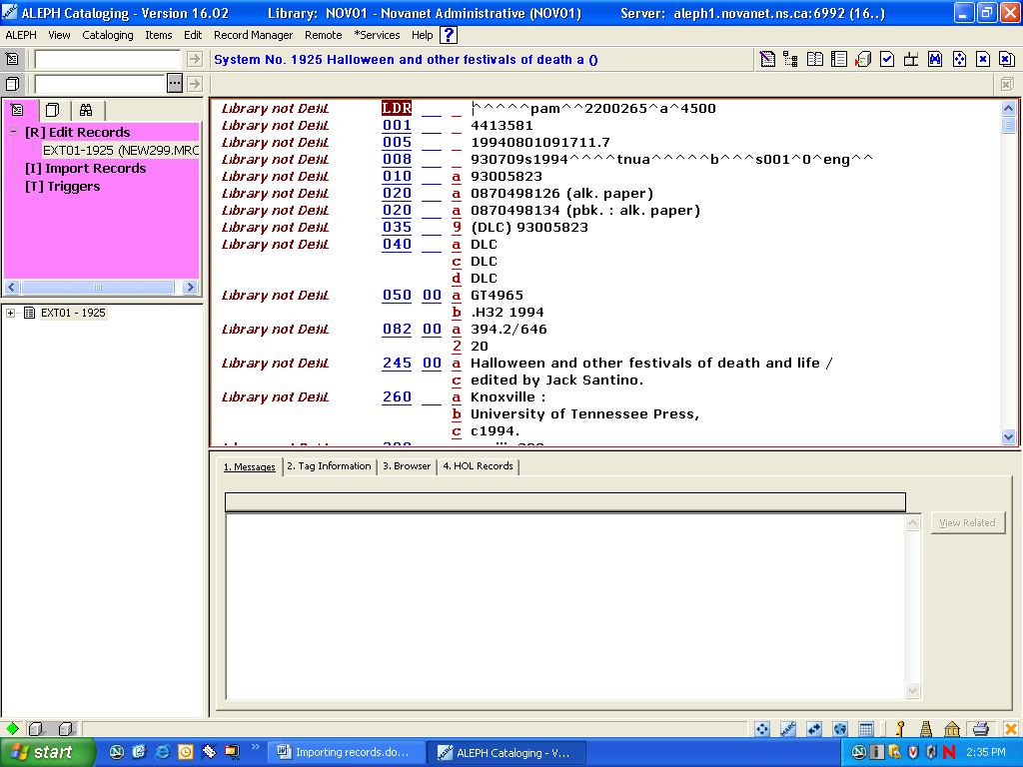
Note:
EXT01-1925 number

3. Copying a record
From the “Main Menu Bar”, select “Cataloging”, then select “Duplicate record”

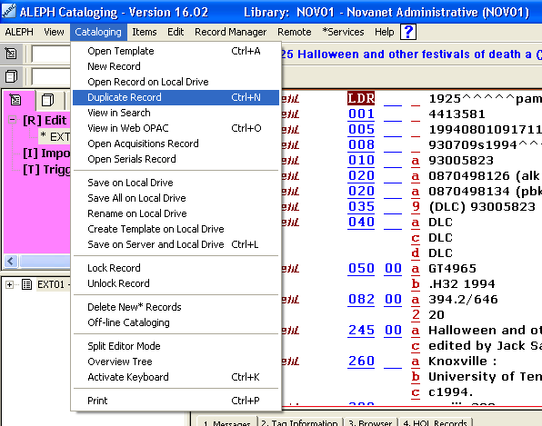

In the Upper Left Pane you will now notice that a new local number - NEW01-#.
The record now may be edited.

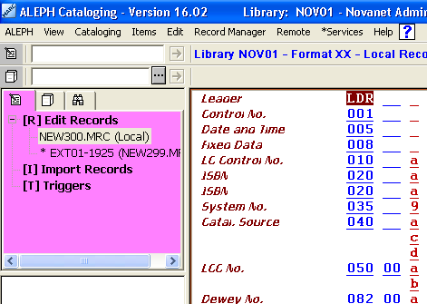

4. Saving the record to the server
Go to “Main Menu Bar”
Mouse-click on “Cataloging”
Mouse-click on “Save on Server and Local Drive”
The “Save on the Server and Local Drive” pop-up box will appear, mouse click on “Continue”
The record will be saved to the NOV01 database and given a “BIB number” – NOV01-#

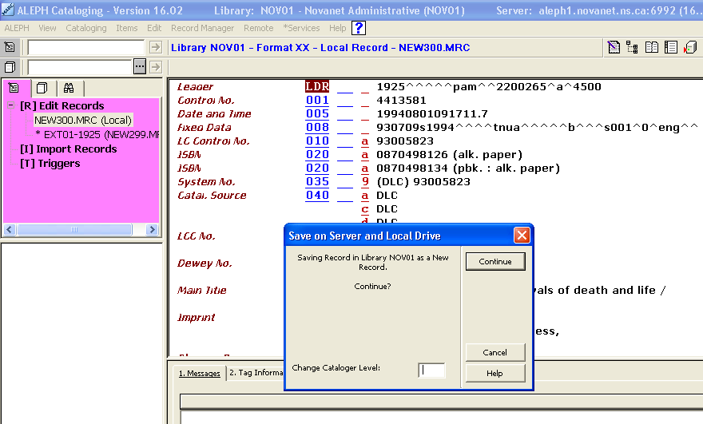

A warning notes / error pop-up box may appear. These notes will populate the Lower Right Pane 1. Messages tab. If you highlight one of the messages, the corresponding MARC tag will be highlighted in the cataloguing editor, on the Upper Right Pane. These messages represent cataloguing information or errors.

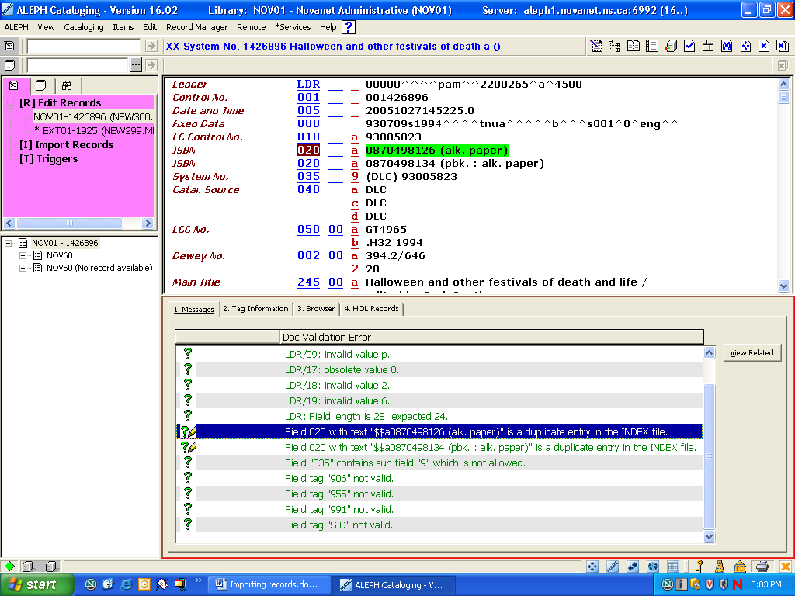

In 2. “Tag info”, in the Lower Right Pane, is the “MARC 21 Concise format for bibliographic data” manual. When you highlight a MARC Tag is the cataloguing editor, the “Tag info” has the information on that particular tag.
