

A. Moving individual items between bibliographic records

B. Moving all Holdings, including order and loaning information, from one record to another

A. Moving individual items between bibliographic records

1. Search and retrieve in to the Cataloguing Editor, the first Novanet record.
2. Search and retrieve in to the Cataloguing Editor, the second Novanet record.

3. Change to split editor mode, having the two records in the cataloguing editor screens.

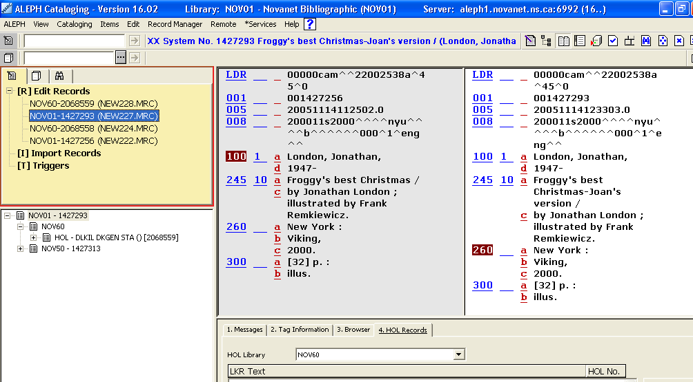
Figure 1

4. Unlink the item record that you want to transfer
i.) Go to Record Manager (Lower left pane)
ii.) Double mouse click on the barcode that is to be transferred, the item tab will open.
iii.) In the Lower right pane, on Tab “6. HOL Link”, mouse click on the “UNLINK” button

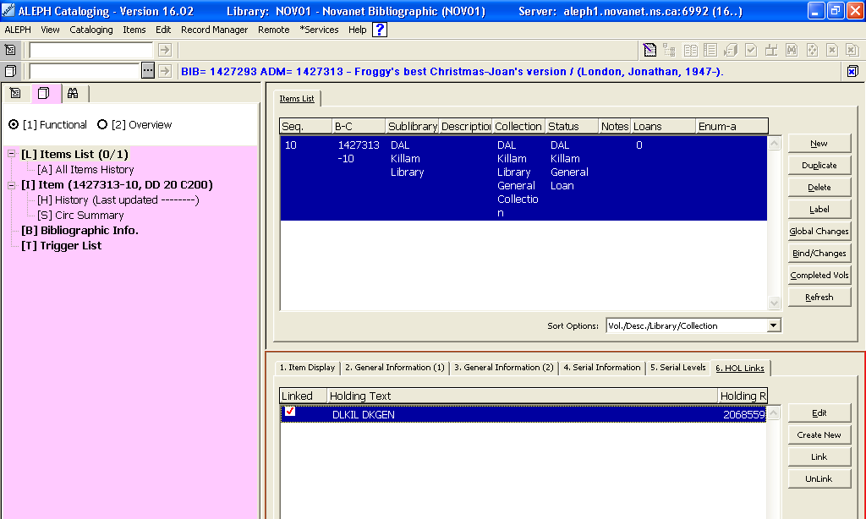
Figure 2

5. Return to the Cataloguing editor (Mouse click on Record Tab)

6. Mouse click to the “Overview Tree”
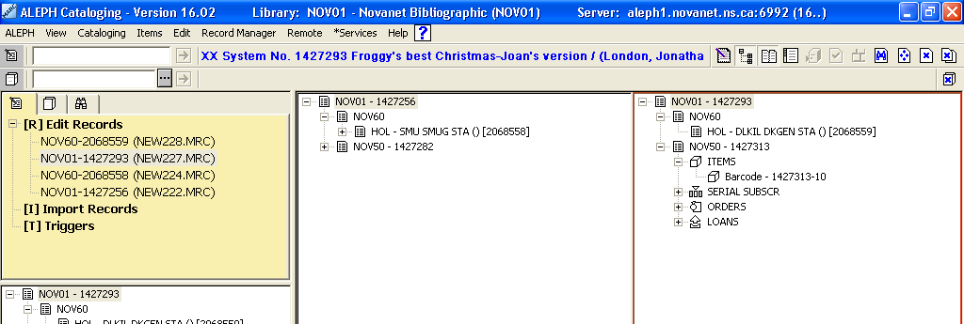
Figure 3

7. Locate the unlinked barcode, which now resides only in the NOV50 tag, on the existing record

8. Drag the item barcode, from the old record overtop of the ADM (NOV50) record of the new record.

9. Return to the Cataloguing Editor (Mouse click on “Overview Tree” again, to return to the Cataloguing Editor)

10. Go to “Record Manager” (Lower left pane). The bibliographic record should be the one that the transferring item will now reside on.
i.) Mouse click on the NOV50 tag.
ii.) Double mouse click on the barcode.

11. The “Items Tab” will open.
Make sure you have the new item (the one transferring in) highlighted, in the upper right pane.

In the Lower Right Pane, on Tab “6. HOL Links”, click on “Create New”.

A new Holdings (NOV60) location, will be created with the item attached.
Click on “Edit” to review Tag 852 $h (call number), and correct as necessary.
Before
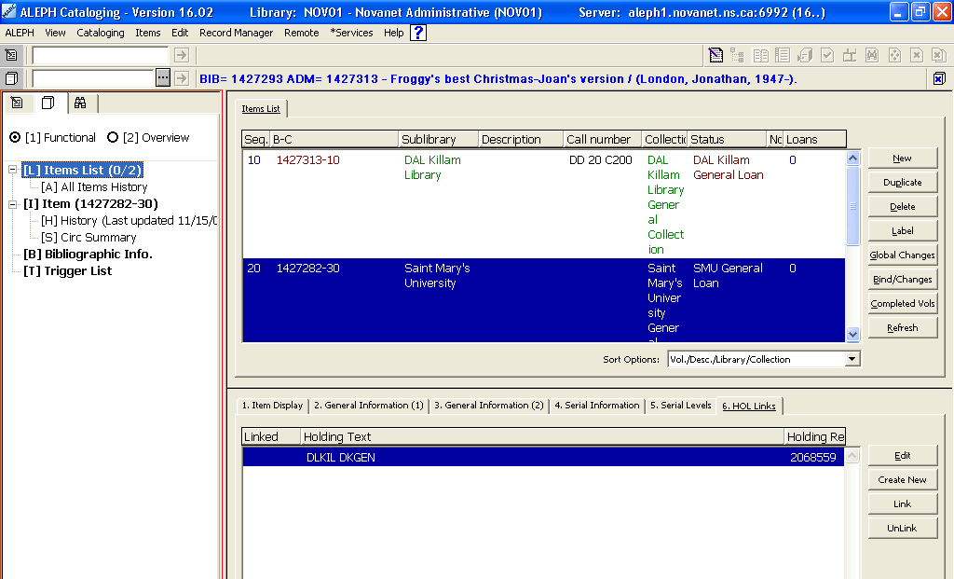
Figure 4

After
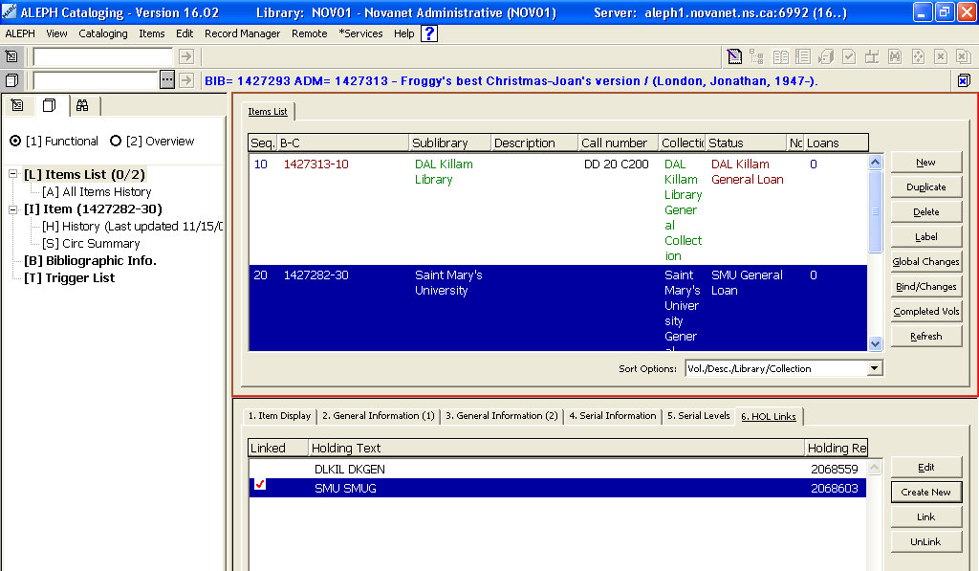
Figure 5

12. Choose the Record Tab in the Navigation Pane
13. In the Record Manager (Lower Left Pane), note that there will now be an additional location with the barcode attached.

------------------------------------------------------------------------------------------------------------

Cleaning up the old record

14. Delete the ADM record of the old record (provided that all items have been removed)
15. Delete the HOL record of the old record (the one that had the barcode moved from).
16. Delete the BIB record of the old record (if all items and locations have been removed).

B. Moving all Holdings, including order and loaning information, from one record to another

1. Search and retrieve in to the Cataloguing Editor, the first Novanet record.
2. Search and retrieve in to the Cataloguing Editor, the second Novanet record.

3. Change to split editor mode, having the two records in the cataloguing editor screens.

Figure 6

4. Mouse click to the “Overview Tree”
Figure 2

Click and drag the NOV50 of the record to be moved, overtop of the NOV50 of the new record.
File on the server Cataloging/Save on Server and Local Drive
Delete previous record as all information has been moved.

