MARC 21 Coding on the Aleph publications pattern template

Tag 853

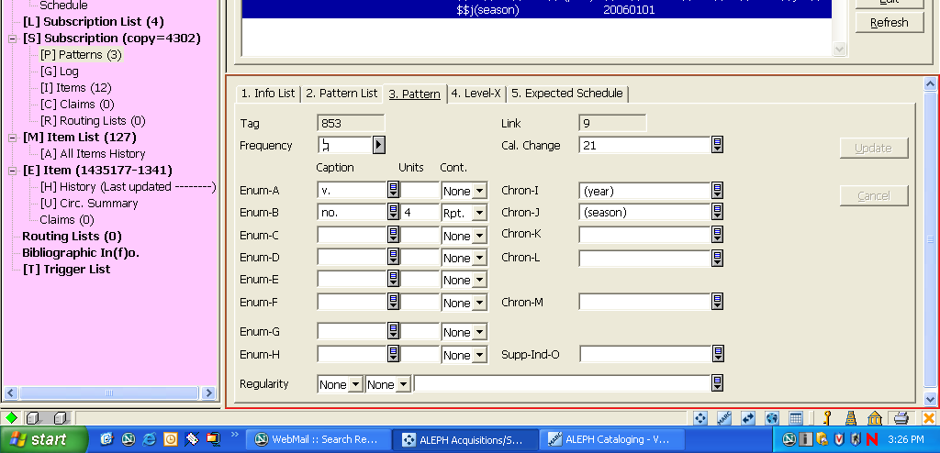
$x Calendar change
$y Regularity
$w Frequency

Frequency
$u Units
$v Continuity
Tag 853 - X

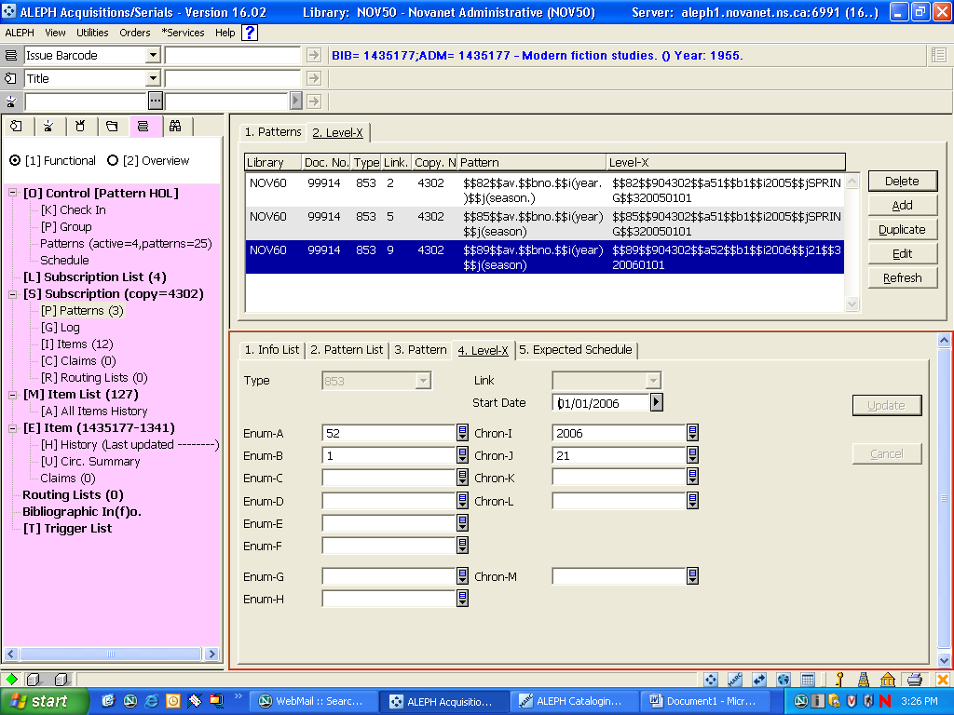
$3
Start date

