The Graphical Layout of the Aleph 16 Acquisitions Serials Desktop Client
Main Menu
Bar

Title Bar
Serial Bar

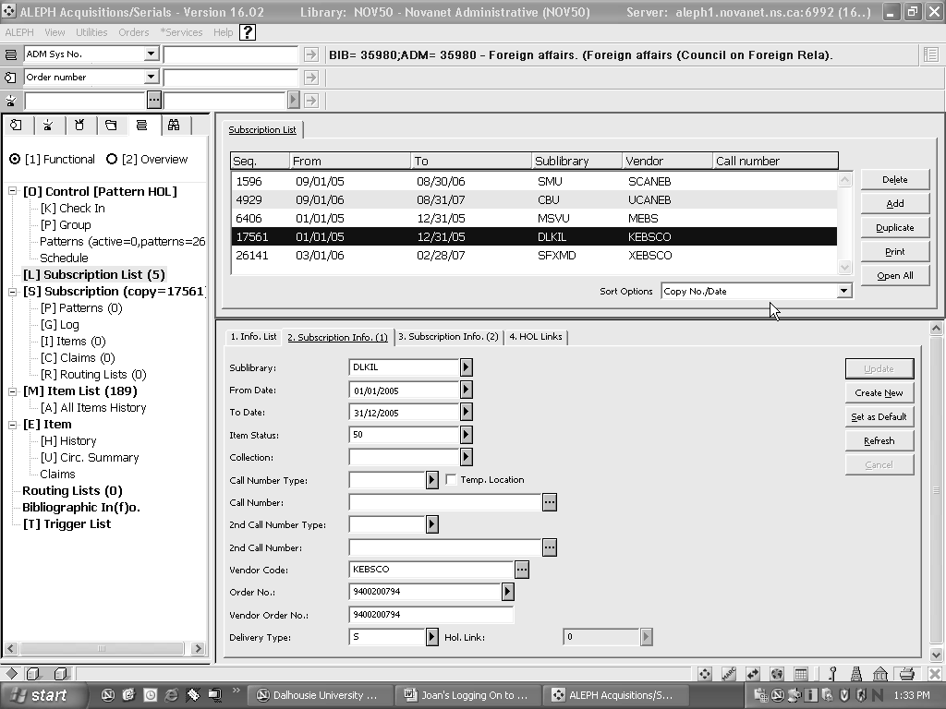
Nodes
Roots
Navigation
Pane

Order Bar
Main tab
Lower Pane
Upper Pane
Figure 1 – Graphical Layout of Acquisitions Serials Desktop
Object Bar

Aleph 16 Desktop Client Layout
Title Bar: Name of Module, Library and Server Information
- Menu Bar:
- Main menu options. Options are ALEPH, View, Utilities, Orders, *Services and Help
- Bars: Beneath the menu options you will find Bars where you can input information specific to that module. For example, in the Cataloging menu, you have two bars, the Cataloging Bar and the Item Bar. In Acquisitions, there is a Serials Bar, an Order Bar and an Invoice Bar. In Circulation, there is a Patron Bar and an Item Bar. The options for what information can be input into these bars are explained within the specific module sections below.
- Serials Bar: If you enter a search here, the result will display on the Serials Tab. You can search by BIB title, ISSN, etc. This bar only works with the Serials Tab.
- Order Bar: If you enter a search here, the result will display on the Order Tab. You can search by Order No., BIB title, ISBN, etc. This bar only works with the Order Tab.
- Invoice Bar: This is where you search for an existing invoice or create a new one. This bar only works with the Invoice Tab.
- Upper Pane: Search options or records in lists, (e.g. Order List, Items List, Check-In List, Bibliographic records, etc.)
- Horizontal Split Bar: You can make the upper or lower pane larger by moving this bar. Once you use the bar to set the Upper and Lower panes, these places will remain persistent.
- Lower Pane: You will usually see search results, or a specific record such as an item, subscription, order, check-in arrival, holdings information, etc. in this pane.
- Operations Bar
- Applications toolbar, change password/log in, library icon, server prompts, The “X’, in this bar, will close all Aleph databases, at once.
- Vertical Split Bar: You can make the navigation pane larger or smaller by moving this bar
- Navigation Pane: This pane lists functions available on a particular tab and consists of Root (higher level) and Nodes (lower levels).
- Root: Specific function on a tab. Click to select a Root.:
- Node: Under each Root there are individual functions, related to the Root, and are located below the that Root. Click to select a specific “Node “.
- Main Tabs: Tabs that indicate specific functional areas within a module. Click to choose a tab
In Acquisitions, there are six tabs:
Order tab : This tab is used for placing orders and recording monograph and standing order arrivals and claims.
Administration Tab : This tab is used to create vendor records and by financial managers to create budget records.
Invoice Tab : This tab is used to review invoice information.
Order Index Tab : This tab is used for searching for orders using the Order Index.
Serials Tab : This tab is used for processing serials receipts and serials claiming.
Search Tab : This tab is used to find bibliographic records.

2. The Serial Tab
The Navigation Pane on the left hand side of the Serial Tab displays the functions that can be performed on this tab:
The Pane consists of Roots and Nodes. Roots are the words in bold and define a specific part of the pane. The Nodes are functions that correspond to the Root that they appear under.

Functional and Overview Buttons
The first nodes you will see on the Serial Tab are Functional and Overview Buttons The Functional radio button will be selected by default when you open the Serial Tab. This means that you are looking at the functions on the Serial Tab.

A. Overview Button
- The Overview Node will bring you to a display of the bibliographic, holdings, item and order information. This is where you will push a title to another module such as Cataloging, Items or Circulation by clicking on the appropriate button on the right hand side.
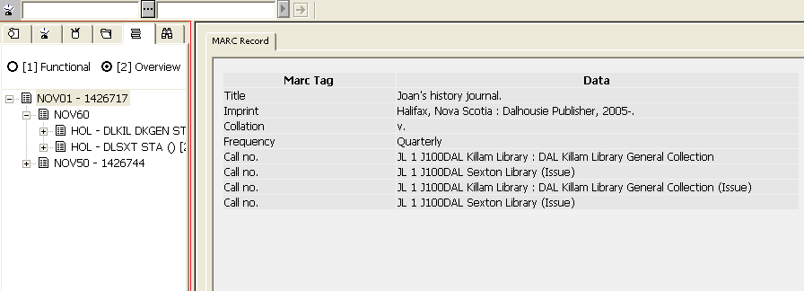
Figure 2 Overview Node

B. Functional Button

I. Control Root
The libraries you have access to is controlled from your log-in permissions.

a) The Check-In Node Navigtion Pane /[O] Control / Check-in
This where you arrive and claim issues.
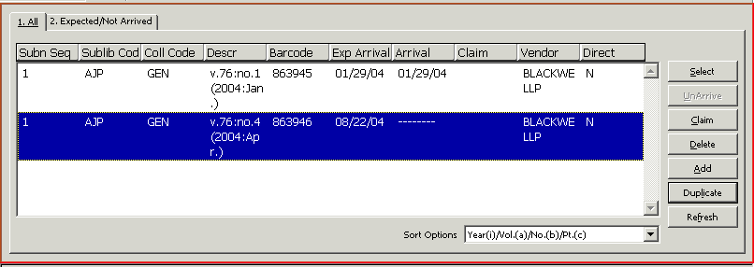
Figure 3: Check-In Node, Upper Pane: All Tab

The Expected, Not Arrived tab will only display those items that have not yet arrived. The tab will also display items that have been claimed.
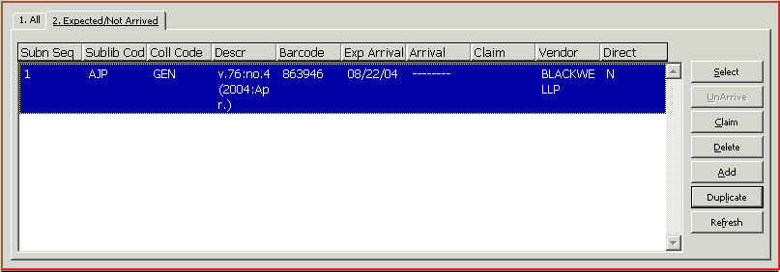
Figure 4: Check-In Node, Upper Pane: Expected, Not Arrived Tab
The columns on the Check-In Node are configurable by right clicking on the gray part of any column heading. See the Aleph Serials Training Version 16 manual for further information on the choice of headings.

b) The Group Node
Beneath the Check-In Node on the Navigation Pane is the Group Node. The Group node is used to check in multiple copies of the same issue all at once. Since most libraries only have one subscription to a title, this is not a useful node. Even if you do own more than one copy of a title, it is recommended NOT use the Group Node in Serials routinely.

II. The Subscription List Root Navigation Pane / [L] Subscription List
Maybe created in the Order Tab or Serials Tab. Any title with order and invoice data should be created in the Order Tab. This Order info will transferred to the Subscription List Root in Serials Tab, but not back to the Order Tab, if created in the Serials Tab
[L]Subscription List is where your basic information is entered. In this List you detail which library and collection the title resides in, order information, vendors and delivery information, claim intervals and dates you expect to receive the title.

III. The Subscription Root Navigation Pane / [S] Subscription
Once you have highlighted a Subscription on the Subscription List Root, information about that Subscription will appear in the Subscription Root and its related nodes.
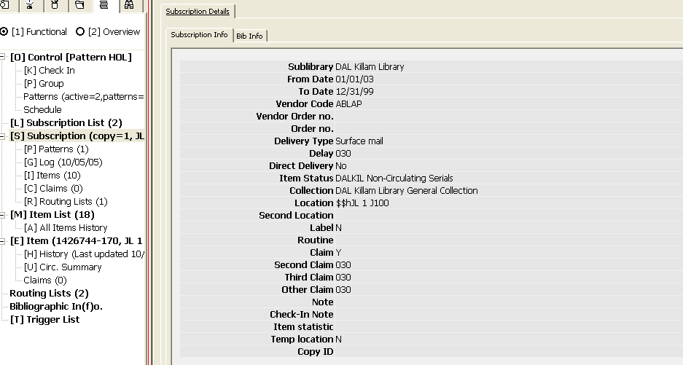
Figure 5: Subscription Root
From the Navigation window, you will see that the Subscription Root will tell you the Subscription Sequence number and the Call number of the title from the Holdings Record
The Upper and Lower Panes feature a display of Subscription Information. To edit information found on this display, you will need to return to the Subscription List and edit the information on the Lower Pane in the Subscription Info Forms.
a) [P] Patterns
Enumeration and Chronology as taken from the Holdings record – Tag 853
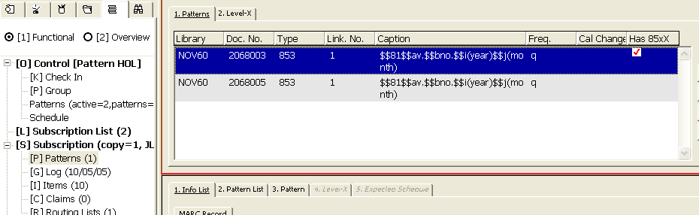
Figure 6: Patterns – Tag 853

Pattern Level – X. The actual expected issue, taken from Holding record, Tag 853-X
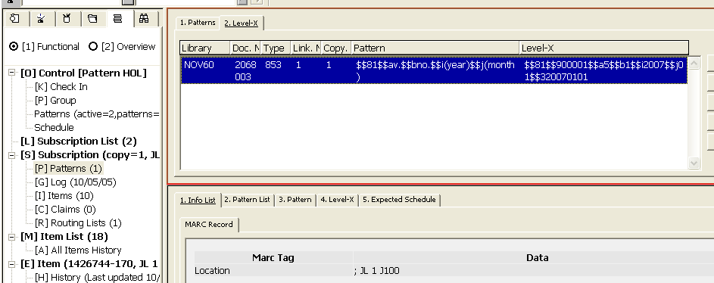
Figure 7 - Pattern Level- X Tan 853

b) Log Node

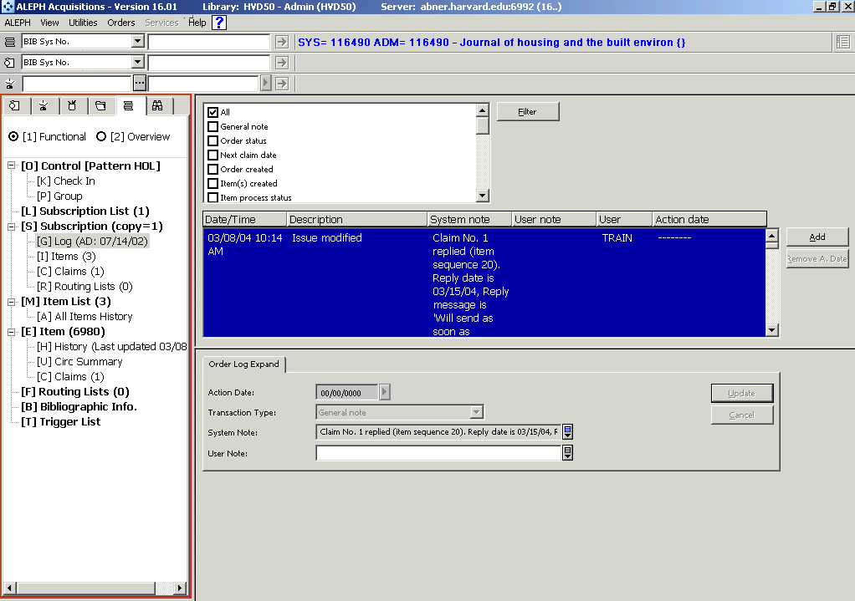
Figure 8: Subscription Log Node
The Subscription Log contains information, such as:
- subscription is created or changed
- Order information from the Aleph Serials Order Tab
- Payment information from invoices paid in Aleph
- Claim information when a claim is made in the system
- For converted orders, a snapshot of the old order record from the previous system.
- Staff can also add notes to the Subscription Log, such as a general note or subscription history note.

c) Items Node
The Items Node contains a list of all items associated with the Subscription that appears on the Subscription Root; you will not see items associated with any other library nor any other subscription on this display.
On the Navigation Pane, the number of items associated with the Subscription that appears in the Subscription Root will display in the parenthesis to the right of the Items Node.

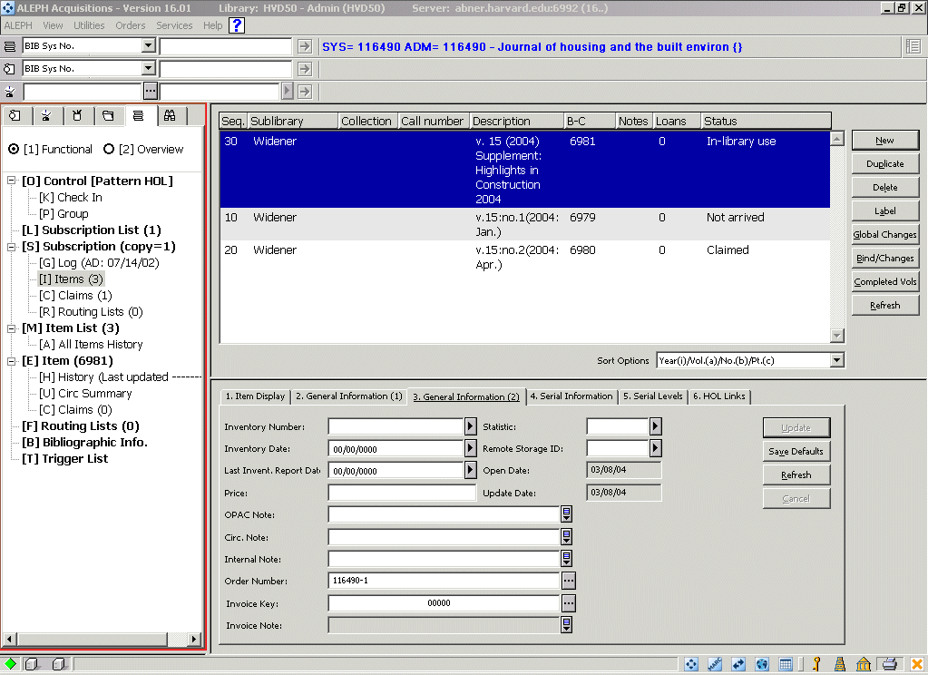
Figure 9: Items Node
The Upper Pane displays the Items List. The lower pane shows particulars on an single item.

d) The Claims Node
The Claims node will show you any claims that have been on items associated with the Subscription displaying on the Subscription Root. You will see the number of claims in parenthesis to the right of the claims node
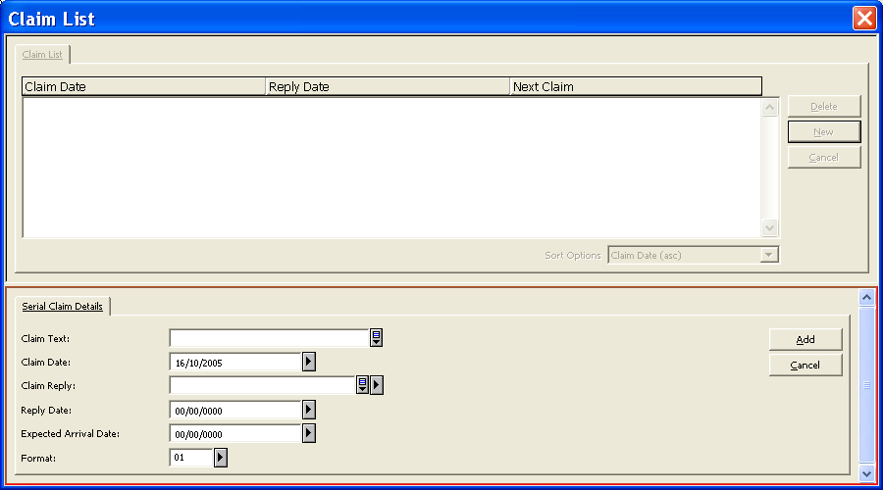
Figure 2 – Claims List
.
The claims node will display the Claims list of the items that have been claimed on this subscription in the Upper Pane.
You can edit an existing claim on this list by highlighting the claim on the Upper Pane and inserting the Reply or text you wish to edit and click the Update button.
Note that you cannot send new claims from the Claims node; you must go to the Check-In List, highlight the item from there, and click the Claim button on the Check-In List or in the Claims Node of the Item Root in order to create a new claim.

e) Routing Lists Node
It is possible to create routing lists. Please note that some policy issues still need to be worked out in this area; a pilot project has been established to work through these issues.
The Routing List node will show you the Routing Lists associated with the Subscription that appears in the Subscription Root
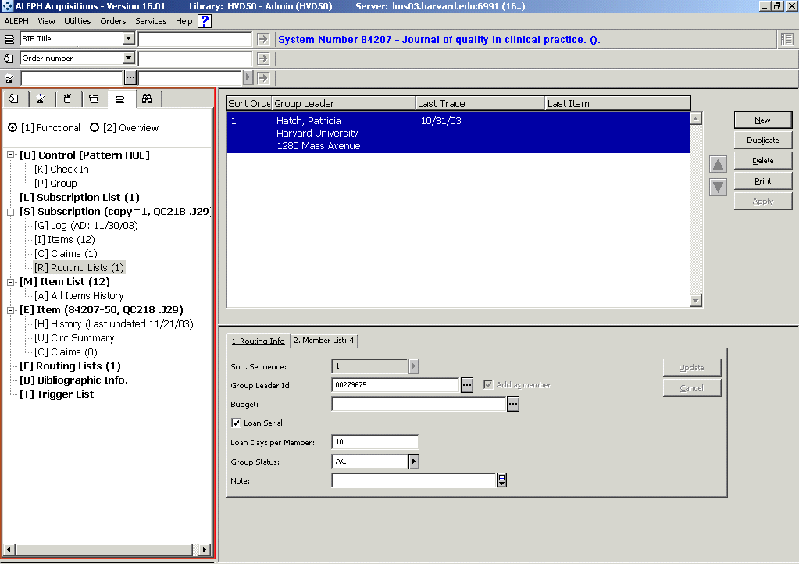
Figure 11: Routing Lists Node
You can use the Routing Lists function to simply create a routing list without loaning the periodical to the members of a routing list.

IV. Item List Root
This root will display all items from all libraries associated with the title, not just your library's title or a single subscription. Next to the word Item Root you will see the number of items associated with the title; this number reflects how many items you have authorization to edit
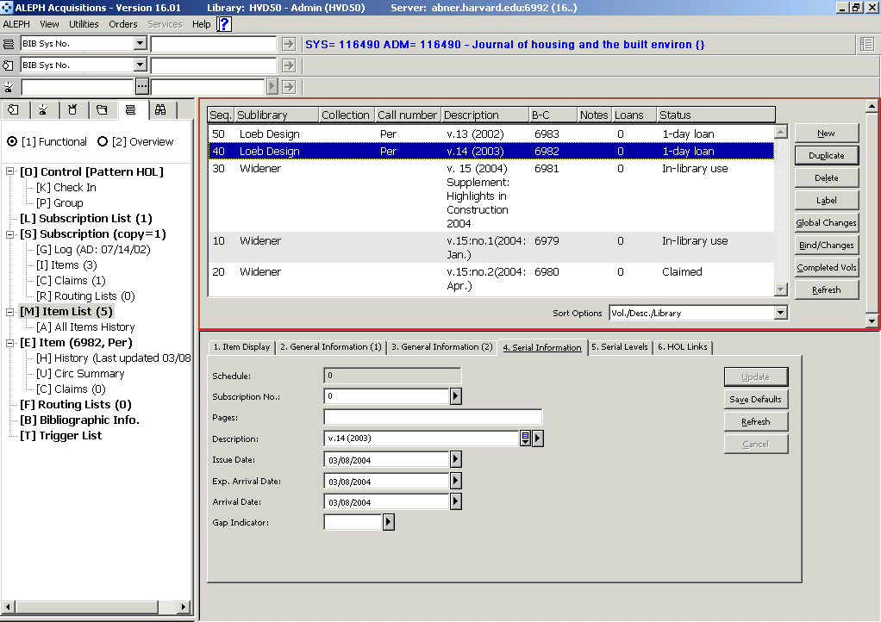
Figure 12: Items List Root: All Items, All Libraries
The Items Root displays the Items List in the Upper Pane.

V. Item Root
The Item Root displays the Item Record that is highlighted in the Upper Pane on the Items List. It will display the barcode number and call number in parenthesis next to the word Item.
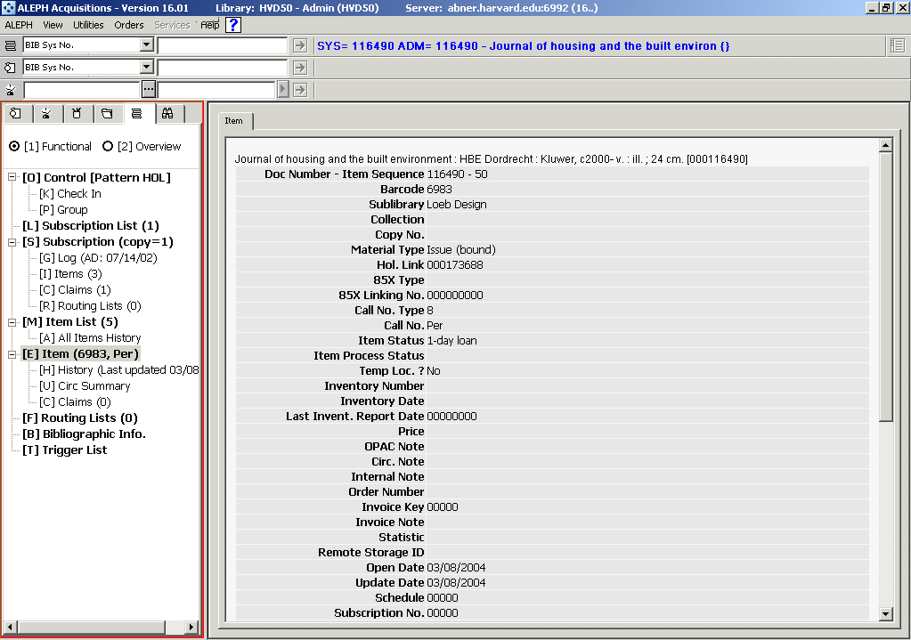
Figure 13 Item Root
The Item Root contains display of brief bibliographic and Item Information.
There are three nodes found under the Item Root: History, Circ Summary and Claims

VI. Routing Lists Root
The Routing Lists Root will display the number of all routing lists associated with this title, not just the routing lists associated with a particular subscription
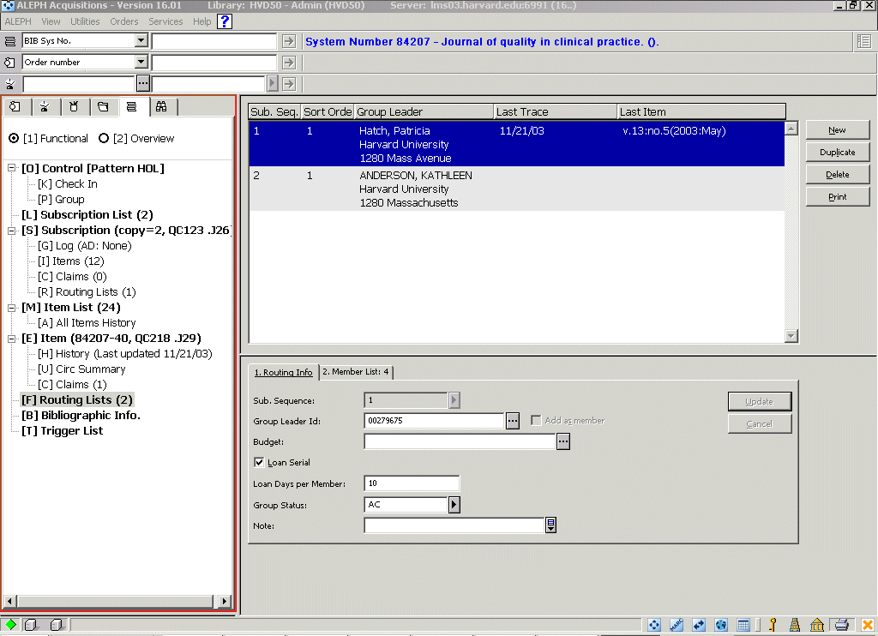
Figure 14: Routing Lists Root
In the Upper Pane, you will see the list of routing lists associated with the title. The Lower Pane will display Routing List information about the list that is highlighted in the Upper Pane.

VII. Bibliographic Info Root
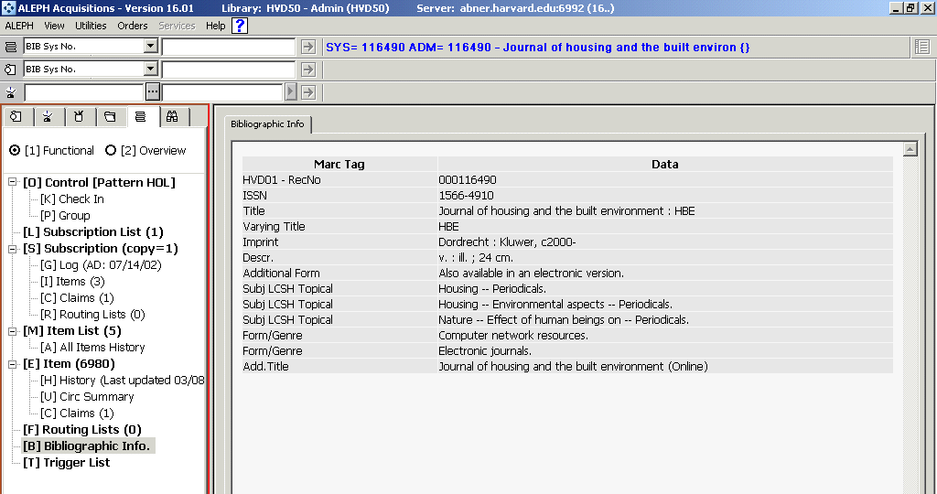
You can access bibliographic information about a title by selecting the Bibliographic Info Root. .
Figure 15: Bibliographic Info Root

VIII. Triggers
Triggers for Serials are used for some of the Service functions.

