

Overwriting a brief or incomplete bibliographic
record in Aleph

1. Search for the brief record from the Novanet Catalogue (NOV01-#)
2. Transfer to the “Cataloging Editor” by mouse clicking on the “Catalog” button in the Upper Right Pane, or on the “Cataloging” button in the Lower Right Pane.

3. Search for a record from an external library (example: Library of Congress).
4. Transfer to the “Cataloging Editor” by mouse clicking on the “Catalog” button in the Upper Right Pane, or on the “Cataloging” button in the Lower Right Pane. It will have an “EXT01-#” record number, upon being placed in the “Cataloging Editor”.

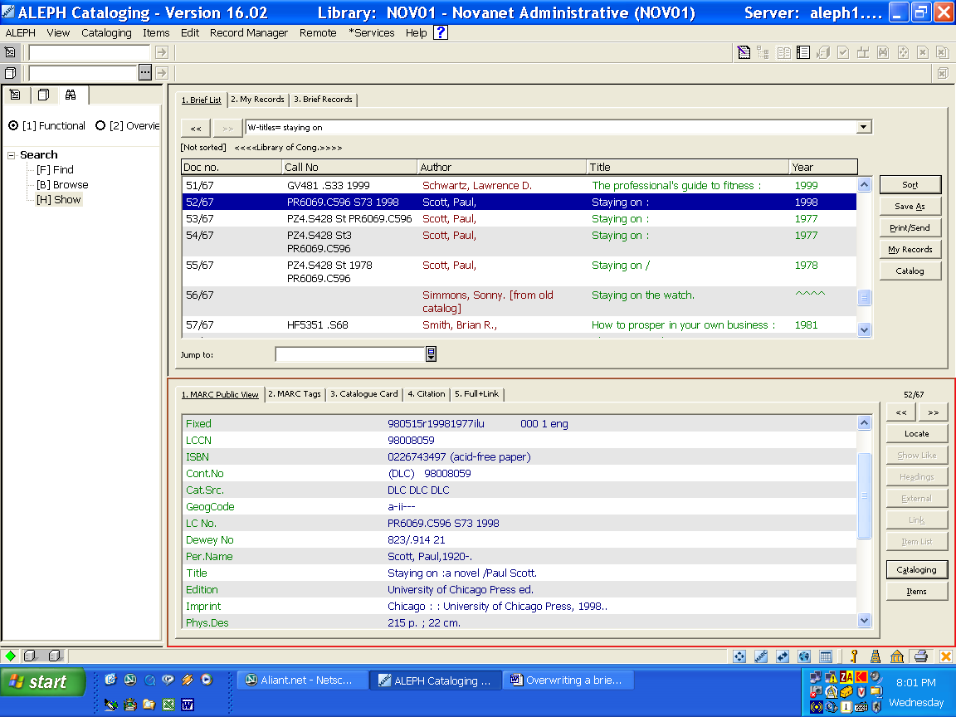
Figure 1 – Retrieving a record from an external library
5. Go into “Split Screen” mode, placing the “NOV01-#” record on one screen and the “EXT01-#” record on the other screen

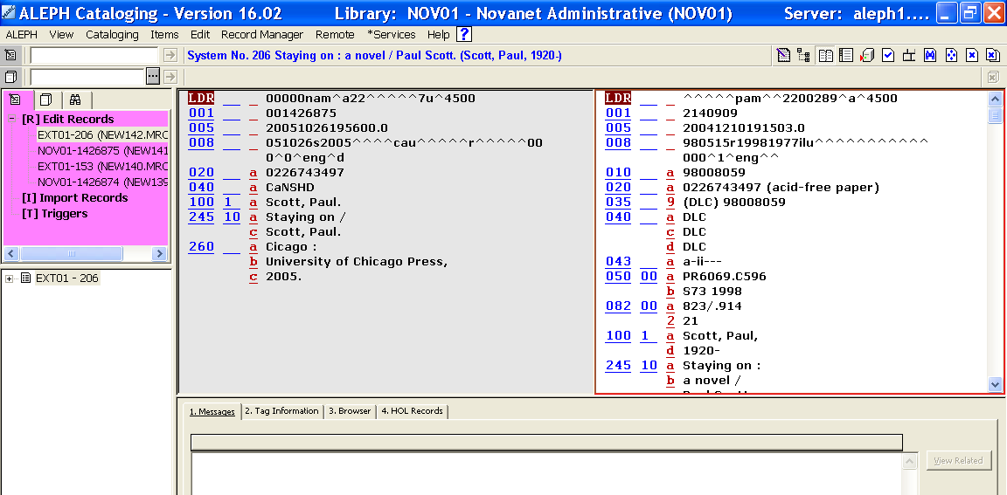
EXT01-#
record
Brief record
NOV01-#
Figure 2 – Split screen format

6. Mouse click in the “EXT01-#” record, followed by choosing “Copy record” in the Edit Menu.
[Main Menu / Edit Menu / Copy / Copy record]

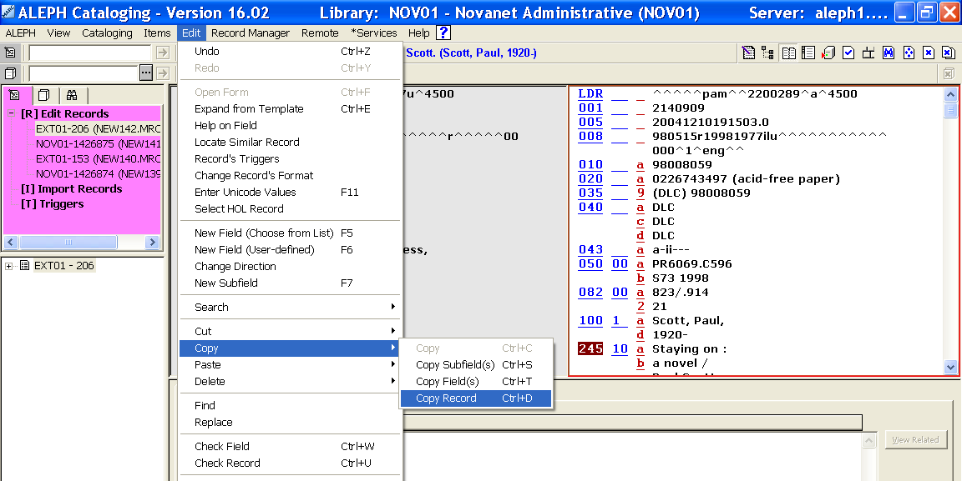
Figure 3 – Copying the EXT01-# record
7. Mouse click in the “NOV01-#” record, followed by choosing “Paste record” in the Edit Menu
[Main Menu / Edit Menu / Paste / Paste record]

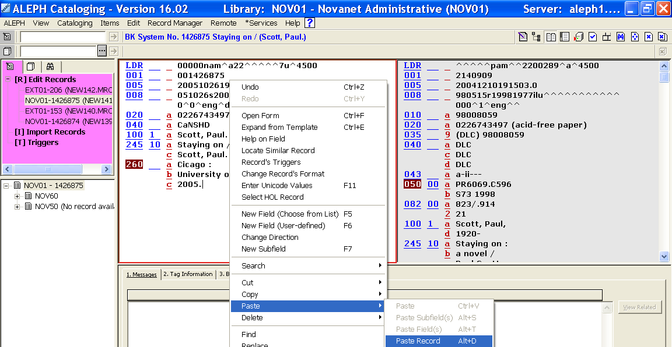
Figure 4 – Pasting the external bibliographic information to the existing NOV01-# record

8. In the “NOV01-#” record, mouse click on “Save on Server and Local Drive” in the Cataloging Menu
[Main Menu / Cataloging / Save on Server and Local Drive]

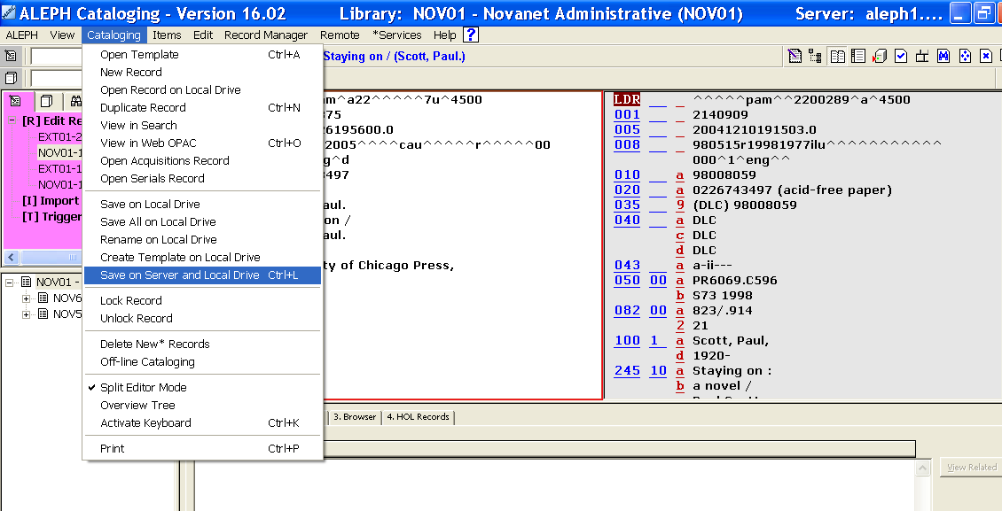
Figure 5 – Saving the existing NOV01-# record to the Server

