

Predictive patterns for index
Creating the Publication pattern (Tag 855)

- Go to patterns [S] Subscription/[P]Patterns
In the Upper Right Pane
2. Mouse click on “1. Patterns” tab
3. Click on the “Add” button in the Upper Right Pane
If a window opens “Choose Pattern Document”, make sure to choose the NOV60 library and for the appropriate sub-library (example DLKIL)
The Lower Right Pane will become active.
4. Enter “855” in the tag box

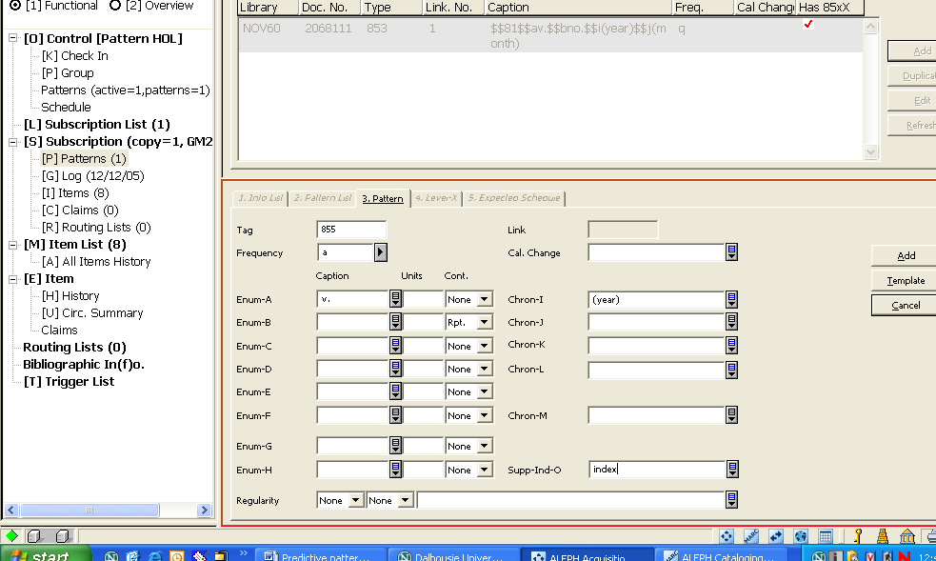

5. Mouse click on the “Template” button
6. Choose the appropriate enumeration, mouse click “OK”
7. Check fields and make appropriate corrections.
***8. Fill in Enumeration-”O” field with the word “index.”
9. Mouse-click on the “Add” button

An 855 field will be created.

Creating the Publication pattern prediction (Tag 855-X)
In the Upper Right Pane
10. Mouse click on “2. Level X” tab
11. Click on the “Add” button in the Upper Right Pane
If a window opens “Choose Pattern Document”, make sure to choose the NOV60 library and for the appropriate sub-library (example DLKIL)
The Lower Right Pane will become active.
12. Enter “855” in the tag box

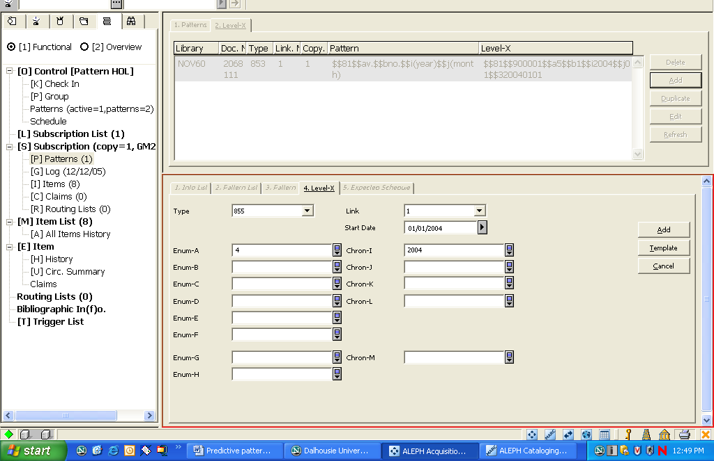

13. Mouse click on the “Template” button
14. Choose the appropriate enumeration/chronology, mouse click “OK”
15. Check fields and make appropriate corrections
The 855 and 855-X pattern choice must match.
17. Choose “4.Serial Level” put the appropriate start date and volume numbering in fields
18. Mouse-click on the “Add” button
An 855-X field will be created.

Supplements file after the 853 Tags
Indices file after the 853 tags and 854 tags.

