

Record Editing

Once you have located a record by either Find or Browse, you will see a Brief List in the upper pane. If you highlight one of the items in the upper pane and click on the Show node, you will see a full display (referred to as the Full + Link view) of the record in the lower pane. Once you are viewing the Full + Link view in the lower pane, click the “Catalog” button on the right in the upper pane or lower pane.

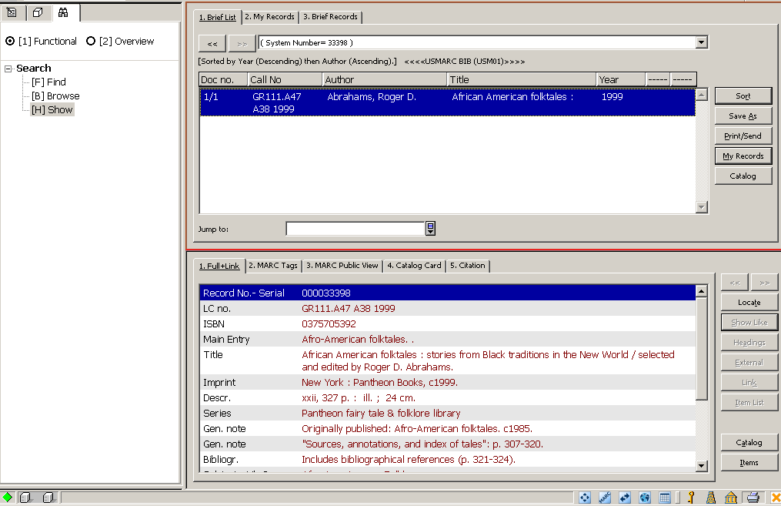

The selected record is relocated to the Catalog Editor node of the Cataloging Navigation Tree and displays in the (upper pane) for editing:

. Records that are open for editing are listed under this node including the Library code – system number (Local “new” number) that has already been saved on the server:

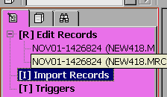

Records not yet saved to the server will have only the “new” number and in parentheses (Local). As you begin to edit either type of record an asterisk will appear before the 3-digit library code before you save it to the server. Once the record is saved, the asterisk will disappear.

Moving Around the Cataloging Record
The following keys on your PC’s keyboard can be used to navigate through the cataloging record:

Up/Down arrows - moves up/down one line
Left/Right arrows - moves left/right one space
[“Tab”] - moves from field to field
[“Page Up”] - moves up one page
[“Page Down”] - moves down one page
[Ctrl + Home] - moves to the beginning of the record
[Ctrl + End] - moves to the end of the record

Editing Tags
If you wish to change a tag, highlight the old text and enter the new text on top of the old. To delete a character, use your keyboard’s spacebar.

Editing Indicators
If you wish to change the indicator, highlight the old text and enter the new text on top of the old. To delete a character, use your keyboard’s spacebar (not the [“Delete”] key).

Editing Subfield Codes
If you wish to change the indicator, highlight the old text and enter the new text on top of the old. It is not possible to delete a subfield code with either the spacebar or the [“Delete”] key. If you wish to delete a subfield, use [Ctrl+F7] or select Edit/Delete/Delete Subfield(s) from the Cataloging Main Menu Toolbar. This will delete both the subfield code and its contents

Editing Contents
. The contents area of the Cataloging record works in ‘insert’ mode. When using the spacebar to enter a blank space, you may enter only one blank space. Carets (^^) must be used to enter multiple blank spaces.
To retrieve the Edit menu, click your right mouse button inside the white space in a open record:
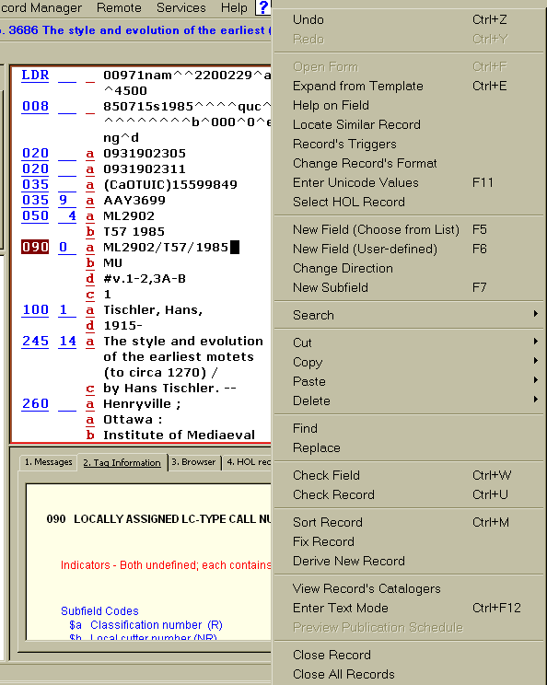

Undo: to undo any edits select EDIT /Undo
Redo: to redo any edits select EDIT /Redo

Fixed Fields

Open Forms
Fixed fields may only be edited through use of a Form. Select EDIT/Open Form from the Main Menu Toolbar . The form lists the positions or subfields and provides spaces for you to enter in the appropriate contents
.Forms exist for the Leader (LDR), 006, 007, and 008 fields. Aleph uses forms to facilitate editing these fields.

Help on Field
When you are positioned on a field or subfield, the 2. Tag Information tab in the lower pane provides guide to using the field. This tab gives a description of the currently highlighted field, along with information regarding the indicators, valid subfields, and a description of the subfields. It also specifies which fields and subfields are repeatable. An example for MARC 21 tag 245 is shown below with the obsolete fields, indicators, and subfields displaying in a different color:

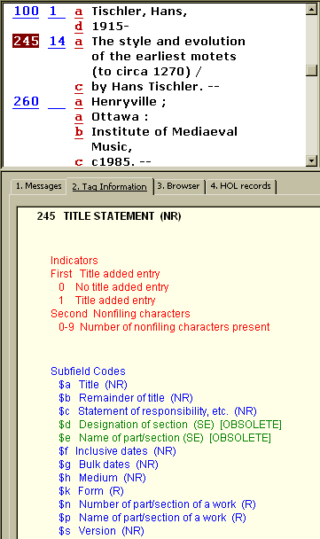

New Field (choose from list)
You can enter a new field below the current field by selecting a field from a standard library-defined list. To do this,select Edit/New Field (Choose from List) from the Edit Menu:

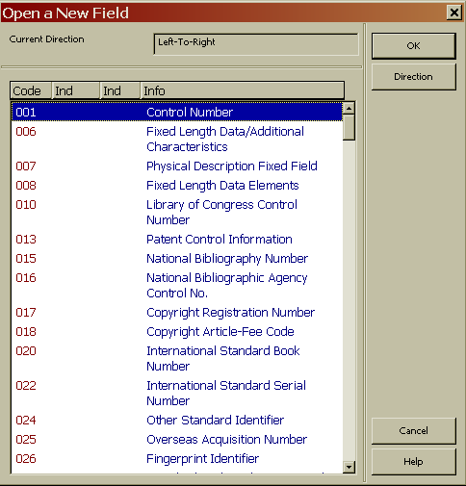

To add a new field, press the first character of the field code to jump to the relevant section of codes. Then highlight the desired field and click “OK”. If subfields have been defined, the tag and its subfields will display. If subfields have not been defined, by default only subfield "a" will display.

New Field (User-defined)
This function enables you to add a field whose tag, indicators and subfields you may choose. Select Edit/New Field (User-defined) from the Edit Menu, a blank field in the MARC record is created:

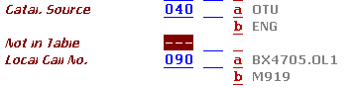

Change Direction
This option enables you to change the text direction of the current field.

Diacritics & Characters

ALEPH Keyboard
The ALEPH Keyboard is a utility that displays a virtual keyboard on your screen. It enables you to insert characters that are not present in your workstation's standard keyboard. According to the configuration settings, the ALEPH Keyboard can be divided into tabs, each one displaying a group of characters. Select Cataloging/Activate Keyboard from the Cataloging Main Menu Toolbar or click the Keyboard icon . The ALEPH Keyboard displays in the lower pane:
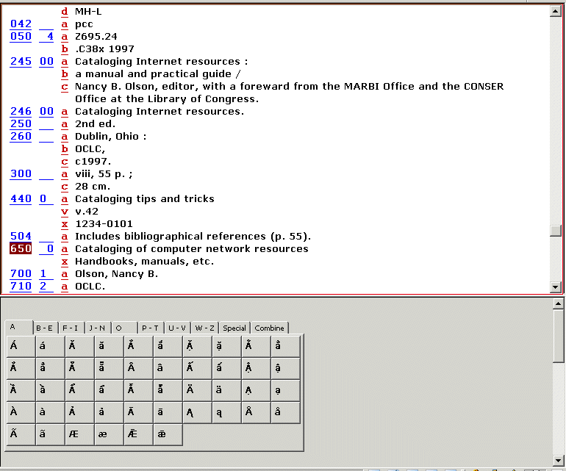

Locate the place where you want to place the diacritic or special character on your keyboard and click on the character from the keyboard. The character will type into your record.

Changing a Record's Format
This function changes the record's current format. The Change Record's Format window will also change the forms (for editing fields) and the checks that are performed on the record. Select Edit/Change Record’s Format from the Edit Menu and the Choose Record Format window displays:

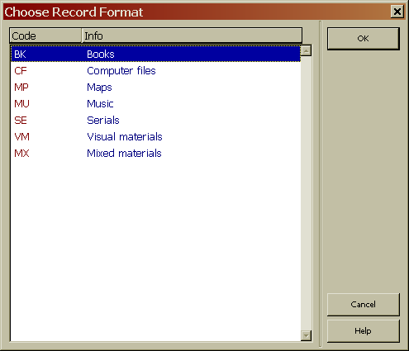

Select the new format for the current record from the list and click “OK”. The new format appears on the header.

Sort Record
Edit/Sort Record or [Ctrl M] sorts the fields of the current record according to the order defined in the ALEPH table of codes.

Fix Record
The Edit/Fix Record option automatically fixes the current record according to standard library-defined procedures (fix routines). Examples of fix_docs are shown below.

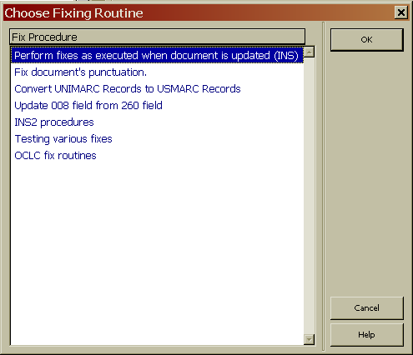

Additional Editing Tips

If you have the cursor anywhere on the record, right-clicking will bring up the Edit menu. Hitting Enter at any time rearranges or sorts the fields and subfields, and deletes any empty fields. Also note: if you are using a template, which has empty fields that you intend to fill in, you will lose them by hitting the Enter key.

Check Field and Check Record (Validation)
It is possible to have the system validate your records for MARC standards compliance and other errors. A base list of common problems is defined in the system. For manual validation, the two options under the Edit menu are:

Check Field [Ctrl + W]
Check Record [Ctrl + U]
The Check Record function can also be accessed by clicking on the “Check Record” icon on the Edit Menu (shown below):

The Check Record function checks the current record to ensure that:
- the indicators and/or subfield codes are valid for the tag
- required fields and subfields are present
- non-repeatable fields and subfields are not repeated
- all dependent fields are present
- values for fixed fields are valid

This function also checks:
- whether a new entry will be opened in the headings list
- whether a duplicate record will be opened in the Direct Request (Get) Index

For either Check Field or Check Record the system displays the potential problems in the 1. Messages tab of the lower pane. If no problems are found, the 1. Messages tab is left empty. The area identified as a problem in the bibliographic record will be highlighted by the system when you click on the specific problem in the 1. Messages tab:

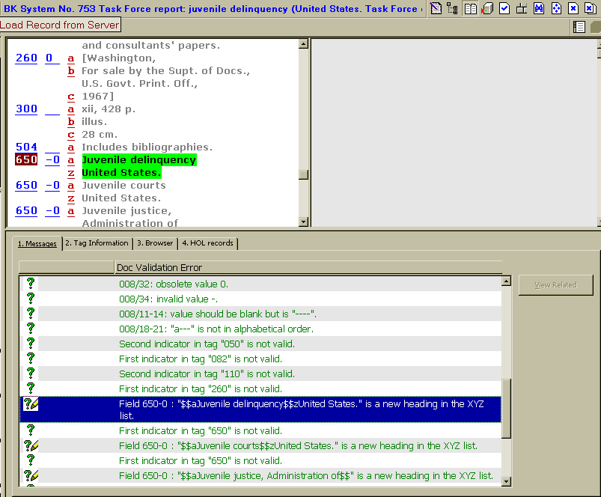

Record validation is also set up to work automatically when the record is saved to the server.

There are three levels of error messages:

1. Message can be overridden ( green question mark)
2. Message can be overridden and create a trigger record ( green question mark with pencil)
3. Message that blocks the record from being filed "Forbidden errors" (red exclamation mark)

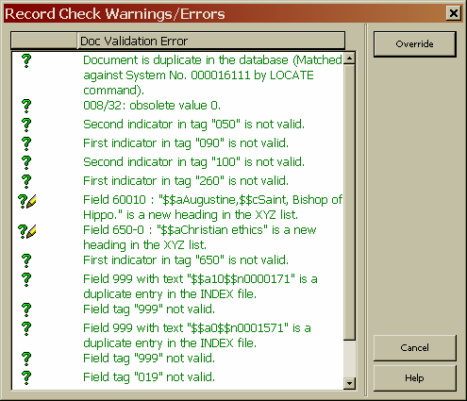

If you have permission you may override green error message, click on the "Overrride" button.
Errors with the red exclamation mark must be fixed in order to save the record.

Saving Records

There are three options for saving records

1. Save on local drive
2. Save all on local drive
3. Save on server and local drive

Save recorcd on Local Drive save the record on your PC's hard disk. Allows your to work on a record later and is not available to users. You may continue editing but no changes will be saved unless record is saved again.

Save All on Local Drive similar to Save on Local Drive except it saves every record that is currently open on your calaloging client

Save on Server and Local Drive updates the server database and assigns a system number to the new record also saves record to your local drive

Select CATALOGING/Save on Server and Local Drive from the Cataloging Main Menu Toolbar or click on the icon in the upper right toolbar.

You will be prompted to save the record. Click on the "Continue" button. Any error message will display.

