Serials in ALEPH - working with the information that migrated

Open the Acquisitions/Serials Client
Enter username and password

Stage one: Locating your title

Locate a serial using the Serials Bar, which is located at the top left portion of the Acquisitions/Serials Client.
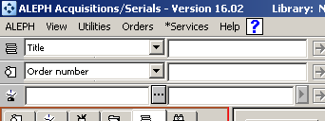
You must type in the exact title or issn using this search method. One of two things will happen: You may get a direct hit, in this case the title will automatically be pushed into the Serials Tab, or You may get a multiple list, where you will have to browse and select your title and then push title into the Serials Tab by selecting the Serials button in the button right corner of window.

Stage two: Does your subscription already exist or do you have to create one?

If your order was not linked to a bib record in the old system, (GEAC) then the title in Aleph will not have a subscription; in this case you will have to add a new subscription. For the most part all of the active/open serial titles that migrated should have a subscription attached.

Subscription exist scenario:

Select [L] Subscription List (1) from the Serials Tab in the navigation pane. The number 1 in brackets beside the words Subscription List represents the number of subscriptions for that title. (This will vary from title to title)

Select your subscription from the Subscription List tab in the upper pane. This will activate the four tabs in the lower pane.

Edit the following tabs:

Tab 2 Subscription Info.1 update the To Date to a date far off in the future (ex. 31/12/2099), select Update.

Tab 3 Subscription Info.2 update the claim intervals and select Yes in the Send claims box, select Update.

In Tab 4 HOL Links select the holdings record you would like to link your subscription to (This link is very important!) and click the Link button on the right side of the Hol Link tab. Once you press the Link button two things should happen: the Holding record you selected in the lower pane should have a red check mark in the Linked column and your subscription record in the upper pane should now display the corresponding holdings record number in the Hol no. column. (If the Hol. no. column does not display just hover the mouse over one of the column options right click and you will get a drop down menu; from the menu check off Hol no. This column will now display in the upper pane. With this action you have linked your subscription record to your holdings record.

Subscription create scenario:

With this scenario you will also be required to create a basic holdings record.

Creating a Subscription record can be done via the Order tab or the Serials Tab. This is a step you may want to decide at your own library. Creation at the time of ordering is beneficial because an acquisition person would know vendor codes etc. which is a mandatory field. On the same note creating via serials tab may be beneficial if it’s a gift etc.

Select [L] Subscription List (2) from the Serials Tab in the navigation pane. In the upper pane click the Subscription List tab, check to see if you have a subscription record. Click the Add button on the right side of the upper pane; this will activate the tabs in the lower pane.

Edit the following tabs:

Tab 2 Subscription Info.1 update mandatory fields: Sub Library; From Date; To Date (to a date far off in the future (ex. 31/12/2099); Item Status; and Vendor Code (Also, Delivery Type may be required if it is not copied from the vendor. Select Refresh. If any other fields for this tab are required you will be alerted with a bubble message, just fill in required information and hit Refresh again.

NOTE: The collection code is not mandatory but you will want to fill in.

Tab 3 Subscription Info.2 complete claim intervals and select Yes in the Send Claims box. Select Refresh.

Tab 4 Hol Links click Create New button. This will add a holdings record, which you may want to edit/add textual statement (See Doc. Creating an 866(Textual Holdings Statement))

Stage three: Adding, setting up, previewing and opening a set of predicted items

You will notice that our old patterns have migrated, but you will want to start fresh. At this stage you will add a pattern and set a prediction, preview and open pattern prediction creating items records.

Adding a pattern

Select [L] Subscription List → [P] Patterns from the Navigation pane
NOTE: You have to select [L] Subscription List to display values in Navigation pane

Click the Add button in the upper pane. Choose Pattern Document window will open. Select holdings (NOV60) record for your library. Click OK
NOTE: If you do not get the Choose Pattern Document window STOP there is a problem. Go back through your steps and make sure your subscription record is linked to your holdings record etc.
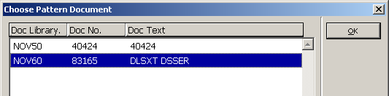
The window will disappear. This will activate tab 3. Patterns in the lower pane.

Click the Template button. This will open a window called Choose Pattern Template File.
Select pattern from upper pane of window. Click OK to close window.
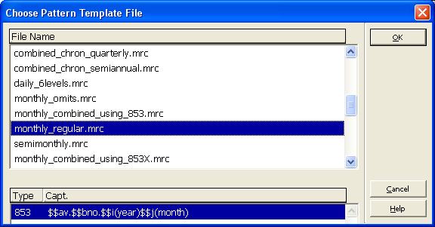
Fields in the lower pane tab 3. Patterns will populate according to the template you selected. Click the Add button. This will activate tab 1. Patterns in the upper pane; your new pattern (853 Tag) will be highlighted.
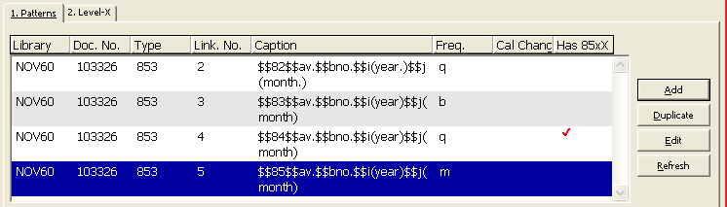

**NOTE: At this step note the Link No. of the pattern you just created. This information will be needed in the next step to link the 853 and 853x.**

Setting a prediction-853x Tag
Select tab 2. Level-X and click the Add button.
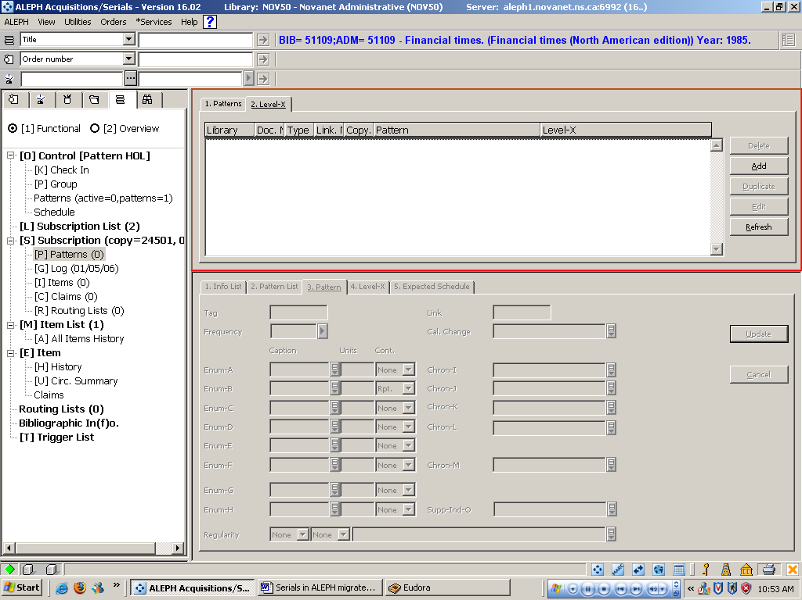
This will activate the lower pane, click the Template button.
Select corresponding pattern from upper pane of window.
Click OK to close window. Fields in the lower pane tab 4. Level-X will populate according to the pattern you selected.

Important fields to update on the 4.Level-X tab are:

Enum. and Chron. Fields – Enter publication information from the item you have in hand. NOTE: Start your prediction with the first issue in the volume or year etc. (Example: If 12 issues published per year you have to predict all 12 issues even if you only want to arrive (check in) last two issue of volume, then delete the item records for the first ten issues.)

Link field – This field will link your 853 to your 853x. Click the down arrow in the Link field and select the number that represents the 853 tag.

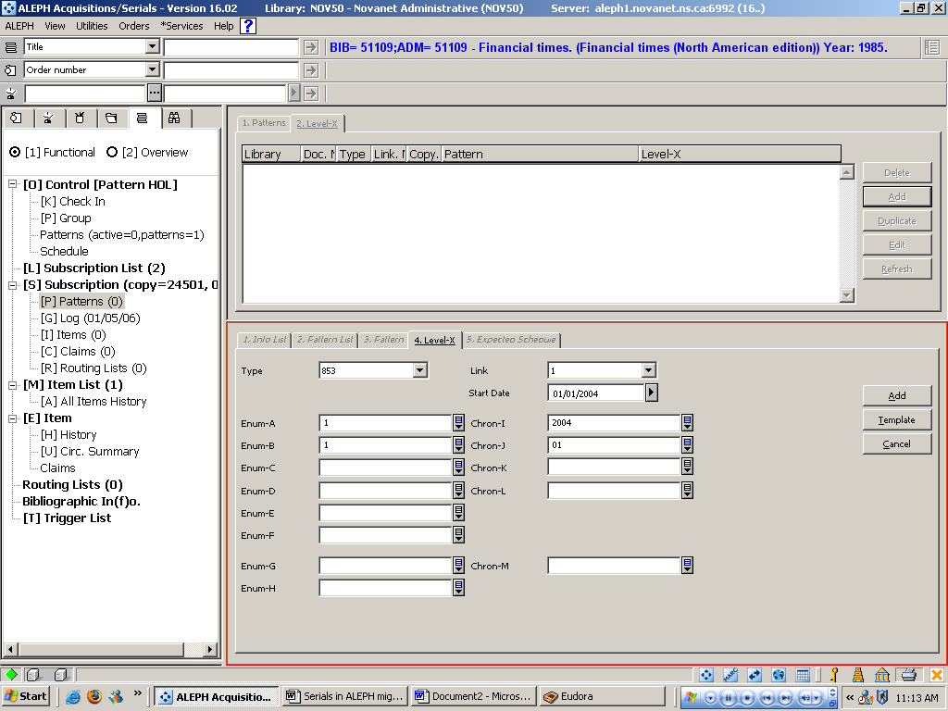
Start Date field - Enter here the publication date of the first issue in the cycle. This field is automatically updated for the next cycle after items were opened for the previous cycle.

Select Add button. This will activate 5. Expected Schedule tab.

Select Tab 5. Expected Schedule in the lower pane and check that the pattern is predicting correctly. If it does you can go ahead and click the Open Items button on tab 5. Expected Schedule . To view newly created items go to navigation pane click [K] Check in; [I] Items or [M] Items List. If it is not predicting what you want go back to tab 4.Level-X and edit your prediction. Click Update to save changes.

You are now ready to arrive issues.

