Standing Orders - Monographic series And Multivolume

Arriving and Invoicing on STO (collective title) order

- Find STO main title in Order Search
( Example used is a Monographic series AGU Geophysical monograph with the monograph title Circulation in the Gulf of Mexico but is the same for a volume of a Multivolume standing e.g. v. 31B of the complete works of Voltaire)

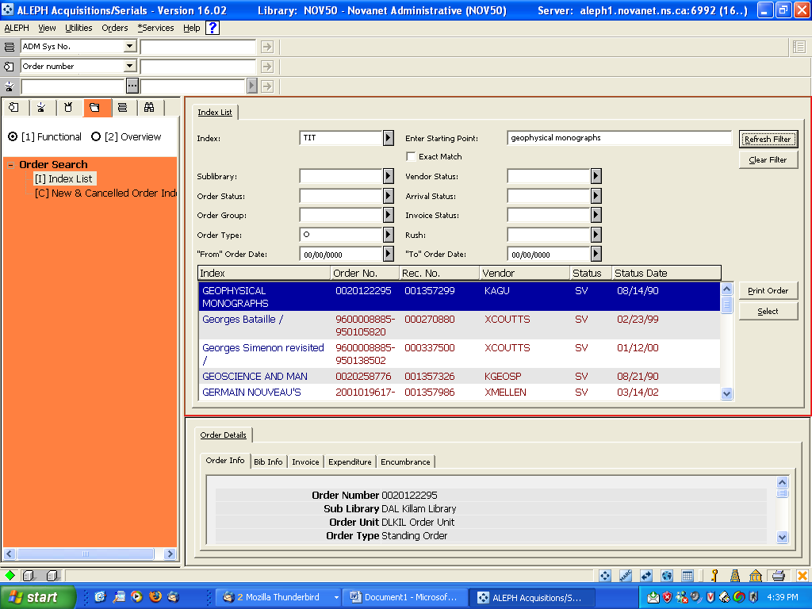

2) Select STO title to record Arrival and to pay invoice.
Make sure (at least initially that Invoice status is Partial (and stays that way) and that Arrival Status is Non Arrived

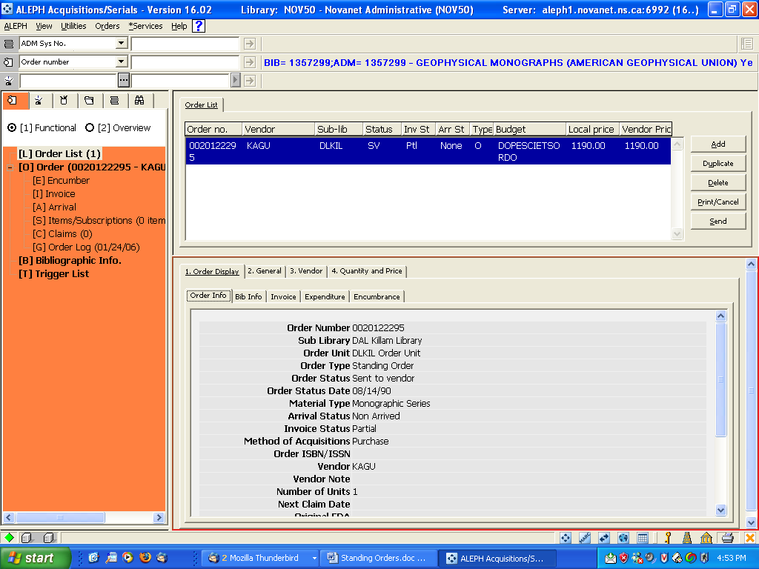
Arrive the volume of the STO by:
  - Click on Arrival
  - Click on Add

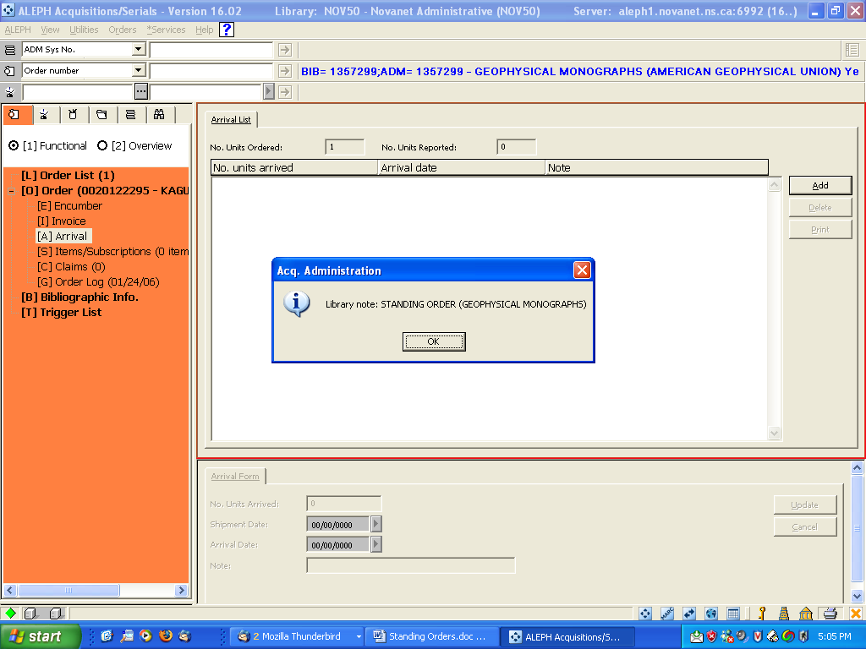

- Clicking OK on the note will open the Arrival Expand form.
a) In the Note Field. Put in the v. # : title of the volume rec’d (Useful but not system requirement )
b) For STO (Aleph Order Type O) Order completely arrived is disabled. Add appears in the Arrival Expand form –bottom pane
c) Click Add.
d) Print arrival slip if desired.

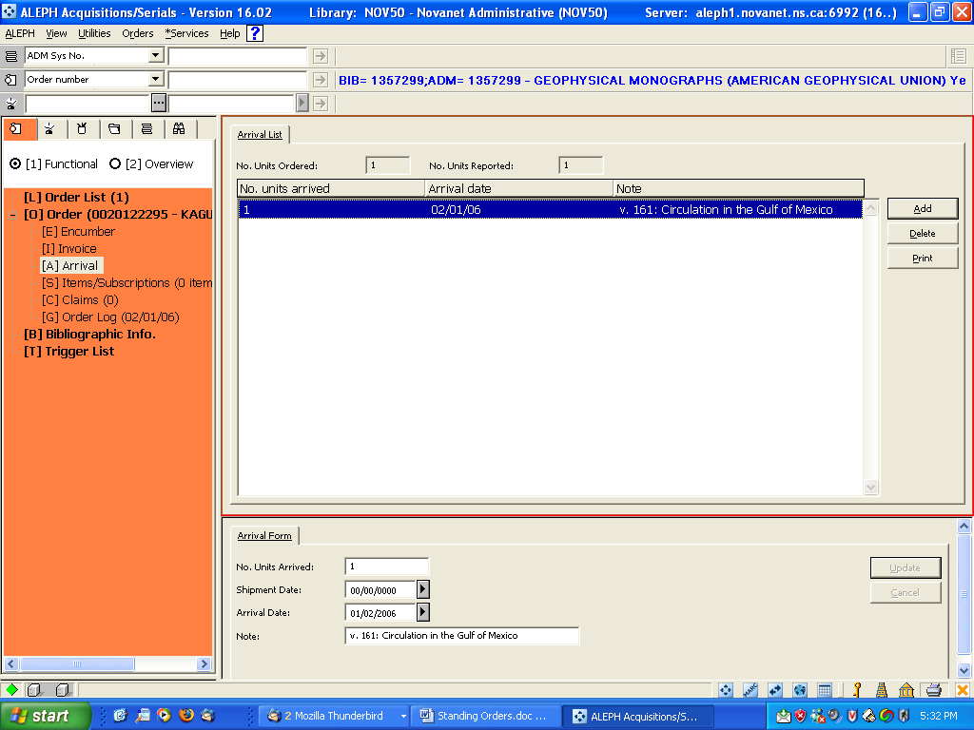

- Invoice for STO volume by:
a) Making a new Gen invoice and line for the arrival following library guidelines.
OR
b)For a one line invoice: (my example)
i)Click on Invoice and click New

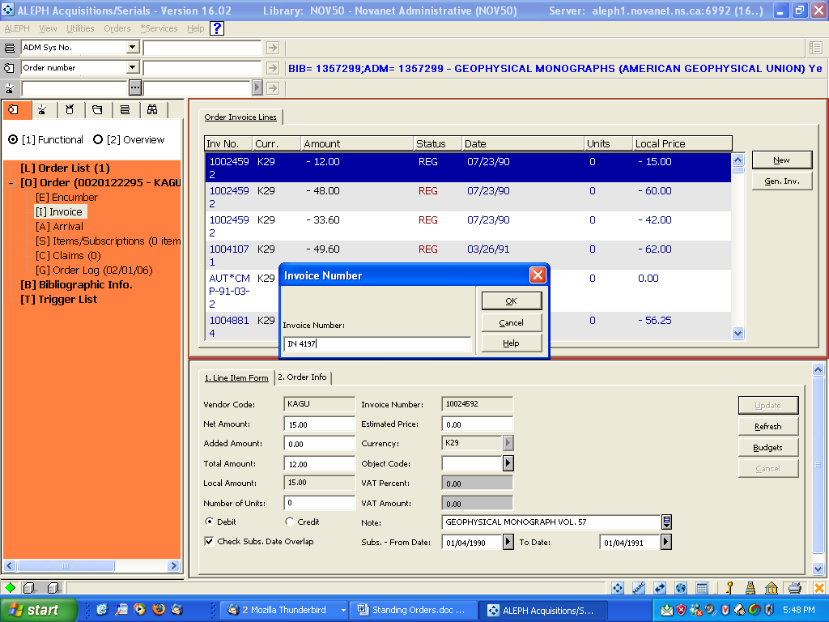

6) Add information as required/desired. Harvard suggests unclicking Check subs. Date overlap. At Killam- again the obsessive-compulsive, need to document everything, so that every one will know what you have done- staff member/librarian, insists that the STO main Title and the individual, separately catalogued title are entered in the invoice note. As well we enter the fiscal year as the subscription date for STO.

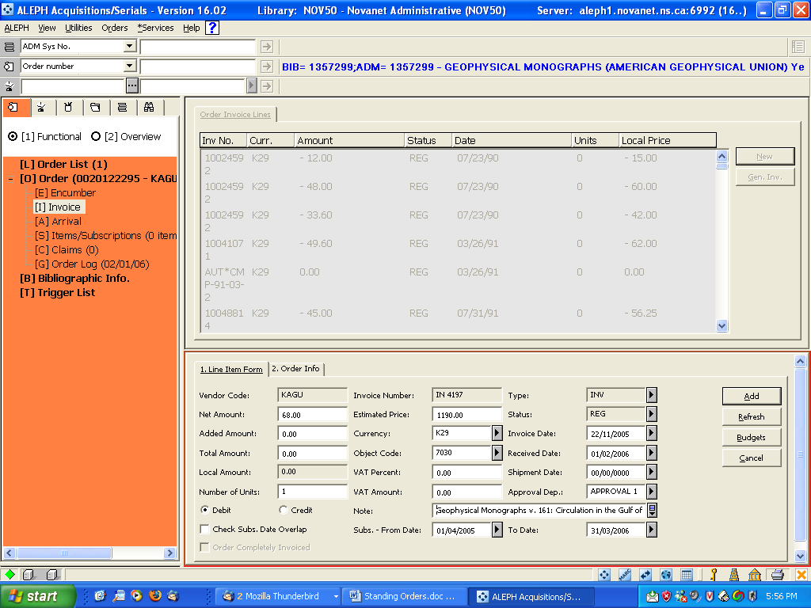

7) Click on Refresh to make sure that all required fields are filled in. Then click Add. As a note it is best to Add before you check on Budgets, Encumbrances etc. I found you have to start all over again at New if you don’t.
Find and highlight the invoice you have just Added. And click on Gen Inv in the upper pane

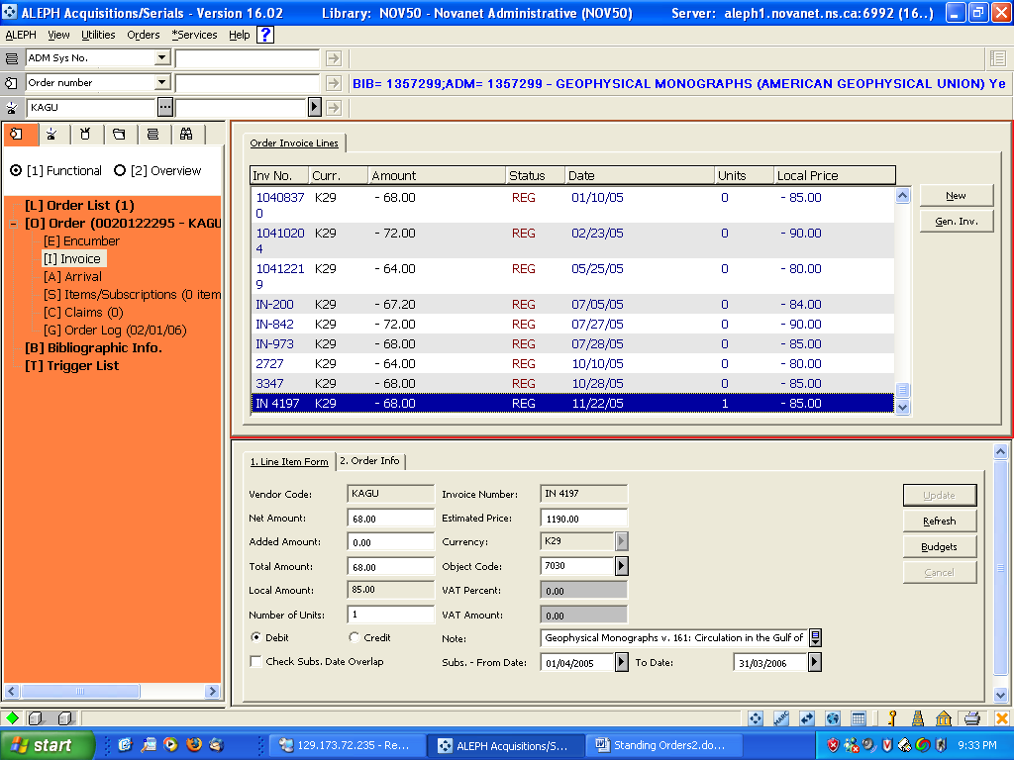

- In the Gen Inv. enter the information required/desired in both the Invoice and Payment Tab. When the Invoice status changes to P, the money will be disencumbered from the budget.

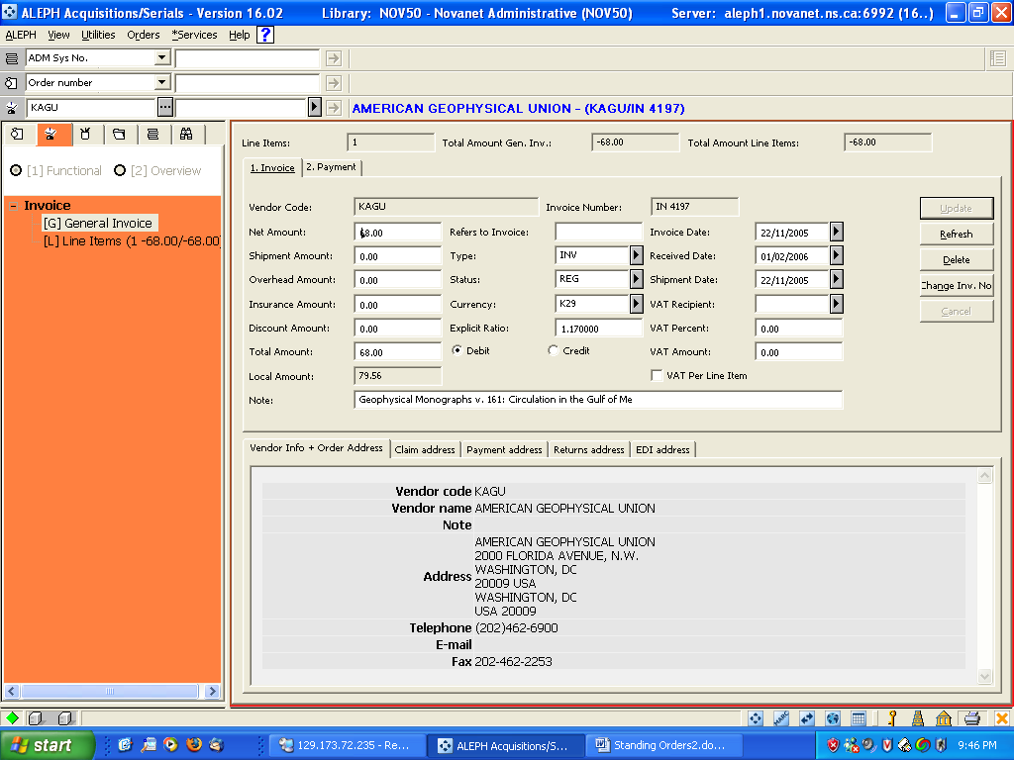

This completes the work needed on the collective title. The adding of the individual item depends on the type of Standing order ( whether Monographic series or Multivolume) and the type of information that you want and where you want it to display.

There are two ways of adding the individual title of a Monographic series.

- The item is created manually on the monograph title.

1) In the Cat Search search for and retrieve, bibliographical record for individual title.
2) Push to Items and New (or Cataloguing if you want to add Hol at this point)
3) On Tab 2 add Barcode, Sublibrary, Collection, Material Type, Item Status, Item Processing status
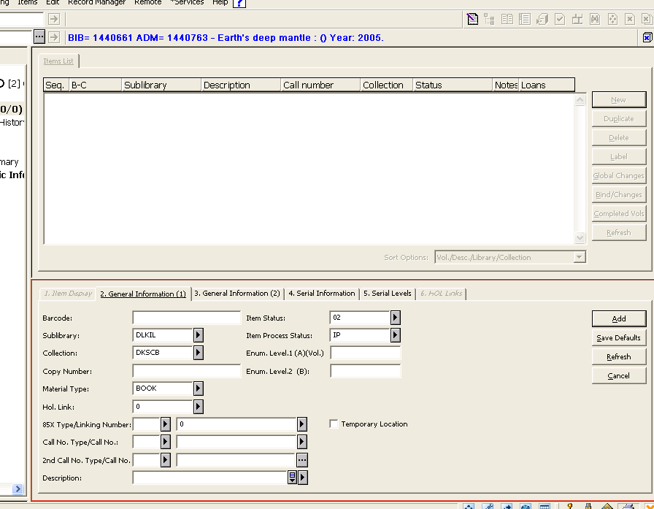

4) On Tab 3 add
Order number type in STO ON or click on List Box … to select
Invoice key click on List Box … to select Invoice key will bring in Invoice note
Type in any additional information
Add

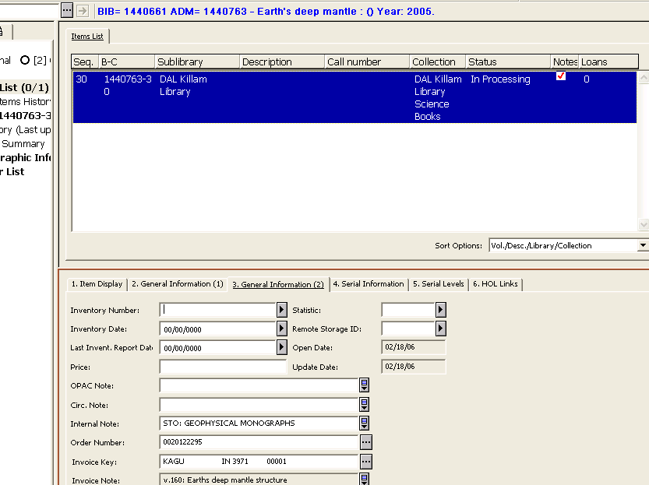

The main disadvantage of this method is that the individual title cannot be found in the ACQ/Serials by title but only through the STO title in arrival notes or invoice notes.
This is solved by the second method.

b) Ordering and Arriving the individual title of a Monographic Series

- In the Acq/Serial or Cat Search search for and retrieve, bibliographical record for individual title.
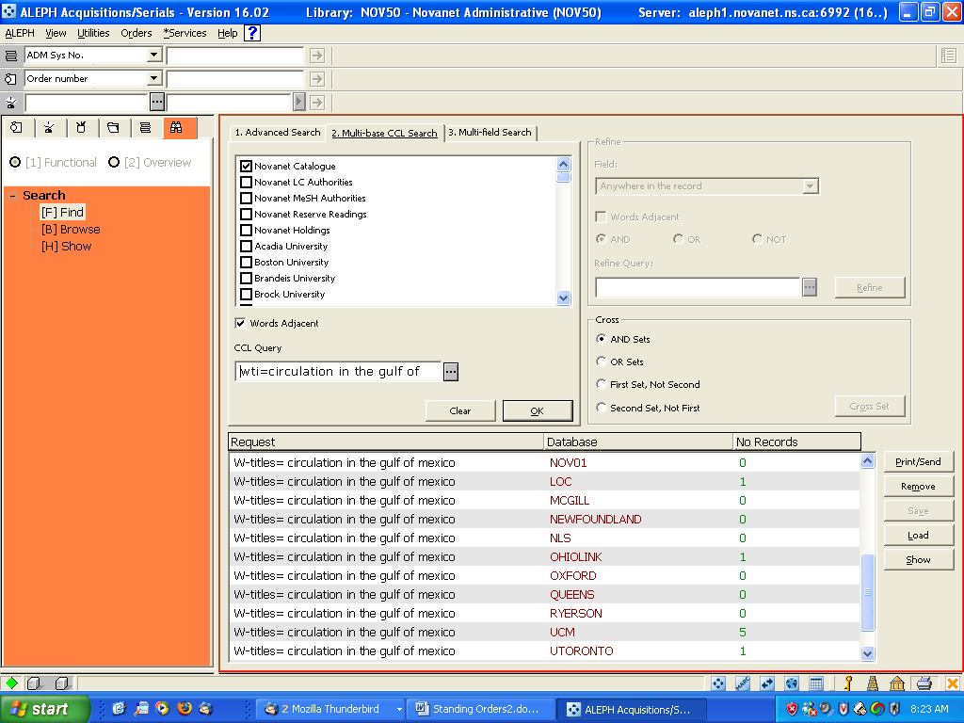

2) When saved in Novanet:
Push record to Acq (orders)
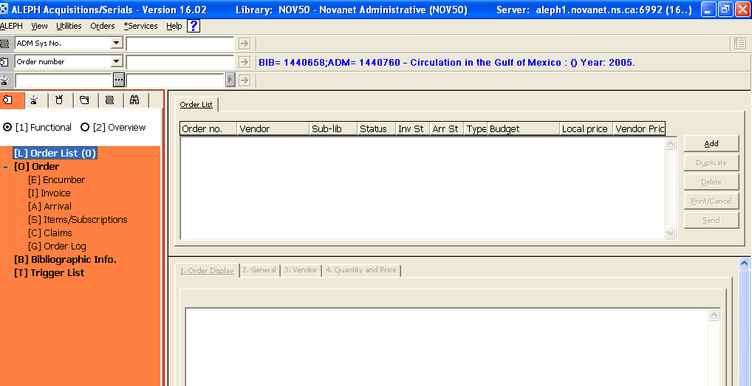

- Click Add and choose Order type: Monograph
Then OK
In Tab 2:
Order no. 2 = STO PO number
Order status = SV (to prevent an order being send)
Acquisition Method =CW or PF (so that list price can be $0.00)
Other defaults to be filled in
Library note: Whatever information you think you need.

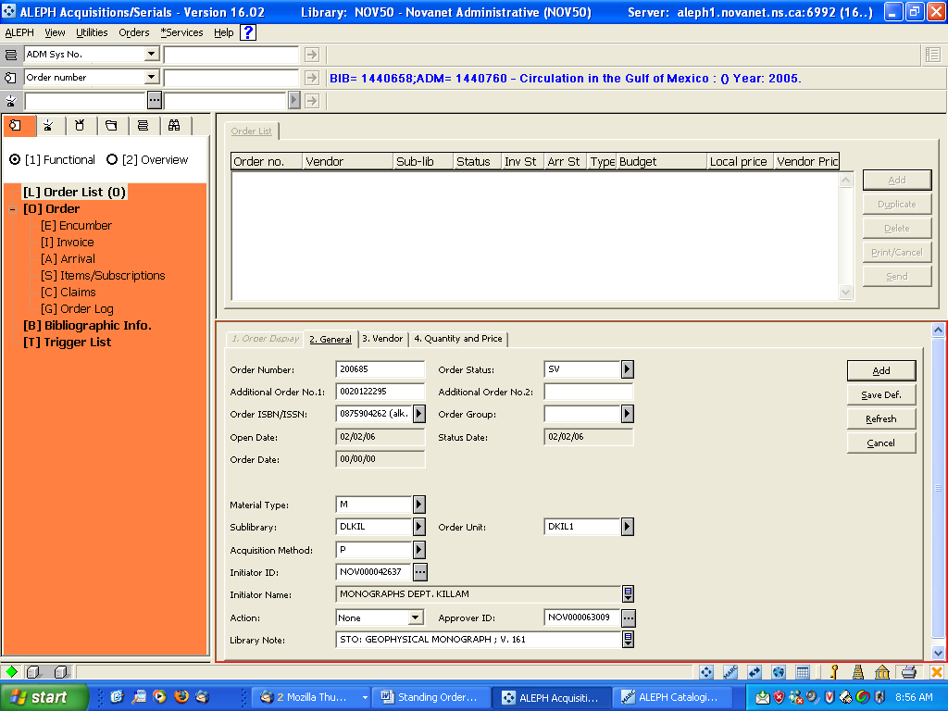

In Tab 3: Fill in Vendor Code
(if you select the Vendor code using the … all the information connected with the vendor record will fill in)

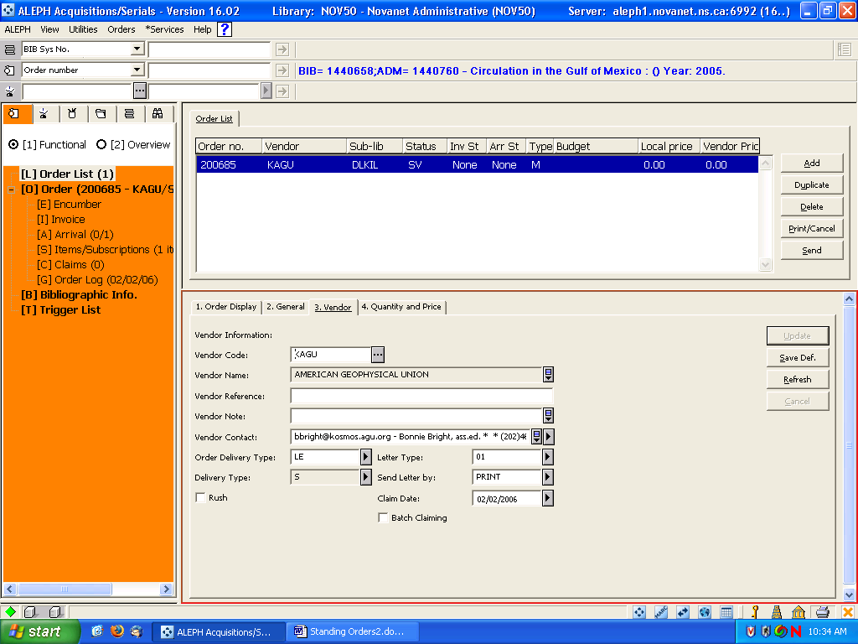

In Tab 4 fill in
Number of units = 1
Unit price, list price =0
Create items record = (checked)
Add = creation of monograph order record with item created in Cataloguing

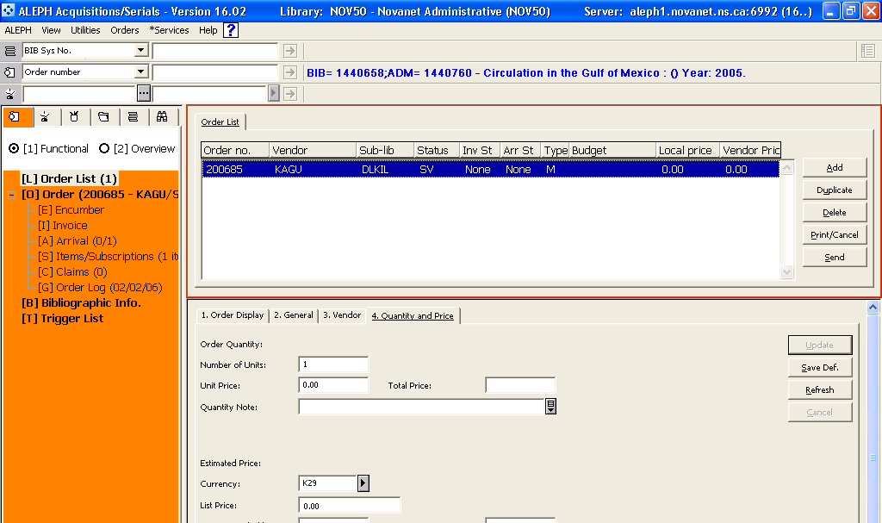
- Arrive title as usual
Note: Order completely arrived = (checked)

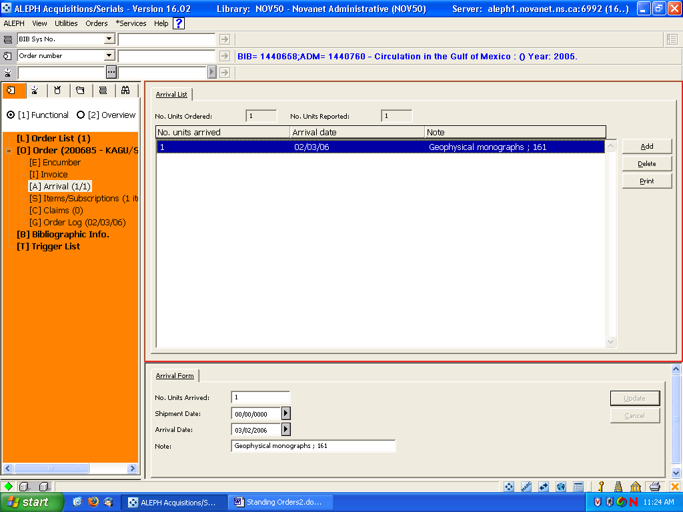

- The item has been created and after arrival has a status of In Processing.
- The order information is
Order Number | 200685
Sub Library | DAL Killam Library
Order Unit | DLKIL Order Unit
Order Type | Monograph
Order Status | Sent to vendor
Order Status Date | 02/02/06
Material Type | Monograph
Arrival Status | Complete
Invoice Status | Non Invoiced
Method of Acquisitions | Comes With
Order ISBN/ISSN | 0875904262 (alk. pap
Vendor | KAGU
Vendor Note
Number of Units | 1
Next Claim Date | 02/02/06
Original EDA | 02/02/06
Quantity Note
Listed Price | 0.00
Estimated Price | 0.00 DLKIL United States Dollars
Estimated Local Price | 0.00
Price Note
Invoice Total Price | 0.00
Invoice Local Price | 0.00
Library Note | STO: GEOPHYSICAL MONOGRAPH ; V. 161
I would recommend changing the status to CLS to stop it appearing on open order reports.

6) You can click on the [S] Items/Subscription to update the item with any notes you may want.
(I got the correct invoice and invoice note into the invoice key by:
In Order number first select the STO ON
Then Select the correct invoice in invoice key
Then in Order number (re)select initial order number)

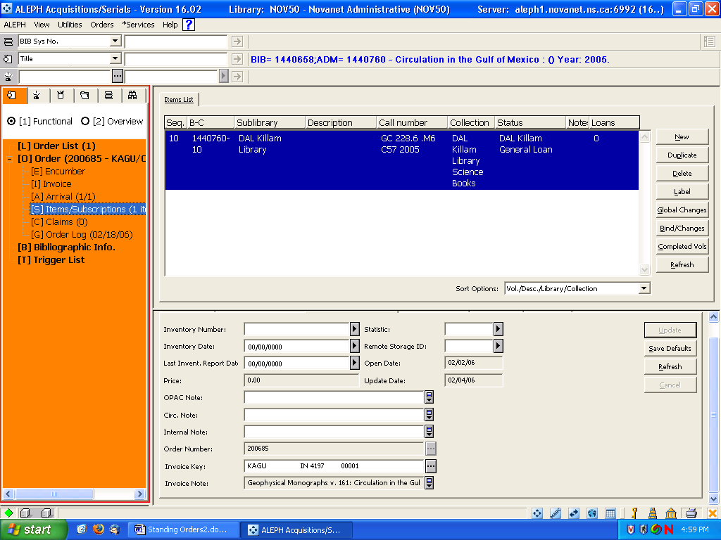
Standing orders - Multivolume

Using orders/records transferred from Geac there will be a holdings record available but if you had only used the Geac system generated holdings (which did not transfer to Aleph) you will need to add an Summary holdings -866. If you had in Geac used a “clickable” Serial copy set, it should have transferred to Aleph as an 866/863.

A) Retrieval and Invoicing of Multivolume Orders
- In Acq/Serials retrieve MV order
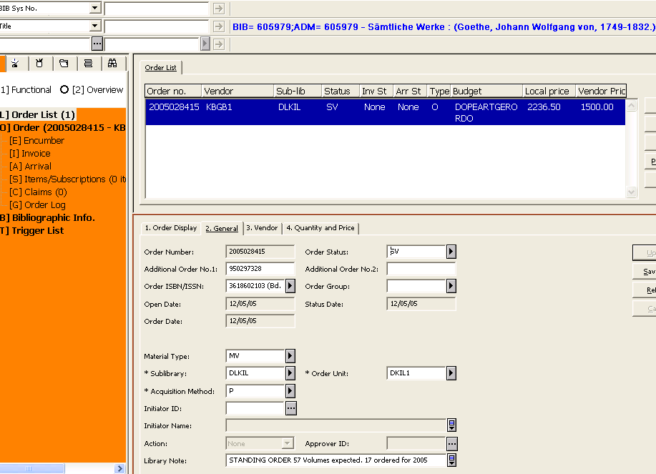
2)Click on Arrival; then Add
3)Click OK on any Library notes that display. In the Arrival Form note field add the volume information. Click Add. Repeat for any other volumes received at the same time.
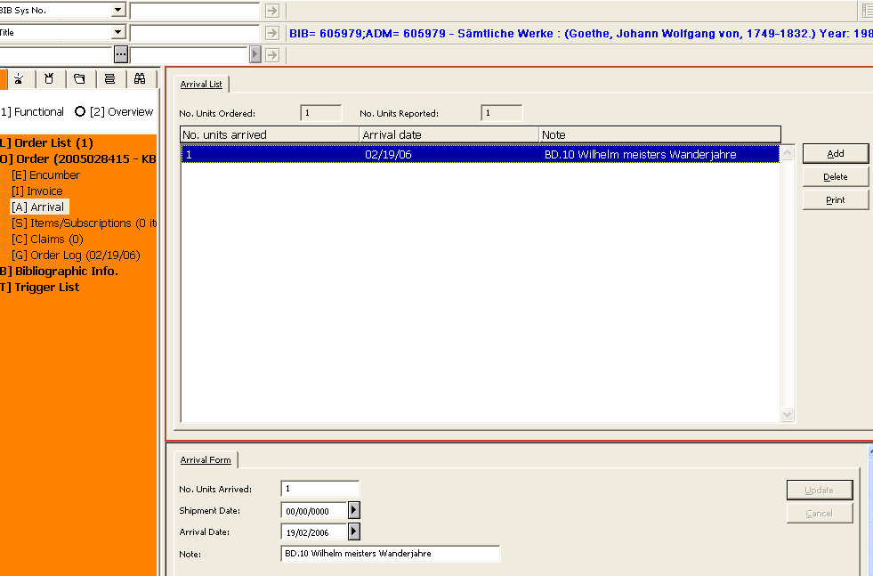

4) Print Arrival slip (if used)
5) You may want to update your order to reflect arrivals and delivery/claim dates.
6) Invoice as usual noting volume/title information in the invoice line note. (Or you may want to move immediately to creating an item) 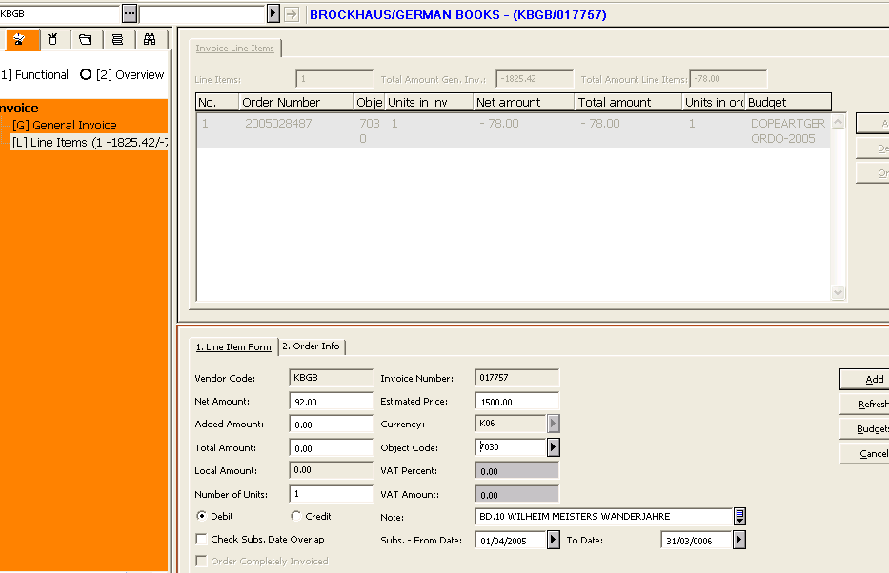
B) Creation of Item Record

(This can also be used to create items for a multivolume monograph order)

- Click on Items/Subscription
- Click on New
- Fill in information in Tab 2 and Tab 3
Note: The holdings link will fill in some fields when Refresh clicked
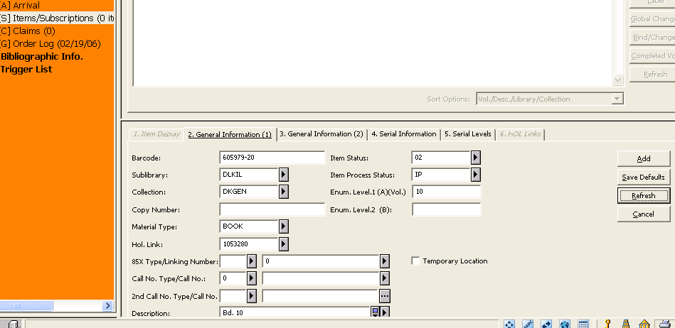
Tab 3
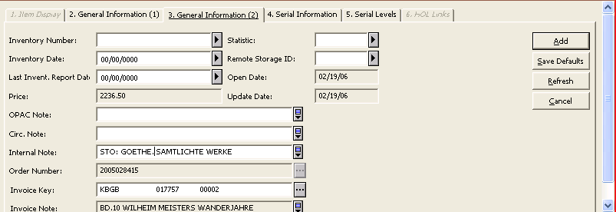
- Click on Add.
- Update the HOL Links (Tab 6)
Highlight your linked holding
Click Edit.

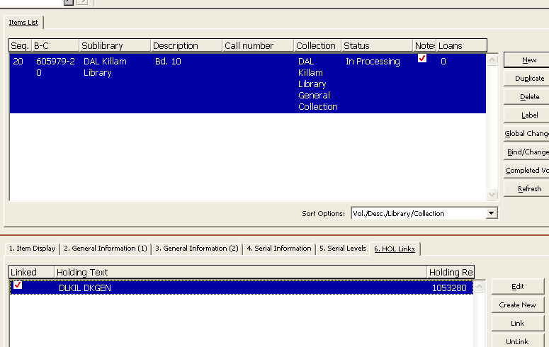

Update holdings record fields 008 (06 from 3 to 4, only at initial receipt) and 852 (if necessary) and 866 to reflect current holdings. (Holding records from Geac will have 863 and 853 tags and information. I believe we do not have to continue updating for new volumes. I think these are the agreed indicators etc)

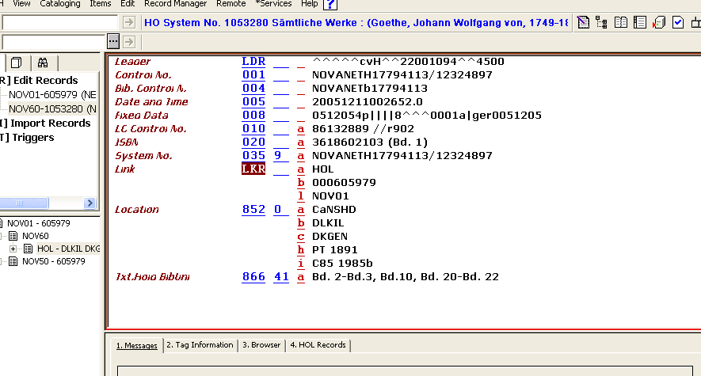
When adding the second ( and third and fourth etc.) arrival/item it is easiest to duplicate the previous item and just change the information as needed.

Repeat until order complete

