Workflow:
Loading a Record from LoC Voyager

- Click the Search Tab
- Select Advanced Search Tab and Base: LoC Voyager
- Enter search criteria and click ok

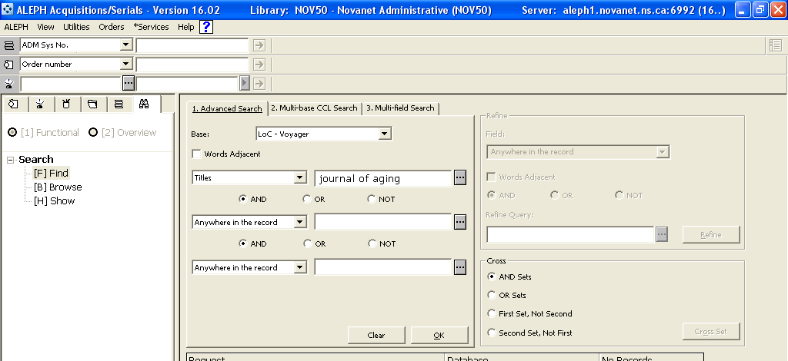

- Click on Show button and all titles are listed in upper pane. Highlighted title information displays in the lower pane.

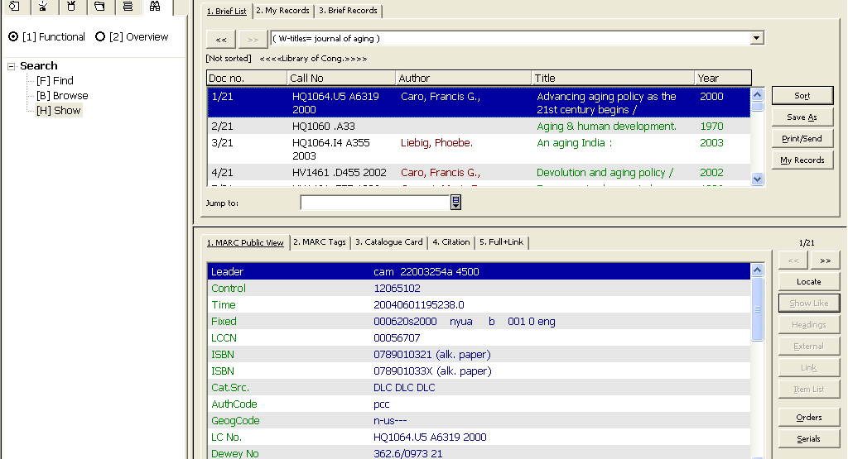

- Highlight your title in the list. And click on the Overview radio button.

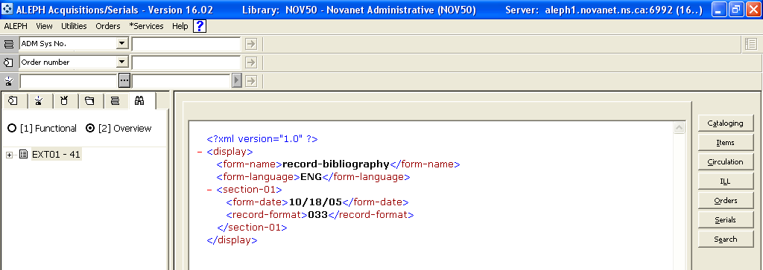

- Click on the Cataloging Button to take this record to the cataloging module.

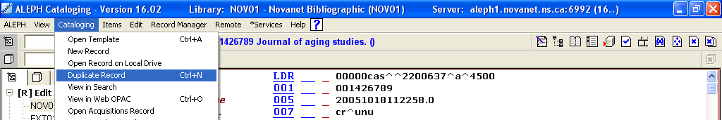

- Select Cataloging from the menu bar, then duplicate record (Ctrl+N)

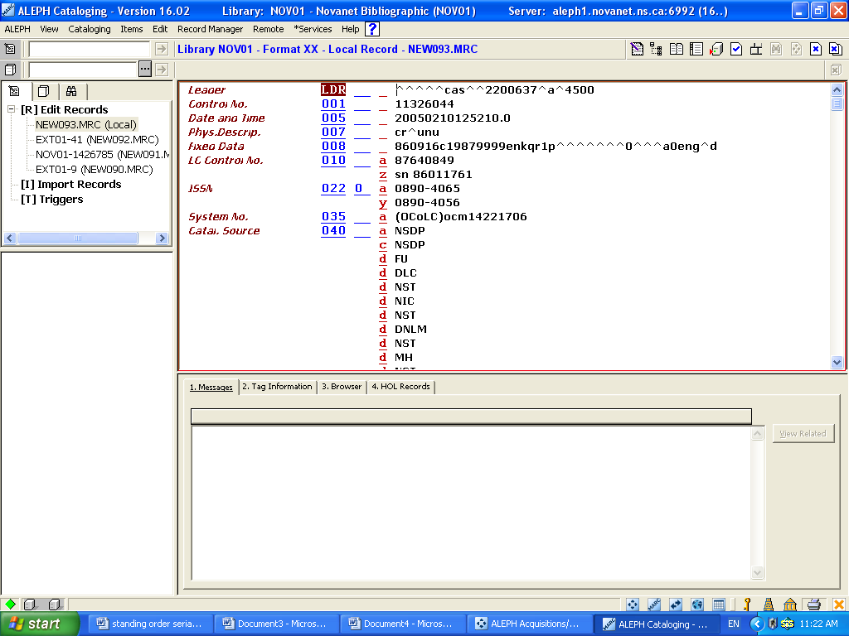

Notice that in the navigation pane there are now a NEW and EXT01. The EXT is from LoC and the NEW is the copy we just created.

- Click on the save to server icon . For this training session, override the errors. Now you will see that a NOV01 record, this is the one we just saved to the server and to our database.

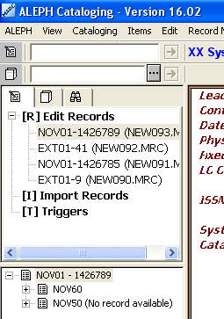

- Highlight the NOV01 record then click on the blue ACQ/SER icon in the upper right hand corner to take this record to ACQ place an order.



