Acquisitions 6.0

- Getting Started

  - Click on AdvAcq Desktop Icon , or: Click on “Start” button; Click on “Programs”; Click on “Advance Clients”; Click on “AdvAcq”.
  - In “Advance User Login” box, type your ADVANCE Username and your ADVANCE user password. (Check with System Administrator if you are not sure of these passwords. Note: these are not your unix login and passwords). See Figure 1.
  - Click on Login (or press Alt + o) to continue with logging in to Acquisitions.

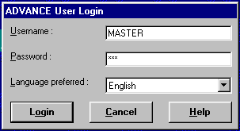
Figure 1

- Acquisitions Client

Acquisitions defaults to the “Orders” Task Group and the “Ordering Data” Task screen. From this screen you may change to any of the other Tasks within the “Orders” Task Group, or, you may select another Task Group by Clicking on the Task Group or by pressing the Ctrl Key + Shift + the Task Group Number. See Figure 2.

From Acquisitions, users can:

Create Orders or Requests
- Pre-order search for bibliographic information in the Main Database, in the Main Workfile, in an Approvals file and/or in the Acquisitions Order file.
- Use GeoPac to Search an external database, such as OCLC to retrieve a bibliographic record. The record can then be “Pushed” to an Acquisitions Workfile.
- Retrieve a record from the Acquisitions Workfile
- Create a New record, i.e. input the bibliographic data to create an order

Add or Edit Ordering Information

- Enter Selectors, Requestors, assign Vendors …
- Enter unit costs, discounts, notes
- Order for specific locations, specific funds, different number of copies for different locations …
- “Cut” an order so that the order can be received immediately, or “Authorize” an order for Order Generation
- When an order is “Cut”, the system will immediately assign a Purchase Order.
- When an order is “Authorized”, the Order Generation Job will assign the Purchase Order Number. The Order Generation Job also encumbers money, set order condition to OPEN, assigns estimated delivery date and marks order for printing.

Transfer to Catalog

- If the Transfer to Catalog flag is set to Yes, as soon as the Order is “Cut”, the bibliographic and copies ordered information will be viewable in OPAC with status of “On Order”
- When the item is “Received”, the OPAC status will be changed to “In Process” (or some other term).

Receive, Return, Claim

- Receive complete or partial orders; you can assign barcodes at receiving, invoice at time of receiving
- Return damaged copies – if items are barcoded, identify the item being returned and OPAC will be updated to show the change in status
- Create claims for copies not received.

Invoicing and Voucher Generation

- Invoices can be created at the time of receipt
- Invoices can be created by entering Header Information and other elements of the invoice; each line item can be added to the invoice
- Validate invoice amounts and Authorize for Payment
- Offline Voucher Job creates the Voucher and “pays” the Voucher, disencumbers the money …

Add and Update Vendors
- Create new vendors or edit existing vendor records
- View vendor statistics
- View Deposit Account balances

Fund and Journals

- View fund accounts, but not update with client
- View journal accounts, but not update with client
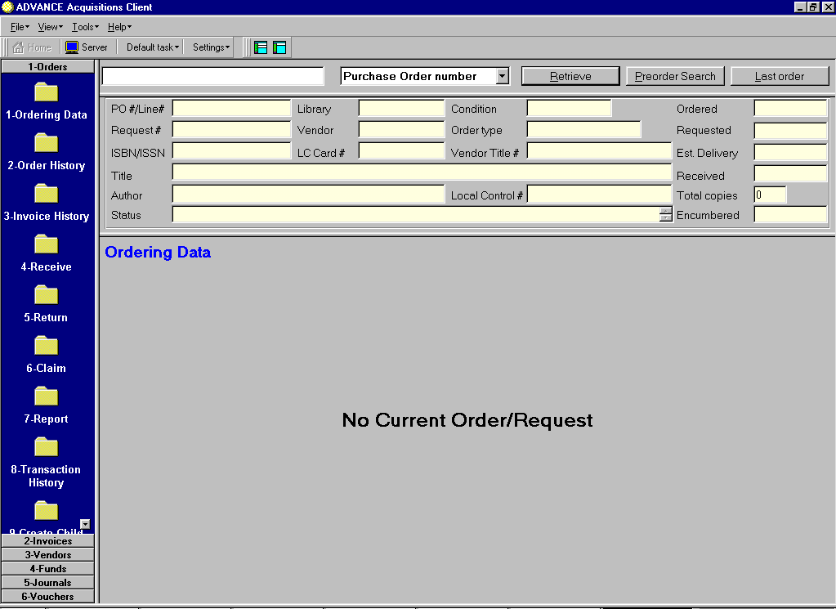
Figure 2

- Acquisitions Setup

3.1 Select “File” from Tool Bar. See Figure 3.
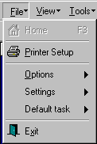
Figure 3

    - Select “Printer Setup” to select the Default Printer Type and Font.

    - Select “Options” to set default colors.

    - Select “Settings” to allow edit access to Acquisitions functions, etc. See Figure 4. Select “Set Default Indicators” to preset default indicators for MARC record when entering the bib info manually. See Figure 5. “Edit mode” is a toggle button to allow or disallow editing for Orders, Invoices, etc.
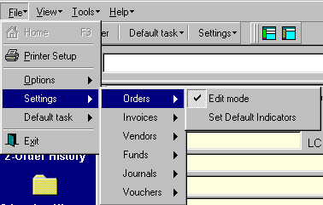
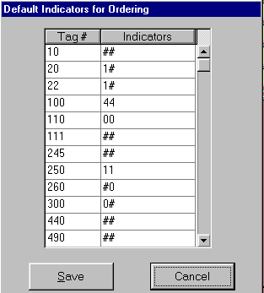
Figure 4
Figure 5

    - Select “Default Task” to set a Default Task screen for this session.

  - View
See Figure 6. Select “Size Heading Panel” to Minimize or Maximize the Work Area. Select “Toolbars” to determine whether to display the Main Toolbar; the Size Heading Toolbar; both Toolbars or neither.

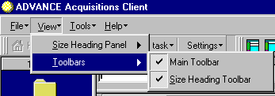
Figure 6

  - When “Tools” is selected, you are able to select Telnet to launch a telnet session to the Local Server.

- Acquisitions Functions

  - Display an existing Order
“Ordering Data” screen defaults to search the local order file. You can search by P.O. Number, Request Number, Author, Title, etc.
Enter a Purchase Order Number in the Search Entry Pane and
Select “Purchase Order Number” from the dropdown list.
Select “Retrieve” to initiate the search.

This launches a “scan” search of the order file. See Figure 7.

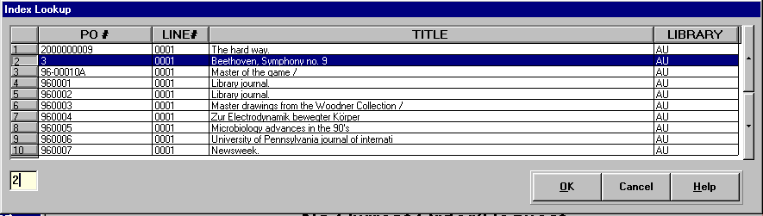
Figure 7

Highlight an entry and click OK, or, double-click an entry to select. Review fields in the order record.

4.2 Create an Order

Orders can be created by retrieving bibliographic data from the Local Database, the Local Workfile, an Approvals file or from the existing order file.

GeoPac can be used to search an external database, such as OCLC, to obtain a bibliographic record. After a record is located, it can be “pushed” to an Acquisitions Workfile for later retrieval via Acquisitions PreOrder Searching.

Orders may also be created as “New”, i.e. the operator inputs the bibliographic information as well as the ordering information.

    - Pre-Order Search

Click on “Preorder Search” to launch a z39.50 search.
From the “Database” dropdown window, select MAIN*BIBMAST to search the local database.
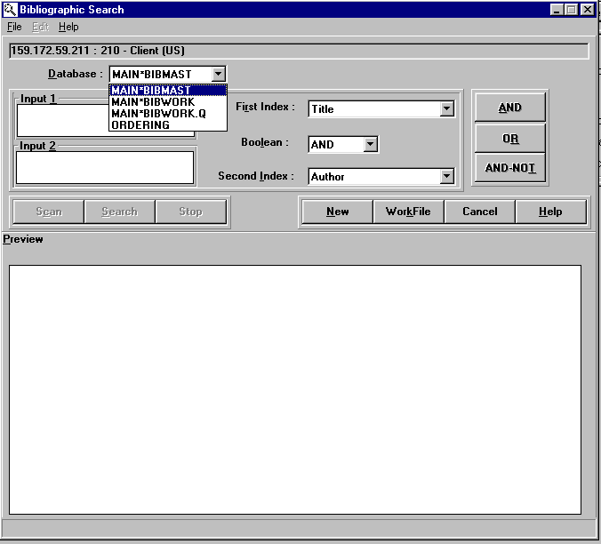
See Figure 8.

Figure 8
In the “Input 1” box, enter a search key. From the “First Index” dropdown window, select the search type. Press ALT c or Click “Scan”.
If a bibliographic record match is not found, Select “WorkFile” by pressing ALT K or Click on the WorkFile button to search the Acquisitions workfile. See Figure 9.

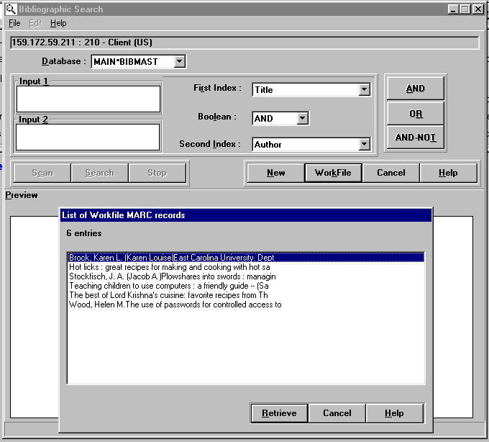
Figure 9

Double-click on a title or Press ALT R to Retrieve the record into Acquisitions. See Figure 10.
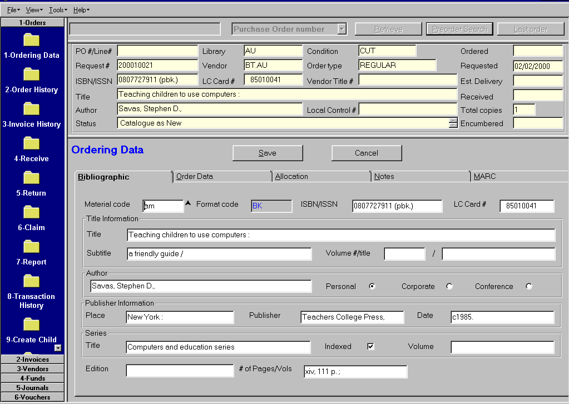
Figure 10

Review the information that is pulled into the order workform, from the bibliographic record or from the user profile.

    - Create Order

Bibliographic Tab

- Remove the number of pages
- Remove the LC Card #
- Change the “date” to 2000
- Select “Order Data” by pressing ALT + O.
- See Figure 11.
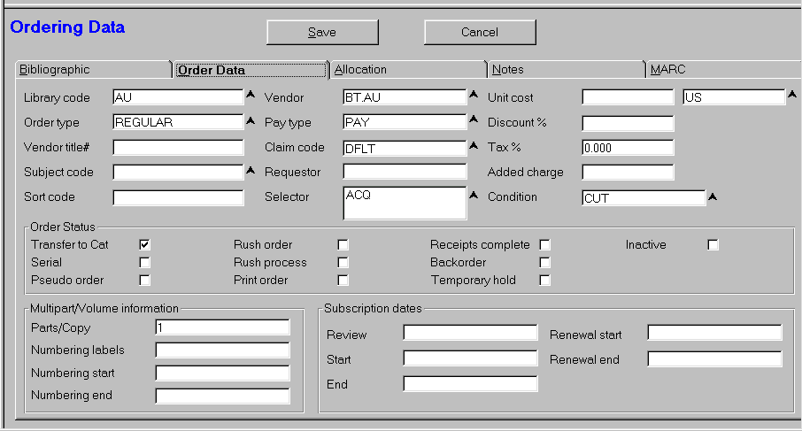

Figure 11

Order Data Tab

- Change any of the Default Data
- Place focus in a window with ^ character and press F8 to display a list of codes. You can then select from the list
- Enter Unit Cost
- Enter Discount
- Review “Order Status” section

- Select “Allocation Tab” by pressing ALT A. See Figure 12.

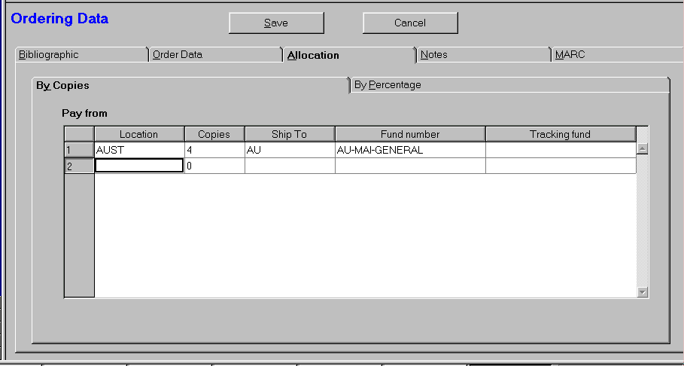
Figure 12

Allocation Tab

- Go to Location and Enter Location for the Order; Press F8 for a list of Location Codes; Press Enter to accept default.
- Enter number of copies and press Enter
- Enter “Ship to” code or Press F8 for a list of codes.
- Enter “Fund number” or press F8 for a list of codes.
- Optional:
Press Enter or Tab to add another location
Press ALT N to go to the “Notes Tab”. See Figure 13.

Notes Tab

- Add notes to any of the windows. These are free-text fields.
- Select the “MARC” tab to go to the MARC Record. See Figure 14.

MARC Tab

- Press ALT E to select “Edit Marc”
- “Edit MARC” will launch GeoCat so that user can edit the MARC record
- Use GeoCat edit functions to modify the record
- Select “File” and “Push Back to Client” to return to Acquisitions.
- See Figure 15.

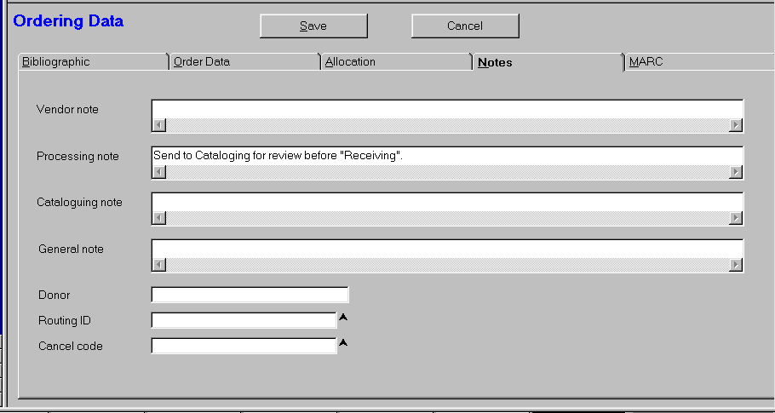
Figure 13

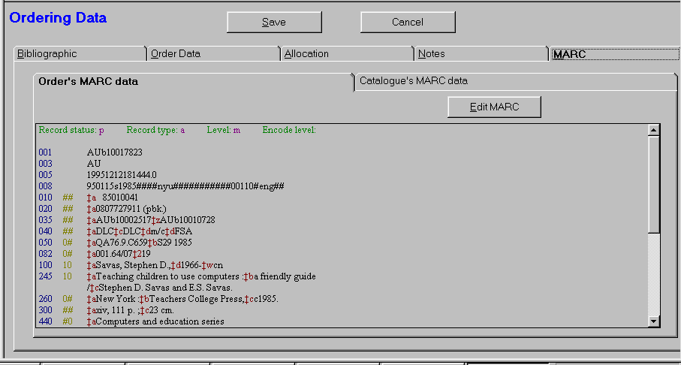
Figure 14

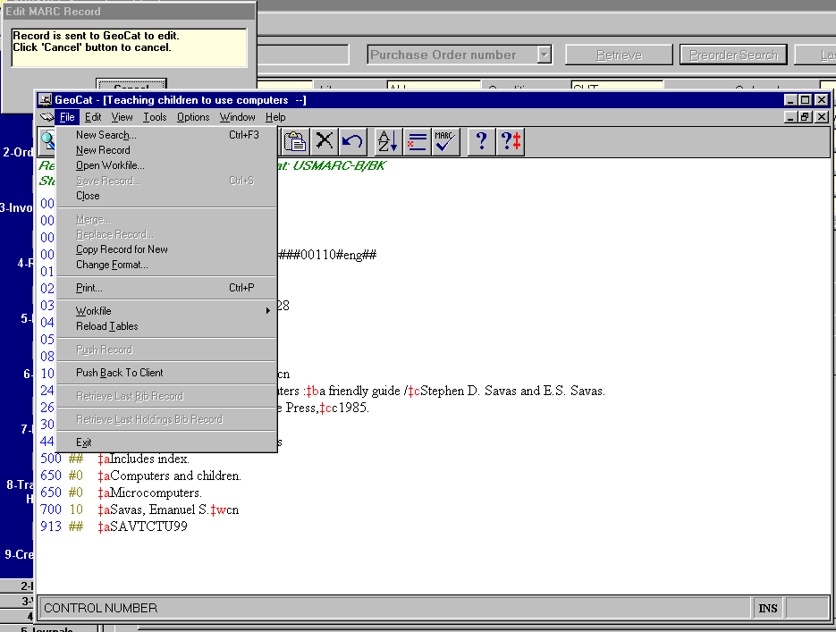
Figure 15

Save Record

- Press ALT S to Save the Order. See Figure 16.
- System verifies ISBN is unique. Press ALT Y to continue; otherwise, Press ALT N to return to the record to remove or correct the ISBN; Then again, Press ALT S to Save.

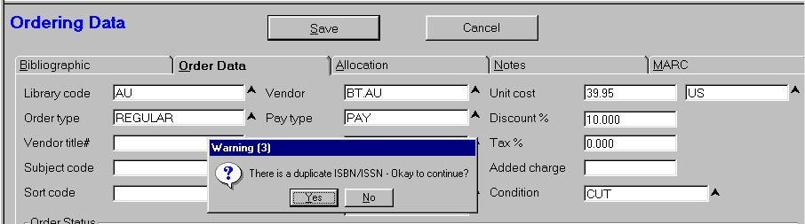
Figure 16

- System will prompt for input of PO number. See Figure 17. You can type in a Purchase Order # and press ALT S to Save or, you can press ALT S without entering a Purchase Order # and the system will assign a Purchase Order Number.

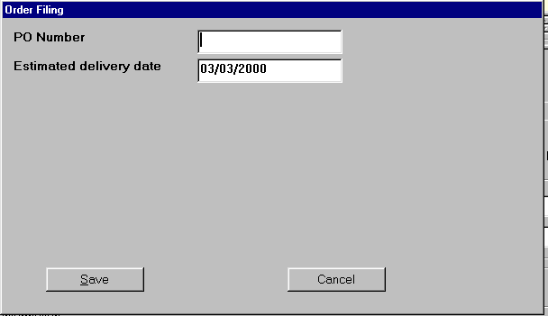
Figure 17

- Review the screen, in particular:
- Purchase Order / Line # has been assigned
- Check the Status Line
- Check Total copies and amount encumbered, etc.
- Click on “Cancel” to return focus to Search Entry Window
- See Figure 18.
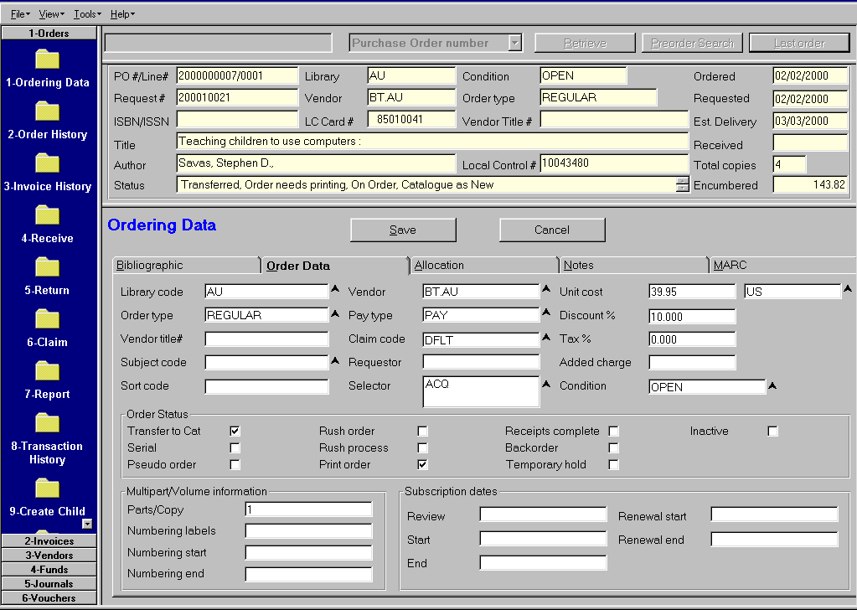
Figure 18

    - Receiving

- Select “Orders” Task Group
- Select “Receive” Task – CTRL + 4
- Enter ISBN (or other search string) and Select Search Type from the Dropdown list
- Select “Retrieve” – Press ALT R
- See Figure 19.
- Verify that you have retrieved the correct record
- Note the information about “Status”
- Note that record is flagged to “Invoice on Receipt”
- Note the processing note on this screen.

- In lower portion of screen, enter the “Qty Receiving”

- Go to the “Barcode field” and Press F2 to display the “Assigning Barcode” Screen.
- Scan or Key in the Item Barcode attached to each copy if you assign barcodes at time of receipt.
- Press ALT S to Save

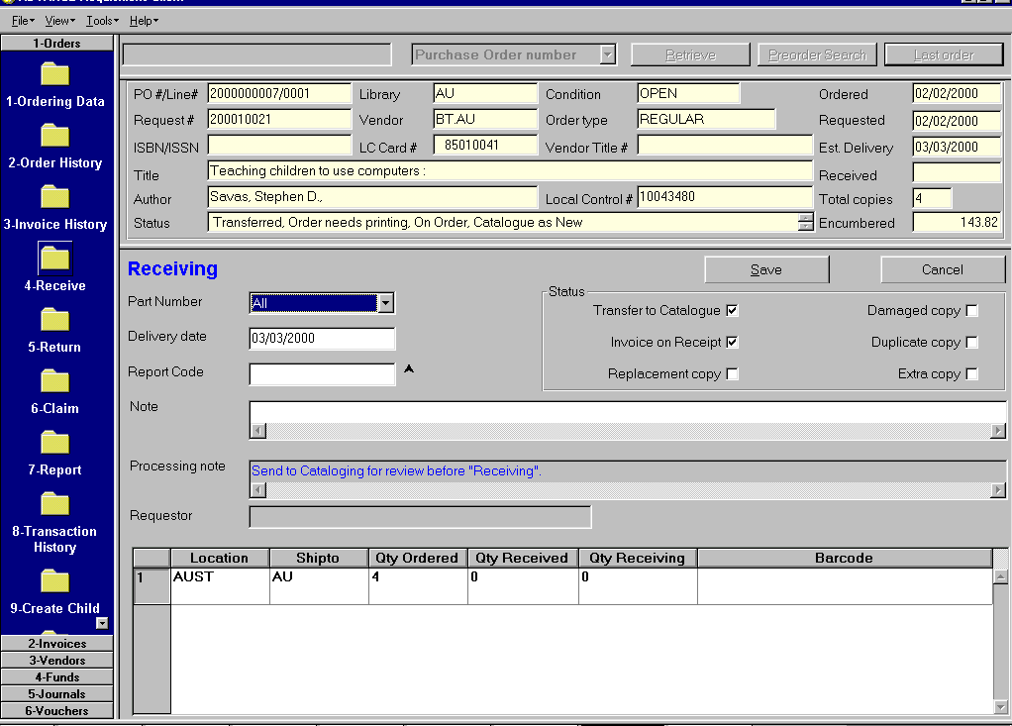
Figure 19

- Press ALT S again to Save. See Figure 20.

    - Invoicing

- Since the order was flagged to “Invoice on Receipt” the “Invoice Full Detail” screen is display when the “Receipt” is Saved. See Figure 20.
- Enter the Invoice # and Press Tab. The “Index Lookup” window will appear in a “closest match” browse list. See Figure 20.
- If the Invoice number already exists, you can select from the list.
- Press ALT N to create a new invoice.

- Complete the invoice template as needed, i.e. may need to enter discount amount or fields to prorate.

- Press ALT S to Save.

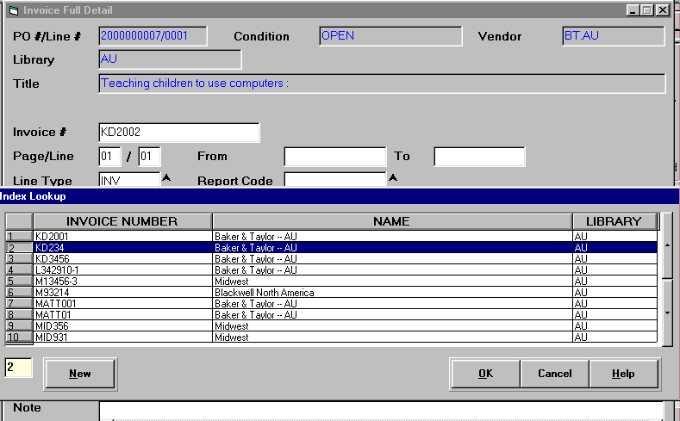
Figure 20

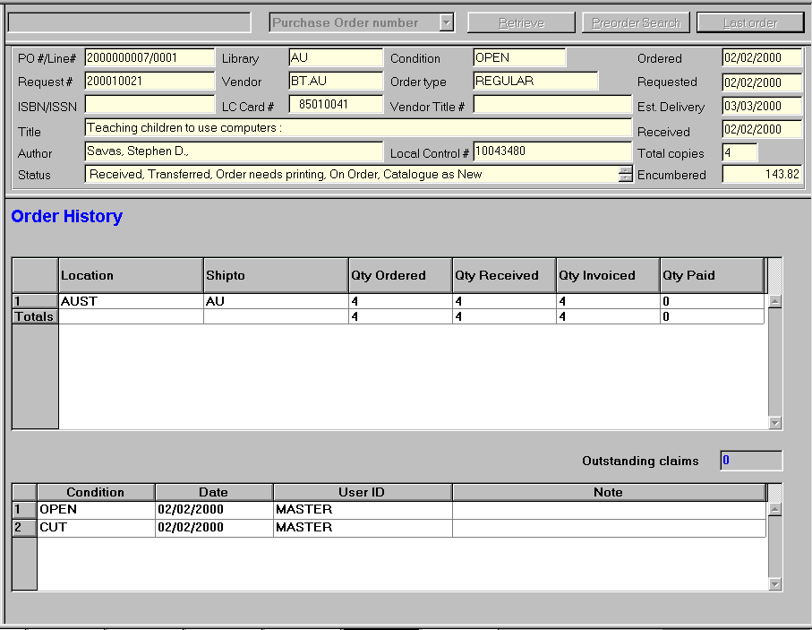
4.2.5 Order History

- Select “Order History” from Task List Bar to review the order. See Figure 21.

Figure 21

4.2.4 Authorize for Payment

- Select “Invoice” Task Group (CTRL Shift + 2)

- Search for Invoice

Enter Invoice Number in Search Entry Screen
Select “Invoice Number” from Dropdown List
Select “Retrieve”
- See Figure 22.

- Review the Invoice.

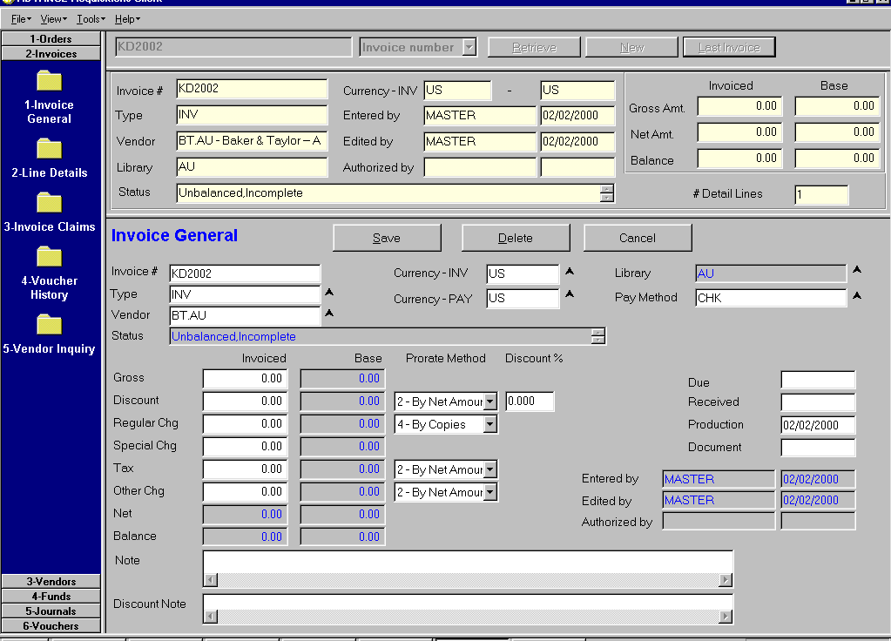
Figure 22

- Select “Line Detail” by pressing CTRL + Shift + 2
- See Figure 23

- Notice the Status Line
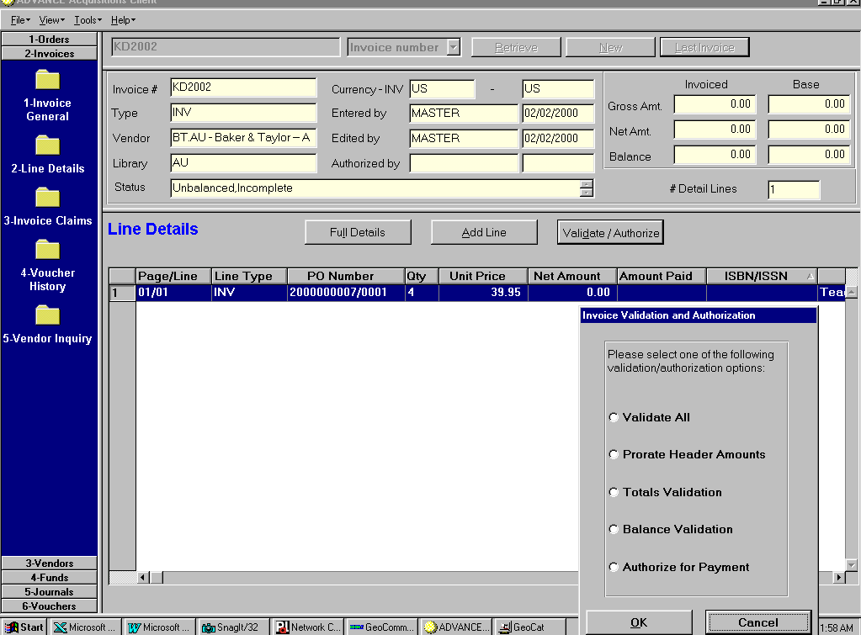
Figure 23

- Select the “Validate/Authorize” button by Clicking on the button or press ALT D
- See the “Invoice validation ant Authorization” box inserted in Figure 23.

- To Authorize

Click next to “Prorate Header Amounts”. See Figure 24.

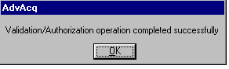
Figure 24

Press ALT O to acknowledge.

Click next to “Totals Validation” and Click OK.
See Figure 24.

Press ALT O to acknowledge.

Click next to “Balance Validation” and Click OK.
See Figure 24.

Press ALT O to acknowledge.

Click next to “Validate All” and Click OK.
See Figure 24.

Press ALT O to acknowledge.

Click on “Authorize for Payment” and Click OK.
See Figure 24.

Authorization for Payment is complete.

See Figure 25 to review the invoice.
Notice the Status line
Notice “Amount Paid” will remain blank until after the vouchering job is run.

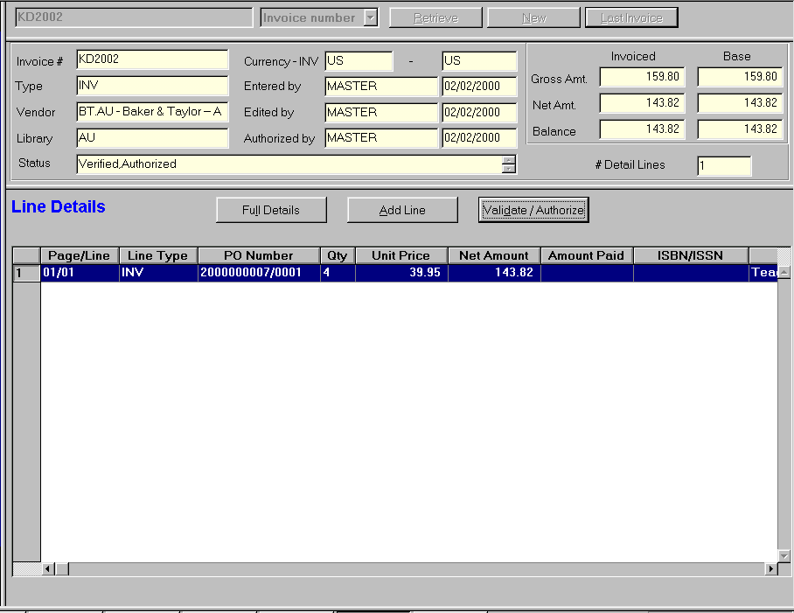
Figure 25

4.2.4 Returning

Items can be assigned a return status of ‘Damaged Copy” of “Replacement Copy” of “Duplicate Copy” or “Extra Copy”.

Free-text notes can be added on the “Returning” screen.

- Select “Orders” Task Group
- Search for title by ISBN, Title, etc.
- Retrieve order record. See Figure 26.

- Select “Return” (Ctrl + 5)

- Flag the “Status” as “Damaged Copy”

- Select the “Location” line for item being returned and enter the number of items being returned in the "Qty Returned” box.

- Press ALT S to Save.

Note:

- If the items were barcoded upon receipt, go to the Barcode Box and press F2. Scan the Barcode to return.
- Press ALT S to Save

- Press “ALT S” again to Save the Return.

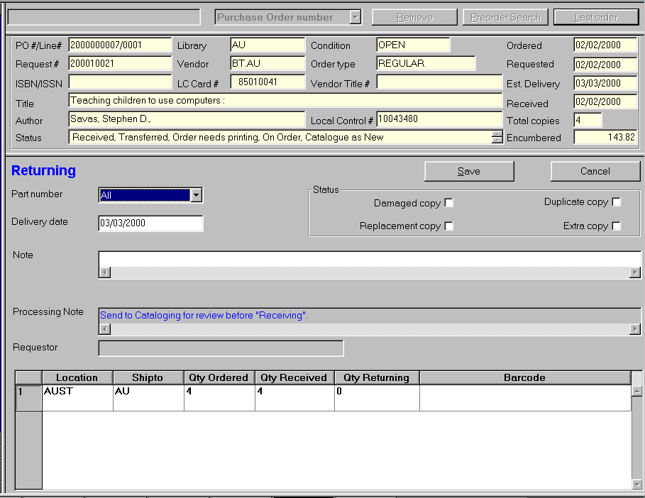
Figure 26

4.2.5 Claiming

- Select the “Orders” Task Group
- Enter the ISBN, Title, etc. in the Search Entry Window
- Select the appropriate search type from dropdown list
- Select Retrieve
- Verify that you have retrieved the correct record

- Go to the “Claims” Task by pressing Ctrl + 6

- See Figure 27.

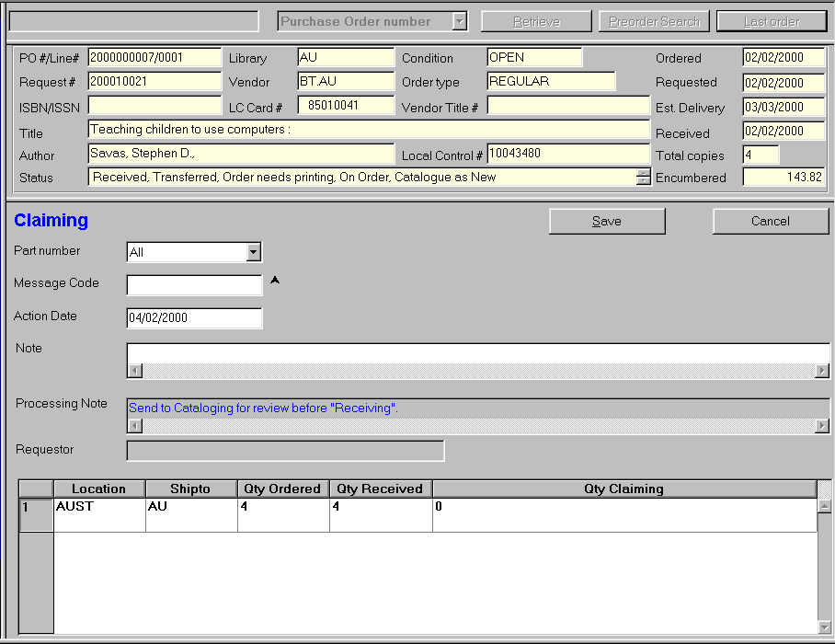
Figure 27

- Go to the “Message Code” window and enter a message code. If the code is unknown, press F8 to display a list and make your selection.
- Go to the “Note” field and enter a free-text claim note.
- Go to the appropriate Location Line and in the “Qty Claiming”, enter the number of items being claimed.
- Press ALT S to Save.

4.2.6 Vendors

- Select the “Vendors” Task Group by pressing CTRL + Shift + 3.
- Enter a vendor name or vendor code in the Search Entry Window
- Select the appropriate search type from the dropdown list
- Click on “Retrieve” to find the record
- You may be placed in a browse list, if so, select the vendor from the citation list. See Figure 28.

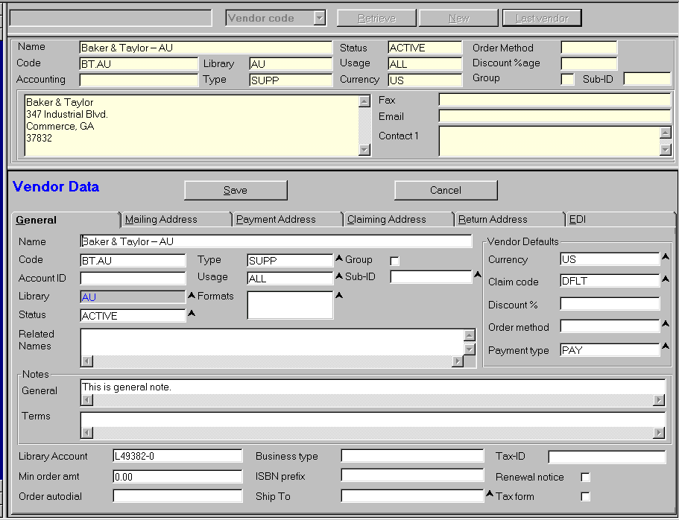
Figure 28

- New Vendors can be added or existing vendors can be updated.
- Note you may have up to four different vendor addresses.

- Select “Statistics” by pressing Ctrl+2 to view Vendor Statistics. See Figure 29.

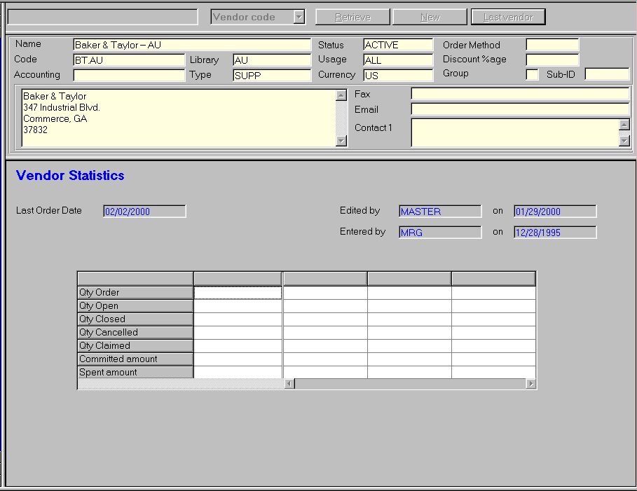
Figure 29

4.2.7 Vouchers

- Press CTRL + Shift + 6 to select the “Vouchers” Task Group
- Enter a Voucher Number, Name or Code in the Search Entry Window - then Click on Retrieve to show Voucher Details.
- See Figure 30
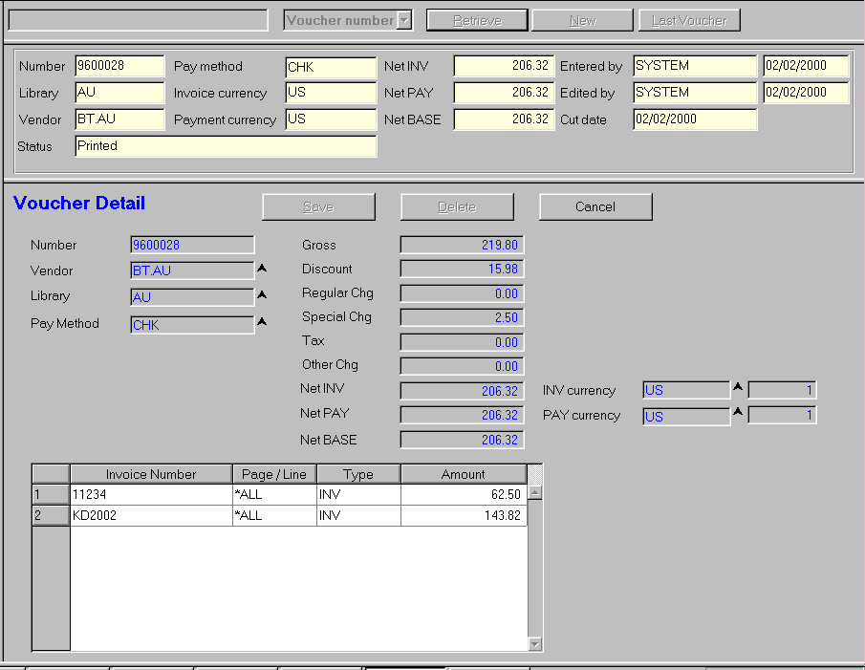

Figure 30

- With Voucher Details displayed, you can select “Vendor Inquiry” from the Tasks (Press Ctrl + 2) to display information about the current vendor.

- From the “Vendor Inquiry” screen, you can display the vendor statistics, vendor addresses, etc.

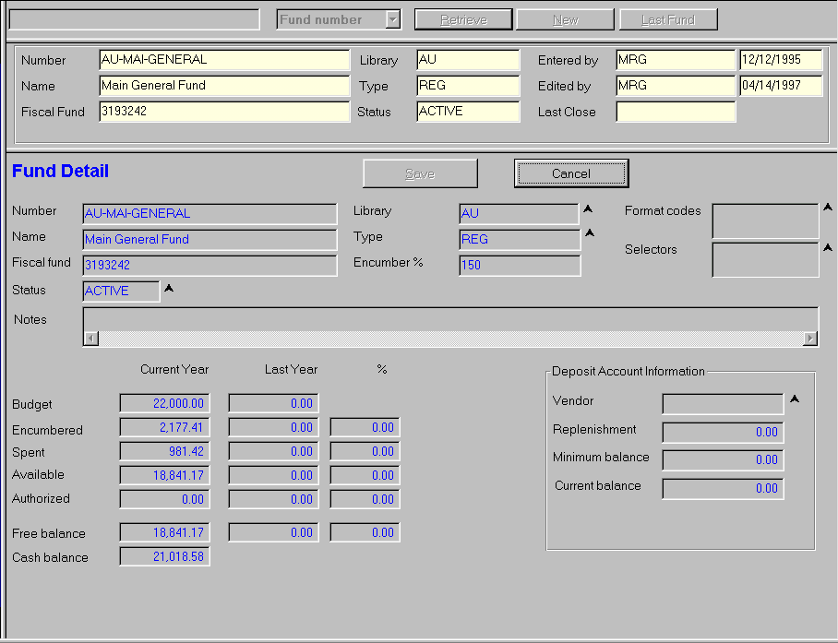
Figure 31

- Funds

Select the “Funds” Task Group by pressing CTRL + Shift + 4.
From the “Funds” Task Group, you can view funds, but you cannot add or move funds.

Enter a fund number or fund name in the Search Entry Window; select the search type from the dropdown list; click Retrieve.

See Figure 31 for fund information.

Select “Journal Entry Display” by pressing CTRL + 2 to Journal details for the particular fund. See Figure 32.

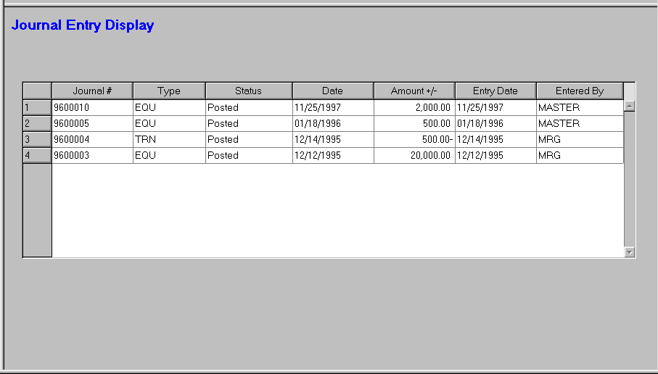
Figure 32

6. 0 Journals Task Group

Select the “Journals” Task Group by pressing CTRL + Shift + 5. From the Journals Task Group you can search for a particular journal entry and display the details. You can view the information, but you cannot add or change journal entries. See Figure 33.

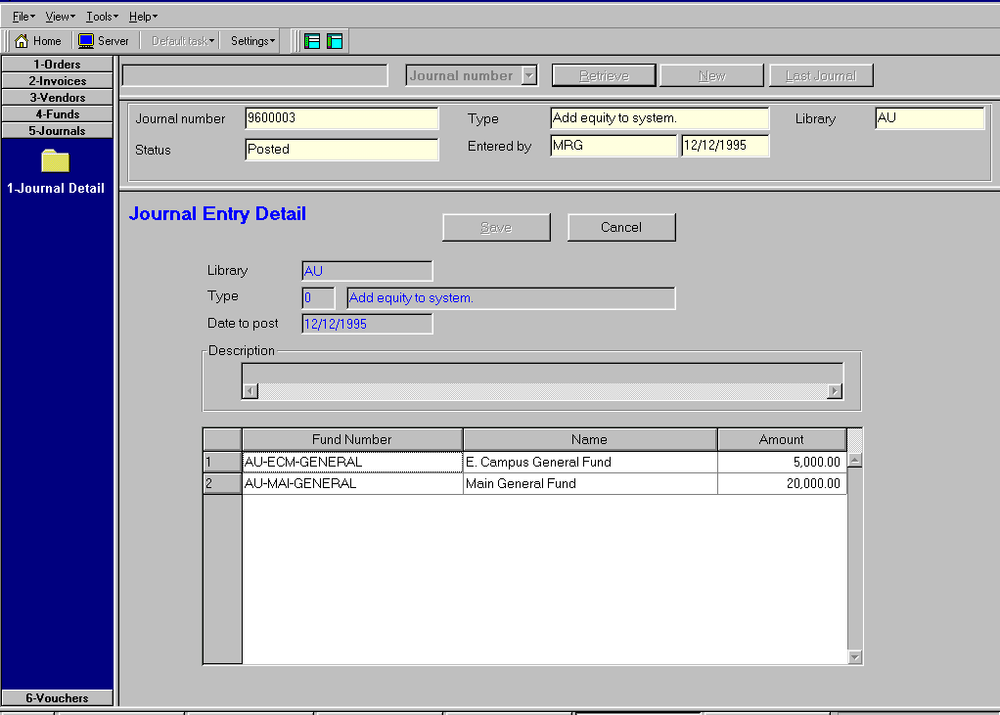
Figure 33

