ADVANCE Holdings Client
6.0

- Installation

- Setup
[See Attached Documents]

  - GeoSec32
  - GeoMarc32
  - GeoParms
  - RegSetup
  - ADVANCE Permissions and Setup

- Getting Started

  - Login to AdvHoldings

  - Login

Enter your ADVANCE Login and Password. [This is the EACC Identification Code and User Password]. See Figure 1.
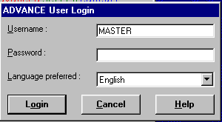

Figure 1

    - Press <Enter> or Click the Login button to proceed with the login.
3.2.2 See Figure 2.

Note: If you receive a message that server is unavailable, check with System Administrator to make sure that the Z39.50 Server is up as well as the Host Server.
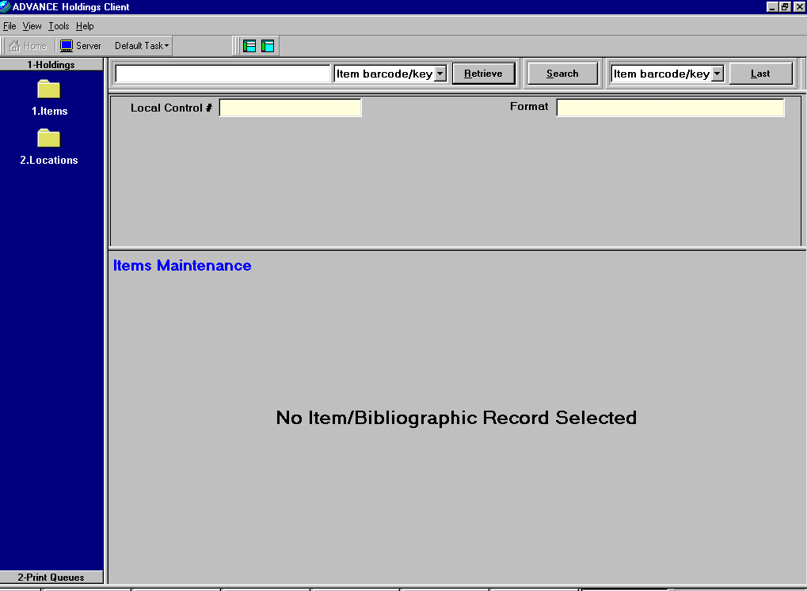
Figure 2

- Client Setup

4.1 File

    - From the Toolbar, select File. See Figure 3.

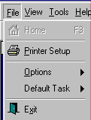
Figure 3

    - Select “Printer Setup” by pressing ALT P or by clicking on “Printer Setup.
You can select the printer for printing labels. You can also select a Default Spine Label definition to be used when printing labels. See Figures 4 and 5.

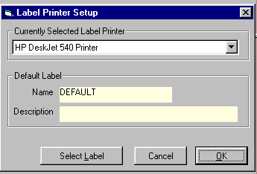
Figure 4

From the dropdown list, you can select the appropriate label printer. Click the “Select Label” button to define a default spine label format. See Figure 5.

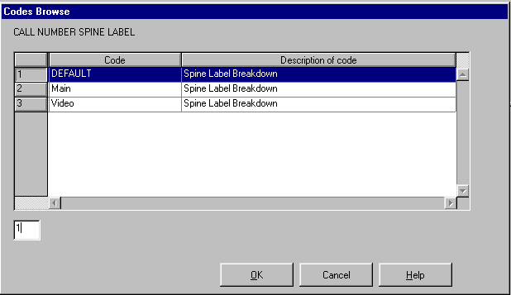
Figure 5

Double click on the appropriate code or highlight the line number and Click the OK button.

    - Select “Options” (See Figure 3) to set Default Colors and to set default Currency Code. See Figure 6.

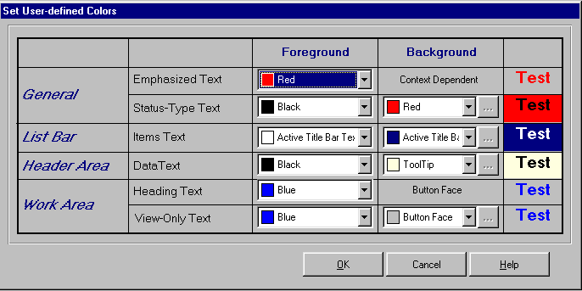
Figure 6

System wide colors are set from the Display icon in the Control Panel. However, emphasized text can be defined as shown in Figure 6.

You can also set two ISO Currency Codes as defaults. These codes are display only. See Figure 7.
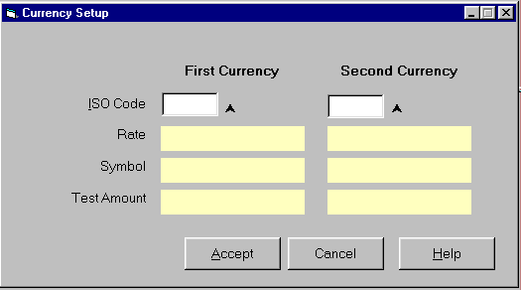
Figure 7

    - Select “Defaults” (See Figure 3) to set the default Task for the session.

  - Select View from the Toolbar

    - User can select “Size Heading Panel” to set screen default to “Maximize Work Area” or to “Minimize Work Area”. See Figure 8.

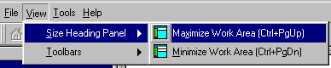
Figure 8

    - User can select “Toolbars” to determine whether to show the Main Toolbar, the Size Heading Toolbar, both or neither. See Figure 9.
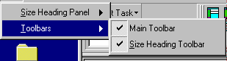
Figure 9

  - Select Tools to launch a telnet session to the local server.

  - Select Help to read and/or print online help.

- Screen Layout

  - Task Groups and Tasks

    - Holdings

- Items

- Locations

    - Print Queue

- Labels Print Queue

  - Data Entry Pane

  - Header Pane and Data Elements

  - Work Pane

- Navigation

  - Mouse or TrackBall
  - Keystroke Combinations
  - Shift + Ctrl + Task Group Number
  - Ctrl + Task Number
  - Alt + Letter underlined
  - F1 = Help
  - F2 = Display a window or template
Displays Item Circ Statistics Chart
Displays template to update holdings info
6.7 F3 = Return Focus to Home
6.8 F5 = Displays Search Function
6.9 F7 = Starts Telnet Session
6.10 F8 = Displays Code List
6.11 F11 = Displays “Summary Count by Location” from Item Maintenance
6.12 F12 = Help

- Holdings Functionality

  - Item Maintenance

Item Maintenance is used for basic day-to-day holdings maintenance such as adding, deleting and updating single level holdings. Item maintenance provides the ability to search by item barcode or local control number, or to search the local database for a bibliographic record. User can retrieve one or more bibliographic records into Item Maintenance at the same time.

Item Maintenance is for Single-part holdings only, working with LOCCPY information and PIECES information.

    - Retrieve an item by barcode

Item barcodes can be scanned in or they can be typed.
[See Figure 2 for “Home” screen]

Enter the barcode number in the Search Entry Window

Select “Item barcode/key” from the dropdown list

Press <Enter> or ALT R to search and retrieve the item record. See Figure 10.

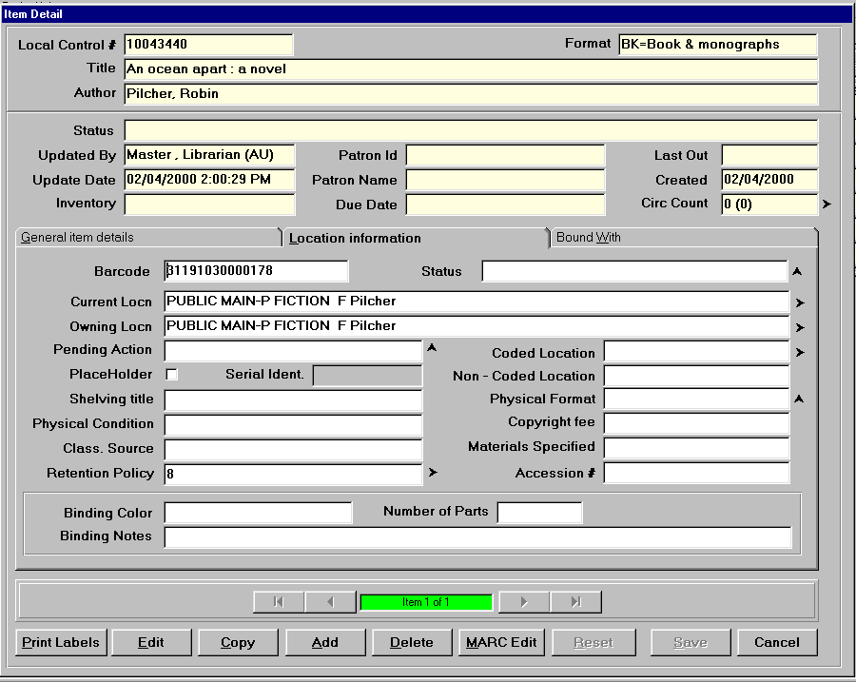
Figure 10

    - Working with the Item Record

Press Alt + E to edit the item Record

Press Alt + C to copy the item record

Press Alt + A to Add an item

Press Alt + D to Delete the item

Press Alt + P to Print Label

    - Editing an Item Record

Press Alt + E

You can change any of the location information. Notice the “Status” field has the character ^, this symbol means there is a code list associated with the field. When this symbol is displayed you can press F8 to display the list of codes.

Note the > symbol in the “Current Location” and the “Owning Location” fields. When this symbol is displayed, with the cursor in the field, you must press F2 or press <enter> to get to a data entry template, i.e. you cannot directly edit the field because it is multi-valued. See Figure 11.

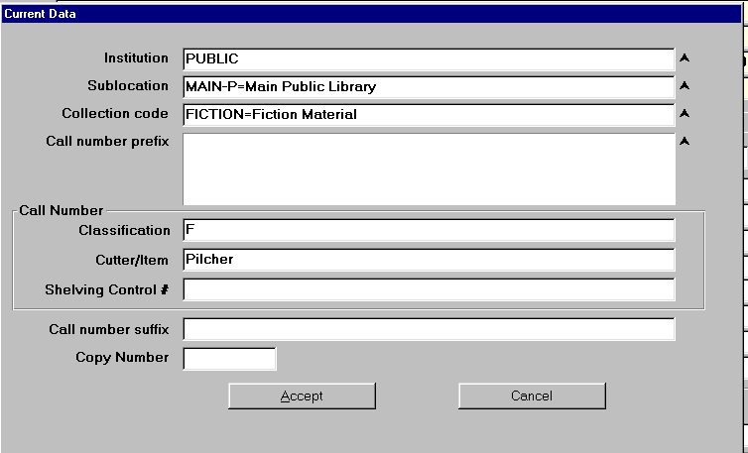
Figure 11

With the cursor in the institution field, Sublocation field, Collection Code field or Call Number Prefix field, you can press F8 to select a value from a Codes List. If you know the correct code for a field, you can just highlight the existing data and type the correct code.

When the template is complete, press Alt + A to accept the screen changes and you will be taken back to the previous screen.

Select the “General Item Details” Tab to add a price, to add notes, etc. See Figure 12.

When finished entering data, you can Press Alt + S to save the changes.
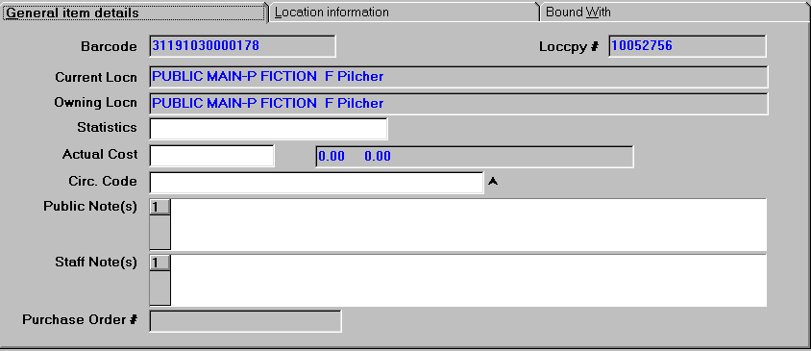
Figure 12

After the item record has been saved, you can Click on “Cancel” to return to the Item Summary Screen, or you can select “Copy” or “Add” to add another item.

Select “Cancel”. See Figure 13.

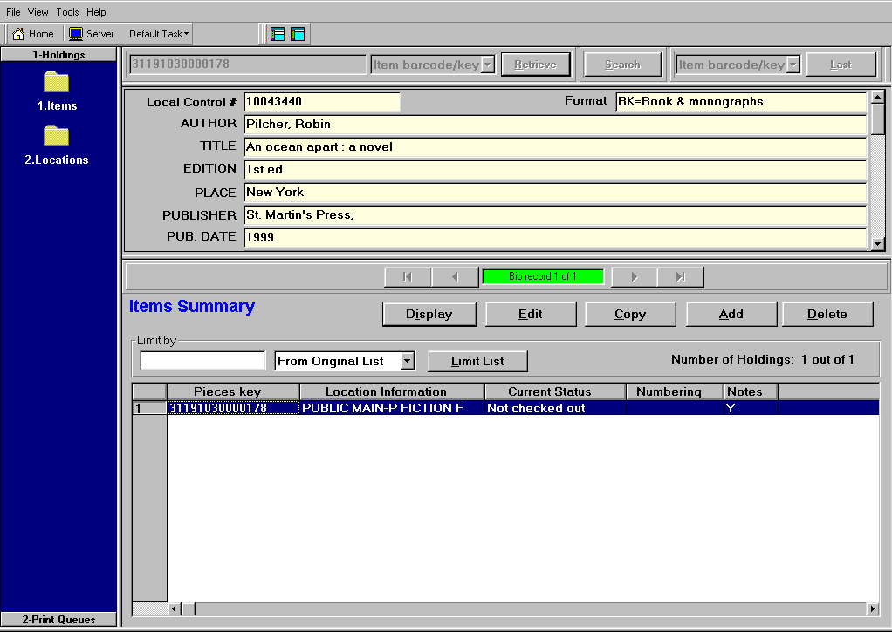
Figure 13

Notice from the “Items Summary” Screen, you can select “Edit”, “Add”, “Copy” or “Delete”. Also notice that you are now seeing more of the bibliographic information. Use the Scroll Bar to display more of the bib information. There is also a “Limit List” option that will allow you to limit a list by values in the Barcode field, Location field, Status, or Numbering fields.

Press F3 to return focus to Home.

7.1.4 Search Local Database for a record

From the “Item Maintenance” Task screen, Click on “Search” to launch a Z39.50 search of the local bibliographic database. See Figure 13.

Type a Search String in the “Input 1” window

Select an “Index” to search from the “First index” dropdown list

Press Alt + S to do a scan search

Note: For Boolean Searching:

Type a Search String in “Input 1” Window

Select an “Index” type from dropdown list

Select “AND”, “OR” or “NOT, from the “Boolean” dropdown list

Type a Second Search String in the “Input 2” window

Select an “Index” from the “Second Index” dropdown list

Select “Search” to do a keyword search.
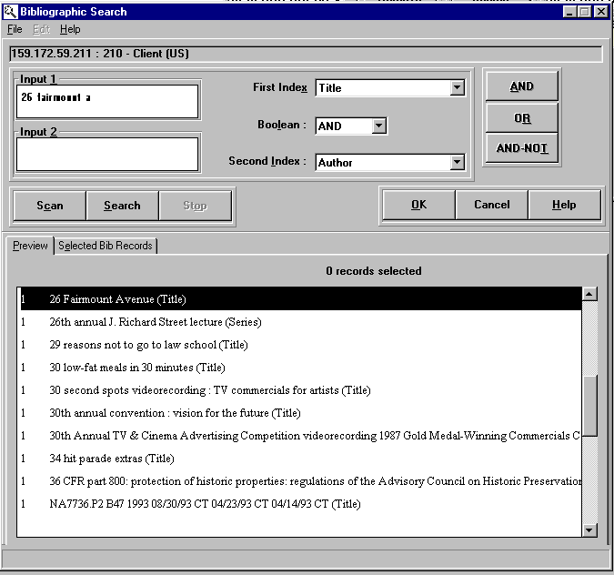
Figure 13

You can select multiple bib records by double-clicking on a highlighted entry or by pressing <Enter> on a highlighted entry. See Figures 13, 14 and 15. You can display the “Selected bib records” and you can retrieve the selected bibs into Item Maintenance.

The bibliographic record will be displayed along with its holdings. At this point you can either select “Back” to return to the Citation List or you can select “Select Bib”. If “Select Bib” is chosen the record will be selected and you will be returned to the citation list so that you can make other selections.

Press Alt + S to Select Bib.

Select 2-3 more bibs from the citation list.

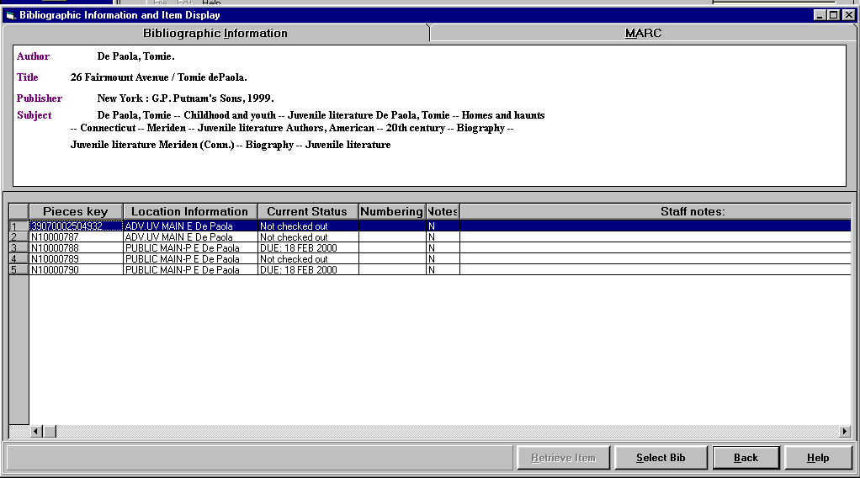
Figure 14

Press Alt + E to display “Selected Bibs”. See Figure 15.

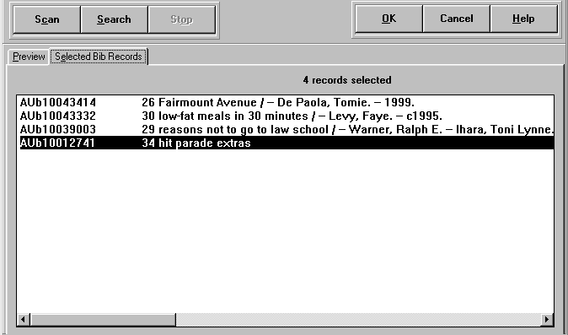
Figure 15
Highlight an entry and Right-Mouse Click to de-select

Press Alt + O to bring the records to Holdings Maintenance.
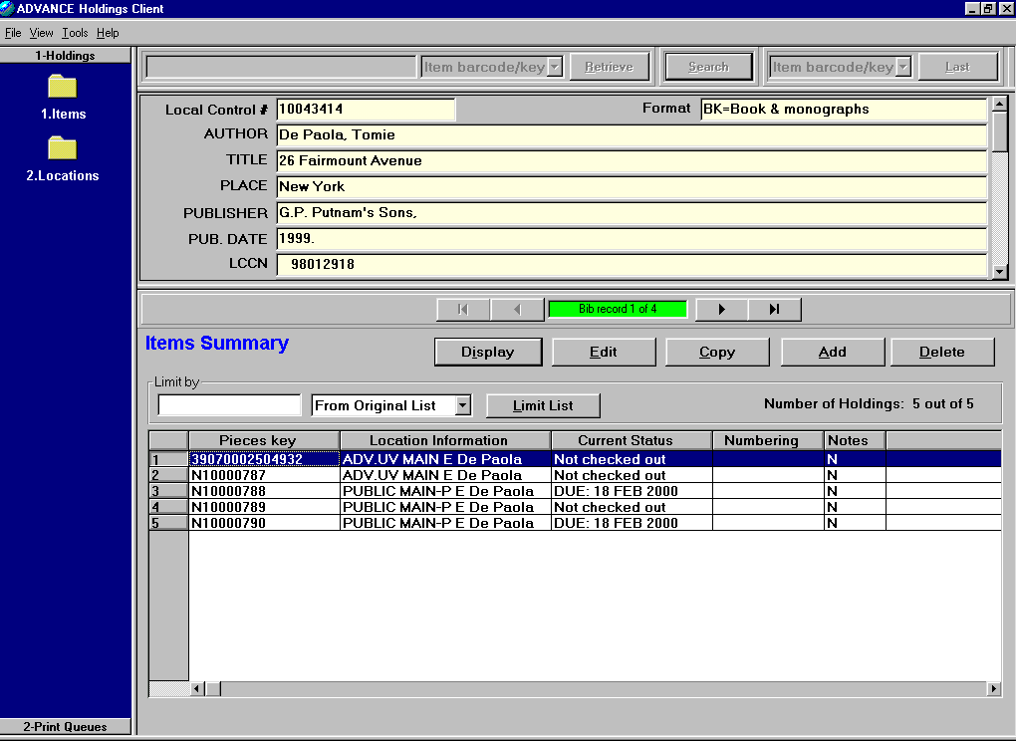
Figure 16

User can navigate between Bib record 1, 2, 3 and 4.

User can click on “Pieces key” to sort the barcodes in ascending or descending order.

User can click on “Location Information”, “Current Status”, “Numbering” or “Notes” to sort by that field.

User can enter 2000 in the “Limit by” window and press Alt + L to limit the list to items with “2000” in the item details, i.e. if this limit is applied to Figure 16, only Pieces Keys; N1000788 and N10000790 will remain in the list.

User can click on one or more of the lines to highlight and Click on “Edit” to edit the records. You can then move between the multiple items to edit. See Figure 17.

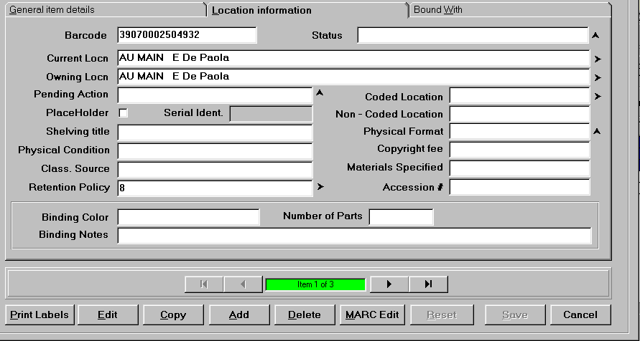
Figure 17

At this point you can use the arrows to navigate from one item to the next. As soon as you make a change to an item, the “Save” button will be highlighted.

7.15 Summary Count

Display an Bibliographic Item Summary Screen

Press F11 to show a “Summary Counts” chart.
See Figure 18.
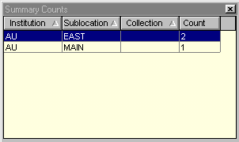
Figure 18

7.1.6 Printing Spine Labels

Display an Item Record

Press Alt + P to Print Labels
See Figure 19

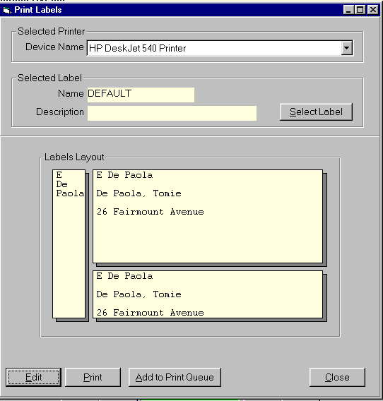
Figure 19
User can Edit the Spine Label

User can change the Spine Label Format

User can print the spine labels one at a time

User can add spine labels to print queue
    - Circulation Count

Display an item record
See Figure 20.

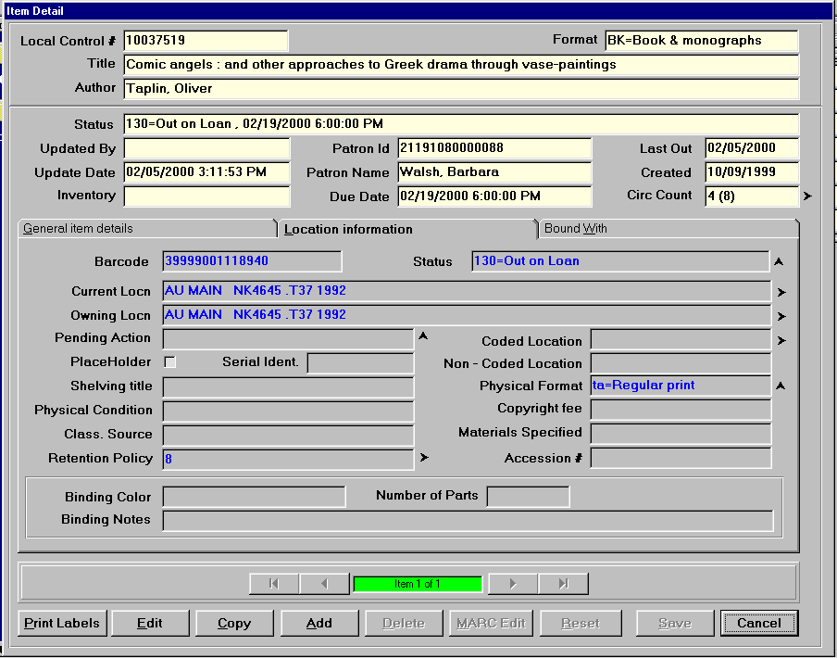
Figure 20

In the Header Pane, notice the “Circ Count” field in Figure 20.

Place the focus in the “Circ Count” field and press F2 to display a Circulation Usage Summary. See Figure 21.

The upper portion of the chart shows the Circulation Usage Statistics Summary by Month and by Year.

The lower portion of the chart shows the In-House Usage Statistics Summary by Month and by Year. In-House usage are those items that have been “checked in” when they already had a status of checked in.

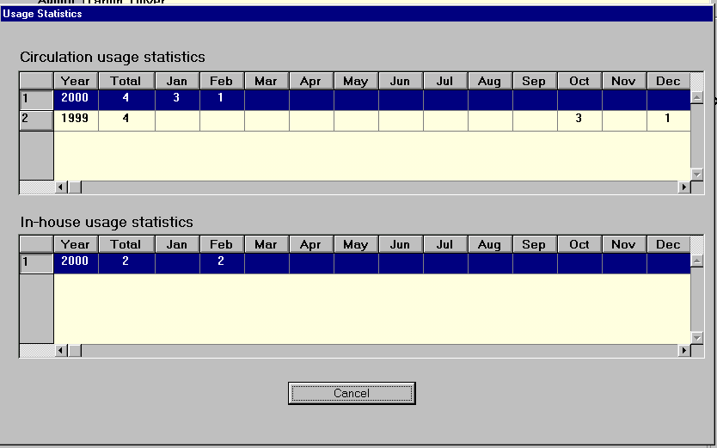
Figure 21

7.1.8 Multi-Part

Multi-Part Items cannot be displayed, updated, added, copied, or deleted in Item Maintenance. See Figure 22.

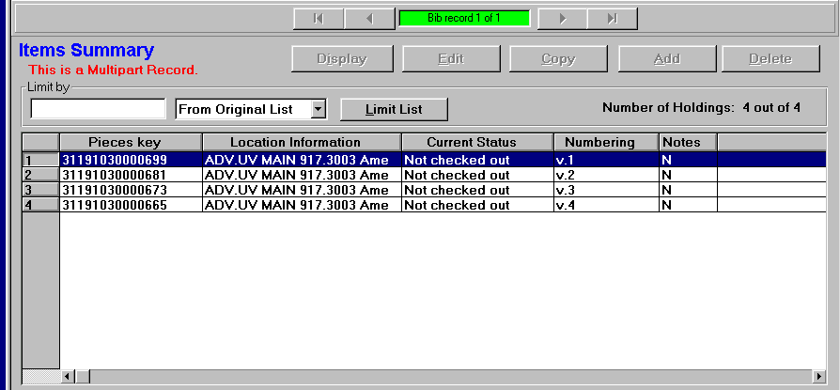
Figure 22

7.2 Location Maintenance

Select the “Locations” Task from the Holdings Task Group by pressing Ctrl + 2.

Type a Local Control Number, select “Bib LCN” and Click on Retrieve to display a bib record. See Figure 23 below.

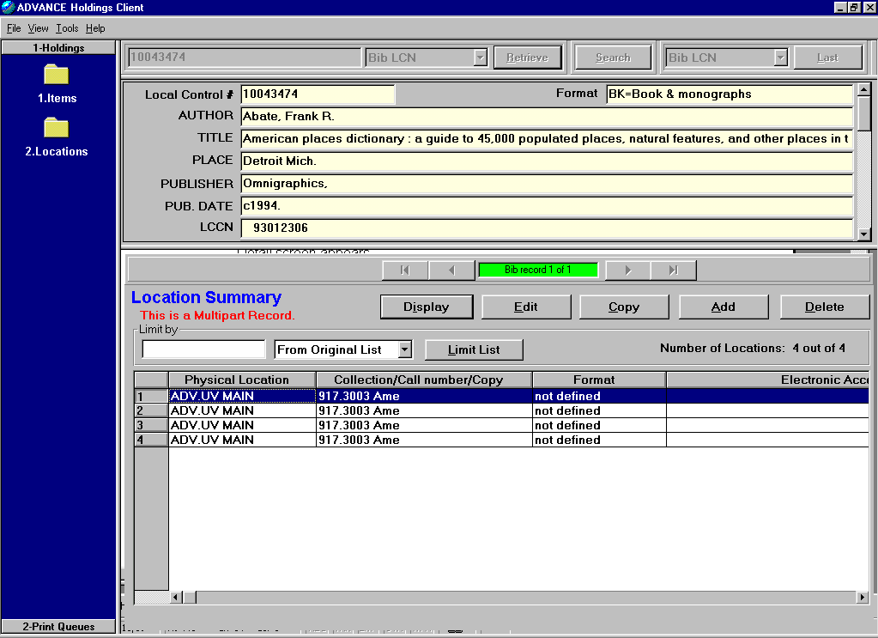
Figure 23

Editing Locations

The Location Summary screen lists all the Location Copy records for the title. There is one Location Copy record for each unique location, physical format, and copy held by the library. You can change the Current Location from the Location Detail screen. To change the Owning Location you must go to the Item Detail screen.

To change the Current Location:

1 Select the Locations task from the Holdings Task Group.

2 Search for an item. The Location Summary screen appears.

3 Select the Location record that you want to edit. The Location Detail screen appears.

4 At the Current Locn field, press F2. The Current Data screen appears.

5 Edit the location information on the Current Data screen. You must tab out of the field at least once to activate the Save button (Alt+S). The Save button appears dimmed until you tab out of a field.

6 Click Save (Alt+S). AdvHoldings displays a message that the Update was done. To return to the Summary screen click Cancel (Esc).

7 Electronic Holdings
Electronic holdings can exist on a bibliographic record with real physical holdings. Electronic holdings are defined by adding 856 tags to the MARC holdings record in the electronic copy record. You can use multiple 856 tags if necessary.
Use the Institution Code table (CHIC) and/or the Sublocation/Building Code (CHSC) on the Holding Setup Menu from the Cataloguing Holdings Menu (CHM) to create institution and sublocation codes for electronic holdings. These codes are necessary if you want your electronic locations to display.

Click the Go To button to start your web browser and access the web site identified in the 856 field.

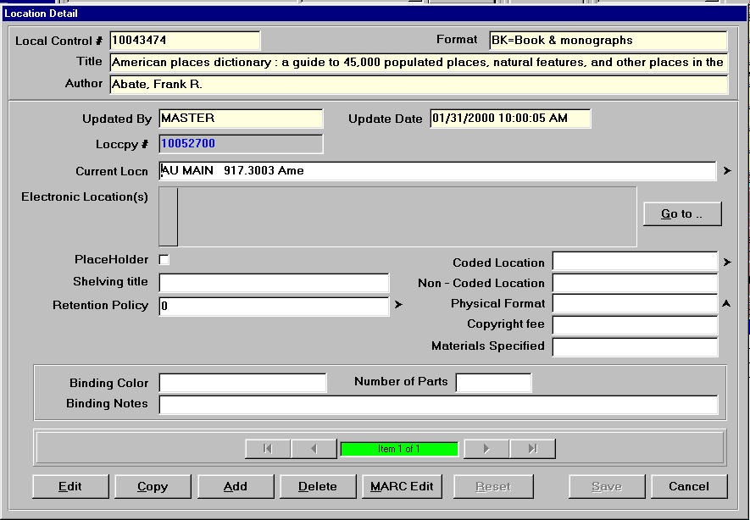
Figure 24

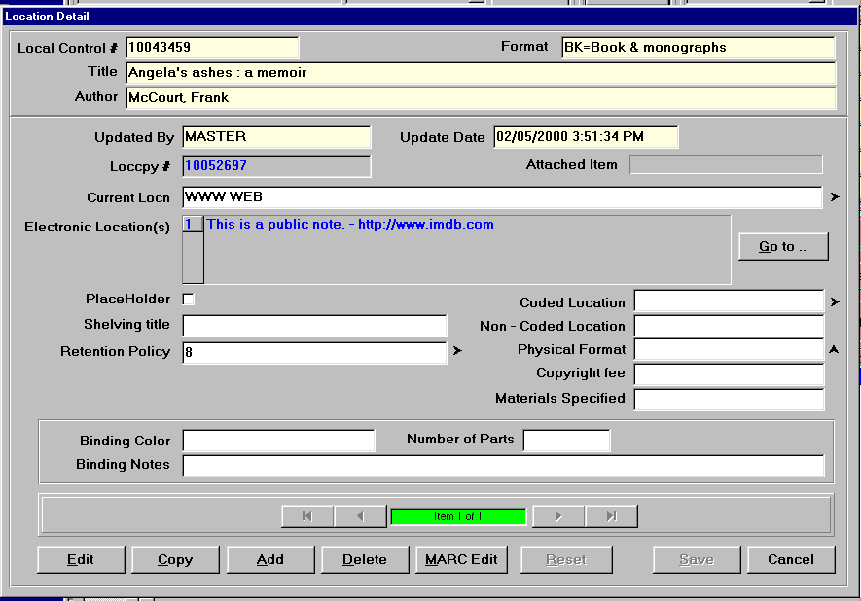
Figure 25

8.0 Print Spine Labels

Select the “Print Queue” Task Group by pressing Ctrl + Shift + 2

Select the Label Type from the dropdown list and Click on Retrieve.
See Figure 26.

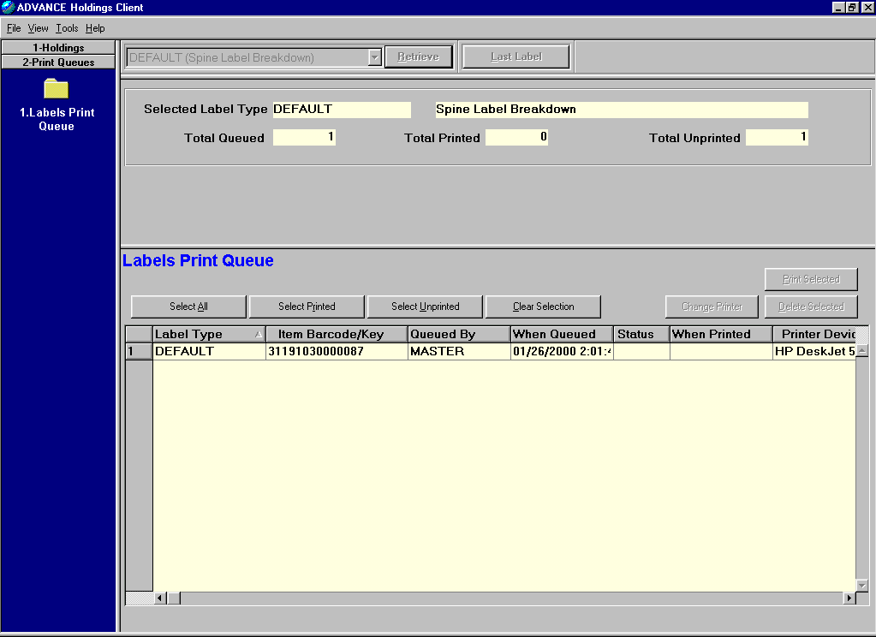
Figure 26

User can “Select All” to print; “Select printed”; “Select Unprinted”; or, “Clear Selection”. See Figure 27.

Click on “Select All” to print all labels.

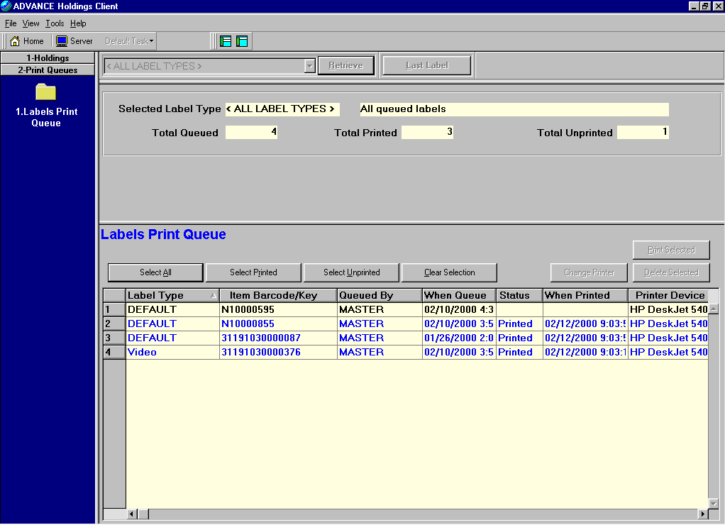
Figure 27

