

Distance Education
Pilot Projects

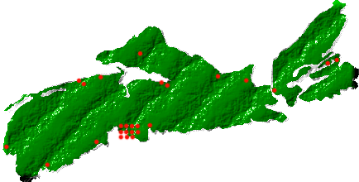

THE NOVANET DISTANCE education project
The Novanet Distance Education Project will develop a new service model in the context of the most recent and innovative developments in information technology, with participation of students, faculty, and those library staff who work with distance/continuing education clientele. The Project has been divided into the following four pilot projects:

Live Help/ Chat Research Assistance

This pilot will use chat software to provide online real time reference assistance to remote students and distance learners. Committee members will evaluate technical issues related to live chat research assistance within a consortium environment.
This service will allow distance education students to receive live reference assistance from home.

Discipline-Specific Electronic Collections
Several programs offered through distance education which are shared by several institutions within Novanet (business administration, nursing, and education) will be the focus of this pilot. Electronic book in these 3 areas will be available through netLibrary for distance students to borrow.
This service will allow distance education students to access e-books from home.

Online Tutorials
This pilot project will develop a generic tutorial on using the Novanet system (catalogue, patron records, reserves, Novanet express, keyword vs. browse searching of databases etc.) that could be shared by all Novanet libraries.

This pilot will use qarbon.com software: short 2-3 minute instructions (viewlets) that can be placed throughout a web site to provide user instruction where it is needed.
This service will assist distance students who often find the Novanet website difficult to use.

Electronic Reserves
From the student survey, this was the #1 priority for students; however, due to high costs it was recommended that a small test be made to compare the costs and problems encountered with print vs. online vs. CD as a means of handling reserves. This pilot project will focus on making these comparisons.
E-Reserves will allow distance education students to access reserve readings from home.



If you would like to get involved please contact:

Bonnie Waddell
Project Manager
Novanet Distance Education Project
Email: bwaddell@nsac.ns.ca
Phone: 902-893-6670
Fax: 902-895-0934
OR
Todie Winter
Assistant Project Manager
Novanet Distance Education Project
Email: twinter@nsac.ns.ca
Phone: 902-893-3394
Fax: 902-895-0934


1550 Bedford Hwy. #501
Bedford, Nova Scotia
B4A 1E6
Phone: 902-453-2470
Fax: 902-453-2369

December 2002

