

Setting up and checking-in serials Using Aleph Predictive Functionality
Part 1

A. Finding a Bibliographic record to work with
1. Select the Acquisition/Serials Module from the icons

2. Type in your username and password
3. Select the find tab and search for a record.

4. Click on the Show button and then click on the Serials button (note that there won't be a Show button if your search retrieves and exact match) this pushes the record from the Search Tab into the Serials Tab.

B. Creating a subscription record and a basic holdings record
1. In the Serials Tab, select (L) Subscription List and click the Add Button.

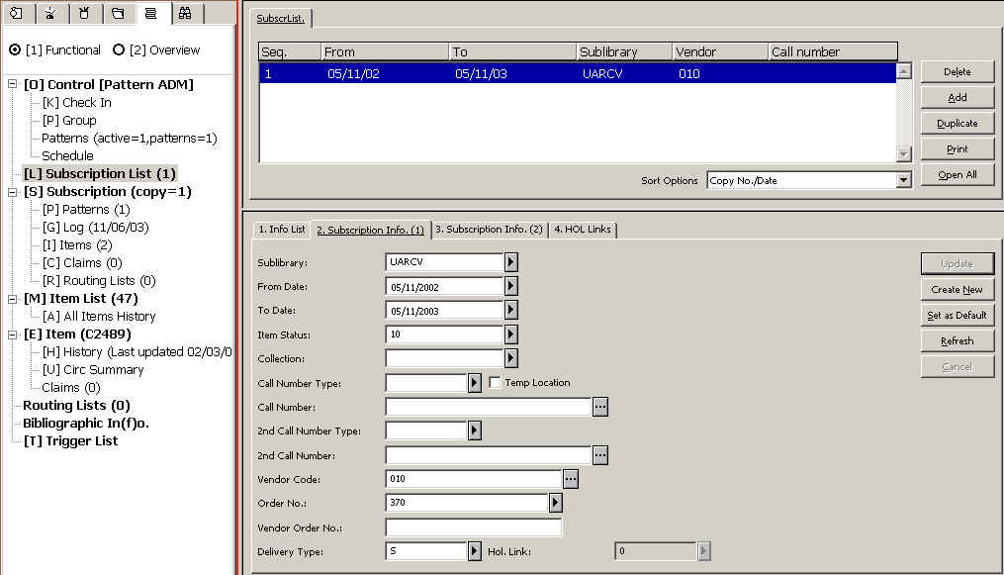

2. In Tab 2, complete the following mandatory fields: Sublibrary, Item Status, Vendor Code and From/To dates (In most cases you will want to set the “to date” way into the future ie. 01/01/2099).
(Note that a Delivery Type will be required too, if it was not copied from the Vendor record).

3. Also complete the following Tab 3 fields: Claim intervals and the Send Claim radio button. Select "Y".

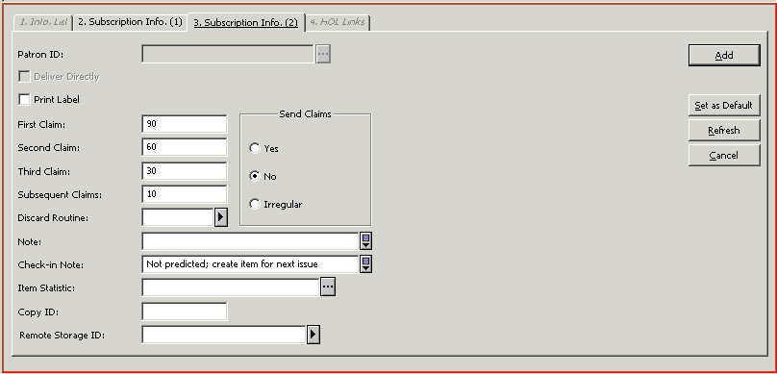
4. Click on the Add button

5. In Tab 4.(Hol LInks), click on the Create New button

