

Setting up and checking-in serials Using Aleph Predictive Functionality
Part 2.

C. Completing fields in the holdings record, including prediction pattern

- Under (S) Subscriptions in the left-hand pane, select (P) Patterns.
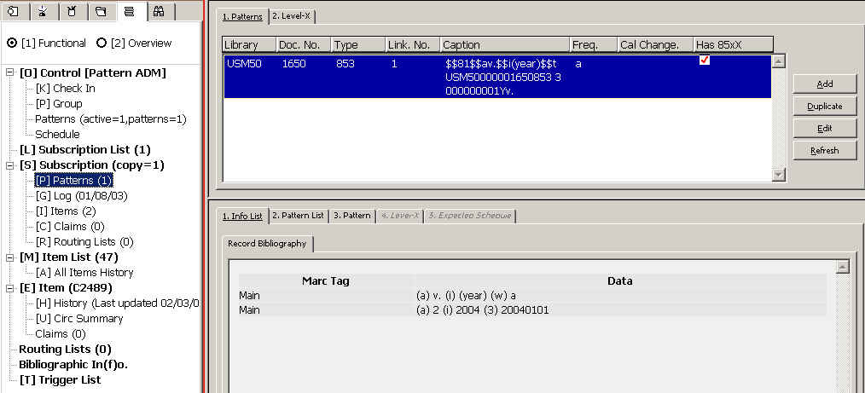

Make sure the active tab in the upper right pane is 1. Patterns.

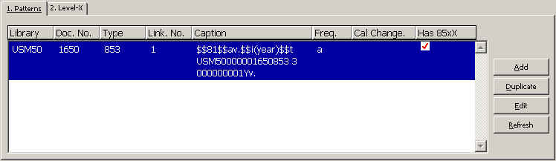

Then click on the Add button
If a window "Choose Pattern Document" appears, make sure to choose
the line for NOV60 ( ie. the holdings record your just created in step B above)

2. In the lower pane, click on the Template button- choose Pattern Template File and then highlight the pattern you want
and click OK

.; 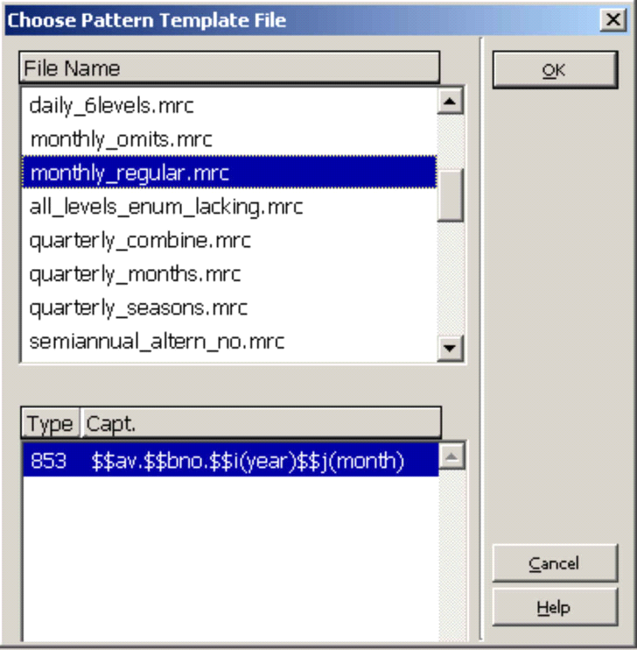

check fields and make any necessary changes.

3. Click on the Add button and you have created the 853 field.

4. In the upper pane click on 2. Level X tab - click on the Add button.

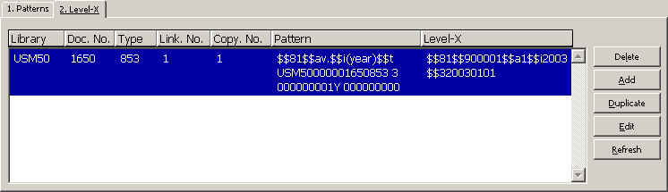

5.In the bottom pane click on the Template button - choose Pattern Template File and highlight the pattern you want then this should be the same pattern you chose for the 853, click OK; check the fields and then click on the Add button. You have created the 853X field.

D. Previewing the prediction and opening items accordingly

Select the 5. Expected Scheule tab and look at your prediction.

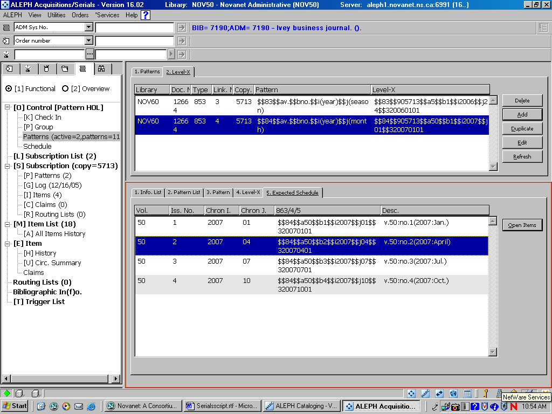

If the prediction is incorrect repeat steps 1-5 above to correct your 853/853X fields

If it looks good click on the Open Items button. In the navigation pane under [S]
Subscriptions [I] Items there now should be the appropriate number of items listed ie: if it was
a quarterly pattern there now would be (4) items.

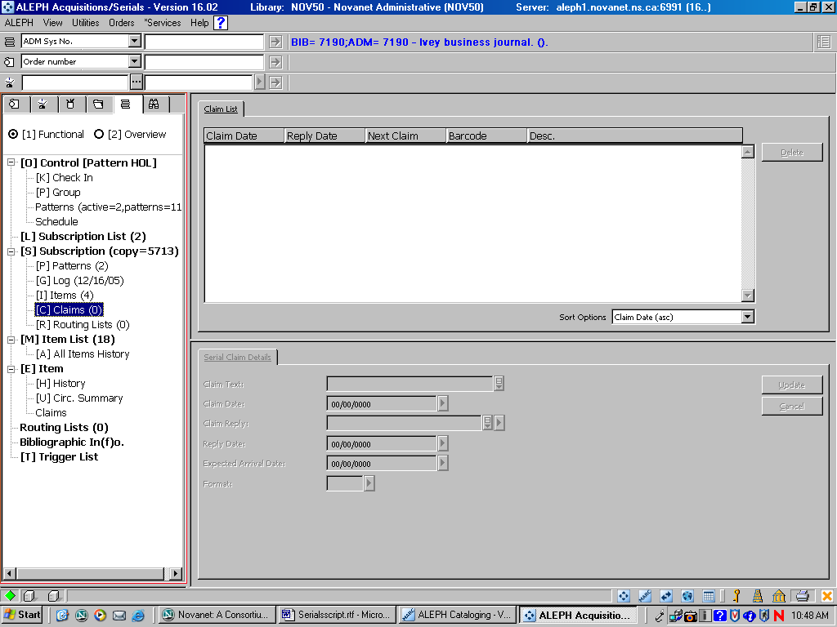

E. Arriving issues

1.In the lelft- hand pane under (O) Control [Pattern HOL] select (K) Checkin

and click on the Arrive button (this will allow you to check in issue per issue)

Highlight the first expected issue and the Arrival Form will appear in the Lower Pane
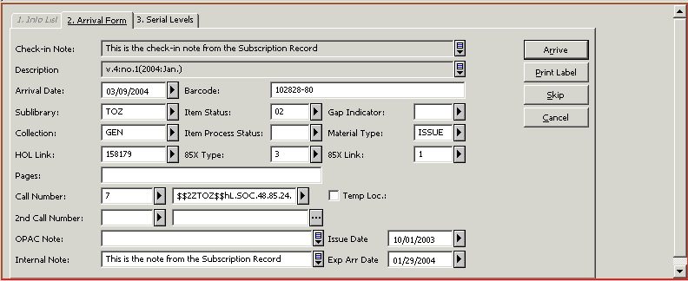
.

In the Lower Pane, click on Tab 2.Arrival Form and make sure you enter the Material Type as ISSUE, and then click on Arrive.
You will get a log window which tells you success and you can then close. You will see the Arrival Date in the Arrival column in the Upper Pane.

3. You may also use (P)Group on the left-hand pane . It allows multiple selection of issues, highlight the first issue you want to receive, hold the Shift key down and select the last issue to be received. All the issues you want to arrive will be highlighted in the Check-in list.

4. Click the Select button in the Upper Pane, in the Lower Pane the Arrival Form will open for the first issue. Click the Arrive button to check in the first issue and the Arrival form for the next issue will appear. Keep hitting the Arrive button in the Lower Pane until all the issues have arrived.

