Holdings Client – Multipart holdings

- A Type of Holdings record is used to specify the types of publication such as issue, index or supplement.
- A Publication Pattern record describes the captions used in the numbering, such as, v., no. The publication pattern is linked to the Type of Holdings Record.
- The Publication does NOT define the frequency or predict issues.
- A Parts record is created to define each of the numbered parts in a set.
- Part record contains the numbering on the part and uses a link to the Publication Pattern record to define the captions that should be used.
- Multipart items always have an associated Location Copy record which defines a specific copy of an item or a set at a specific location.
- Pieces/Parts option from the Copy Detail screen shows a list of parts for a given location.
- A multipart piece record is not needed if the part is not barcoded.
- All multiparts must be linked to at least one part.
- When an order for a new multipart title is transferred to the catalog, a location copy record is created for each copy specified on the Allocation Screen. A default ISSUE Type of holdings is created.

Launch the Holdings Client

You can search by Barcode or by Local Control Number from Holdings Task Group. Or, you can do a Z39.30 search of the local database. You can search by author, title, subject, series, etc. Scan Searching or Keyword Searching is available as well as Boolean Searching.

Initiate a Z39.50 Search of the Local Database:

________________________________________________________________
Select a Bibliographic record from the Citation List and Retrieve.

- Highlight and Entry and Click the OK button.
- See Figure 1.

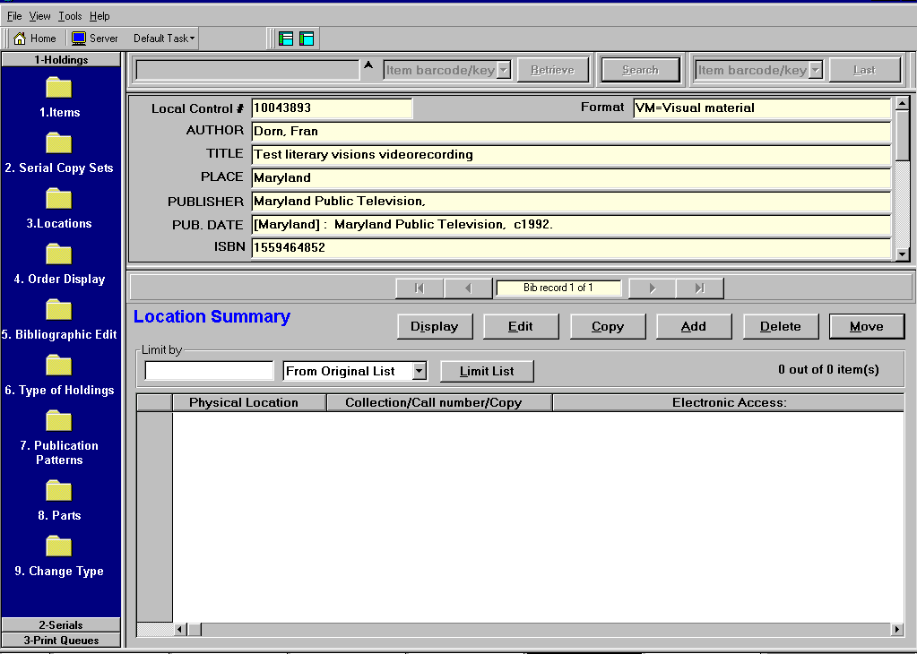
Figure 1

- Select #9 Change Type Task from the List Bar. (CTRL + 9). See Figure 2.

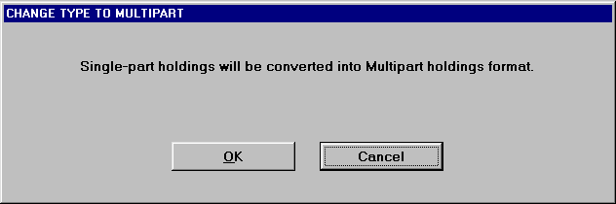
Figure 2

- Select OK to change from Single Part to Multipart format.

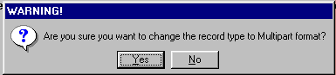
Figure 3

- Select Yes to the prompt in Figure 3.

- At the “Record has been changed into a Multipart” box, select OK.
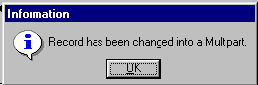

- Note the record is now a Multipart record.

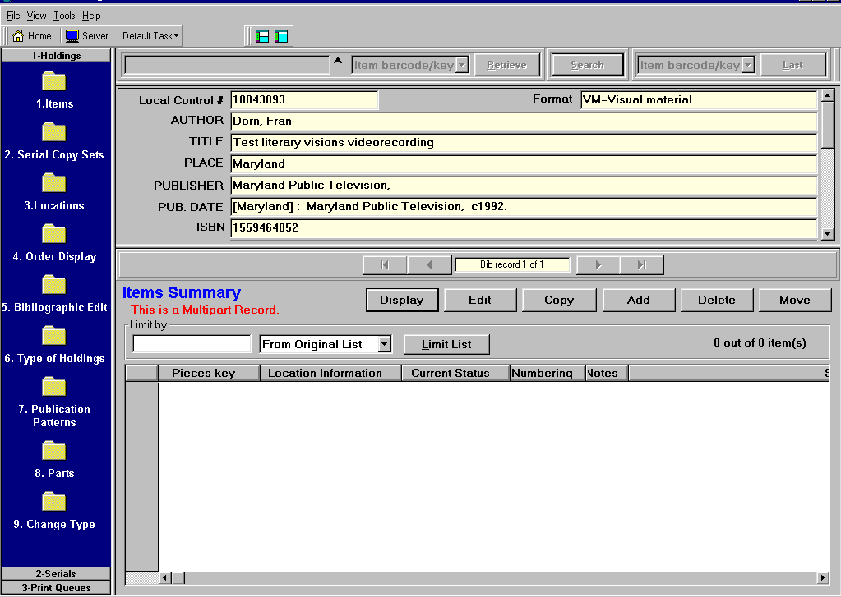
Figure 4

- Select Add to Add a Location Copy Record.

Figure 5
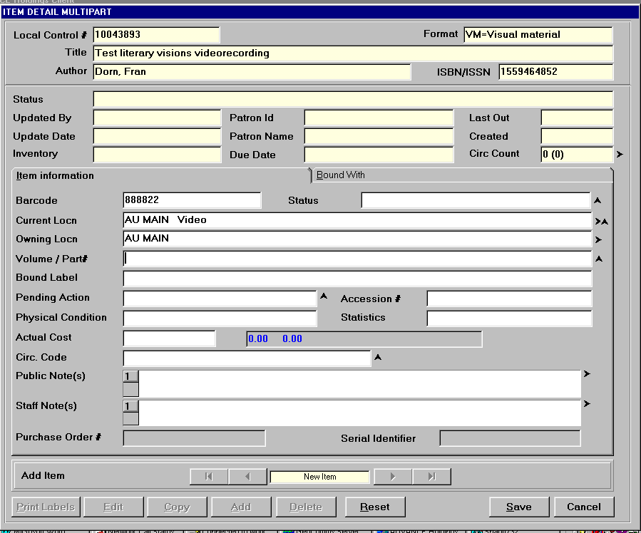

- Enter the item barcode in the Barcode field.

- In the Current Locn field, press F8.

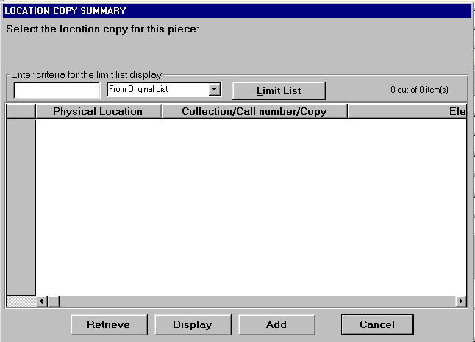
Figure 6

- Since no Location Copy record exists, select Add to create one.

- If a location record exists, you can select Retrieve to Retrieve the Location Record.

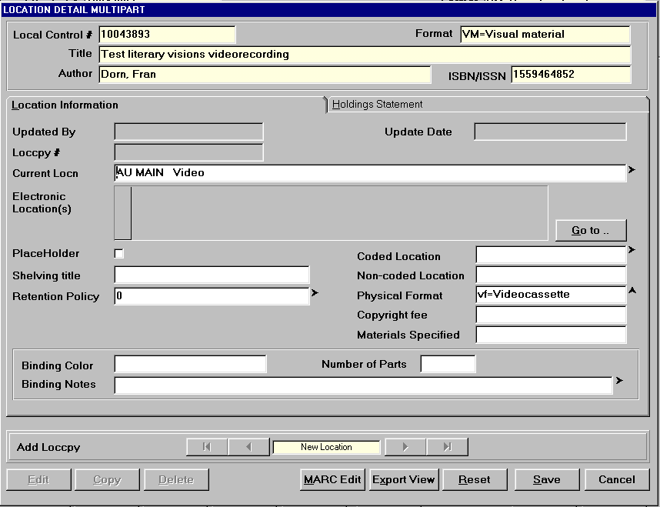
Figure 7

- Go to the Current Locn field and press F2.

- Select the Institution, Sublocation, Collection, Call Number, etc.

- Select Save.

- Select MARC Edit to add an Electronic Resource
This launches GeoCat where you can add an 856 Tag.

- Select Save when finished.

- At the Item Detail Maintenance screen, go to the Volume/part# field and press F8.

Figure 8

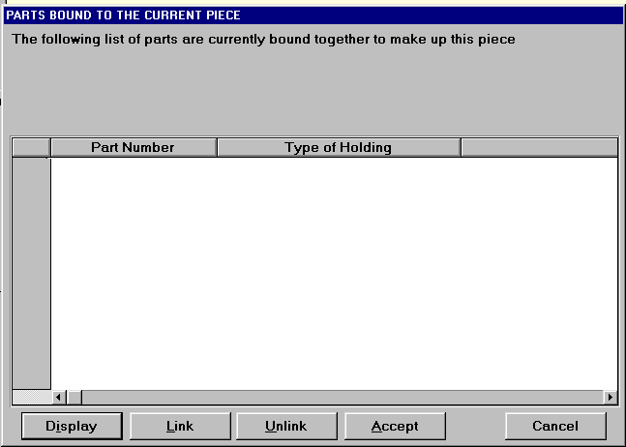
- Select Link to link Part to Type of Holdings.

- Select Add to add Parts detail.

- Go to Enter Type of Holdings field and press F2.
- Enter free text description in the Description field.
- Enter publication type in Publication Type field.
- Select Save.

- Go to Publication Pattern field and press F2.
- Enter the enumeration caption label, i.e. v. or no. …
- Turn off the Auto prediction flag.
- Save the record.

- At prompt “Is this publication pattern going to be used to predict issues?” select NO.
- At prompt “Can holdings data for the publication pattern be compressed?”, select YES.

- Select Save.
Figure 9
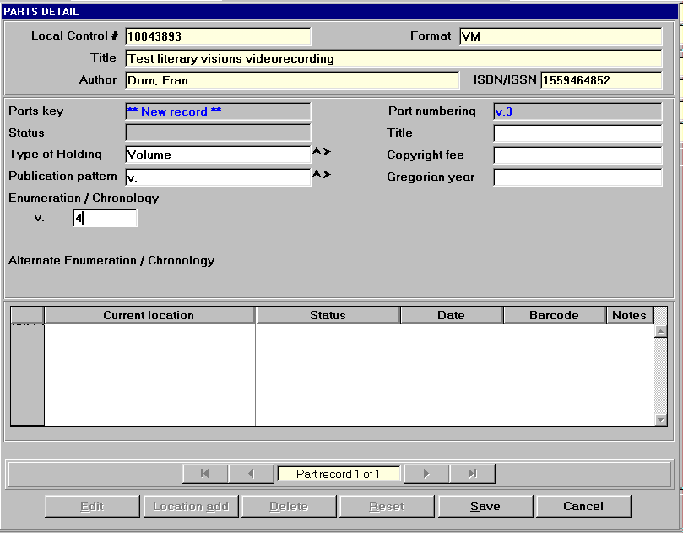

- At the Parts Detail screen, you can change the Type of Holdings or Publication Pattern.

- Enter the enumeration/chronology, i.e. 1 for volume 1.

- Select Save.

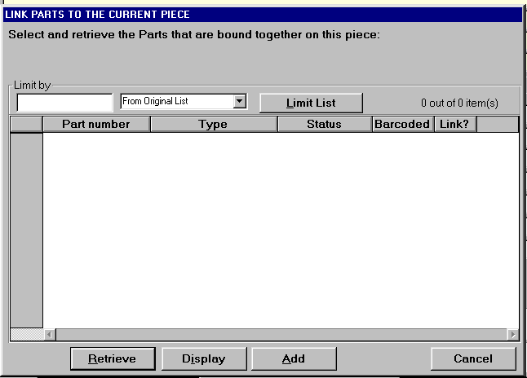
Figure 10

- With entry highlighted, select Accept.

Figure 11

- Select Save.

- Respond YES to prompt about updating owning information.

- Select Add to add another part or select Cancel to exit.
- Enter Barcode
- Change Location if needed.
- Go to volume/part # field and press F8.
- Select Link
- Select Add if a different number (select Retrieve to use the same number)
- Change the “1” to “2” in enumeration/chronology field.
- Select Save. Select Save. Select Save.
- Select Cancel to exit or Add to add another part

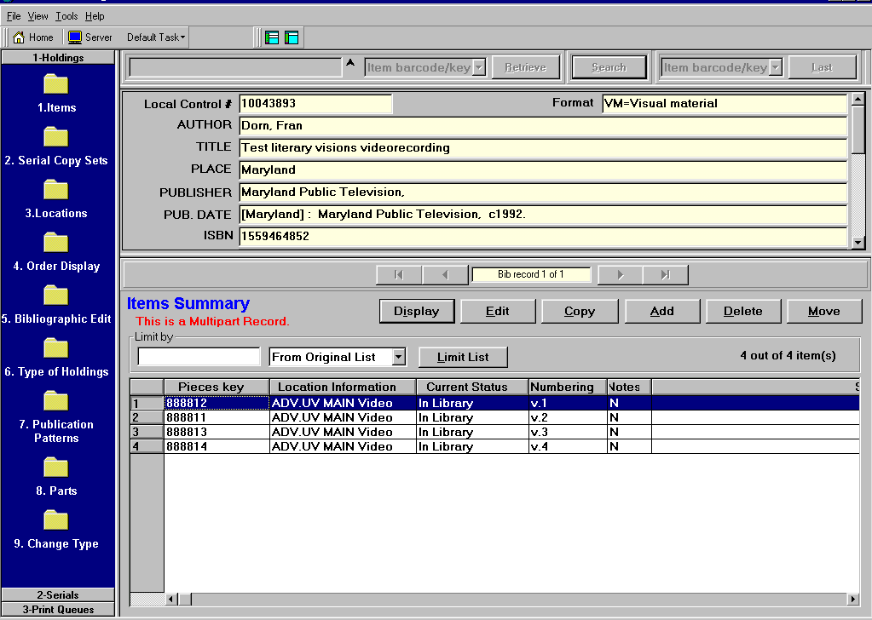
Figure 12

- The Pieces Key, Location Information, Current status , Numbering and Notes fields can be sorted.

- You can limit the list of items by data in any of the columns.

- You Edit, Copy, Add, Delete or Move items.

