

Creating Cataloging Records
(Original Cataloguing)

There are two ways to do original cataloguing:

1.) Open Template

Create a new record based on pre-defined template. Select CATALOGING/Open Template from the Cataloging Main Menu Toolbar.
Select the appropriate template from the List of Templates and Local Templates dialog box (ie book, serial, etc.).

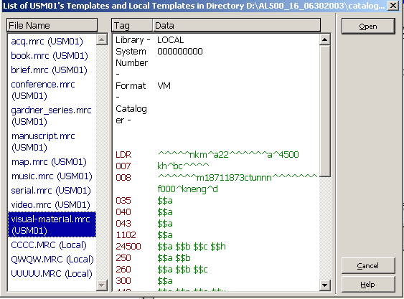

Once you select the appropriate template and click “Open”, a new record is created with a full complement of fields. The content of each field is blank. You can now continue editing records. The Tag Information tab of the lower pane provides a guide on the use of valid indicators, subfield codes and values for the highlighted field.

You can enter text into the content of a field or subfield by typing directly, by searching field or subfield headings, or by searching subfield options. The record automatically receives a temporary filename that begins with the prefix "NEW" and a number:

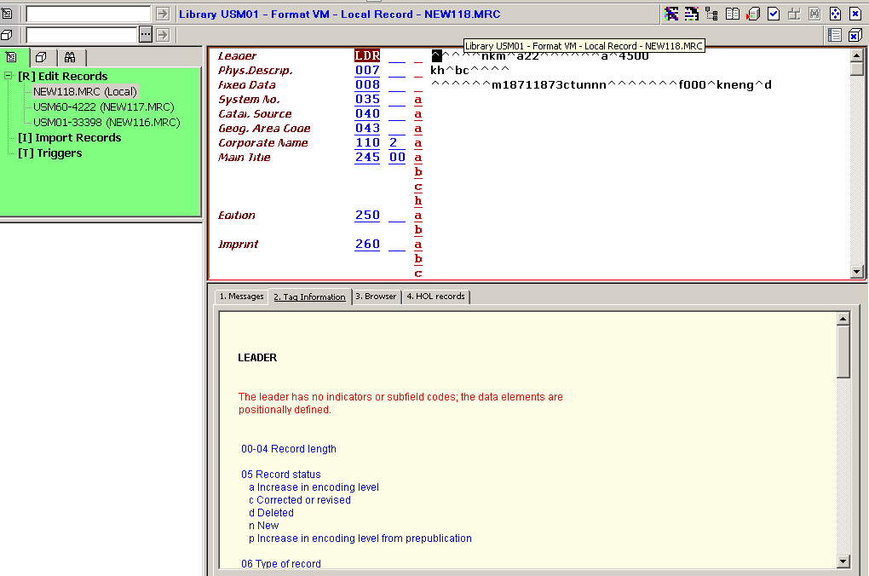

Add field and subfields to the record. To retrieve the Edit menu, click your right mouse inside the white space in the open record.

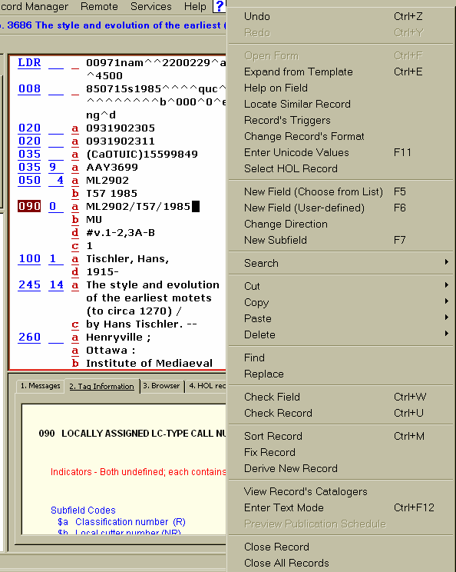

You can enter a new field below the current field by selecting a field from defined list. Select Edit/New Field (Choose from list) from the edit menu this allow you to add a field with tags, indicators and subfields already defined

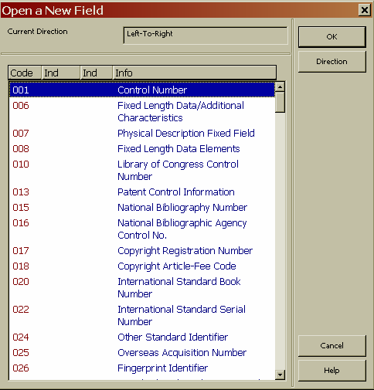

or select Edit/New Field (User-defined) from the edit menu, a blank field is created. To add a new subfield, select Edit/New Subfield from the Edit menu, this function inserts a new subfield below the current subfield. Remember to change the subfield letter to the correct letter, default is "a".

OR

Open New Record

Create a new record from scratch. Select CATALOGING/New Record from the Cataloging Main Menu Toolbar and highlight the appropriate format for your record from the Choose Record Format dialog box (ie. book, serial, etc.).

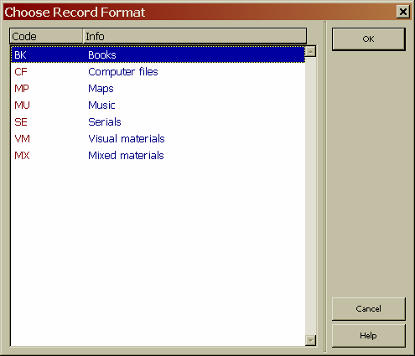

A form for the leader (LDR field) displays in the upper pane. The Tag Information tab in the lower pane provides a guide to the valid values for completing the form.

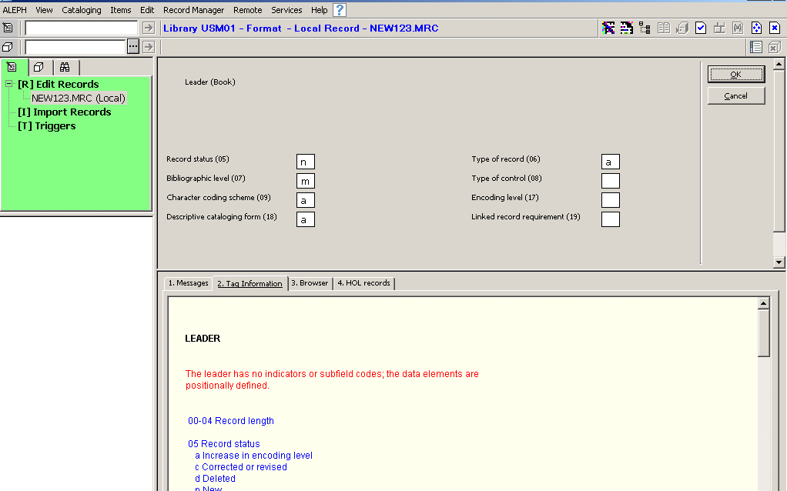

After you finish editing the form, click"OK". The system will check for errors, if errors are found, error messages are shown in the Messages tab of the lower pane. After closing the form for the leader the form for the 008 field displays, complete this form and click "OK".

Following the editing of the forms, a new record displays in the upper pane with the LDR and the 008 fields. This record recieves a temporary file name that begins with the prefix "new" and a number.

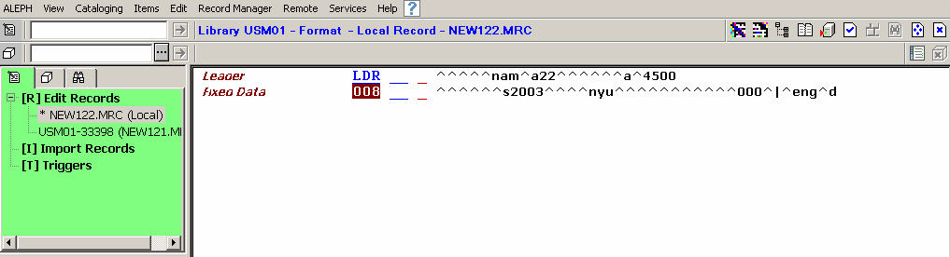

Add field and subfields to the record. To retrieve the Edit menu, click your right mouse inside the white space in the open record. You can enter a new field below the current field by selecting a field from defined list. Select Edit/New Field (Choose from list) from the edit menu this allow you to add a field with tags, indicators and subfields already defined or select Edit/New Field (User-defined) from the edit menu, a blank field is created. To add a new subfield, select Edit/New Subfield from the Edit menu, this function inserts a new subfield below the current subfield. Remember to change the subfield letter to the correct letter, default is "a".

