- A serial is a publication in any medium issued in successive parts bearing numerical or chronological designations and intended to be continued indefinitely.

2. A copy set is a run of issues of the serial, basically a subscription.

3. A publication pattern defines the enumeration levels, chronology levels and frequency patterns for the serial.

- Enumeration terms ( vol. / Part / Section / Issue / No. )
- Maximum Units (how many issues per month, year, etc.
- Numbering Code (R=Restart; C=Continuous)

4. Chronology shows the issue cover date, such as Month and Year.

5. Base Level (when should numbering be reset)

6. Elements of Serial Record

- Serial Copy Set represents a subscription and includes vendor code, shipto, claim code, etc.
- Location Copy record defines a specific copy of an item at a specific location and for a specific format.
- Type of Holdings record categorized the material being described, i.e. issues, supplements, indexes.
- A Publication Pattern record defines the labels, captions, frequency and regularity of publication.
- A Parts record is created when an item is checked in
- A Pieces record contains a barcode and circulation information.

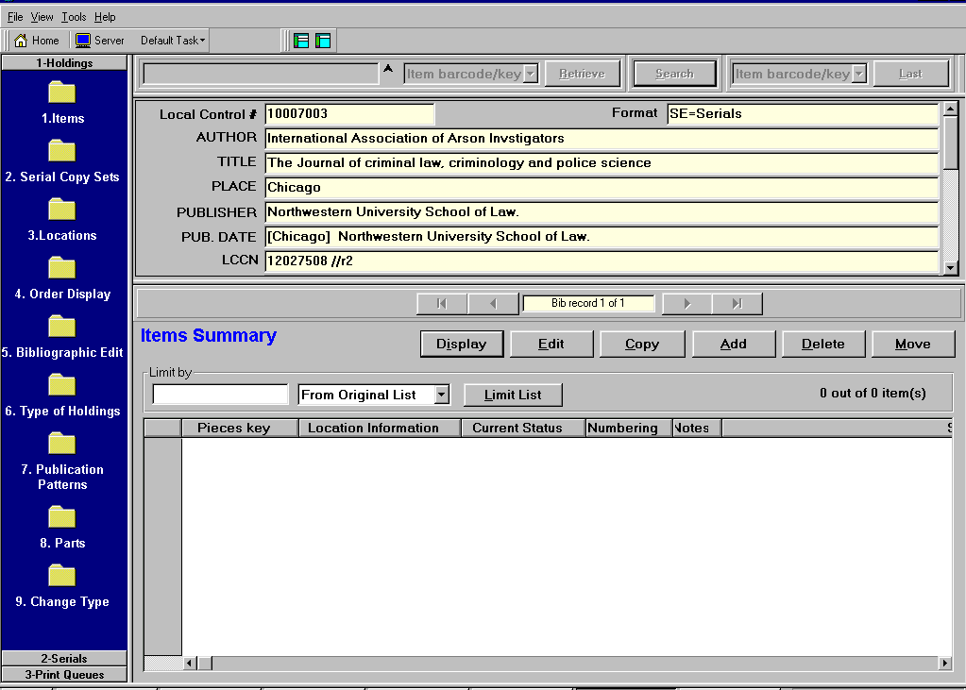
Step 1: Retrieve Title

Search by Local control # or Item Number
Z39.50 search by author, title, series, subject, etc.

Highlight entry in citation list and select OK to retrieve.

Step 2: If not already a multipart record, Select Task #9 – Change Type to change from single-part to multipart ( if not already a multipart)

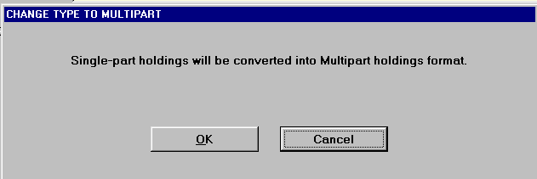

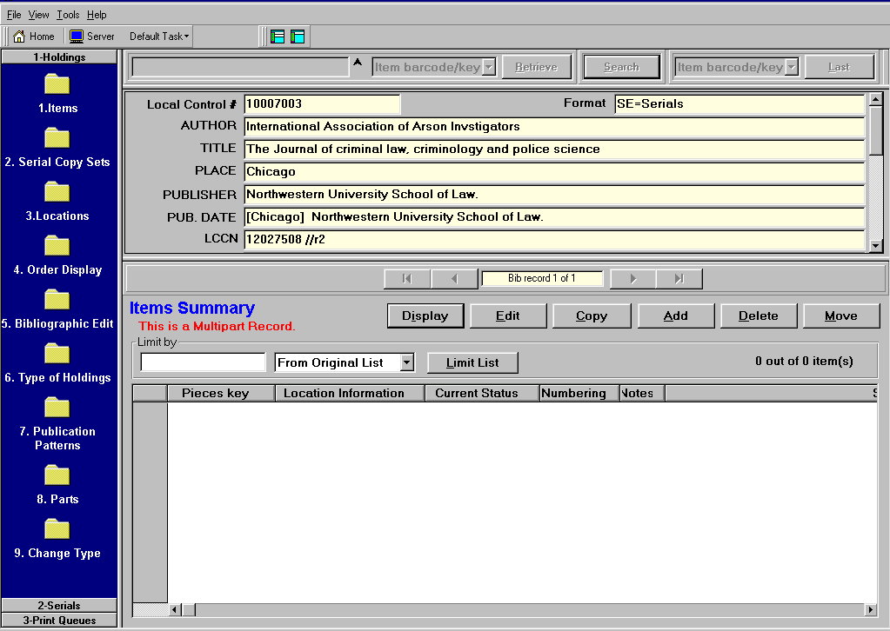
Note: “This is a Multipart Record” in red.

Step 3: Select Task # 2 – Copy Set Details to add copy set information

Select ADD to add the Location.
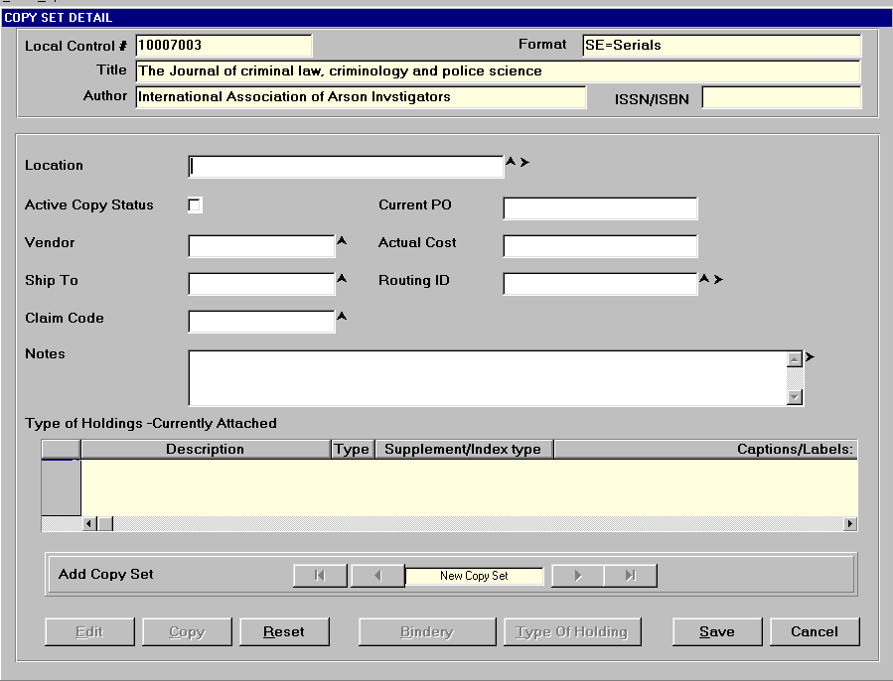

In the Location field, press F8 to add the Copy set Location
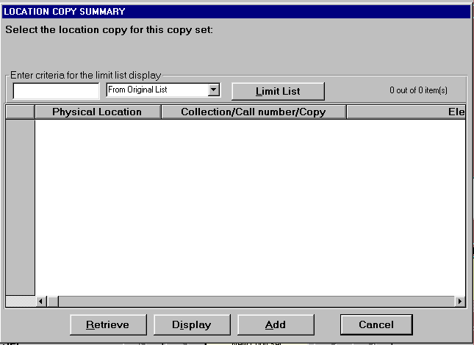
Select “Add” to add a location.

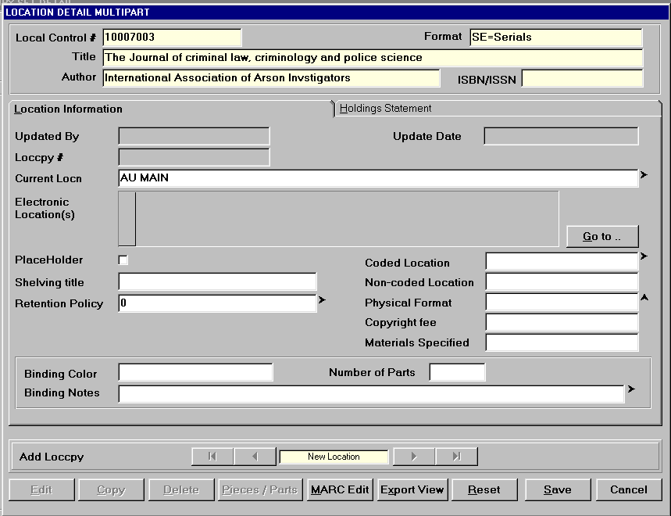

Press F2 for the data entry template in the Current Location field.

Complete the template and select “Accept”.

At the “Location Detail Multipart” screen fill in other information as desired, then select Save.

After the Location is added, set the copy set status to Active

Enter a Vendor Code

Enter a Shipto Code

Enter a Claim Code

Enter the Price

Enter the Routing ID

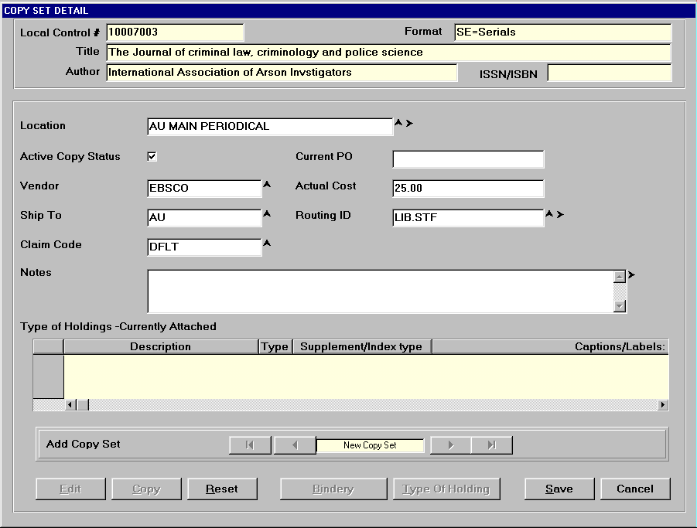
Select Save to save the Copy Set Record.

Note warning when Save is selected.

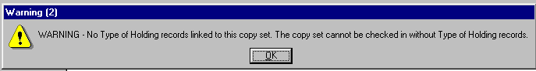
Select OK.

Note: You can press F10 to display an up-to-date checklist of requirements for adding a copy set.

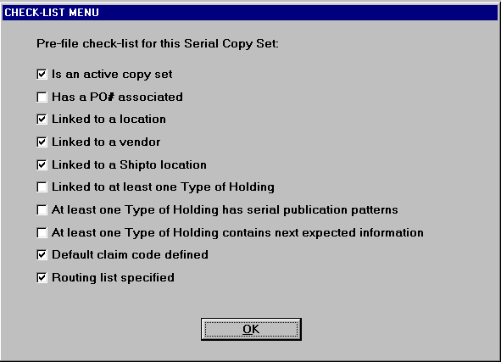

Step 5: Select Type of Holdings to add the TOH record.

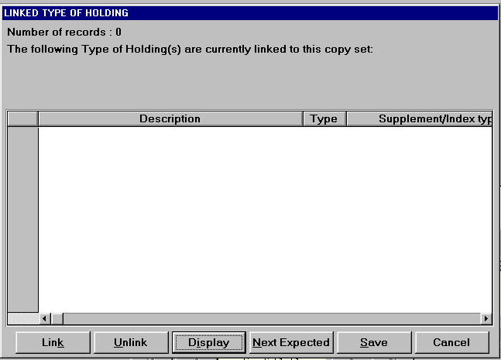
Select “Link” to link TOH to Copy Set.

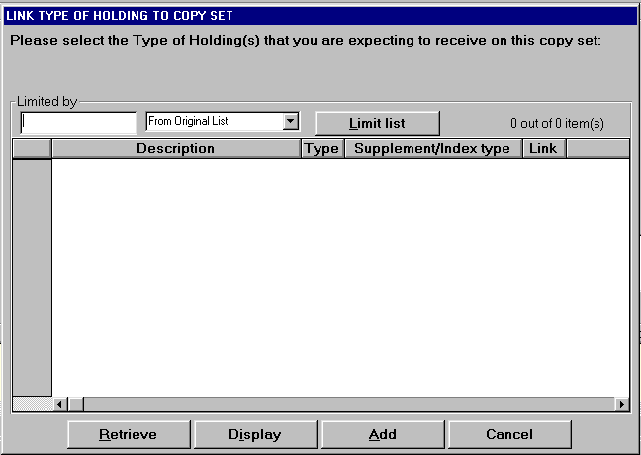

Since a TOH record does not exist, select Add to add a TOH record.

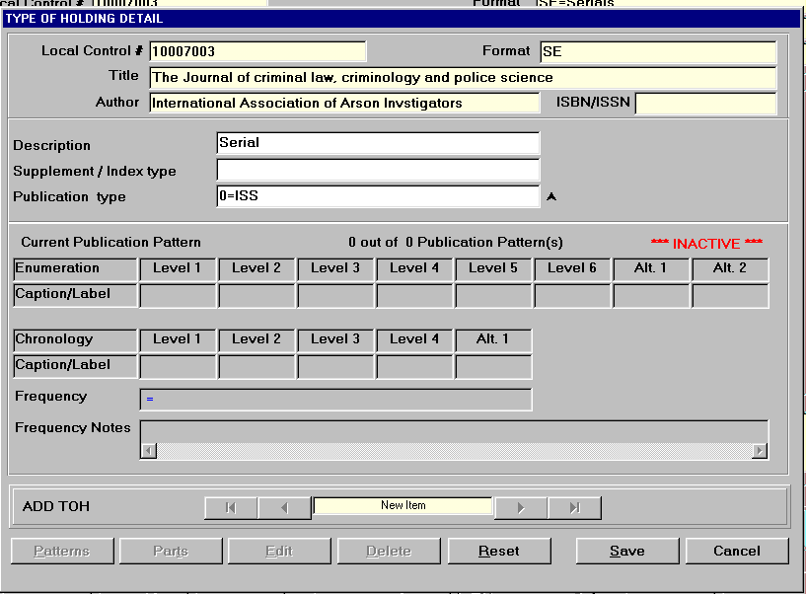
Enter a description and select the publication type.

Save the record.

After record is saved, select Patterns.

Step 6: Add Publication Pattern

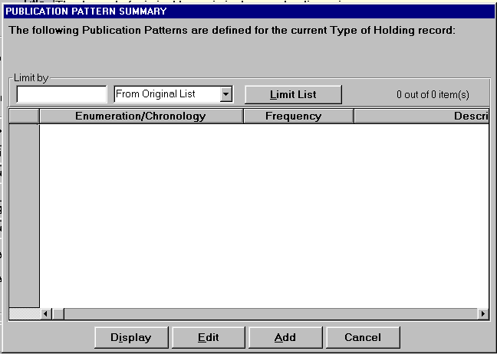

Since a pattern does not exist, select Add to add a publication pattern.

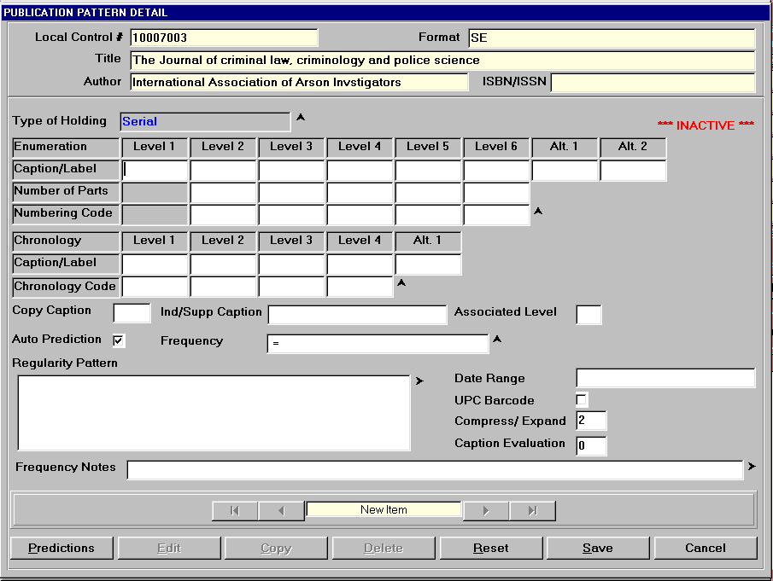

Fill in the template. Add the enumeration’s caption/label levels, number of parts and regularity.

Add the chronology’s caption/label and chronology codes.

Enter the frequency

With focus in the regularity pattern box, press F2 to display a template to set the regularity pattern.

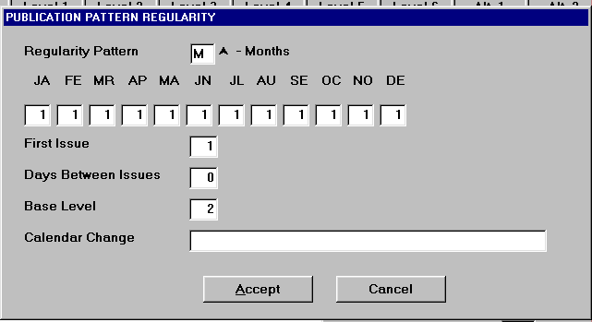
Fill in the template and select Accept.

Back at the Publication Pattern Detail screen, select Predictions.

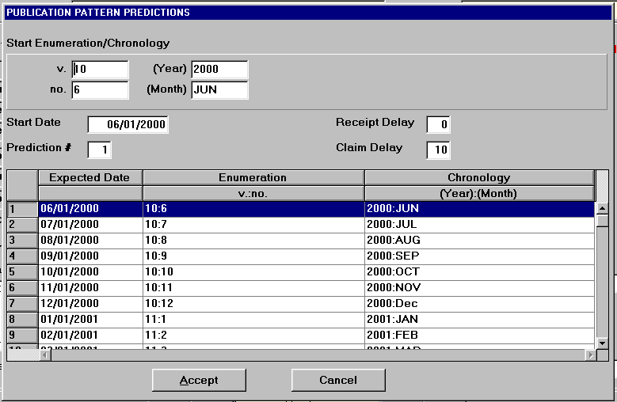

Fill in the template with start volume, number, year, and month, etc.

Select Accept.

Back to the Publication Pattern Detail screen, select Save to save the pattern.

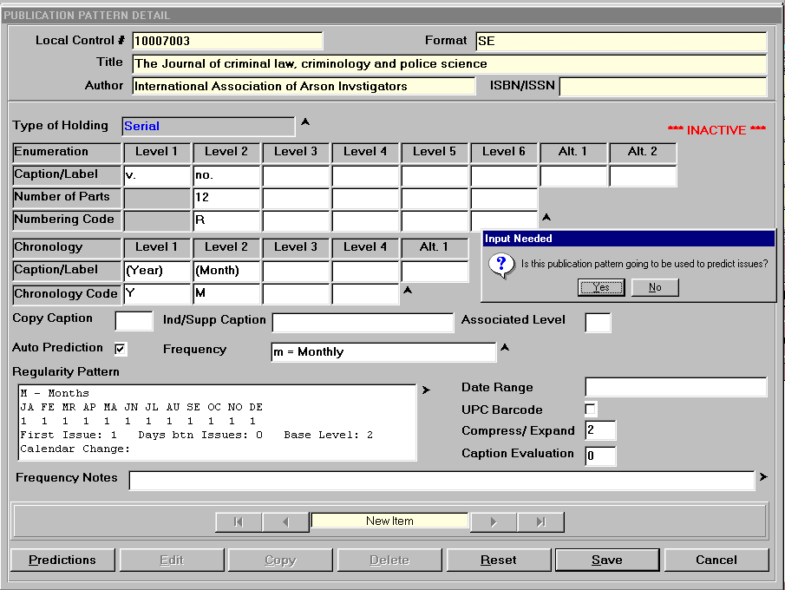

Respond “Yes” to the prompt “Is this publication pattern going to be used to predict issues?”

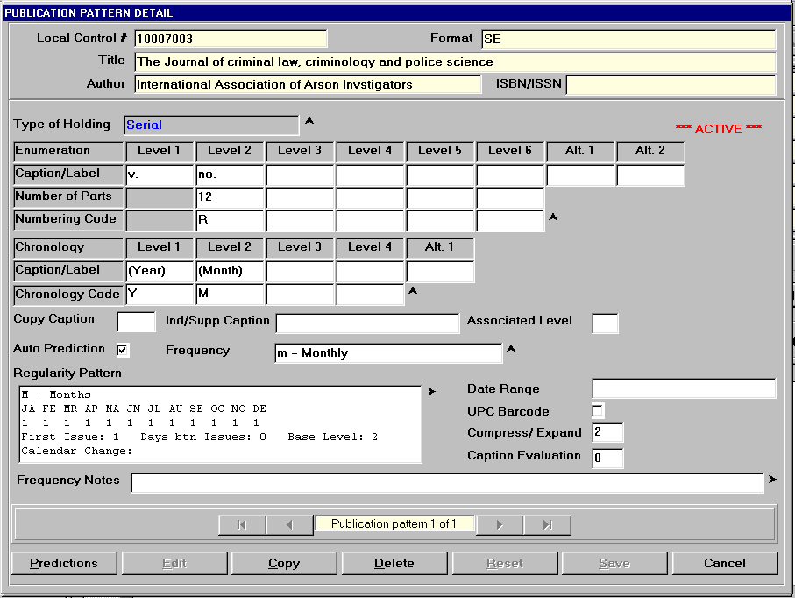
Note: The pattern is now Active.

Select Cancel.

Select Cancel, again.

Select Retrieve to retrieve the Type of Holdings.

Select Save at the Linked Type of Holdings Screen.

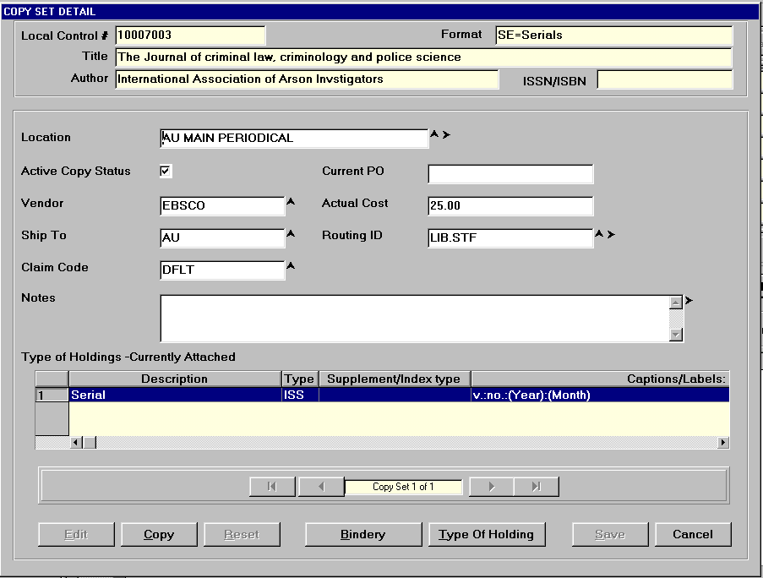

Select Cancel.

Note: Before selecting Cancel, you may select Copy to copy the current copy set to create an additional copy set, then you are prompted to link the TOH, etc.

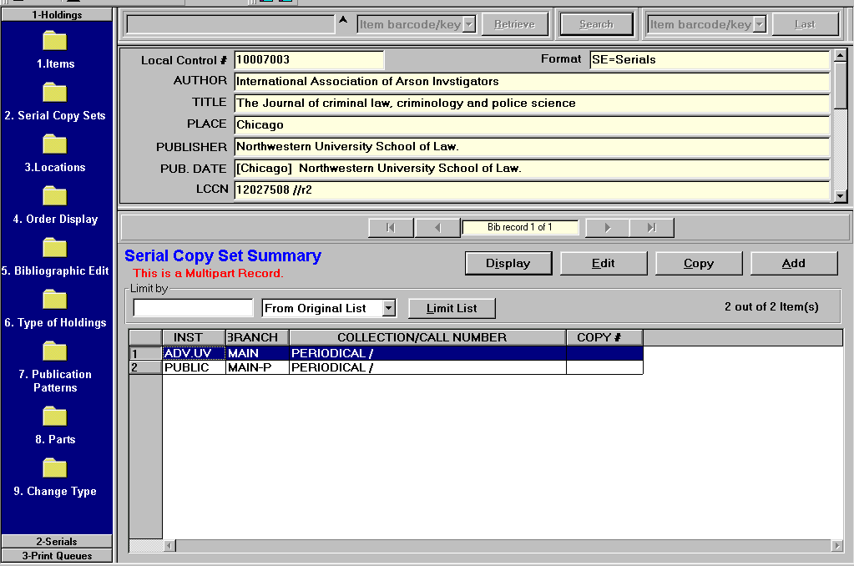

Go to Serials Checkin to receive an issue.

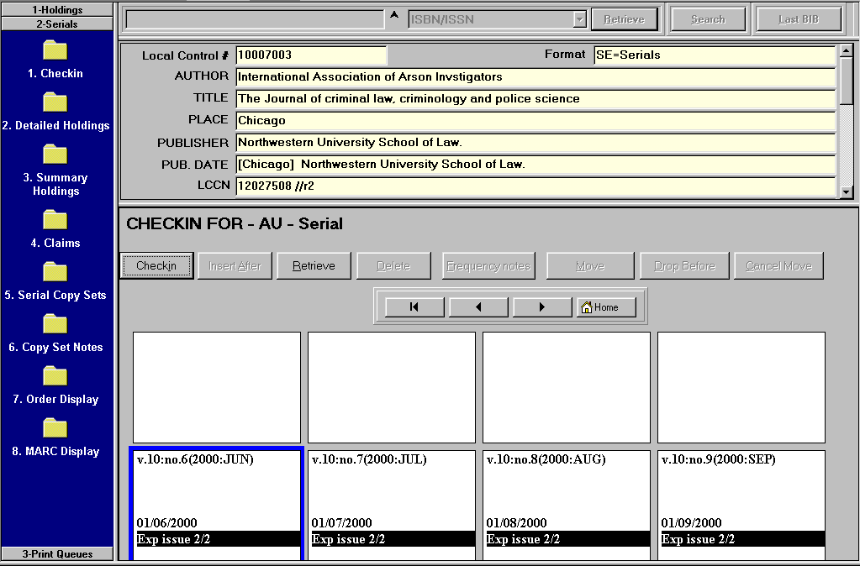
Serials Checkin

Right Mouse Click on a box and select checkin or highligh a box and select checkin.

Hightlight a box and select retrieve to retrieve box.

