Acquisitions: Standing Orders, Serials and, Memberships/Packages

1. Creating Standing Orders
Serial and Standing Order types in Aleph are used for titles that are published over a period of time; you will see, however, that different Aleph functions are associated with each. The order type you choose for a particular title may depend on your library's local practice.
This lesson focuses on Standing Order-order creation. Standing Orders are usually used for monograph series, continuations, memberships, or blanket orders. In each case, an order is placed for volumes that are due to be published in the future, with no predictable arrival dates. Standing orders are open-ended orders that are closed when all volumes have been received.

1.1 Choosing Standing Order or Serial Order
Standing Order type is typically used when ordering titles that are works-in-parts, or for monograph series, blanket orders or memberships. All acquisitions functions (orders, receipts, payments, cancellations, items creation, holdings editing, etc.) for standing orders are performed in Acquisitions/Serials module.
Serial Order type is typically used for ordering newspapers, periodicals, annuals, etc.: anything that has a predictable publication pattern. Serial Orders are ordered and paid for in Acquisitions, but all other functions done in Serials module (check-in, items, claims).

1.2 Creating a Standing Order
- To order the first volume and all following of a work-in-parts, search for your record in the Search Tab, display in Full + Link, and click on the Order Tab button to push the title to the Order Tab.
- From the Order List, click on Add; then choose Standing Order from the Order Type window.
- Fill in fields on Tab 2 (same as Monograph order form except as noted below)
- Order ISBN (for work-in-parts will be ISBN; note that you could have choice of multiple ISBNs—for specific volumes, for set—choose or enter appropriate one for order)
- Material type (choose Book or Book Work-in-Parts; note that what you’ll use is governed by local practice decisions)
- Library note (internal note; “expected in 3 vols.”, e.g. Pops up when piece is received (“arrived”)
- Order unit (some libraries may have special order unit, which is actually receiving unit, for this type of order)

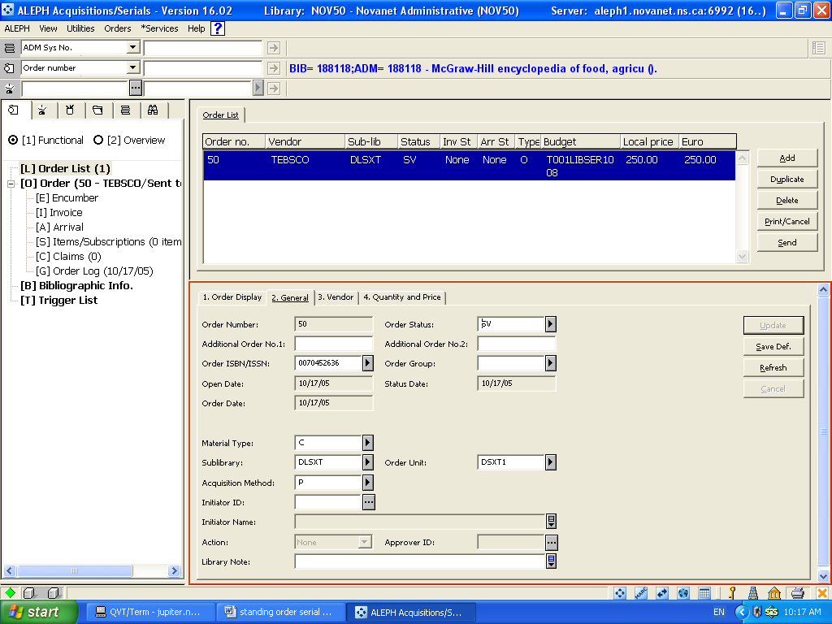

Figure 1: Standing Order Order Form: Tab 2
- Click Tab 3 and fill in the Vendor fields. You may wish to add a Vendor Note indicating that you are ordering v.1 and all following of this standing order.

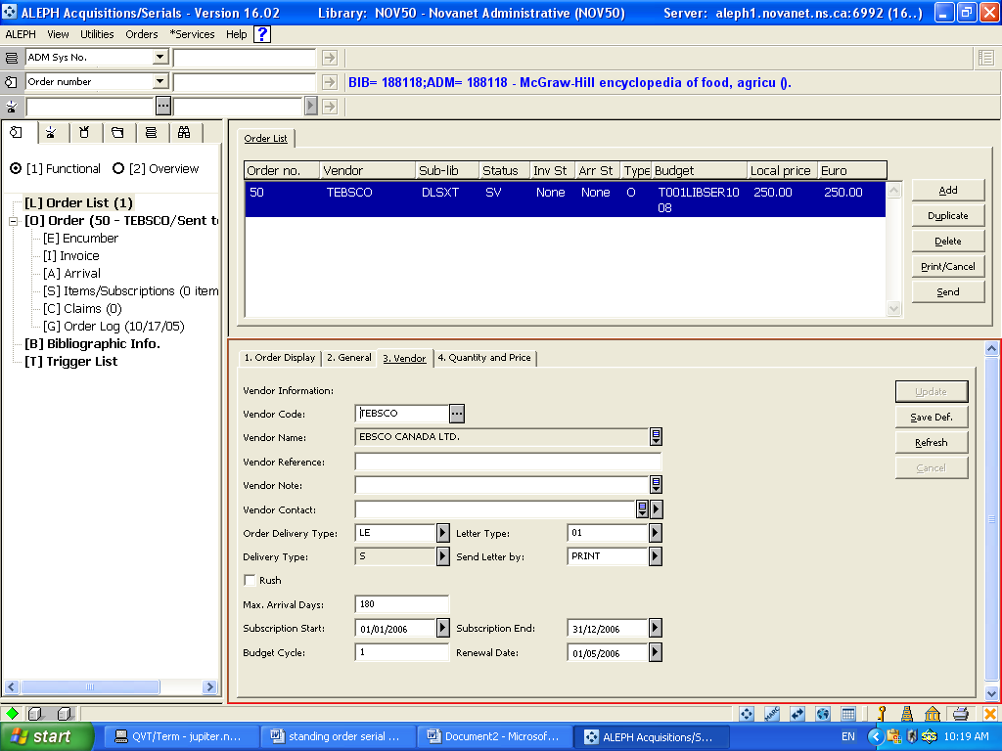
Figure 2: Standing Order Order Form: Tab 3
- Add the Max. arrival days: this sets Claim interval between vols.; if maximum is reached, order will appear on Standing Orders to Claim list
- Click to Tab 4 and fill in fields the same as Monograph order except as noted below
- Number of units (this is the number of copies of each volume you want; not total number of vols. expected)
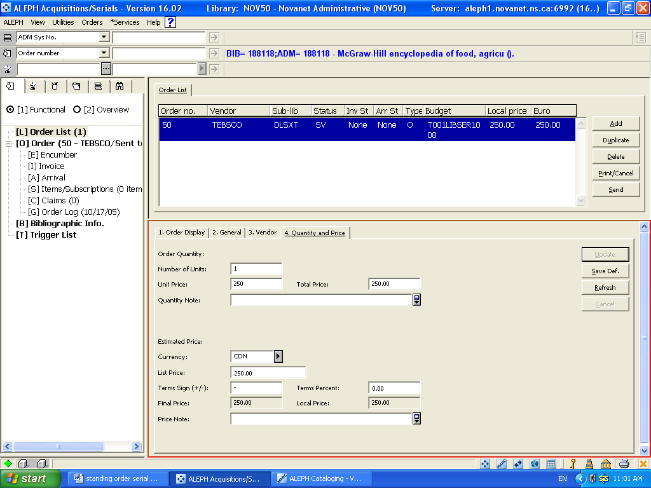
Figure 3: Standing Order Order Form: Tab 4
Notice that the Create Item Record checkbox does not appear on a Standing Order record; no items are created for Standing Orders.
7. Click Add. You will return to the Order List with the Order appearing on your screen.
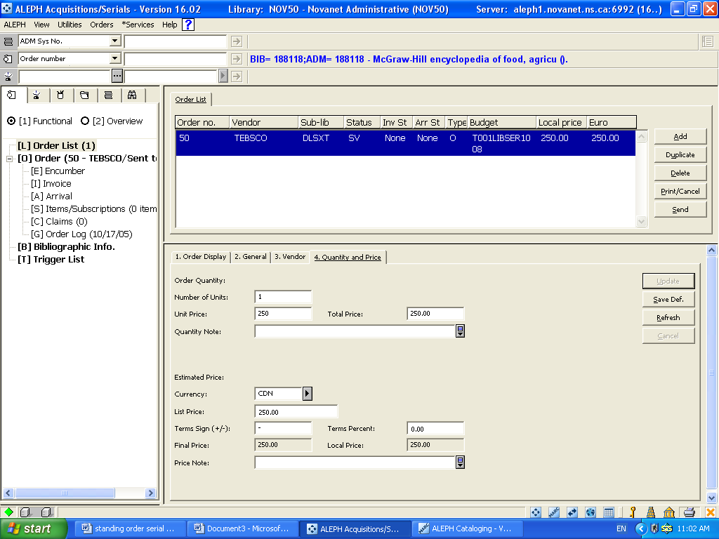
Figure 4: Order List with Standing Order (Order Type "O")
Notice that the Order Type for a new Standing Order in Aleph is listed as "O". Order types for orders that migrated often appear as “S”.
- Highlight order; click on Send button.

1.3 Creating a Holdings Record
For Monograph orders, public display of order status comes from the Item Processing Status in the Item record (On order, Ordered—received, Cancelled, etc.). Item Records are not created at point of order for either Standing or Serial Order types. In order to display location information and order status for Standing Orders and Serial Orders, you will need to create a Holdings record for each title at point of order.
From the Order Tab, click on the Serial Tab.
- Click on [M] Item List
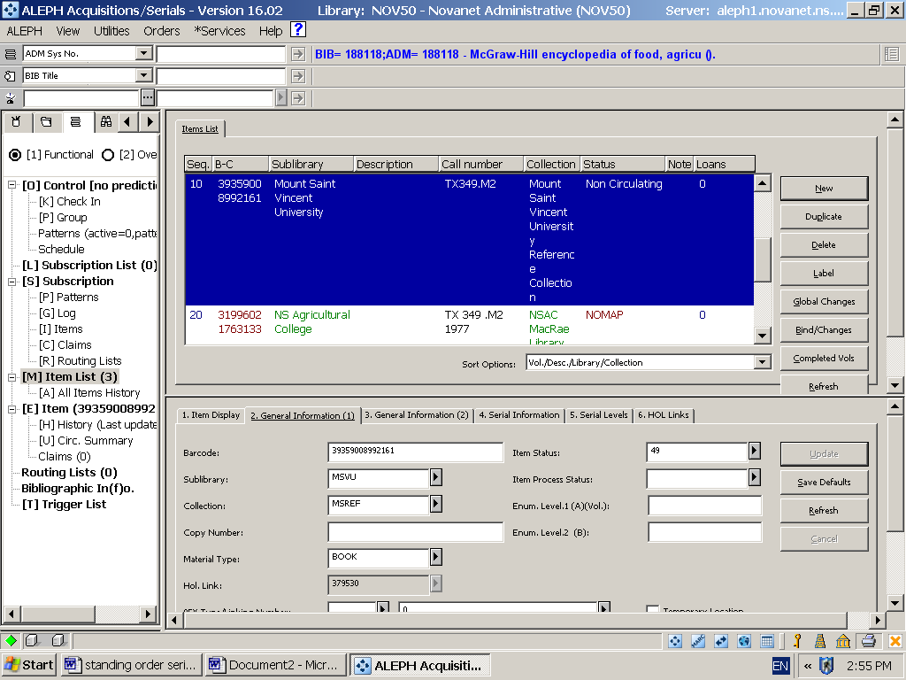
Figure 5: Serial tab item list
- Click on New button on the right; the lower pane will open to the General information 1Tab and the grayed out items list will display in the Upper Pane.
- Fill in the necessary fields. Clicking the Refresh button will show you any missing data. Sublibrary; collection; material type; item status; item process status.
- Click the Add button and a new item record has been created. Now, Hol. Links tab 6 is available. Click on tab 6.
- Click on Create New on the right side of the lower pane and a new linked holdings record is created from the sublibrary and collection code information you put in the General Info tab 1.
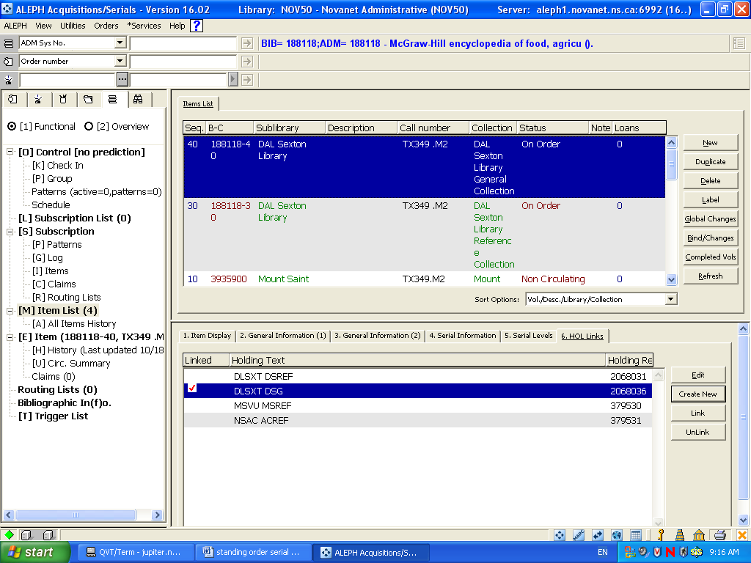
Figure 6: Create new holdings link

- This creates an On order status for the item in the catalogue.
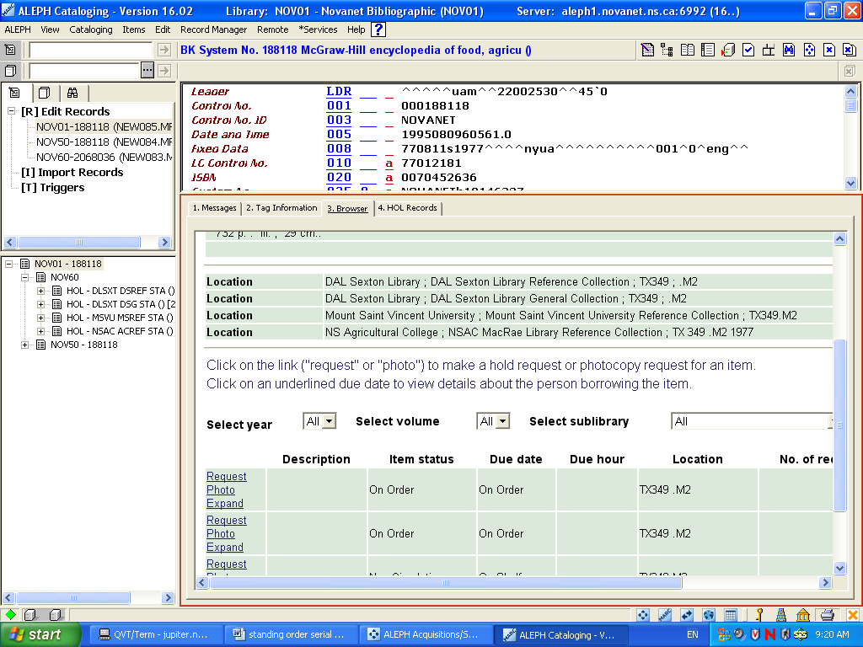
Figure 7: Browser view of On Order status from Cataloging module

2. Creating Serial Orders
The Serial Order is commonly used for periodical subscriptions, annuals, etc. This order type is meant for ordering titles that have predictable publication patterns or arrive on a continuous basis.
While serial titles are ordered and paid for in the Order Tab; receipts are done in the Serials Tab. Serial Orders, like Standing Orders, need to have holdings records created at point of order.

2.1 Creating a Serial Order
To create a Serial Order:
- Search for your record in the Search Tab and push it to the Order Tab.
- From the Order List in the Upper Pane, click on Add. When the Order Type window appears, click on ‘Serial’.

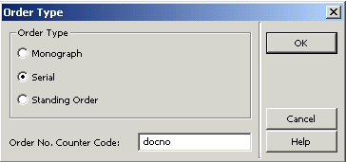
Figure 8: Serial Order Type

- Fill in fields on Tab 2 General
- Order ISSN
- Material type (choose the specific type for a Serial): Periodical, Newspaper, Mono Series, Serial)
- Sublibrary
- Acquisition method
- Order unit (institution specific)
- Library Note: You may want to add something in this freetext field.

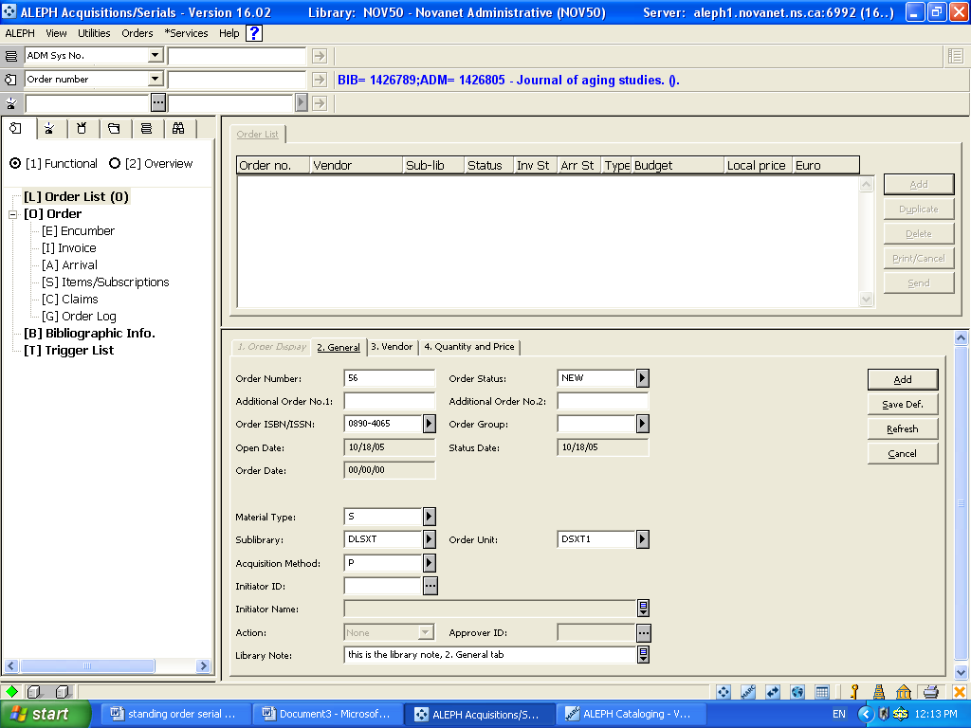
Figure 9: Serials Order Form Tab 2
- Click Tab 3 and fill in fields for Vendor
- Vendor code
- Order delivery type ; Delivery type
- Vendor note: This is where you would send ordering information such as "We would like to subscribe to this title. Please send v. 1, 1990, and all following"; or, "Please send v. 75, no. 1 and all following, etc.")
- Subscription start and end dates: (gets copied into the Subscription record; you will learn more about this in Serials). The recommendation is to start with Jan. 1 of the current year for a new title, and put the end date of 31/12/2099.
- Budget cycle is used for re-encumbering orders. 1=every year, 2=every other year, etc.
- Renewal date: use if your unit needs to renew subscriptions every year. Use your old “GEAC Review Date”

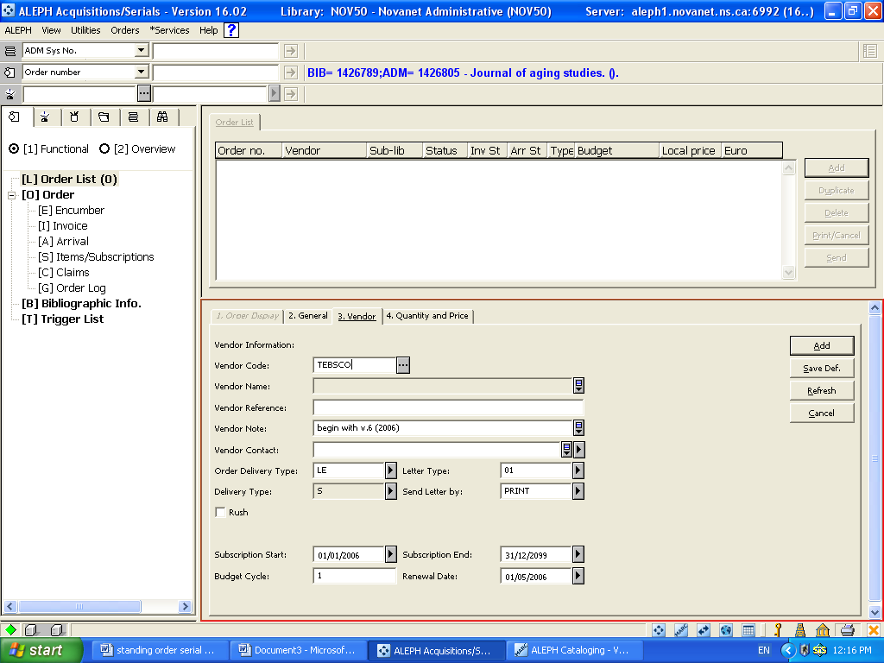
Figure 10: Serials Order Form Tab 3

- Click Tab 4 and fill in fields
- Number of units: is number of copies of each no. you want.
- Unit Price: If you encumber for your serials, you can put in the price here.
- Currency
- Encumber Budget

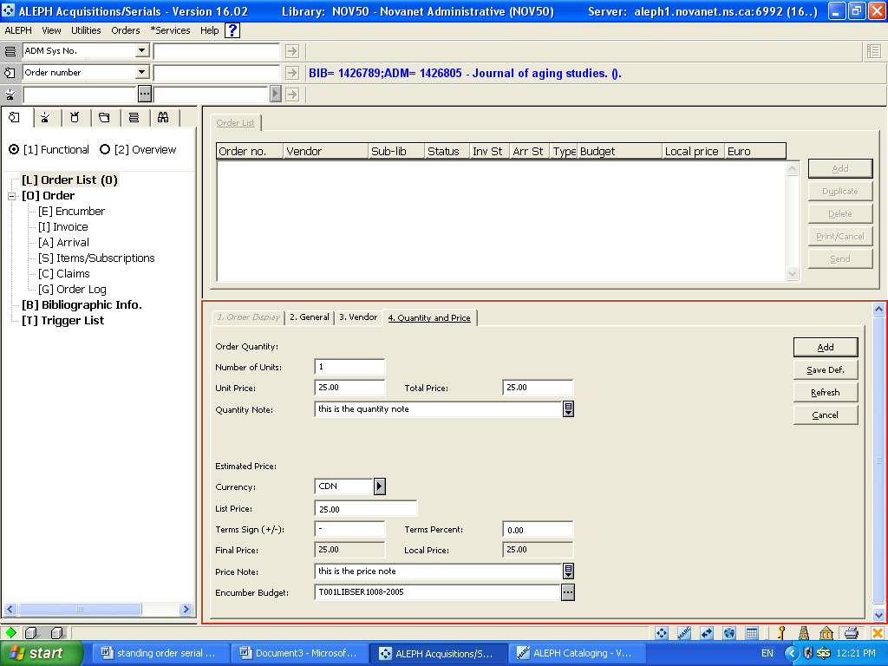
Figure 11: Serials Order Form: Tab 4
Note that the Create item records checkbox does NOT appear on a Serial Order; no items are created for Serial Orders.
- Click on Add.
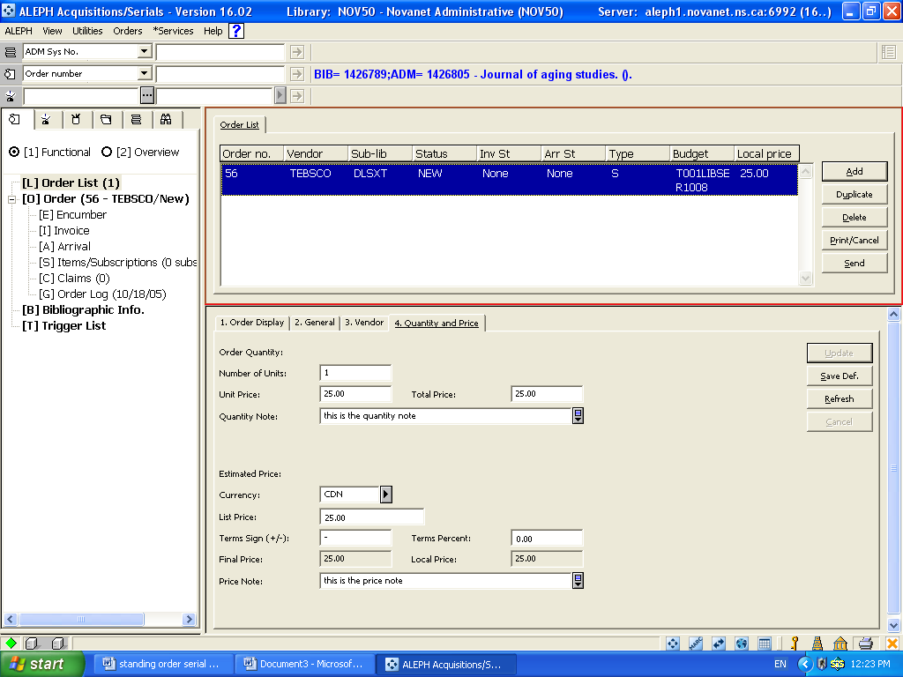
Figure 12: New Serial Order
Note display of order on Order List (status NEW, Order Type S, etc.)
- Click on Send.

2.2 Creating a Holdings record
In Standing Order creation you learned how to create a Holdings record. When placing a Serial Order you must also create a Holdings record in for public display of library location and order status. See page 4 of this document.

3. Memberships and Packages

3.1 Creating a Membership/Package (Order and Payment)
Libraries may join a society or association to take advantage of discounts on the organization’s publications or because the organization requires membership to obtain its publications. Before you can create a subscription record for a serial of this kind you must first create a membership record within the Cataloging Module.

The Catalogued membership record should include the name of the organization as well as the titles and system numbers of all titles covered by the membership or package plan. Other information could be added regarding each title in the respective 740 ($$a or other sub-fields)

    - Create and Suppress the Membership/Package record

  - Go to Orders at top of screen

  - Click on Catalog Order

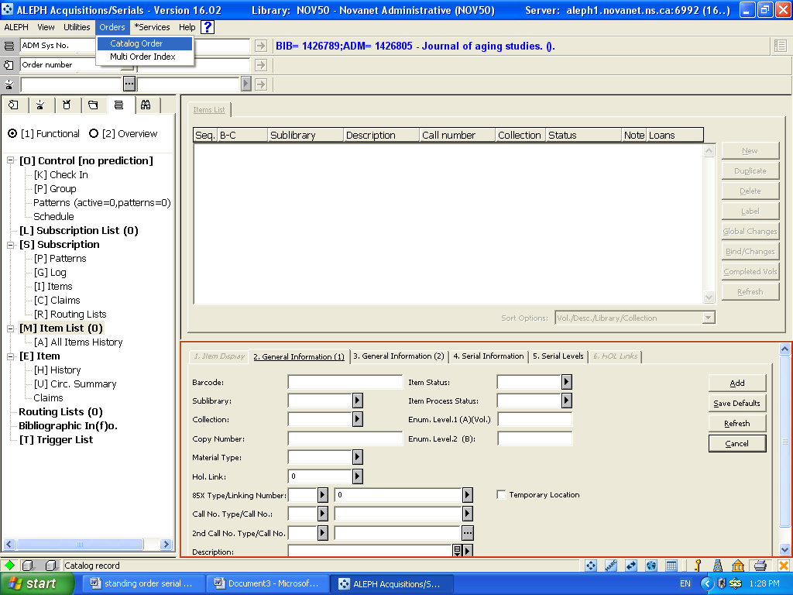

  - Click on NOV01 Novanet bibliographic in the Choose Bib Library box that pops up then click OK.

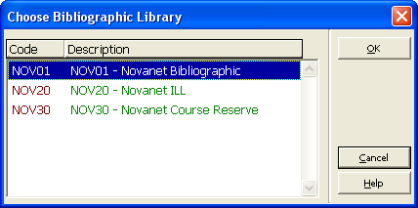

- The Template for an Acq-created record will come up, fill in the following mandatory information:
- Title
- Group field – right now one of these 035,022,020 must be filled in. I’ve been putting a “1”in the 035 and it is accepting the information.

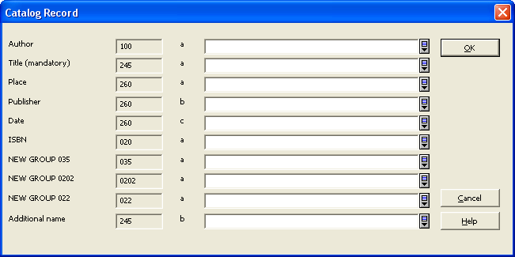

- Click OK. The catalog record is filed and you are taken to the order list screen, the package information is in the order bar.

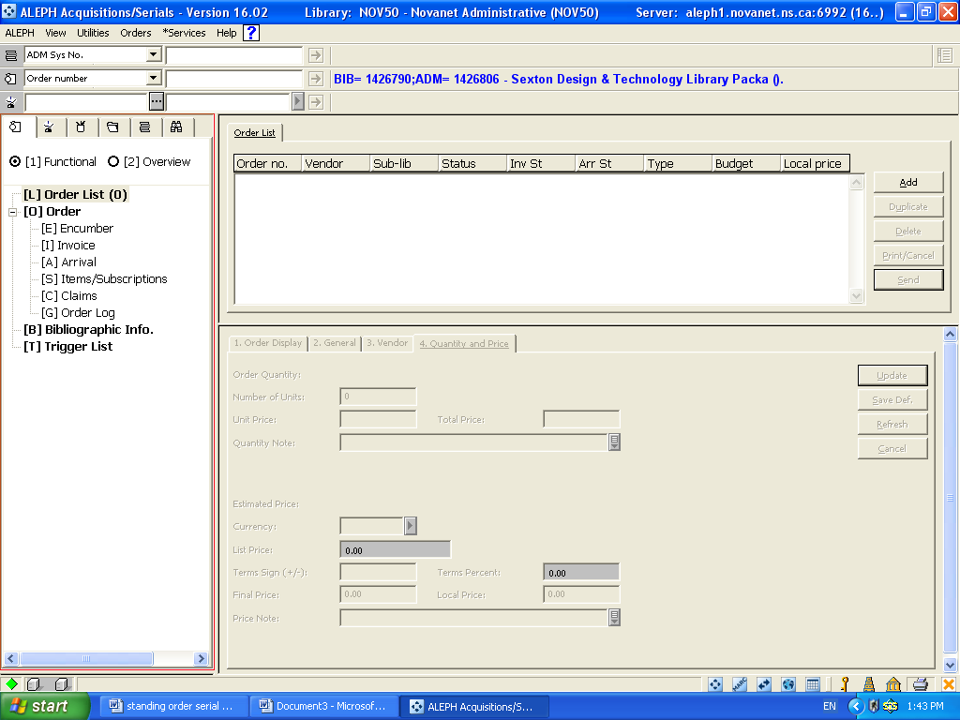

- Click on the Add Button. At the order type box, select “Standing Order”

- Fill in General Tab with information same as for regular standing order except for the following:
- Order Group – type in “Membership” ; this will allow retrieval of membership orders from the Index List node of the Order Search Navigation Tree Tab
- Material Type – C (continuation)
- Acquisition Method – M (membership)

- In the Quantity and Price Tab note that if you type in “1” in Number of Units, it fills in as 10 so you have to delete the zero.

- Complete the information and click on Add.

- Click on the overview radio button

- Click on Cataloging

- Select edit from menu bar, select New Field (select from list)

- Scroll until you see status; double click to add to your marc record template

- Type in all caps SUPPRESSED

- Save to server (override errors)

    - Creating Individual Serial Titles

In order to create individual serials titles received as part of a membership, you must catalog them individually. Each of these serial titles can be pushed into the serials client by selecting Open Serial Record from the Cataloging Main Menu Toolbar, in order to create subscription records for them.

  - Search for title in Novanet
  - click on cataloging
  - select Open Serials Record from Cataloging in the main menu bar
  - highlight [L] Subscription List
  - click on Add
  - fill in all info, remember to use same po# and vendor code as for membership order

  - Add holdings link

    - Adding 740 to “parent” and LKR to “child”

In order to link titles to membership/package order records the Parent must have 740’s for each title in the package. You need to make note of the record numbers for both the member/package record and the child record.

To Add 740’s
  - Go to the “child” record and make note of the record number
  - go to “parent” record
  - Edit – add new field (select from list) – 740
  - Follow description in Tag information tab lower pane (indicators 0b $a title (record #))

  - Save to server
LKR
- Go to the parent record and note the record number
- go to the child record
- edit – add new field (select from list)- LKR
- Follow description in Tag information tab lower pane
LKR bb $aANA (analytic; PAR =parallel; ITM=bound with)
$b (parent record number)
$lNOV50 (Novanet admin library)

5. Save to server.

