

Creating Cataloging Records with
Templates
(Original Cataloguing)

Creating Cataloging Templates

New records can be created based on pre-defined templates. There are two types of templates:
1. Local templates (stored on your PC)
2. System-wide templates (saved on the server)

Local Templates (Stored on Your PC)
Cataloging templates can be created based on the currently displaying record in the Catalog Editor (upper pane of the Edit Records function). Select CATALOGING/Create Template on Local Drive from the Cataloging Main Menu Toolbar. The Create template window displays for you enter in the name of the new template.

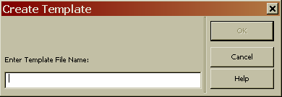

When you are finished, click the “OK” button. You will receive a confirmation message informing you that the template has been created.

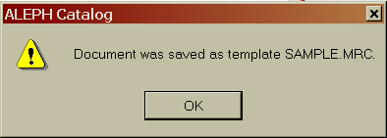

The template is saved in the list of templates (accessible via CATALOGING/Open Template from the Cataloging Main Menu Toolbar). Templates are only available from the workstation from which it was created. Local templates are stored in the Catalog/Templates directory on your PC.

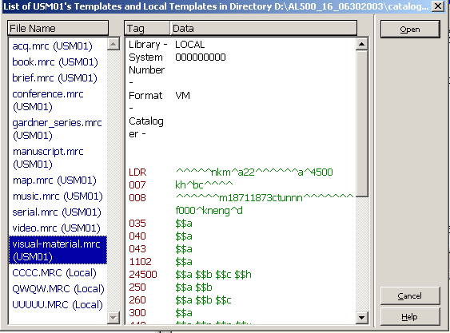

To remove a local template, search for the template under this directory and delete the file.

Additional Editing Tips

If you have the cursor anywhere on the record, right-clicking will bring up the Edit menu. Hitting Enter at any time rearranges or sorts the fields and subfields, and deletes any empty fields. Also note: if you are using a template, which has empty fields that you intend to fill in, you will lose them by hitting the Enter key.

Saving Records

There are three options for saving records

1. Save on local drive
2. Save all on local drive
3. Save on server and local drive

Save recorcd on Local Drive save the record on your PC's hard disk. Allows your to work on a record later and is not available to users. You may continue editing but no changes will be saved unless record is saved again.

Save All on Local Drive similar to Save on Local Drive except it saves every record that is currently open on your calaloging client

Save on Server and Local Drive updates the server database and assigns a system number to the new record also saves record to your local drive

Select CATALOGING/Save on Server and Local Drive from the Cataloging Main Menu Toolbar or click on the icon in the upper right toolbar. You will be prompted to save the record. Click on the "Continue" button. Any error message will display.

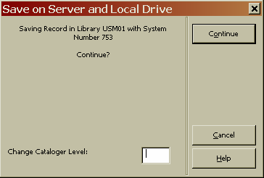

There are three levels of error messages:

1. Message can be overridden ( green question mark)
2. Message can be overridden and create a trigger record ( green question mark with pencil)
3. Message that blocks the record from being filed "Forbidden errors" (red exclamation mark)

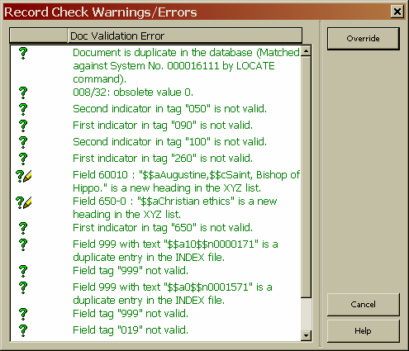
If you have permission you may override green error message, click on the "Overrride" button. Errors with the red exclamation mark must be fixed in order to save the record.

Creating a holdings record

In the bottom right pane select 4.HOL records tab, click on 'create" button to create a holdings record.

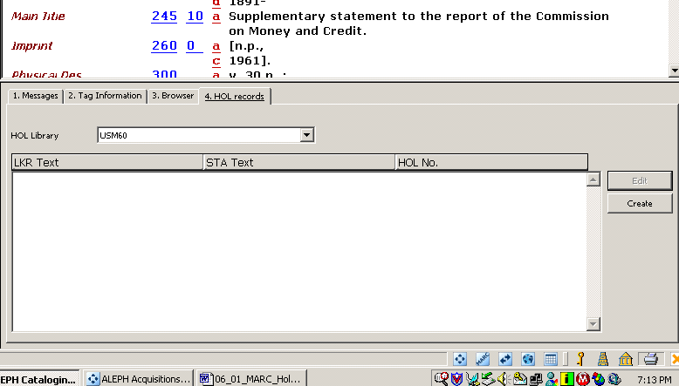

Click on the "edit" button on the right hand side of the lower pane

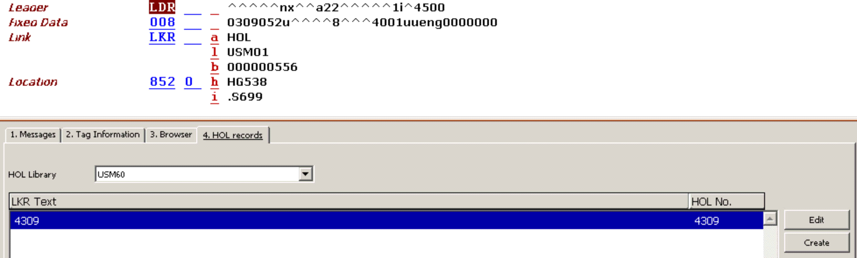,

this moves the HOLdings record to the upper pane for editing. The Leader (LDR), system number (001), LKR (004), 008 (Fixed Field Data) will display as well as the 852 $h (call number) if there is an 050 in the biblographic record. The 852 $b (sublibrary) and $c (collection) are mandatory subfields.
To add a subfield, right-click with your cursor on the 852 field.

After you finish editing the 852 field, save the record to the server (NOV60) by selecting Cataloging/Save on server and local drive from the Cataloguing Main Menu Toolbar or clicking on the icon from the Toolbar (upper right).

Creating items

In the bottom left pane expand the NOV50 library node (click on the + in the box) until you see the Items line. Double-click on the Items line and you will be taken to the items tab so you can create an Items record.

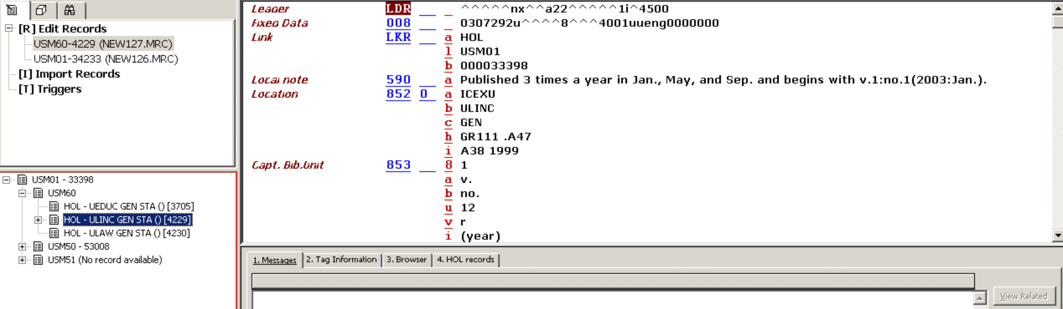

Click on "New" to activate the Item Form in the lower pane for item creation.

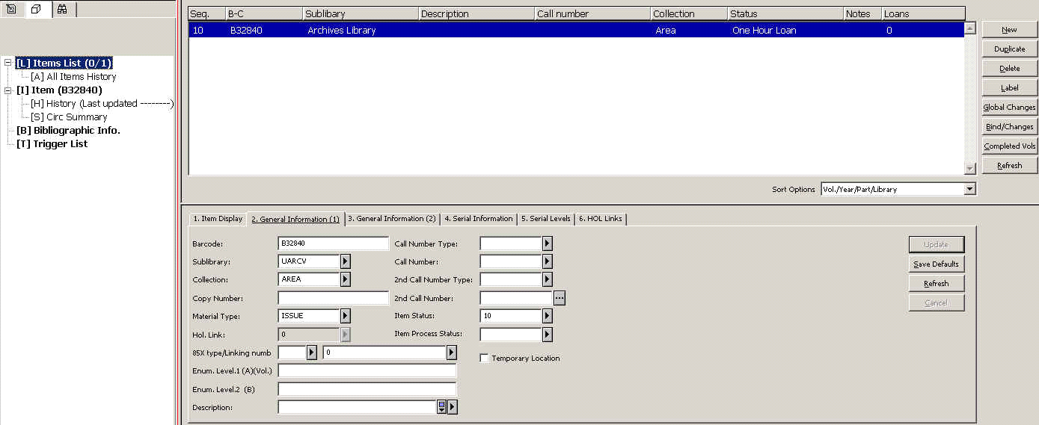

In the 2. General information tab fill in the HOL Link field this will link the item to the HOLdings record you just created. Click "Refresh" this will automatically fill in fields and prompt you for areas not completed. The call number will be copied from the HOLdings record to the item record.
Wand in your barcode and fill in the following fields: Material type and item status these are mandatory fields. Click on "Add" and your item is now created.

Check what it will look like in the Web OPAC

Check how it will look to the user by looking in the Web OPAC. To do so in Cataloging, double-click on your NOV01 record in the Records Tab, this will move the record to the upper pane and press CTRL+O. The Web OPAC version of your record will appear in the lower pane.

